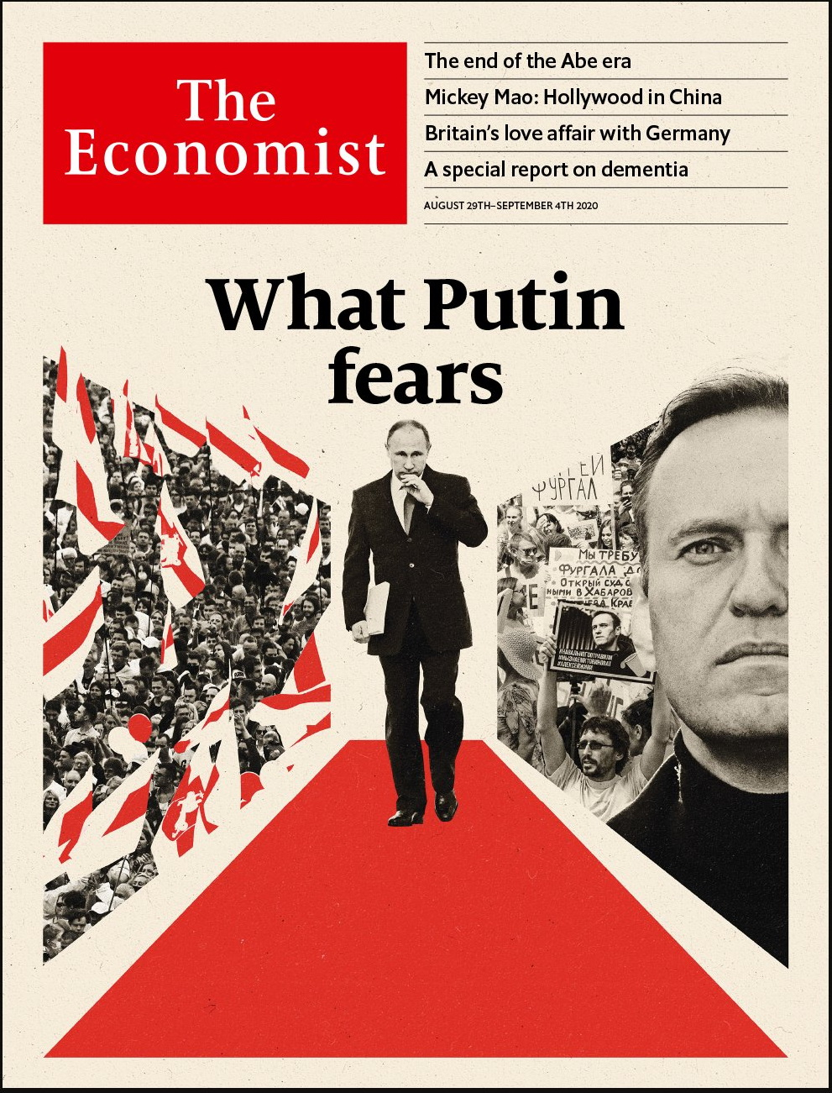

# Table of Contents

The world this week

Politics this week

Business this week

KAL’s cartoon

Leaders

Russia: What Putin fears

Dementia: The forgotten problem

Mexico: How not to handle a scandal

Hollywood and China: Un-American activities

Covid-19 and mental health: A world of trauma

Letters

Letters to the editor: On Kamala Harris, vaccines, fishing rights, postmen, IPOs, Boris Johnson, TikTok

Briefing

Belarus and Russia: The people lose patience

United States

Natural disasters: The condor’s cry

QAnon: On and on

Guo Wengui and Steve Bannon: Cognitive dissidents

More trouble in Wisconsin: A summer of fury

Sparring for the Senate: Kennedy fatigue?

Back to school: Learning and covid

Covid-19 in schools: Don’t blame the children

Lexington: Hail to the king

The Americas

Mexico: Bombshells on board

Sibling storms in the Caribbean: Storms Marco and Laura strike the Caribbean

Asia

Japanese politics: After Abe

The Christchurch massacre: Dignity in the face of depravity

North Korea’s economy: Self-strangulation

Catering in the time of covid-19: Grounded beef

Banyan: Tough, but incompetent

China

Podcasting: Listening in

Matronymics: In the name of the mother

Chaguan: System, heal thyself

Middle East & Africa

Mozambique: More misery, few answers

Migration: Cheques don’t check treks

Nollywood and the pandemic: Time to sharpen up

The Palestinians: Very brief holidays in the sun

Islam and dogs: Bone of contention

Europe

Germany’s refugee influx: Did they handle it?

Green-fingered Bulgarians: Constant gardeners

Montenegro’s election: Not very Christian

French higher education: Saclay sacré

Charlemagne: The Pampers index

Britain

Housing: Generation rent grows up

Fading Sinophilia: Flying dragon, passing fashion

The Labour Party: Middle-class hero

Politics and music: Last fight of the Proms

The hospitality business: Turning the tables

Books: The old stories

School uniforms: The new school tie

Bagehot: Learning German

International

Mental health: The common tragedy

Special report

Dementia: The perils of oblivion

The science: Plaque blues

Care: God’s waiting rooms

Going abroad: The last resort

Financing care: Alms for oblivion

Ethics: Still human

Business

Hollywood and China: Red carpet

German blue chips: Ascend and deliver

Health care: Left to their own devices

Energy utilities: Lit

Bribery: A closer look at greasy palms

Palantir Technologies: A prickly patriot

Schumpeter: For your eyes only

Finance & economics

Stock exchanges: Big fish

King of the hill: Ant Group IPO filing shows its might

Phil Hogan: Exit bruiser

Norges Bank: An expensive dream

Lebanon’s insurers: Broken cover

Housing in Seoul: The high-rise life

Buttonwood: Pinky v Blinky

Free exchange: Razing hopes

Schools brief

Greenback dominance: Buck up

Science & technology

Automation: Walking with robots

Covid-19: Trials and tribulations

Books & arts

Body art: The new ink masters

Elena Ferrante’s new novel: The second sex

The Freemasons: Inside the Lodge

Pop music: Send for “Help!”

Economic & financial indicators

Economic data, commodities and markets

Graphic detail

Vaccination: A first-world problem

Obituary

Marvin Creamer: Wind, sea and stars



### Friday, August 28, 2020

|  |  |
| --- | --- |
| The world this week | 3 |
| Leaders | 5 |
| Letters | 1 |
| Briefing | 1 |
| United States | 8 |
| The Americas | 2 |
| Asia | 5 |
| China | 3 |
| Middle East & Africa | 5 |
| Europe | 5 |
| Britain | 8 |
| International | 1 |
| Special report | 6 |
| Business | 7 |
| Finance & economics | 8 |
| Schools brief | 1 |
| Science & technology | 2 |
| Books & arts | 4 |
| Economic & financial indicators | 1 |
| Graphic detail | 1 |
| Obituary | 1 |

|  |  |  |
| --- | --- | --- |
|  | Sections | Leaders |

The world this week

Politics this week

.

Business this week

.

KAL’s cartoon

.

|  |  |  |
| --- | --- | --- |
|  | Sections | Leaders |

|  |  |  |  |
| --- | --- | --- | --- |
|  | Articles | Sections | Next |

# Politics this week

Aug 29th 2020 |

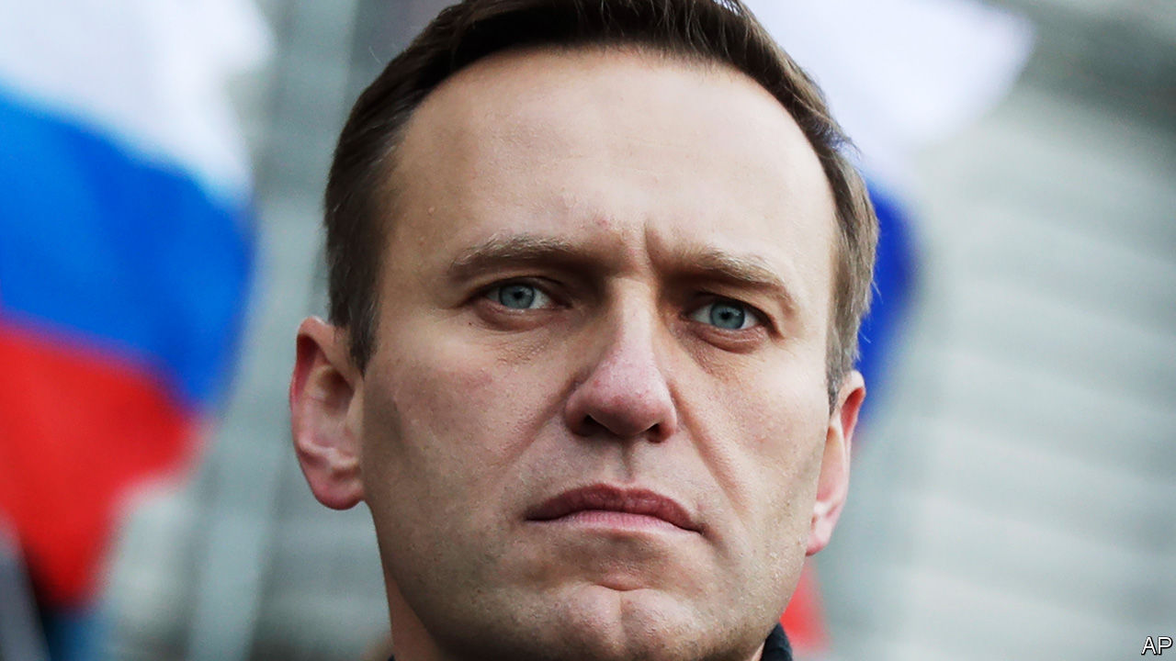

Alexei Navalny, Russia’s most prominent opposition leader and anti-corruption activist, fell into a coma after being poisoned. He was held for two days in a Russian hospital, before being released and flown to Germany, where doctors said they thought the poison included cholinesterase inhibitors, an ingredient in some Russian-made military toxins. Kremlin flacks said perhaps he was suffering from low blood sugar. Germany has offered him asylum. See article.

Hundreds of thousands of protesters continued to demand the resignation of Alexander Lukashenko, Belarus’s dictator, despite facing arrest and torture. Mr Lukashenko flew by helicopter to a secure location and brandished an AK-47 rifle. Western countries have not recognised a rigged election on August 9th that Mr Lukashenko “won”. See article.

Phil Hogan, the EU’s commissioner for trade, resigned after violating covid-19 social-distancing rules while on a trip to his home country of Ireland. See [article](https://www.economist.com/node/21791258).

Africa was declared free from wild polio, after decades of work by governments, volunteers and global health bodies. Nigeria was the last African country to be given the all-clear. The disease is now only found in Afghanistan and Pakistan. There is no cure, but there is a vaccine.

The UN Security Council blocked America’s effort to restore UN sanctions on Iran, which were lifted as part of a nuclear deal that America ditched in 2018. The rotating president of the council said many members disagreed with America’s position. Meanwhile, Iran agreed to grant inspectors from the International Atomic Energy Agency access to two nuclear sites after a months-long stand-off.

Israeli warplanes bombed targets in Gaza belonging to Hamas, the Islamist group that runs the territory. The strikes were a response to Palestinians launching incendiary balloons towards Israel. There were no reports of casualties.

Several pro-democracy activists were arrested in Thailand as student protests raged against the military-backed regime. Facebook obeyed an order to block access to a group with 1m members that the state claims is rude to the monarchy—a crime in Thailand.

In India Prashant Bhushan, a lawyer, was found guilty of contempt of court for a tweet chiding the chief justice for flouting social-distancing rules and another saying courts were abetting the erosion of democracy in India. The ruling on the two tweets was 108 pages long.

A white supremacist who massacred 51 people at two mosques in Christchurch was sentenced to life in prison without the possibility of parole. It was the first time such a sentence has been handed down in New Zealand. See article.

Abu Sayyaf, an insurgent Islamist group in the Philippines, carried out two suicide-bombings in the city of Jolo, killing 14 people.

A deposition containing startling allegations of corruption against three former Mexican presidents and other politicians and officials was leaked to the press. The current president, Andrés Manuel López Obrador, proposed holding a referendum to decide whether to prosecute them. Critics noted that this would make a mockery of the rule of law. See article.

Canada’s Conservative Party, the main opposition to the Liberal government of Justin Trudeau, chose Erin O’Toole to be its new leader.

Prosecutors in Brazil charged Flordelis dos Santos de Souza, a gospel singer who is now a congresswoman, with conspiring to murder her husband, an evangelical pastor. They accused six of her 55 children (most of whom are adopted) of participating in the murder. Ms dos Santos claimed her husband, who was shot 30 times, was killed in a robbery.

America’s Republicans held their convention, with most of the speechifying broadcast via video link. Donald Trump used the White House as a backdrop for parts of the jamboree. Mike Pompeo also flouted protocol by praising Mr Trump’s accomplishments. Secretaries of state normally keep a low profile at overtly political functions. See [article](https://www.economist.com/node/21791234).

Mr Pompeo broadcast his speech from Israel, where he had earlier called on other Arab states to follow the lead of the United Arab Emirates and normalise relations with the Jewish state.

Protests against the shooting of a black man by police in Kenosha, Wisconsin, that left him paralysed, descended into violence. A white teenager was charged with shooting dead two people. See article.

Hurricane Laura battered Haiti and the Dominican Republic, killing dozens, before roaring across America’s Gulf coast, hitting Louisiana and east Texas. The National Hurricane Centre said that the expected storm surge was “unsurvivable”. See [article](https://www.economist.com/node/21791233).

Steve Bannon, a former adviser to Mr Trump and inspiration to nationalists and populists globally, was charged with swindling donors to a charity that supports building a wall along the Mexican border. He was arrested on a yacht owned by Guo Wengui, a Chinese billionaire who lives in exile in New York. See article.

## Coronavirus briefs

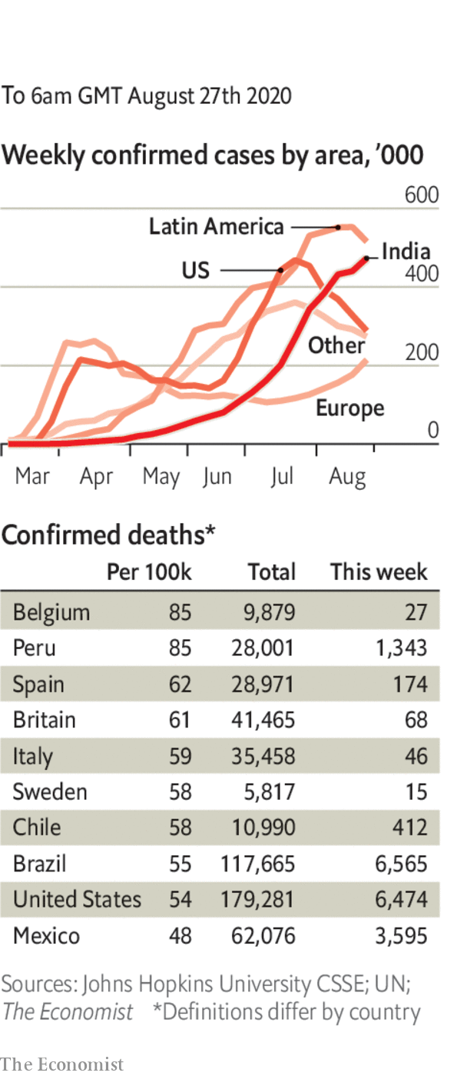

Researchers in Hong Kong reported the world’s first genetically verified case of someone who has been reinfected with covid-19, suggesting that immunity from the disease does not necessarily last long. The WHO called for more studies.

Mexico officially passed 62,000 deaths in total and 574,000 cases. Unofficially, the real numbers are thought to be perhaps three times higher. In the United States the number of new cases continued to fall.

Japan was reportedly set to lift its ban on foreign residents returning to the country.

Joe Biden said he would “listen to the scientists” and, if elected president, would be willing to shut the economy to stop another wave of infections.

The World Economic Forum postponed next year’s Davos summit from January until the middle of the year.

This article was downloaded by calibre from <https://www.economist.com/the-world-this-week/2020/08/29/politics-this-week>

|  |  |  |  |
| --- | --- | --- | --- |
|  | Articles | Sections | Next |

|  |  |  |  |
| --- | --- | --- | --- |
| Previous | Articles | Sections | Next |

# Business this week

Aug 29th 2020 |

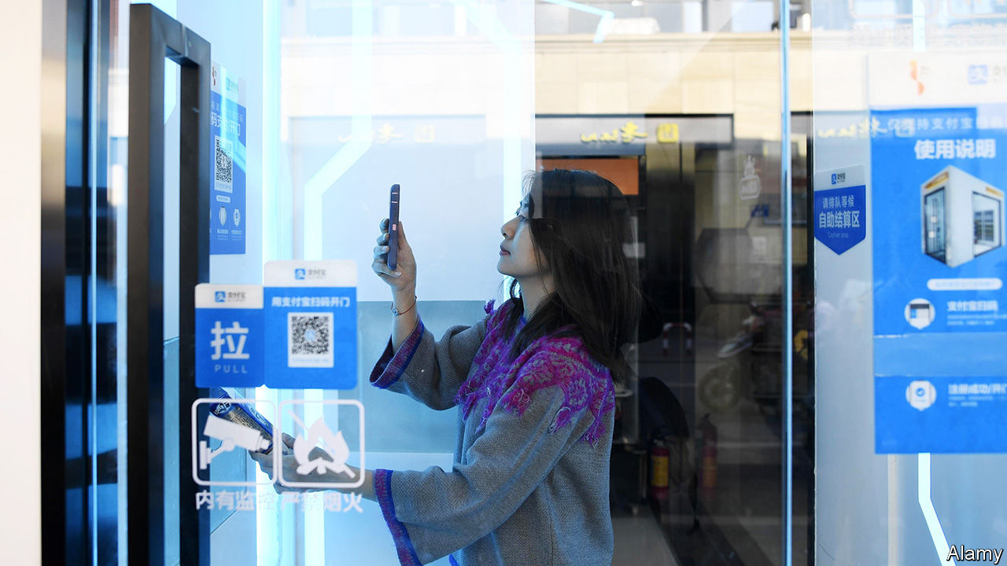

Ant Group filed papers for what could be the biggest-ever IPO, raising up to $30bn. Most famous for its Alipay service, the group is affiliated with Alibaba, China’s biggest online retailer, and its founder, Jack Ma. Much of China’s online payments are made on its platform. It is the world’s most valuable fintech enterprise. Ant’s dual stockmarket flotation, in Hong Kong and on Shanghai’s STAR exchange, could see it valued at upwards of $200bn. See article.

The Taiwanese government said that Taobao Taiwan,an e-commerce platform which is operated by a British-registered firm, but in which Alibaba holds a substantial stake, posed a security risk because customers’ details could be held on Alibaba’s servers in China. The government gave the British firm six months to either re-register as a Chinese company or “withdraw” its investment.

Kevin Mayer is to step down as TikTok’s chief executive, after just three months in the job. The video-sharing app is the latest Chinese-owned firm to stir up national-security concerns in America. It has filed a lawsuit against Donald Trump’s order that bans it unless it sells its American operations to an American company. TikTok said it had “taken extraordinary measures to protect the privacy” of data.

A group of WeChat users also sued the administration over a similar order from Mr Trump. The group argues that a ban on the Chinese-owned messaging app curtails their right to free speech and forms part of the president’s “racial animus” against Chinese people.

The recent decision by Apple to split its stock prompted a reconfiguration of the Dow Jones Industrial Average, an index of 30 American companies weighted by share price. Out go ExxonMobil, Raytheon and Pfizer, to be replaced by Amgen, Honeywell and Salesforce. Exxon traces its roots in the index to 1928; it was then known as Standard Oil of New Jersey. Its removal leaves Chevron as the only oil company in the Dow. The changes offset the reduction in Apple’s weight in the index, but also “better reflect the American economy”, according to Dow Jones.

## Still on the road. For now

A court in California granted Lyft and Uber an emergency stay against an injunction that would have forced them to reclassify their drivers as employees in the state, wrecking their business model. The ride-hailing companies’ appeal will be heard on October 13th.

Germany’s statistics office now thinks theeconomy shrank by 9.7% in the second quarter compared with the first, a bit better than an initial estimate of -10.1%.

Public-sector net debt in Britain rose above £2trn ($2.6trn) for the first time. The government’s debt at the end of July was roughly equal to GDP.

American Airlines confirmed that it would slash 19,000 jobs in October, when the requirement to retain staff ends under the conditions of the federal bail-out of the aviation industry. The government was said to be considering a new rescue package for America’s biggest airlines.

Virgin Atlantic reached a vital agreement with creditors that will allow a £1.2bn ($1.6bn) private-refinancing plan to proceed. The cash-strapped airline was unable to secure a rescue deal earlier in the year from the British government.

Rolls-Royce reported a £5.4bn ($6.8bn) pre-tax loss for the first six months of the year. The engineering company has been hurt by the grounding of flights during the pandemic; airlines pay it based on how many hours they use its engines.

In contrast to the aviation industry’s woes, the boom in home shopping has led Tesco, Britain’s biggest supermarket chain, to create 16,000 extra permanent jobs in its online business, mostly warehouse pickers and drivers.

Purveyors of electronic goods have also done well as people spend more time at home. Best Buy reported a 242% increase from online revenue in its most recent quarter. Trade has been so brisk that the American retailer could run out of some goods, such as game consoles.

The cost of building Crossrail, which will link west and east London by train and is Europe’s biggest infrastructure project, rose again, to £18.7bn ($25bn). The opening date was again pushed back, to mid-2022. It was supposed to open in 2018.

Once a scourge of the music industry because of its pioneering platform that allowed people to share tunes, illegally, over the internet, Napster was sold for $70m by RealNetworks, its current owner, to MelodyVR, a startup based in London. Napster was forced to close in 2001 but the name lived on and it reinvented itself as a music-streaming service.

## Don’t touch your face!

Kentucky Fried Chicken’s latest ad campaign dropped the “finger lickin’ good” slogan it has used for 64 years, because it doesn’t “quite fit” with clinical advice on covid-19.

This article was downloaded by calibre from <https://www.economist.com/the-world-this-week/2020/08/29/business-this-week>

|  |  |  |  |
| --- | --- | --- | --- |
| Previous | Articles | Sections | Next |

|  |  |  |  |
| --- | --- | --- | --- |
| Previous | Articles | Sections | Next |

# KAL’s cartoon

Aug 29th 2020 |

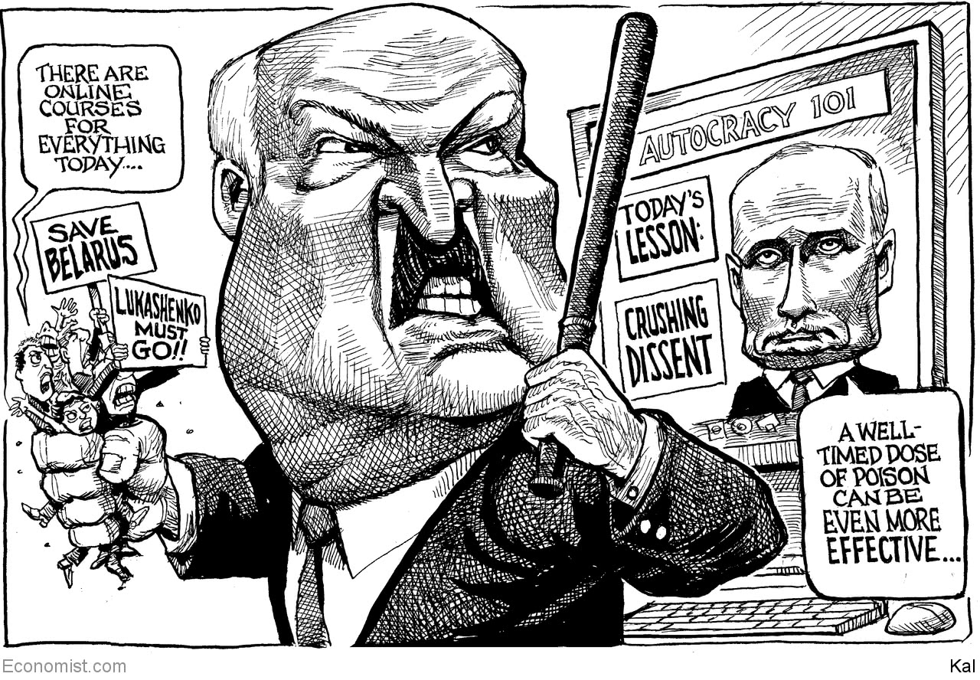

This article was downloaded by calibre from <https://www.economist.com/the-world-this-week/2020/08/29/kals-cartoon>

|  |  |  |  |
| --- | --- | --- | --- |
| Previous | Articles | Sections | Next |

|  |  |  |
| --- | --- | --- |
| The world this week | Sections | Letters |

Leaders

Russia: What Putin fears

.

Dementia: The forgotten problem

.

Mexico: How not to handle a scandal

.

Hollywood and China: Un-American activities

.

Covid-19 and mental health: A world of trauma

.

|  |  |  |
| --- | --- | --- |
| The world this week | Sections | Letters |

|  |  |  |  |
| --- | --- | --- | --- |
|  | Articles | Sections | Next |

#### What Putin fears

# Russians and Belarusians are tired of backwards-looking autocrats

The old tools of truncheon and syringe may keep them in power. But for how long?

Aug 29th 2020 |

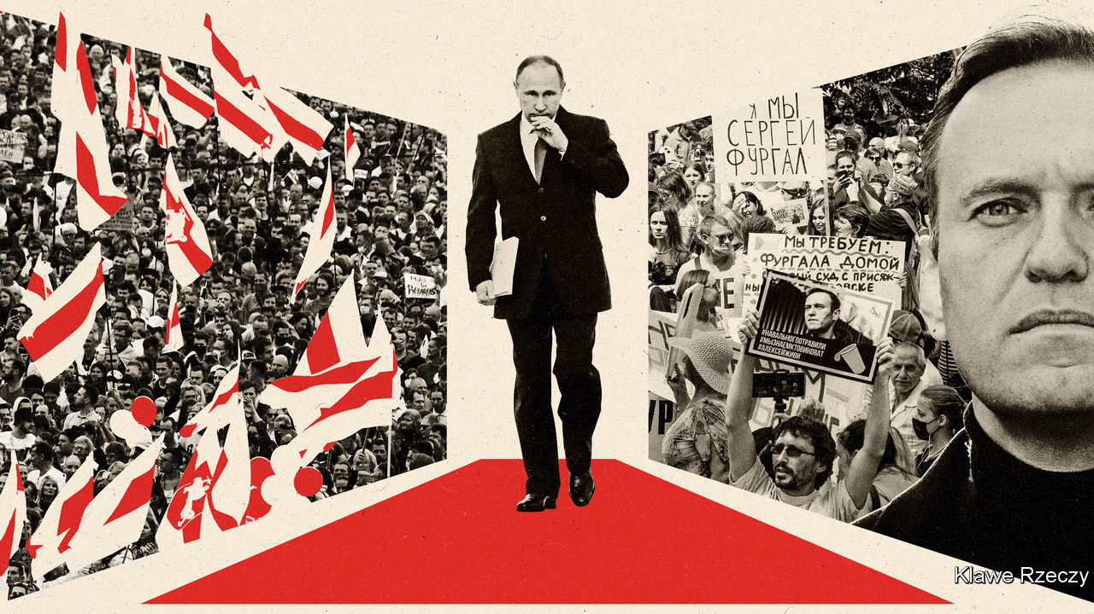

NOTHING IS AS inspiring as seeing people take to the streets to demand their freedoms—and nothing is as terrifying for the dictators they are defying. In Belarus, among scenes that recall the revolts of 1989, people are turning out in their hundreds of thousands after a blatantly rigged election, heedless of the threat of state violence. In the Russian city of Khabarovsk tens of thousands march week after week to protest against the arrest of the local governor and the imposition of Moscow’s rules. Vladimir Putin is rattled. Why else is Alexei Navalny, an anti-corruption crusader and Mr Putin’s greatest popular rival for the Russian presidency, lying poisoned in a Berlin hospital bed?

Regimes that rule by fear, live in fear. They fear that one day the people will no longer tolerate their lies, thieving and brutality. They try to hang on with propaganda, persecution and patronage. But it looks increasingly as if Mr Putin is running out of tricks, and as if Alexander Lukashenko, his troublesome ally in Minsk, is running out of road (see article). That is why, despite the Kremlin’s denials, they are falling back on the truncheon and the syringe. And it is why, as the protests roll on, they must be wondering whether state violence can secure their regimes.

Both leaders came to power promising relief from the chaos that followed the collapse of the Soviet Union. Mr Putin offered his citizens a deal: stay out of politics and you will get order and better wages. Mr Lukashenko promised Soviet-style continuity. Mr Putin was lucky that oil prices soared after he took over. Ordinary Russians benefited (though not nearly as much as the regime’s cronies). Mr Putin built a mafia state; Mr Lukashenko, an old-fashioned dictatorship. Both men seek to project an image of strength through tame media—Mr Lukashenko had himself filmed this week whizzing around in a helicopter and brandishing an AK-47 to face down the supposed Western plot to overthrow him. However, neither regime can reform itself. They may use state television to proclaim virtual change, but they struggle when it comes to the real thing.

Start with the economy. Belarus retains a theme-park version of the old Soviet system. When Mr Lukashenko went to gather support among the workers, he flew off to a state-owned tractor factory like some latter-day Lenin. The country’s exports largely consist of potash and petroleum products refined from Russian oil that used to be discounted. Russia is different from Belarus. Its economy is more open and less monolithic. Yet the commanding heights of industry and finance are in the hands of the oligarchs in the Kremlin’s trusted circle. Mr Putin has thus been unable to unleash competition and dynamism without upsetting the relationships that keep him in power. He has failed to diversify away from hydrocarbons, so the recent double shock of low oil prices and covid-19 has sent the economy reeling. As belts tighten, he has nothing to offer but nationalism and nostalgia.

That cocktail is losing its potency. For two decades Mr Putin has invoked an imaginary past of glory, plenty and certainty in the days of the Soviet and tsarist empires. His regime is a pioneer of disinformation. It invented the troll factory, and has created a media environment where, as one commentator put it, “nothing is true and everything is possible”. Yet Mr Putin’s offering looks tired next to that of Mr Navalny, whose popular YouTube videos are as skilful as the regime’s, but resonate with a growing sense of frustration. They are also grounded in exhaustive research into the regime’s corruption—and thus, in reality.

As well as failing to bring about economic and cultural renewal, both Mr Putin and Mr Lukashenko have failed to renew their regimes. Neither has a plausible successor. Mr Lukashenko has taken to trotting out his 15-year-old son, most recently in combat gear. Mr Putin cannot easily groom a successor lest it upset the factions he must keep sweet. This year he attempted to solve the problem by changing the constitution to allow himself to stay in power until 2036, when he will be 84. But that, too, was a sign of exhaustion. Mr Navalny, by contrast, has been busy organising opposition votes for regional elections to be held on September 13th. He may have been removed from the stage because if Russia had seen a popular movement like that in Belarus, he would have been its most plausible leader.

Mr Navalny’s poisoning is evidence that when these regimes run out of ideas, they resort to violence. And yet Belarus shows how hard a tool violence is to wield. Mr Lukashenko tried savage repression by arresting and torturing protesters but, so far, it has emboldened them and further undermined him. Sunday’s huge protests overwhelmed his threat to use force against them. He might have been willing to kill people in their hundreds or thousands, but he cannot afford to lose the loyalty of his security forces. Mr Putin recognises that blunt force used against the people could fuel further protests—it is why the Kremlin has largely left the demonstrators in Khabarovsk untouched in the hope that they will lose interest. But were the protests to start to spread from the far east, Mr Putin would face a similar calculus. He can arrest and intimidate the elites all he likes. The people, in sufficient numbers, are less easy to control.

What can other countries do about all this? The answer begins with defending the principle of human rights. Germany has correctly offered asylum to Mr Navalny. Its doctors can explain what was done to him—and be believed by ordinary Russians. The European Union and America have properly declined to recognise the results of Mr Lukashenko’s stolen election. Their refusal may be spun by propagandists in Minsk and Moscow as evidence that the protests are a covert operation by the West, but the people in the street do not believe it. Outside powers should warn Russia that any use of force in Belarus would be followed by severe sanctions. Mr Putin and Mr Lukashenko will not be restrained by moral, legal or diplomatic norms, but if they spill blood to stay in office there must be consequences.

How long these two dismal regimes will survive is anyone’s guess. Backward-looking autocracies can cling on for years. Mr Putin and Mr Lukashenko are not alone in taking power and promising a return to an imagined era of lost glory. But the pattern is clear. Although this may feel good at first, the people eventually become, in the words of one Belarusian protester, “sick of them”. And that is when dictators should be afraid.■

This article was downloaded by calibre from <https://www.economist.com/leaders/2020/08/29/russians-and-belarusians-are-tired-of-backwards-looking-autocrats>

|  |  |  |  |
| --- | --- | --- | --- |
|  | Articles | Sections | Next |

|  |  |  |  |
| --- | --- | --- | --- |
| Previous | Articles | Sections | Next |

#### The memory hole

# The rising prevalence of dementia is a global emergency

It requires more research, better provision for long-term care and changes in individual behaviour

Aug 29th 2020 |

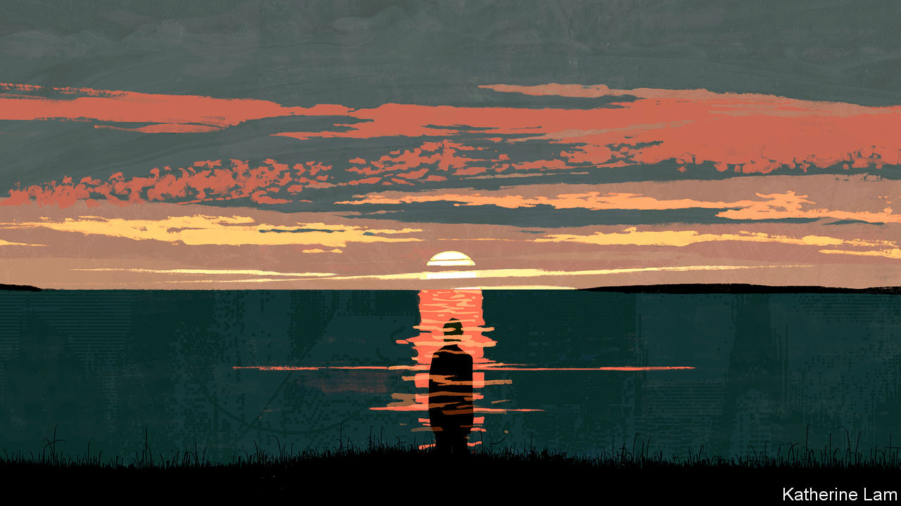

OF ALL THE troubles facing the world, the rising prevalence of dementia might seem among the less pressing. The reason behind it—longer lifespans—is to be cheered; it does not advance at the speed of a viral infection but with the ponderous inevitability of demographic change; and its full effects will not be felt until far into the future. But the reality is very different. As our special report this week makes clear, dementia is already a global emergency. Even now, more people live with it than can be looked after humanely. No cure is in the offing. And no society has devised a sustainable way to provide and pay for the care that people with it will need.

“Dementia” is an umbrella term for a range of conditions, with a variety of causes, of which the most common is Alzheimer’s disease, accounting for 60-80% of cases. It usually starts with forgetfulness and a mild loss of cognitive functioning. But as it advances, people lose the ability to look after themselves. Many require round-the-clock care long before they die. It does not just affect the elderly, but they are much more likely to have it—and life expectancy globally has climbed from not much more than 30 a century ago to over 70 now, and over 80 in rich countries. By some estimates, 1.7% of 65- to 69-year-olds have dementia and the risk of developing it doubles every five years after that. At present, about 50m people around the world have the condition, a number expected to rise to 82m by 2030 and 150m by 2050. Most of the new cases are in the developing world, where populations are rising and ageing.

The problems these numbers will bring everywhere have already been felt in countries where people are older, and especially acutely during lockdowns—witness the difficulty of looking after people with dementia in their own homes, and the large numbers in overstretched care homes who receive little individual attention. As families shrink, single children and grandchildren will struggle to cope with their old folk. Already, dementia care has had a knock-on effect on general health care. Before the pandemic as many as a quarter of beds in British hospitals were occupied by people with dementia. There was nowhere else for them to go.

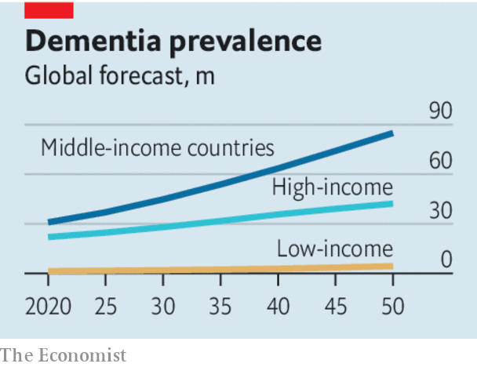

Not all the news is bad. Recent research has shown that behaviour such as smoking less, exercising more and losing weight in middle age has reduced the risk of dementia among old people in some Western countries in the past 30 years. And America’s Food and Drug Administration has promised to decide by March 2021 whether to license a drug said to be the first to stem cognitive decline in Alzheimer’s patients. But the risk of dementia still seems to be rising in much of the world and any new therapy in the foreseeable future is likely to benefit only some patients partially.

That is why governments should act now to lessen the social and economic harm from the growing prevalence of dementia. The first step is to recall the urgency with which many were promising to tackle the problem just a few years ago—in 2013, for example, when David Cameron, then Britain’s prime minister, used the rotating chairmanship of the G8 to convene a “dementia summit”, which promised to fund research with the goal of finding a “disease-modifying treatment” by 2025. Instead, funding for work on dementia has lagged far behind that for cancer or coronary heart disease. And as the pandemic hampers or prevents clinical trials and research, and sucks resources away from other areas, dementia risks again being left behind.

Governments also need to think about long-term care for people with dementia. The question that is most often asked is how to pay for it. Japan’s compulsory long-term-care insurance scheme, requiring everyone aged 40-65 to pay a premium, seems attractive, as it avoids penalising the young. But it is not self-financing. The increasing burden there as elsewhere will fall on individuals and the taxpayer.

And an even more fundamental question than who pays for care is: who will do it? Undertaken with humanity and dignity, it is extremely labour-intensive. Technology can help lighten the load—using remote monitoring to let people stay at home and, perhaps in future, robots to perform some basic tasks (see article). But looking after people with dementia requires people. The job is usually classified as low-skilled and is often poorly paid. In fact it demands huge reserves of patience, empathy and kindness. It should be better rewarded and more highly regarded even though that would add to the bill. In countries such as Japan and Britain, with acute shortages of care-workers, immigration will have to be made easier for those willing and able to do it.

Lastly, evidence suggests that as many at 40% of cases of dementia can be delayed or averted by changing behaviour earlier in life. The trouble is that public-health campaigns have a patchy record and they do nothing for dementia’s most intractable pre-existing condition—old age. No cure, insufficient financing and a tricky public-health message: perhaps that is enough to make you throw up your hands in despair. Instead, however, it only underlines how the solutions to dementia, like the disease itself, will take decades to unfold. It is yet another reason to start working on them right away. ■

This article was downloaded by calibre from <https://www.economist.com/leaders/2020/08/29/the-rising-prevalence-of-dementia-is-a-global-emergency>

|  |  |  |  |
| --- | --- | --- | --- |
| Previous | Articles | Sections | Next |

|  |  |  |  |
| --- | --- | --- | --- |
| Previous | Articles | Sections | Next |

#### Integrity theatre

# Mexico’s president shows how not to handle a scandal

Rather than strengthening institutions to fight graft, Andrés Manuel López Obrador is grandstanding

Aug 29th 2020 |

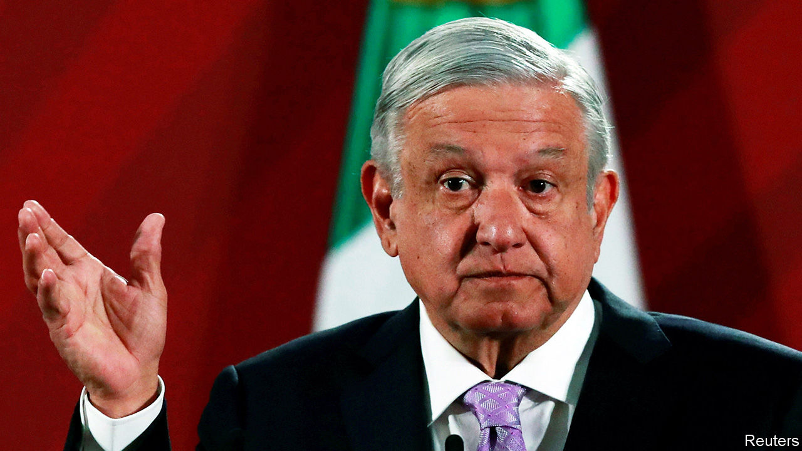

THE ALLEGATIONS are unproven but stunning. In a 63-page deposition, disclosed on August 19th, Emilio Lozoya, once head of Pemex, Mexico’s state oil firm, accuses 17 prominent Mexicans of corruption. According to Mr Lozoya, Enrique Peña Nieto, president in 2012-18, benefited from the payment of millions of dollars by Odebrecht, a Brazilian construction firm that has bribed officials across Latin America. The money financed his election campaign and coaxed legislators to vote for energy reforms (see [article](https://www.economist.com/node/21791232)). The governor of Veracruz gave him a Ferrari, Mr Lozoya says. Felipe Calderón, Mr Peña’s predecessor, oversaw corrupt dealings between Pemex and Braskem, a petrochemical firm part-owned by Odebrecht. Mr Lozoya fingers two candidates in the presidential election in 2018. The size of the pay-offs, and the status of alleged recipients, would make this the biggest scandal in Mexican history.

President Andrés Manuel López Obrador sees it as a vindication. AMLO, as he is known, has long argued that poverty and inequality are the fault of a “corrupt regime”. He won a landslide victory in 2018 by vowing not just to reduce graft but, implausibly, to eliminate it.

If he were serious, he would step back and allow a thorough, impartial investigation of Mr Lozoya’s charges, followed by trials. That would provide a model for punishing corruption and discourage future wrongdoing. The scandal might thus mark a turning point in Mexico’s losing struggle against bribery. That is what AMLO says he wants, but it looks unlikely. He would rather win applause for decrying fraud than build the institutions to investigate, punish and prevent it.

Some of those institutions are already in place, thanks to Mr Peña, of all people. He established an “anti-corruption system”, which provides for an attorney-general separate from the executive branch, an anti-corruption prosecutor and an oversight role for NGOs. However, his government ensured that the new apparatus would not work properly, by stalling appointments and blocking investigations. And AMLO has done little better. The attorney-general, Alejandro Gertz, is a political ally (he was AMLO’s security adviser during the election campaign). Mr Gertz chose an anti-corruption prosecutor without issuing a public call for candidates. Last year the budget for the prosecutor’s office was the lowest sum allocated since 2008.

In the Lozoya case these officials look like bystanders. The president plans to hold a referendum on whether former presidents should be prosecuted, in effect handing the prosecutors’ job to voters. That is incompatible with the rule of law. He also showed a video of officials counting cash at his morning press conference and had himself filmed flipping through Mr Lozoya’s dossier while offering a running commentary. Such grandstanding contrasts with the Lava Jato (Car Wash) anti-graft investigations in Brazil, which were conducted by independent judges and prosecutors, and went after three former presidents.

Few question AMLO’s personal probity, and his government has been less scandal-prone than its predecessors. But in some ways it may be encouraging corruption. AMLO cut the salaries of senior officials, increasing their temptation to seek pay-offs. The share of Mexicans who say they have paid bribes rose by 7.5% between 2017 and 2019, and the average amount of bribes they paid leapt by 70%, says an official survey.

Soon after Mr Lozoya’s testimony came out, a video surfaced of AMLO’s brother accepting bags of cash in 2015 from an official in the state of Chiapas to support Morena, AMLO’s political party. Of course the matter should be investigated, AMLO said. He insisted that there is no comparison between the misdeeds of past governments and anything Morena might have done.

His words ring hollow. Cleaning up Mexico requires building effective, independent institutions. This may be slower and duller than presidential showboating, but it is far more likely to work. Mexico needs the rule of law, not a strongman. ■

This article was downloaded by calibre from <https://www.economist.com/leaders/2020/08/29/mexicos-president-shows-how-not-to-handle-a-scandal>

|  |  |  |  |
| --- | --- | --- | --- |
| Previous | Articles | Sections | Next |

|  |  |  |  |
| --- | --- | --- | --- |
| Previous | Articles | Sections | Next |

#### Un-American activities

# How Hollywood should deal with Chinese censors

Upholding freedom of speech means leaving the studios alone

Aug 29th 2020 |

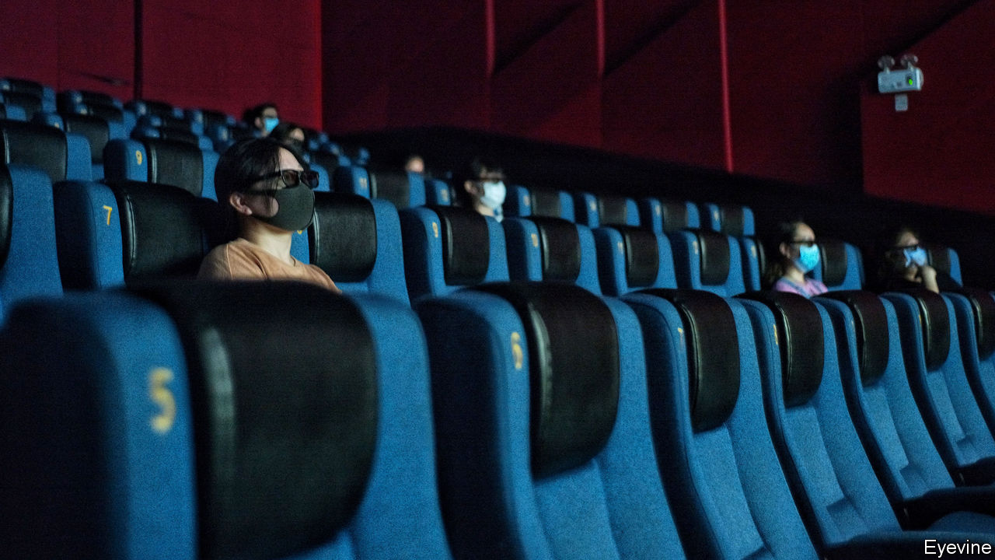

THE CURTAINS are still down at most American cinemas but in China the box office is back in business. This week audiences lined up—socially distanced, of course—to see films including “The Eight Hundred”, a war drama for which Americans will have to wait. Next week Disney will send its summer tentpole, “Mulan”, straight to streaming in most of the West, whereas Chinese filmgoers will get the chance to watch it on the big screen.

China’s box office increasingly props up Hollywood. China may overtake America as the world’s largest cinema market by revenue this year. Meanwhile, Chinese media companies are investing in American films. The result is that, from “Mulan” to “Pacific Rim” and “Kung Fu Panda”, Hollywood’s output is geared towards the Chinese market (see [article](https://www.economist.com/node/21791222)).

But it is also tailored to Chinese censors. Sometimes just the Chinese version of a film is altered to please them. But on occasion the version that global audiences see is changed, too. That is causing alarm. America’s attorney-general has accused the movie industry of “kowtowing”. Politicians have proposed penalties for studios that agree to censors’ edits. As it pushes deeper into this promising new market, Hollywood faces the growing risk of official interference—not just in China but at home, too.

China used to be an afterthought in Hollywood. In 2005 its box office took $275m. Last year the figure was nearly $10bn. A cinema-building binge has left China with almost as many screens as Europe and America combined. Such a market cannot be ignored: it can mean the difference between a blockbuster and a bomb. Hollywood studios would be foolish not to tailor films for their fastest-growing audience. Nor is it a bad thing if, after a century of American-dominated movies, the script allows for superheroes and princesses who are not Western.

Yet the fears over censorship are well-founded. Some of the Chinese bureaucrats’ demands are silly, like their insistence that dirty laundry be removed from a Shanghai skyline in “Mission: Impossible III”. But airbrushed underpants are not the end of it. Flags are removed and maps altered. To get a release in China, movies must avoid the “three Ts” of Tiananmen, Taiwan and Tibet. American actors who once liked to pose with the Dalai Lama know that a selfie could get them blacklisted by the Chinese authorities. The sanctions are asymmetric: when Liu Yifei, who plays Mulan, tweeted support for the police who put down pro-democracy protests in Hong Kong, Disney said nothing.

The trouble is that the proposed cures are often worse than the disease. Ted Cruz, a senator from Texas, wants studios that agree to censors’ demands to be banned from working with the Department of Defence, which lends its hardware as props. That would turn the government into an arbiter of what is politically acceptable—surely an idea more at home in the Communist Party than the Republican one. PEN America, a free-speech body, says studios should disclose any changes they make to their Chinese releases. A fine idea—but studios have little incentive to do so, and if forced, they might respond by ensuring the original cuts of their movies were inoffensive enough to pass without edits, thus subjecting the whole world to China’s censorship.

Fortunately, two factors should limit Hollywood’s kowtowing. First, bending too far for the Chinese market risks losing the American one. When the National Basketball Association apologised to “our Chinese friends” for the pro-Hong Kong tweet of a team’s manager, American fans’ indignation forced it to backtrack. Activision Blizzard, an American gaming firm, performed a similar U-turn after fans decried its punishment of an e-sports competitor who had spoken out about Hong Kong. Following Ms Liu’s tweet about the police, #boycottMulan started trending. Hollywood casting directors have long memories and are as allergic to controversy as any communist censor.

The other factor is the rise of streaming. Whereas the box office is global, streaming is not. Locked out of China, Netflix can commission documentaries like “Joshua: Teenager vs Superpower”, about a Hong Kong activist. The economics of streaming are all about exploiting niches, making it easier to say different things to different audiences.

All this calls for a dose of that rarest of Hollywood ingredients: realism. There is no way to eliminate the Chinese government’s influence on the global film industry. But Western policymakers should hold back from telling film-makers what they can say. Upholding freedom of speech starts with leaving them alone—and leaving the meddling to China. ■

This article was downloaded by calibre from <https://www.economist.com/leaders/2020/08/29/how-hollywood-should-deal-with-chinese-censors>

|  |  |  |  |
| --- | --- | --- | --- |
| Previous | Articles | Sections | Next |

|  |  |  |  |
| --- | --- | --- | --- |
| Previous | Articles | Sections | Next |

#### A pandemic of psychological pain

# How to reduce the mental trauma of covid-19

A few cheap steps can make a big difference

Aug 29th 2020 |

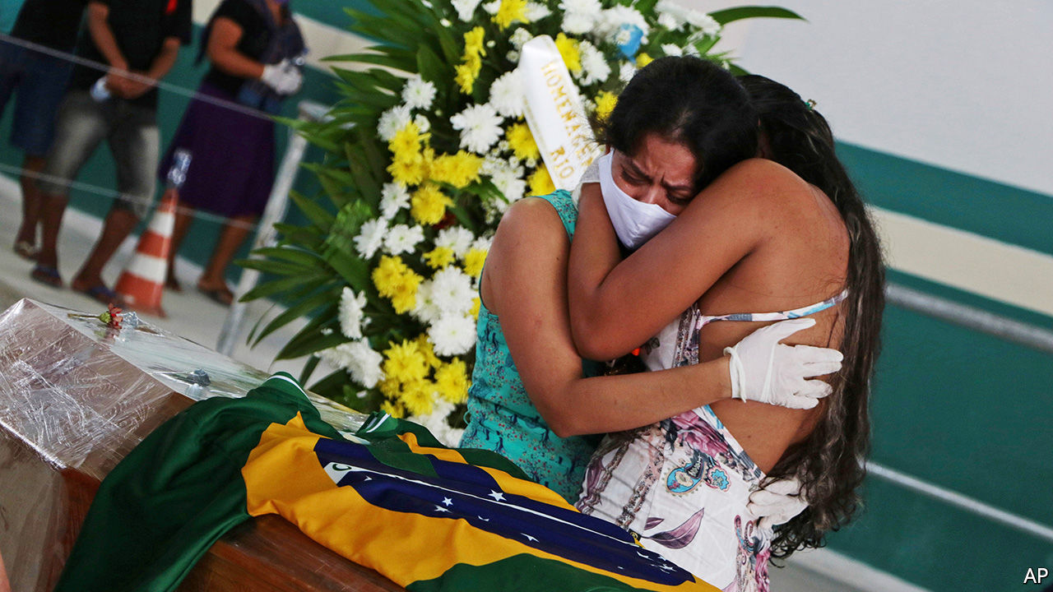

Editor’s note: Some of our covid-19 coverage is free for readers of The Economist Today, our daily [newsletter](https://my.economist.com/user#newsletter). For more stories and our pandemic tracker, see our [hub](https://www.economist.com/news/2020/03/11/the-economists-coverage-of-the-coronavirus)

IN ECUADOR PEOPLE are still searching for the bodies of relatives who died of covid-19 four months ago. In Italy a boy begged a priest to forgive the “sin” of lowering his face mask outdoors. Not since the second world war have so many people in so many places been traumatised at once (see article). Even after the disease itself is brought under control, the mental scars will linger.

For many, the pandemic is merely an annoyance. But some groups face a particular risk of post-traumatic stress disorder (PTSD), the symptoms of which include nightmares, flashbacks and feelings of guilt, anxiety or isolation. The most vulnerable are those who have been very ill, or lost relatives, as well as victims of previous traumas (such as refugees), and those with front-line jobs, such as doctors and nurses. In Spain nearly a sixth of those infected are health-care workers, and most of them show signs of PTSD. In Bangladesh, where the incomes of poor people briefly fell by 80% when lockdowns were tight, 86% of people in one poll reported covid-19-related stress.

Humans are resilient. Those who experience trauma mostly cope. When their homes are destroyed by earthquakes, they rebuild them and carry on. Even the mass bombing of cities in the second world war did not break civilian morale. Nonetheless, the world should take the collective mental damage of covid-19 seriously. Steps to reduce it cost little, and can benefit not only individuals but also society more broadly.

Research into previous disasters suggests that survivors’ long-term mental health depends more on “perceived support” than “received support”. In other words, donations of money or food matter less than the feeling that you can turn to your neighbours for help. Such help is typically offered spontaneously, but governments can also chip in. France, for example, sets up “medical and psychological emergency units” after terrorist attacks and other disasters. These try to minimise the long-term mental-health consequences of such events by offering immediate walk-in psychological support near the site of the disaster. Several cities in France have reactivated this “two-tent model”, one for medical care and the other for mental care, to help people cope with the toll of the virus.

Some people draw comfort from the fact that they are not alone—millions are facing the same tribulations at the same time. But the pandemic also presents unusual challenges. No one knows when it will end. Social distancing makes it harder to reconnect with others, a step in recovering from trauma. And the economic shock of covid-19 has undermined mental-health services everywhere, but especially in poor countries.

The most important measures will be local. A priority should be bringing people together by, say, expanding internet access. Mutual-aid networks (eg, WhatsApp groups to deliver groceries to the elderly), which tend to peter out once the initial disaster subsides, should instead be formalised and focused on the most vulnerable. Mental-health professionals should connect patients to such services, and train more lay folk as counsellors. In Zimbabwe, well before the pandemic, hundreds of grandmothers were taught how to provide talk therapy on village benches to depressed neighbours who could not afford to visit a distant clinic. Such innovations can work elsewhere, too.

Religious services and sporting events can provide a physical or virtual space for mourning. The story of the pandemic can be taught in schools, helping those for whom it was a hassle empathise with those for whom it was life-changing. The mental trauma of covid-19 cannot be erased, but it can be eased.■

This article was downloaded by calibre from <https://www.economist.com/leaders/2020/08/29/how-to-reduce-the-mental-trauma-of-covid-19>

|  |  |  |  |
| --- | --- | --- | --- |
| Previous | Articles | Sections | Next |

|  |  |  |
| --- | --- | --- |
| Leaders | Sections | Briefing |

Letters

Letters to the editor: On Kamala Harris, vaccines, fishing rights, postmen, IPOs, Boris Johnson, TikTok

.

|  |  |  |
| --- | --- | --- |
| Leaders | Sections | Briefing |

|  |  |  |  |
| --- | --- | --- | --- |
|  | Articles | Sections | Next |

#### On Kamala Harris, vaccines, fishing rights, postmen, IPOs, Boris Johnson, TikTok

# Letters to the editor

A selection of correspondence

Aug 29th 2020 |

Letters are welcome via e-mail to letters@economist.com

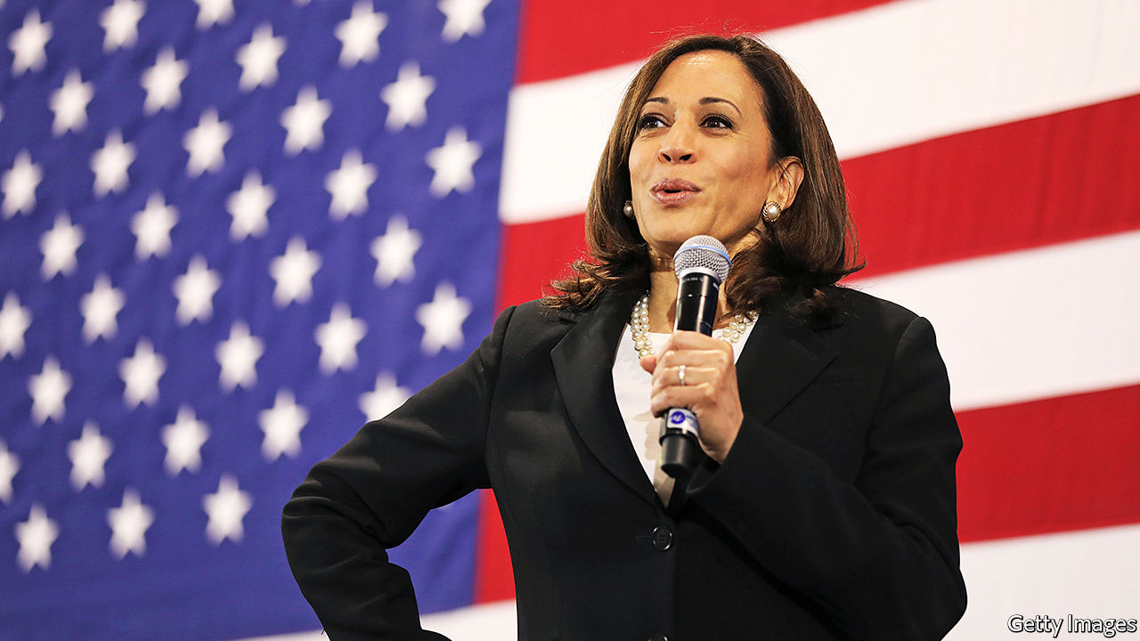

## The Democratic ticket

Kamala Harris, you claim, “comes from the Democratic Party’s centre”, is “not particularly ideological”, and never strays “too far from where a majority of voters are” (“[What Kamala says about Joe](https://www.economist.com/leaders/2020/08/13/what-kamala-says-about-joe)”, August 15th). Her voting record in the Senate indicates otherwise. According to UCLA’s VoteView website, Ms Harris’s votes are more left-leaning than that of any other senator, except Elizabeth Warren. Her voting record is further to the left than even Bernie Sanders, the only avowed socialist in the Senate.

ROBERT HELBING  
Monrovia, California

Your otherwise excellent leader repeated a general misunderstanding about life expectancy. For an American male at birth, life expectancy is 76 years. But at Joe Biden’s age, 77, a male can expect to live an extra ten years. So Mr Biden is statistically very likely to live out a four-year term, at least.

DR DEBORAH HAMMOND  
Tacoma, Washington

It might be true that if Mr Biden loses in November, Ms Harris “would be first in line next time round” for the Democratic nomination in 2024. History suggests otherwise. Of all the vice-presidential candidates on a losing ticket in the past 50 years only two went on to be nominated by their party for president: Walter Mondale, who had actually served as veep, and Bob Dole, and he had to wait 20 years (from 1976, when he was on the losing ticket with Gerald Ford, to 1996, when he won the Republican nomination).

JAMES KENNARD  
Melbourne

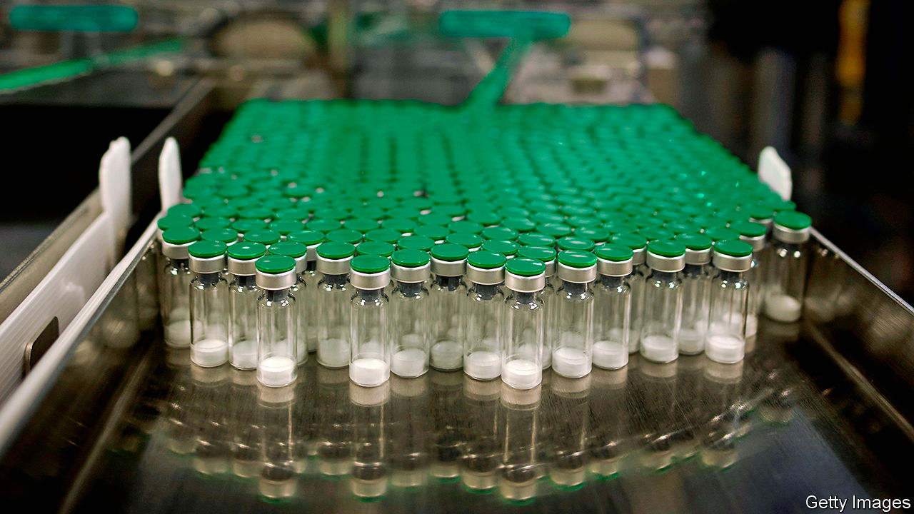

## Whichever way you slice it

Your leader calling for more resources to support vaccine research for the coronavirus gave the analogy that if a person needed to eat pizza to survive he would over-order pizza, so some would go to waste (“[A bigger dose](https://www.economist.com/leaders/2020/08/08/the-world-is-spending-nowhere-near-enough-on-a-coronavirus-vaccine)”, August 8th). The analogy is flawed.

Eating pizza, even for survival, is a classic private good. But funding for vaccine research is fundamentally different. Increased spending on vaccines means that we will finance some failures, but the knowledge that such failures gives us is incredibly valuable. Support for research is not like an insurance policy of over-ordering pizza to make sure everyone is fed. It is actually a productive investment given the public-good of scientific knowledge. The knowledge, unlike uneaten pizza, won’t go to waste.

JOHN GERSHMAN  
Clinical professor of public service  
Robert F. Wagner Graduate School of Public Service  
New York

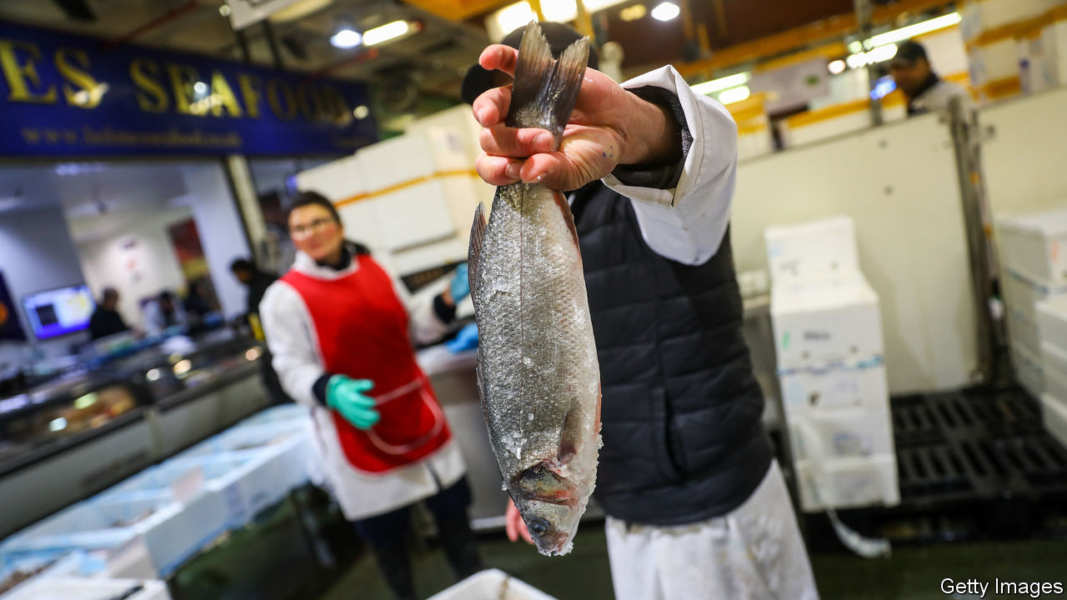

## Britain doesn’t rule the waves

With reference to fishing rights in the UK-EU trade negotiations (“[On the menu](https://www.economist.com/britain/2020/07/23/how-fisheries-could-sink-a-brexit-trade-deal)”, July 25th) it is worth emphasising that under international law, Britain can never revert to becoming an independent coastal state. This nationalistic trope was eagerly seized upon by Brexiteers. Unfortunately for them there is a binding international treaty obligation on post-Brexit Britain to allow any surplus fisheries within the United Kingdom’s 200 nautical mile exclusive economic (fishing) zone to be shared with fishermen from other countries, especially those who have traditionally fished in British waters.

This obligation is contained within the UN Convention on the Law of the Sea. Non-compliance may result in the British government being brought before a Conciliation Commission. While conciliation sounds friendly, a similar commission established as a result of an application by the tiny state of East Timor ultimately led to mighty Australia being compelled to negotiate a maritime boundary treaty that, inter alia, provides for the equitable sharing of any offshore hydrocarbon resources found in the seabed between these two countries.

It is hardly satisfying to think that much of the supposed Brexit dividend will now probably need to be spent on more maritime enforcement vessels.

DAVID ONG  
Professor of international and environmental law  
Nottingham Trent University

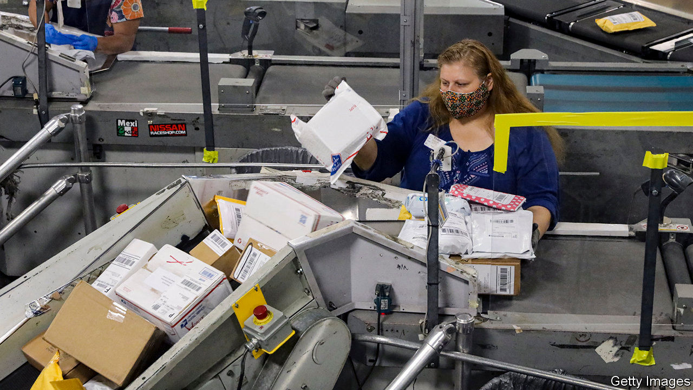

## Postmen’s pensions

“[Law of the letter](https://www.economist.com/united-states/2020/08/08/the-postal-service-has-become-vital-to-americas-elections)” (August 8th) reported on the state of the United States Postal Service and highlighted a simple truth about financial transparency: the cost of defined-benefit retirement plans for public-sector workers is unknowable. Costs generally exceed forecasts and returns generally lag behind them, so initial estimates are often too low. Since defined-benefit plans kick the can of the liability into the future, the full cost of funding those pensions becomes someone else’s problem.

Defined-contribution plans, however, make the cost transparent today. Understanding true costs will help public-sector organisations like the post office price their services better to promote a sustainable business model.

STEVEN KIRKPATRICK  
Portsmouth, Rhode Island

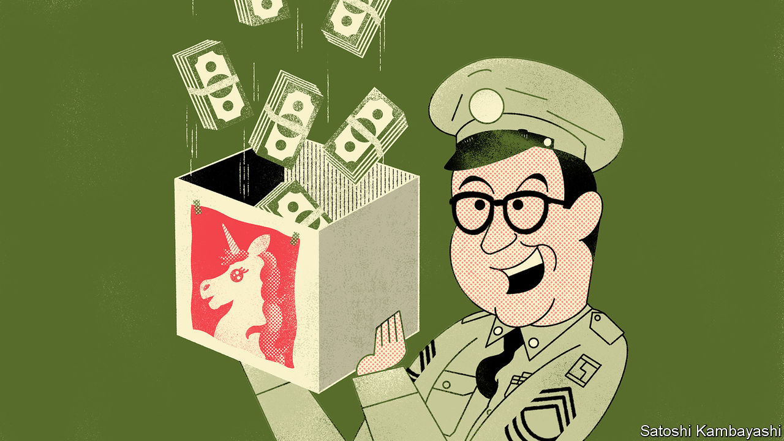

## The greenshoe option

[Buttonwood](https://www.economist.com/finance-and-economics/2020/07/30/the-spac-hack) perpetuated a common misunderstanding of the greenshoe option when he said that in an initial public offering “the banks retain the right to issue more stock to ‘stabilise’ the market”, and echoed complaints that this is a “rapacious practice” (August 1st). In fact, the greenshoe option was designed as a stop-loss option for underwriters, who over-allot shares of up to 15% in the new issue (go short) in order to “stabilise the market” in the immediate aftermath of an IPO.

They do this by buying any stock from the IPO that might “come back” and put pressure on the share price, thereby covering their short position. The expectation is that there will be a bid, by the underwriters, at or close to issue price for 30 days. So, if stock is offered back at prices below the issue price, the underwriters can cover their short position and sop up loose stock. However, as we all know, if the share price goes up rather than down, the underwriters lose on their short position and the potential loss is unlimited.

The greenshoe option gives the underwriters the right to buy more shares from the company’s “treasury” (not sell investors more shares than initially planned) in order to cover their short position. It was created to ensure that underwriters do not lose money in providing this valuable service. That is only fair.

What is not fair, and what annoys issuers, is when the stock softens in the after-market and the underwriters fail to provide support in the market, preferring to wait for 30 days and exercise the option. Underwriters do this because it is more profitable for them to buy from the company’s treasury than to buy from the market.

NELSON SMITH  
Toronto

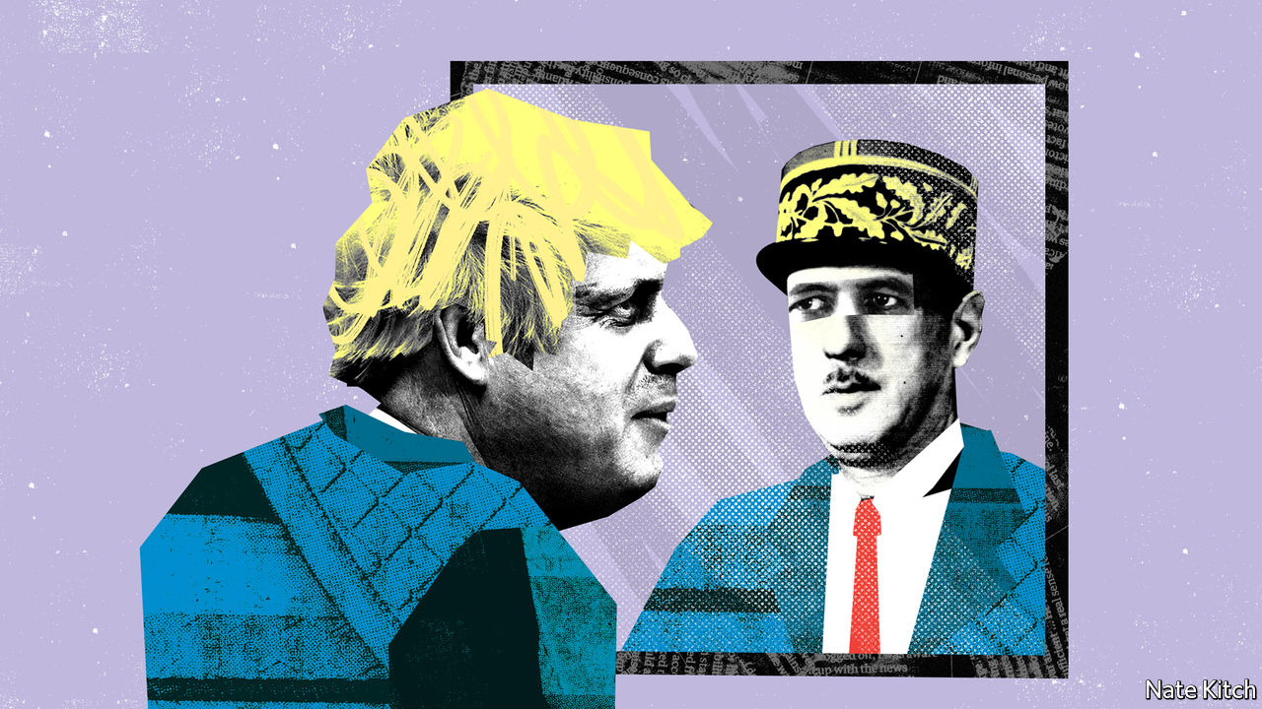

## Get him to the church on time

[Bagehot](https://www.economist.com/britain/2020/08/15/what-boris-could-learn-from-de-gaulle) was slightly optimistic about Boris Johnson’s nuptials (August 15th). Although the prime minister has indeed had a busy year, he hasn’t remarried (yet).

LENY MORRISONLinlithgow, West Lothian

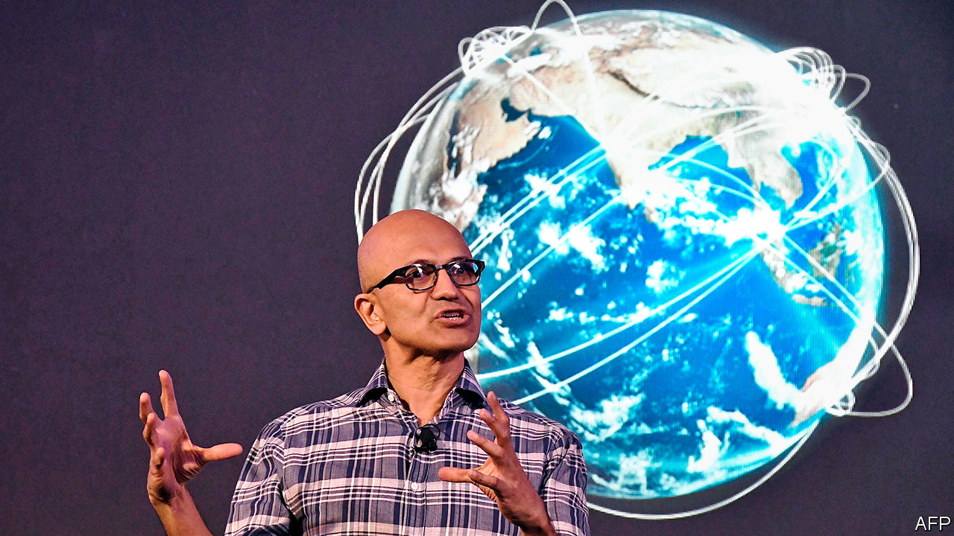

## The kiss of death

So Donald Trump has threatened to kill TikTok if Microsoft doesn’t buy it (“[Unproductivity puzzle](https://www.economist.com/business/2020/08/08/microsoft-wants-a-slice-of-tiktok)”, August 8th). Isn’t it usually fatal for an up-and-coming social-media firm to be bought by Microsoft anyway?

J.J. GASPAROTTI  
Laguna Beach, California

This article was downloaded by calibre from <https://www.economist.com/letters/2020/08/29/letters-to-the-editor>

|  |  |  |  |
| --- | --- | --- | --- |
|  | Articles | Sections | Next |

|  |  |  |
| --- | --- | --- |
| Letters | Sections | United States |

Briefing

Belarus and Russia: The people lose patience

.

|  |  |  |
| --- | --- | --- |
| Letters | Sections | United States |

|  |  |  |  |
| --- | --- | --- | --- |
|  | Articles | Sections | Next |

#### A cold coming together

# The uprising in Belarus and the poisoning of Alexei Navalny

Together they reveal the weakness of Russian autocracy

Aug 29th 2020 | MINSK

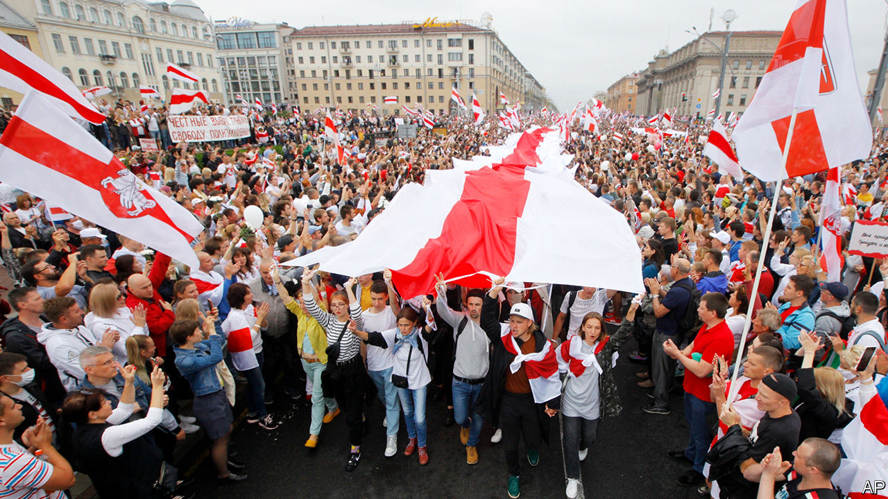

TO RUSSIA’S WEST, Belarus, previously a model of authoritarian stability, is in tumult. On August 9th its people refused to accept the official assertion that they had, once again, chosen to elect Alexander Lukashenko, the country’s dictator. In Russia’s far east demonstrators have been on the streets since July, when the governor of the Khabarovsk region, who had been elected without the Kremlin’s blessing, was arrested on Moscow’s orders and charged with murders committed in the early 2000s.

Those protests were a harbinger of hope for Alexei Navalny, a charismatic Russian opposition leader. He was looking forward to issuing a palpable rebuke to the Russian regime at this September’s regional elections; the far-eastern unrest showed the strategy was working. But Mr Navalny now lies in a coma in a Berlin hospital, having apparently been poisoned in Russia by persons unknown on August 20th.

Together, these three developments make the prospects for Russia’s president, Vladimir Putin, more precarious than at any time since he came to power.

The unspecified neurotoxin which his doctors blame for Mr Navalny’s condition seems to have been administered while he was returning to Moscow after a trip to Siberia. Whoever carried out the attack, the subsequent attempts by the Kremlin to stop Mr Navalny’s transfer to a hospital in Germany, its refusal to investigate the attack and its efforts to muddy the waters strongly suggest complicity if not outright responsibility.

For years Mr Putin has used the power of the state to harass Mr Navalny, pursuing him through the courts, imprisoning him for short spells, excluding him from ballots—but never silencing him definitively. Holding back in this way, it was thought, demonstrated the president’s confidence in his invincibility. At the same time it held out the faint possibility that Mr Navalny might one day lead a real uprising—a possibility which helped ensure the support of the elites with whom Mr Putin lives in codependency. For Mr Navalny to be removed from the scene, as has now happened, would show either that the president no longer controlled his own partisans or that he felt real fear.

What there is to be afraid of can be seen over the western border. Despite—indeed to some extent because of—reprisals which have included beating and torture, apparently leaving at least five people dead, the people of Belarus are protesting in ever greater numbers, feeling their moment has come. Their revolt matters to Mr Putin not because he is particularly dependent on Mr Lukashenko, nor because the two countries have, since 1996, been joined in a two-country common market known as the “Union State”. It matters because Belarus has served as a template for many of the tactics Mr Putin has used to achieve and maintain his power, and Mr Lukashenko has now lost any semblance of legitimacy. Though Mr Putin has never been dictatorial in quite the same way, he may only be a few steps behind him.

Those involved join the dots quite explicitly. On August 15th Mr Lukashenko, trying to drum up support, said on television “It is not a threat to just Belarus anymore. Defending Belarus today is no less than defending our entire space, the Union State, and an example to others.” The others who needed that example set, it went without saying, were those in Russia sympathetic to Mr Navalny. Or, as Leonid Volkov, Mr Navalny’s chief of staff, put it on Facebook, “Lukashenko with a rifle or Putin with his poison—which one of them is more crazy?...What is happening in Belarus today provides some clues about what awaits Russia in the very near future.” On the streets of Khabarovsk the protesters have started shouting their support for the Belarusian uprising.

## Under the helicopter

The Belarusians, for their part, are experiencing a true awakening. On August 23rd, in the biggest protest to date, hundreds of thousands came to Independence Square in Minsk, covering it with the red and white of the flag used by the short-lived Belarusian republic of 1918-19. The authorities, which have dialled back the extreme violence of their response to the first protests, sent in police patrols and played patriotic songs from the second world war over a rooftop tannoy system. The protesters responded by howling, beating drums and chanting, shaking their heads in seeming disbelief at what they were doing. The atmosphere had an odd resemblance to that of an early Pride parade: something repressed was coming out, surprised and delighted to recognise itself.

The awakening is decentralised, its lack of established leaders a testament to the years Mr Lukashenko has spent steamrollering all opposition. Svetlana Tikhanovskaya, the candidate who the protesters believe would have won the election handily if the ballots had been fairly counted, was a complete unknown when the campaign started. She stood because her husband Sergei, a popular vlogger who had announced his intention to run for president and thereby crush Mr Lukashenko, had been jailed as a result.

“There has never been a plan other than reminding people of their own dignity,” says Maria Kolesnikova, one of the two other women who helped lead Ms Tikhanovskaya’s campaign and now the only one of the three still in the country. Ms Tikhanovskaya fled for Lithuania on August 11th after the government effectively took her hostage and coerced her into reading out a condemnation of the protests.

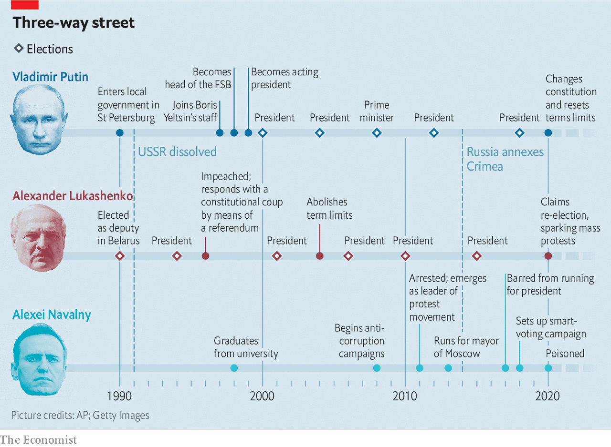

Mr Lukashenko seems in shock. The four previous elections he has staged since becoming president in 1994 (he abolished his country’s term limits 16 years ago) all provided him with between 75% and 85% of the vote. This one, rigged just as well if not better, seemed sure to see the streak continue. But when his 80% of the counted vote was duly announced the people simply refused to believe it. On August 23rd he flew over the protests in a helicopter with his 15-year-old son, railing at the streets below. On landing he emerged toting a semi-automatic rifle, oddly lacking a magazine, to cheer the riot police guarding his residence in their armoured personnel carriers: “Thank you. You are gorgeous. We will sort them out.” The images were meant to demonstrate his resolve to the armed forces. Their brittle edge of craziness may have undercut the intended message.

Were it not for Russia’s support, so far political and rhetorical, Mr Lukashenko would probably have fallen by now. Sergei Lavrov, Russia’s foreign minister, claims that the country’s backing for Belarus stems from a need to shore up all former Soviet territory against inroads by Russia’s Western enemies. But Mr Putin’s reasons have more to do with maintaining power at home than with geopolitics.

Mr Lukashenko and Mr Putin are hardly cut from the same cloth. Boris Yeltsin, Russia’s first president and Mr Putin’s patron, staked his legitimacy on a rejection of the Soviet past. Mr Lukashenko’s maverick rise to power was based on returning to it. He implemented no market reforms and privatised no large state enterprises. He kept wages low, but roughly equal. His critics and opponents disappeared.

Most Belarusians did not seem too bothered. Some Russians, their economy in tatters and their lives upended by reforms, gazed over the border in nostalgic envy at old-style collective farms, filthy but functional factories and clean streets. When he negotiated the agreement that created the Union State in 1996, Mr Lukashenko may have entertained the hope that, after Mr Yeltsin shuffled on, the desire for a simpler past might see him become the two countries’ leader himself.

When Mr Yeltsin anointed Mr Putin as his successor in 1999 it was expressly to prevent any such backsliding. The former KGB man’s remit was to protect the wealth and safety of Russia’s new elite and preserve Mr Yeltsin’s reforms. But in securing his grip on power Mr Putin appealed to some of the same feelings as Mr Lukashenko. He championed those who felt they had lost out in the 1990s, and provided them with the symbols, at least, of the past they held dear—rather as Mr Lukashenko had when he restored a version of its green and red Soviet-era flag to Belarus. He encouraged them to identify with him, and returned the favour; as he said when criticised for re-establishing the Soviet Union’s Stalinist anthem in 2001: “Perhaps I and the people are mistaken, but...” The Russian state media, which he quickly made his own, reinforced the identification.

## How to be president for life

Mr Putin chose to act on the people’s dislike of the new elite not, in the main, through economic appropriation but through political emasculation. Those who had made fortunes in the post-Soviet world could expect protection as long as they got out of politics and accepted that they now depended on him. He was not worried about jailing those who balked at the new dispensation.

Having consolidated power, in 2008 Mr Putin embarked on a sojourn as prime minister in order to avoid the constitutional limit on consecutive presidential terms, with Dmitry Medvedev sitting in for him as president. When they swapped jobs again in 2012, though, it was against a background of new level of discontent. The urban middle class, despite having done well under his rule, was protesting.

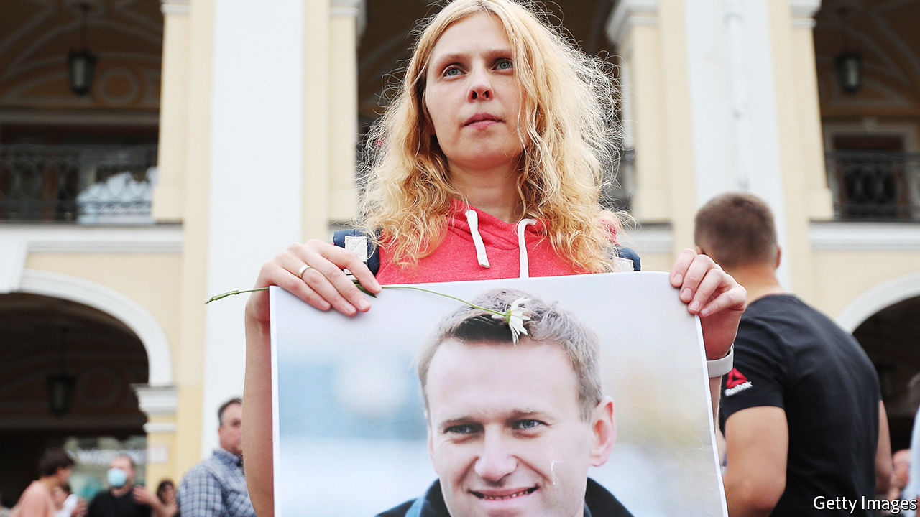

These protests marked the beginning of Mr Navalny’s career as a front-rank politician. Previously mostly known as an anti-corruption blogger and activist, they made him a leading figure in the opposition. His vision of Russia as a modern nation state offered an alternative both to the excesses of the 1990s and to Mr Putin’s increasingly imperial autocracy.

In Belarus, Mr Navalny would have mysteriously disappeared. But Russia was an autocracy, not a dictatorship. To keep the country’s elites, regional leaders and private sector on-side Mr Putin needed some sort of pseudo-democratic legitimacy. So when Mr Navalny announced he would stand in Moscow’s mayoral election of 2013, the Kremlin permitted it—while at the same time seeking to undermine his efforts with trumped-up embezzlement charges. The ruse backfired when an overzealous court sentenced Mr Navalny to five years in prison shortly before the election. Tens of thousands of Muscovites took to the streets to demand his release. In the end he won 27% of the vote, according to the official count.

Things changed in February 2014, when Viktor Yanukovych, a corrupt president, was overthrown by the Ukrainian people. Mr Putin encouraged pro-Russian thugs in the east of the country who rose up against the new regime—portrayed in the Russian media as fascists—and made use of the conflict to annex Crimea. This massively boosted his popularity, sidelining the opposition for years. In 2018 Mr Putin was re-elected president; Mr Navalny was not allowed on the ballot.

At that point, though, Mr Putin faced a problem. The constitution barred him from a fifth presidential term. But without the possibility of one he was a lame duck. He considered reviving Mr Lukashenko’s 1990s notion in reverse—amalgamating Russia and Belarus, and becoming the first president of a new country that would benefit from a retailored Putin-friendly constitution. Mr Lukashenko was not keen on the idea and sought, by resisting it, to rally his people round the flag (the green and red one he had introduced in 1995, rather than the white and red one now flying above every protest).

Stymied on the whole-new-country front, Mr Putin was eventually forced to change the constitution under the cover of a plebiscite in which the abolition of presidential term limits was bundled up with all sorts of other changes, most of them crowd-pleasing but inconsequential. It was, as it happens, a stratagem Mr Lukashenko had employed to bestow new powers on himself after he was impeached by parliament in 1996.

## A rising tide

Through all this Mr Navalny continued to organise. In 2017, when the post-Crimea euphoria had largely dissipated and the economy was sagging, he sensed a new opportunity. The country’s growing reliance on the internet, as opposed to state-controlled television, for information helped him to seize it. A YouTube video which detailed Mr Medvedev’s yachts and palaces sparked a protest that rolled from Vladivostok in the east to St Petersburg and Moscow in the west, engulfing some 90 cities.

Mr Navalny himself was taken by surprise. You can never predict how many people will turn up, he said at the time; they won’t come out just because they are asked to. The protesters of 2017 were angrier and poorer than those of 2011-12, and half of them were under 30. What brought them on to the streets, Mr Navalny noted, was their lack of prospects.

Mr Navalny looked to fill that emptiness with the optimism and confidence of an American-style politician. He shunned ideological issues that might divide people, concentrating instead on what brought them together: incomes, health, education and a desire for the rule of law. The most important thing, he said, was to battle “learned helplessness”.

Unable to register a party and disqualified from standing in the 2018 presidential elections, he nevertheless built up a formidable campaigning machine, mobilising 120,000 volunteers. He came up with a strategy of “smart” voting in regional elections: his followers were to vote for whoever was best placed to defeat the Kremlin’s candidate regardless of party and however uninspiring or unpalatable that choice might be. At a rally in Khabarovsk he said his job was to create as many stresses for the Kremlin as possible.

The stress was seen in the summer of 2019. The Kremlin, afraid of smart voting, disqualified all of the independent candidates from seemingly insignificant local-council elections in Moscow. Protests broke out; the Kremlin responded with violence. Across the country, though, most sympathy was on the side of the protesters. The level of brutality being applied was counterproductive. This probably explains why there has been very little police violence in Khabarovsk over the past month.

That success, coupled with evidence that Mr Putin’s popularity was in long term decline, led Mr Navalny to concentrate even more effort on the regional elections to be held on September 13th as a rehearsal for the parliamentary elections in 2021.

The increasing appeal and sophistication of his operation, coupled with the protests in Belarus, may have changed Mr Putin’s calculations about the safety of leaving an opposition leader in place as a signal that such opposition did not worry him. And events in Minsk have shown again the limits of police violence. Even when applied with bestial enthusiasm it could not make up for Mr Lukashenko’s cataclysmic loss of legitimacy; instead it accelerated it. Better act savagely against a leader now than take on the people later.

The irony is that this could lead to the regime’s eventual downfall being more tumultuous than it would have been. Mr Navalny may be the last Russian opposition leader who can control street protest while also engaging in negotiations with the Kremlin. His absence does not make future protests a lot less likely, but it makes them a lot less predictable. Mr Putin may feel that he has the situation under control. So did Mr Lukashenko. ■

This article was downloaded by calibre from <https://www.economist.com/briefing/2020/08/29/the-uprising-in-belarus-and-the-poisoning-of-alexei-navalny>

|  |  |  |  |
| --- | --- | --- | --- |
|  | Articles | Sections | Next |

|  |  |  |
| --- | --- | --- |
| Briefing | Sections | The Americas |

United States

Natural disasters: The condor’s cry

.

QAnon: On and on

.

Guo Wengui and Steve Bannon: Cognitive dissidents

.

More trouble in Wisconsin: A summer of fury

.

Sparring for the Senate: Kennedy fatigue?

.

Back to school: Learning and covid

.

Covid-19 in schools: Don’t blame the children

.

Lexington: Hail to the king

.

|  |  |  |
| --- | --- | --- |
| Briefing | Sections | The Americas |

|  |  |  |  |
| --- | --- | --- | --- |
|  | Articles | Sections | Next |

#### Natural disasters

# Why California is experiencing its worst fires on record

Plague, fire and water

Aug 26th 2020 |

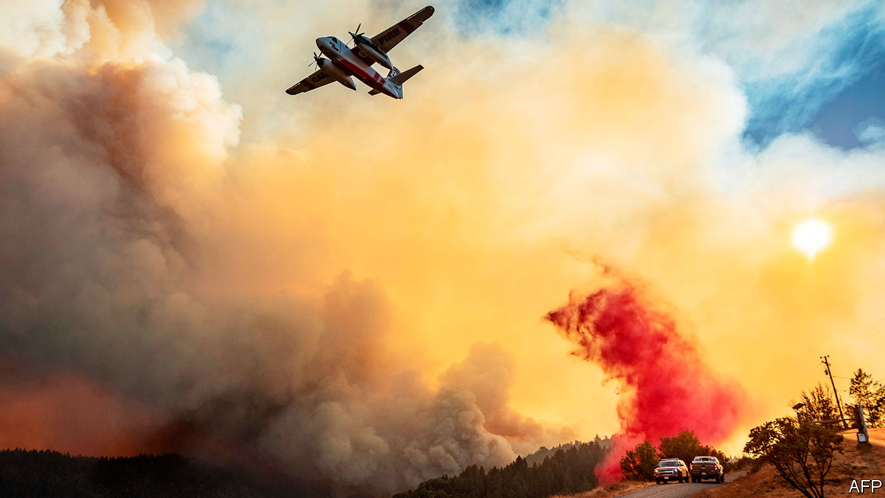

THE WEBCAM above her nest shows Iniko, a four-month-old California condor, high in the trees of the Ventana wilderness area, looking out as flames advance towards her. She is part of a 20-year breeding programme to reintroduce the giant birds, which were extinct in the wild, to California’s central coast. She is alone—her parents have fled the danger—and cannot yet fly. At 10:40pm on August 20th the webcam shows a flash of wing feathers, then the live stream goes dark, as the flames, presumably, engulf the nest.

Had the fire been in a previous year, Iniko would probably have been old enough to fly: the worst of the fire season takes place in September or October. But the season of 2020 has started early and with astonishing force. The California Department of Forestry and Fire Protection (CAL FIRE) said that there had been over 700 wildfires between August 15th and 26th, burning 1.3m acres (500,000 hectares). That is two-thirds as much, in just 12 days, as burned as in the whole of 2018, the worst year to date, and the season has not yet reached its peak. The two biggest conflagrations, one east of San Jose, the other north of San Francisco, are the state’s second- and third-largest on record. Gavin Newsom, the governor, was not exaggerating when he said: “We simply haven’t seen anything like this in many, many years.”

Some previous fires have been man-made. One started when a car tyre blew and the wheel’s metal rim scraped the pavement. This year’s fires are the latest and starkest example of a different man-made influence: climate change.

On August 16th a monitoring station in Death Valley measured a temperature of 54.4°C (130°F). If confirmed, that would be the highest reliably recorded anywhere on Earth. It may reflect a broader trend of global warming hitting Californians harder than most places. According to the National Oceanic and Atmospheric Administration, temperatures in many parts of the state, including Santa Clara County, which is being scorched by the largest of the fires, rose by 2°C between 1895 and 2018, roughly twice the global average.

The state is drier as well as hotter. California has experienced droughts throughout history, but the one between 2011 and 2019 was the longest and driest recorded. According to a study in Nature Geosciences in 2019, that drought killed almost 150m trees, leading to a state of emergency in 2019 intended to help reduce the huge build-up of flammable dead wood. Too late. Drought returned this year, when the state had its driest February on record (matters improved a bit later). A recent study in Environmental Research Letters by Michael Goss of Stanford University and others found that climate change had doubled the number of days of extreme risk for wildfires in the state during autumn.

There is some evidence that climate change is also increasing the danger of lightning strikes, which (rather than burst tyres) lit the inferno this season. Northern California’s fires began after a massive electrical storm passed over the Bay Area in mid-August, producing, said CAL FIRE, 11,000 strikes in three days. According to a study published in 2014 in Science by David Romps of the University of California, Berkeley, climate models suggest the number of lightning strikes across the continental United States could rise by about 12% for every degree of global warming (though another study, in Nature, questions the link with climate change).

Such change has not worked its destruction unaided. Mistaken policies have made the forests more vulnerable, especially the decades-long suppression of wildfires. Fires thin out the dense, flammable undergrowth. Preventing them—as a study in Science pointed out as long ago as 2006—increases what is called fuel loading and turns forests into tinder boxes. Frank Lake of the US Forest Service talks of a tipping-point: “There is too much fuel loading; it is too warm and the probability of ignition is greater.” That summarises what has happened this season.

Considering the vastness of the fires and their position—on the edge of the Bay Area, home to more than 7m people—the cost in human life could have been far greater. Seven people had died by August 25th. Californians have learned the lessons of previous fires, such as the one in 2018 which destroyed the town of Paradise and killed 85 people: evacuate early. Southerners fleeing Laura, a mighty hurricane that hit the Gulf coast on August 27th, will follow the same guidance.

So far, the responses of state and federal governments have held up fairly well in California, despite ritual hazing by the Democratic governor and Republican president. Donald Trump declared a major disaster, speeding federal funds to those who had lost their homes. And this week firefighters seemed to be making progress.

Still, California’s many crises—covid-19, fires and rolling blackouts—are overlapping, which hampers a long-term response. Early this year, the governor proposed spending $100m to make existing houses more fire-resistant (replacing wooden shingles with tiles, for example). He had to suspend the programme because of a state budget crisis caused by covid-19.

In 2008 another condor chick was caught in a fire and miraculously survived. She was, inevitably, renamed Phoenix. Iniko, alas, need not be renamed. Her name means “born in troubled times”. ■

This article was downloaded by calibre from <https://www.economist.com/united-states/2020/08/26/why-california-is-experiencing-its-worst-fires-on-record>

|  |  |  |  |
| --- | --- | --- | --- |
|  | Articles | Sections | Next |

|  |  |  |  |
| --- | --- | --- | --- |
| Previous | Articles | Sections | Next |

#### Political rabbit holes

# QAnon conspiracy theorists could prove awkward for Republicans

On and on

Aug 29th 2020 | CHICAGO

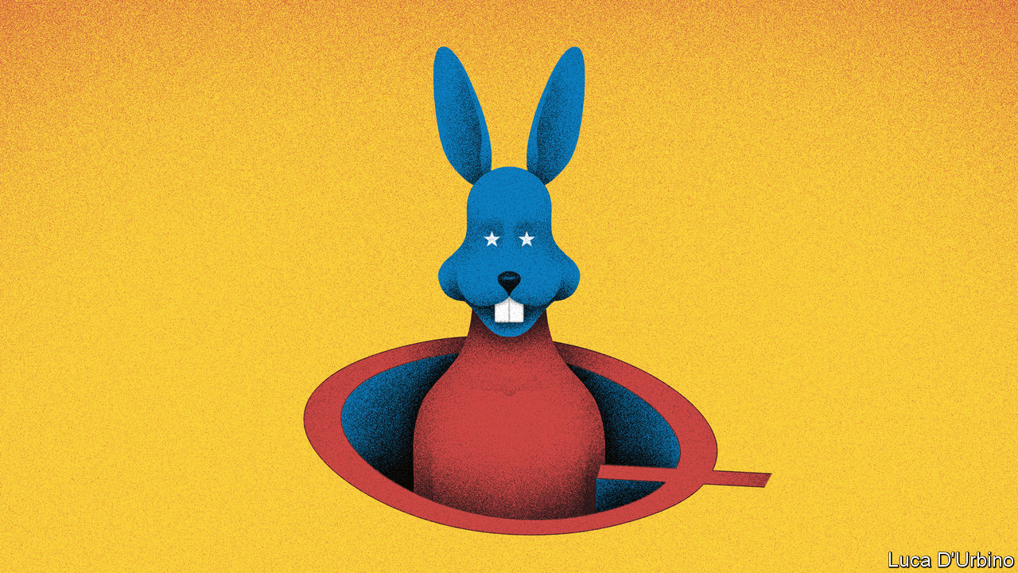

UNTIL RECENTLY, most people asked to identify “Q” would mention an eccentric inventor of gadgets for James Bond. Now a nastier, if equally fictitious, Q is becoming better known. Digital searches surged this month among people who hoped to unpick the meaning of “QAnon”—an anti-Semitic and incoherent conspiracy theory. It has been spun for three years in cryptic messages posted by Q, posing as a senior government official.

The alleged conspiracy is both outlandish and dismally familiar. Supposedly Donald Trump is set to smash a cabal of paedophiles and cannibals, including Hillary Clinton, Barack Obama and George Soros. Every generation or so, some outfit alleges that a secret league of the powerful—often cast as a financial, globalist or simply Jewish elite—is out to destroy America.

QAnon’s version has echoes of Robert Welch, a sweetmaker who founded the anti-communist John Birch Society in 1958. He claimed a “furtive conspiratorial cabal of internationalists, greedy bankers, and corrupt politicians” wanted America to be run by a socialist United Nations. It also shares some characteristics of the “satanic panic” of the 1980s, when rumours suggested devil-worshippers ran kindergartens and abused children.

The new conspiracy spread first in half-hidden corners online, then moved to mainstream social-media platforms and beyond. (Amazon now offers piles of mumbo-jumbo-filled QAnon screeds for sale.) Facebook, Twitter, YouTube and others recently removed QAnon-affiliated groups and pages from their sites. Yet the movement surges, partly because the president prods it on. Last week he cheered Q-adherents as “people that love our country”. Media Matters, a left-leaning think-tank, counted 216 times by late August when he had retweeted messages of QAnon folk. Q-fans are ubiquitous at his rallies.

By one count 72 Republicans who have sought office this year are sympathetic to QAnon, including two Senate candidates and 17 candidates for the House who will appear on the ballot in November. Mr Trump recently praised Marjorie Taylor Greene, a House candidate who expects to win in Georgia, as a “future Republican star”. She has accused Mr Soros of helping Nazis and published dozens of articles lauding QAnon’s barmy ideas.

The president may welcome QAnon as a distraction from the pandemic. Its adherents also align with his supporters. Many use language familiar to evangelical Christians, eager to see a rapture or a cleansing “storm”, when their enemies will vanish. A review last year of academic research into who believes in conspiracies all but described Mr Trump’s most loyal fans—people who are typically poorer, less educated, outsiders and distrustful of institutions. One hint of QAnon’s potential reach was offered in a poll by Pew Research in June. It found that a quarter of adults believe a claim that nefarious plotters may have spread the coronavirus deliberately.

Mr Trump also indulges QAnon for a simple reason: because it lauds him. “It is very reciprocal, it’s about fealty to him,” says Ethan Porter, a researcher into the spread of misinformation, at George Washington University. He notes how the movement draws hangers-on, notably older people who lose themselves in “online rabbit holes” trying to grasp the conspiracy. Others joined recent QAnon-affiliated “save the children” marches in various cities.

Moderate Republicans are aghast. Some observe that the FBI last year identified QAnonners as potential terrorists. Denver Riggleman, an exiting congressman from Virginia, this week co-sponsored a resolution condemning QAnon, which he likens to “mental gonorrhoea”. The vice-president, Mike Pence, dismisses it “out of hand”. Kevin McCarthy, the House minority leader, says it has no place in the party. His colleague Liz Cheney calls it a “dangerous lunacy”. Ben Sasse, a senator, warns that “garbage like this” will deter swing voters and let Democrats take the Senate.

None of this deters Mr Trump. He has asked Ms Taylor Greene to hear him speak at the White House on August 27th. ■

Dig deeper:  
Read the [best of our 2020 campaign coverage](https://www.economist.com/us-election-2020) and our [presidential-election forecast](https://projects.economist.com/us-2020-forecast/president), then sign up for Checks and Balance, our [weekly newsletter](https://www.economist.com/checksandbalance/) and [podcast](https://www.economist.com/podcasts/2020/08/21/checks-and-balance-our-weekly-podcast-on-american-politics) on American politics.

This article was downloaded by calibre from <https://www.economist.com/united-states/2020/08/29/qanon-conspiracy-theorists-could-prove-awkward-for-republicans>

|  |  |  |  |
| --- | --- | --- | --- |
| Previous | Articles | Sections | Next |

|  |  |  |  |
| --- | --- | --- | --- |
| Previous | Articles | Sections | Next |

#### Guo Wengui and Steve Bannon

# Meet Guo Wengui, Steve Bannon's Chinese-exile friend

Cognitive dissidents

Aug 29th 2020 | NEW YORK

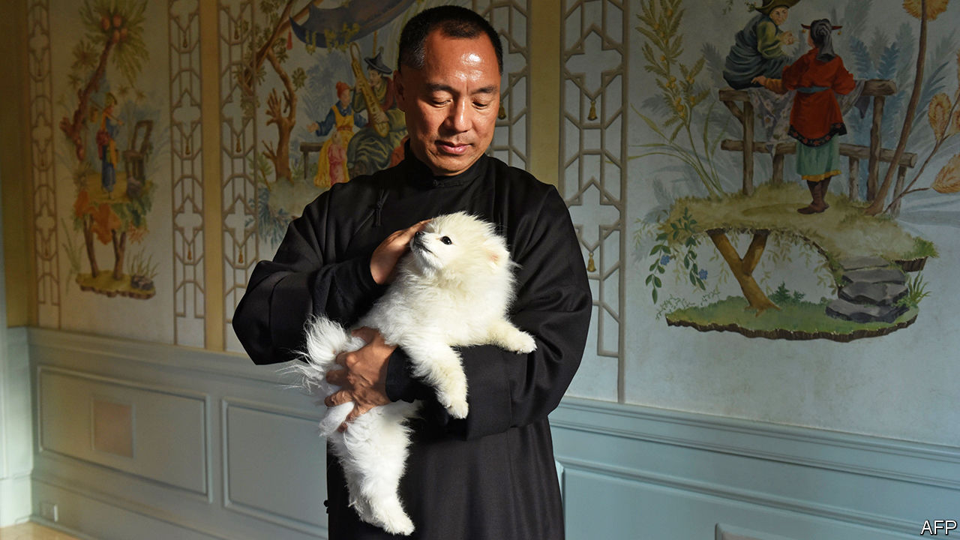

ON AUGUST 20TH, shortly after Steve Bannon was arrested aboard a yacht in Long Island Sound in connection with an alleged charity fraud, the owner of the yacht, a property developer named Guo Wengui, posted a video online intimating that the Chinese Communist Party (CCP) had orchestrated the downfall of the former White House adviser. Mr Guo, who fled China in 2014, has established a formidable online persona as an outspoken dissident who, in his telling, will bring down the CCP.

From his 152-foot yacht and his $67.5m penthouse overlooking Central Park, he spins tales of Chinese elite corruption and purges, styling himself a “CCP terminator”. (Mr Bannon is given the same nickname.) On June 4th, the anniversary of the Tiananmen Square massacre in 1989, Messrs Guo and Bannon announced, aboard the yacht in New York harbour, the founding of “The New Federal State of China”, meant to supplant the People’s Republic.

Mr Guo’s penchant for grandiosity has made it difficult to sort truth from fiction in his claims. Even his personal details are hard to pin down. He is about 50 and also goes by the name Miles Kwok, or Miles Guo, though he is also possibly known as Guo Wugui or Guo Haoyun, and he holds as many passports as he has names. (According to the New York Times Magazine, he also claims never to wear the same underwear twice.) In China he amassed a fortune of $1.1bn, according to a Forbes estimate in 2015. It is not clear how much he still has; both his yacht and his Manhattan apartment are for sale.

On his way up Mr Guo befriended Ma Jian, vice-minister of state security from 2006. He also played a part in bringing down a deputy mayor of Beijing, reportedly with the help of a sex tape of the official with a mistress. He became an object of fascination to American diplomats in Beijing, who pumped him for political gossip. But Mr Guo fled to America during President Xi Jinping’s anti-corruption campaign, which would soon sweep up his friend, Mr Ma.

Chinese authorities have accused him of multiple crimes, from bribery to sexual assault. He denies any wrongdoing. The Wall Street Journal has reported several efforts by Chinese authorities in 2017 to repatriate Mr Guo; he has applied for asylum in America. Chinese state media have attacked him. But some dissidents and sceptics, wary of his past ties to Chinese state security, do not trust him, wondering if he works both sides (he has dismissed such insinuations). American intelligence is said to listen to his insights—but also to keep him at arm’s length.

That may be wise. The day before Mr Bannon’s arrest the Journal had reported that a company he and Mr Guo are involved in, GTV Media Group, was the subject of a federal investigation into its fundraising. Mr Guo called the report a fabrication, part of the CCP’s plot to take Mr Bannon down. But his antics have worn thin on his hosts. “There would be a lot of groans when his name came up,” says a former Trump administration official. In both Beijing and Washington, it seems. ■

This article was downloaded by calibre from <https://www.economist.com/united-states/2020/08/29/meet-guo-wengui-steve-bannons-chinese-exile-friend>

|  |  |  |  |
| --- | --- | --- | --- |
| Previous | Articles | Sections | Next |

|  |  |  |  |
| --- | --- | --- | --- |
| Previous | Articles | Sections | Next |

#### Violence in Kenosha

# Wisconsin’s summer of fury

Another round of shooting and protests

Aug 29th 2020 | KENOSHA, WISCONSIN

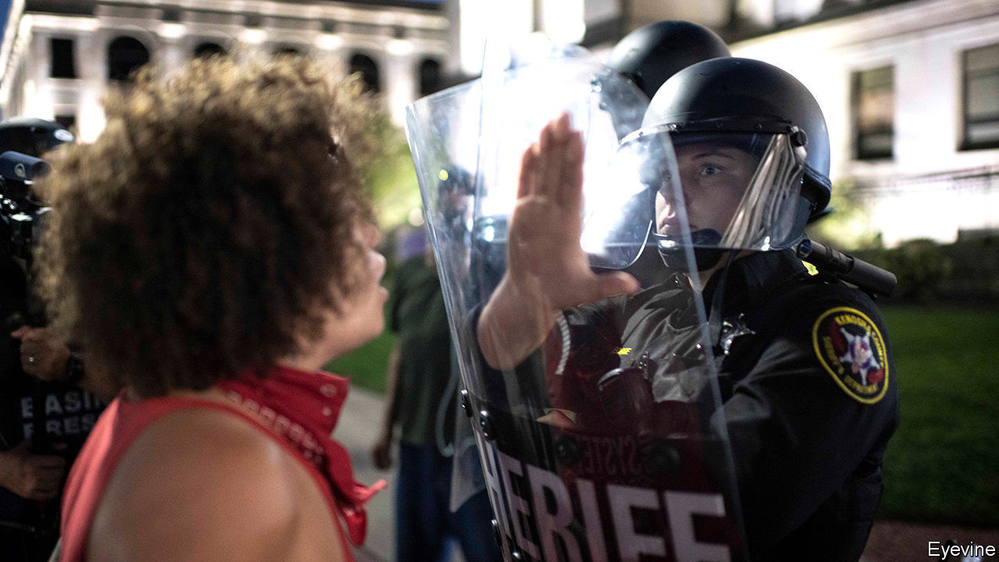

THE WAY Dee sees it, America is locked in a dangerous spiral. Standing near the courthouse in Kenosha, Wisconsin, the middle-aged man watches volunteers sweep glass from beside two blackened wrecks of lorries. “People feel a certain type of animosity in their heart now. It’s not gonna stop,” he says. He took his adult son to demonstrations in the city this week as confrontation escalated from peaceful marching to looting, arson and then to murder. “Protests are gonna continue, because two more lives were taken,” he says.

He says his fellow protesters, though they smashed property, were not set on violence. Yet they were enraged. They erupted after a white policeman trying to arrest an unarmed 29-year-old black man, Jacob Blake, shot him repeatedly on August 23rd. Bystander videos showed him shot at close range as he tried to get into a car with his three young children. “How can you justify shooting that man in the back seven times? Why you got to shoot a person with intent to kill?” asks Dee.

Mr Blake survived, but may be partially paralysed. His relatives called for calm: his mother said all sides must “take a moment and examine your hearts.” Yet clashes flared in ways similar to confrontations after police choked to death George Floyd, in Minneapolis, in May.

After many buildings were destroyed, armed men—said by some locals to be white vigilantes from beyond Wisconsin—arrived, set on resisting rioters. One 17-year-old, Kyle Rittenhouse, was filmed firing an assault rifle at a crowd. He was arrested at home in neighbouring Illinois on August 26th, and charged with murdering two protesters. Footage online suggests he shot them, and injured a third, as they chased him along busy streets.

Kenoshans deny that their city is usually troubled. Many blamed outsiders. David, a businessman who picked through wreckage at his car-sales lot, says rioters destroyed stock worth $400,000. He described feeling terror when they came, saying attackers left only when he brandished his own weapons. “Half of the people in the protest are armed, the business owners are armed. I’m surprised there wasn’t a mass shooting before,” he says. He predicts a surge in support for President Donald Trump. Voters “don’t want lawlessness, this is like a war zone”.

Will Mr Trump get a boost? For all the popular dismay over police killings, some voters—especially older and whiter ones—are anxious about recent looting, violent protests and an uptick in urban gun deaths. Polls suggest there is support for reforming the police, but not defunding them. That helps to explain why Joe Biden, on August 26th, said: “Burning down communities is not protest, it’s needless violence.” Tony Evers, Wisconsin’s Democratic governor, was also quick to take an offer from Mr Trump of federal agents to restore order.

At the Republican convention the vice-president, Mike Pence, spoke of the need for more law and order, referring to Kenosha. But a close focus on the city could be risky. It looks awkward that the man charged with murder is a police cadet and avid fan of the president, who sat in the front row of a Trump rally, in Iowa, in January. Vigilantes rarely help promote law. In Dee’s view, such people came to this city with “the intent to hurt somebody”. ■

This article was downloaded by calibre from <https://www.economist.com/united-states/2020/08/29/wisconsins-summer-of-fury>

|  |  |  |  |
| --- | --- | --- | --- |
| Previous | Articles | Sections | Next |

|  |  |  |  |
| --- | --- | --- | --- |
| Previous | Articles | Sections | Next |

#### Kennedy v Markey

# The Kennedy name no longer assures victory, even in Massachusetts

Sparring for the Senate

Aug 29th 2020 |

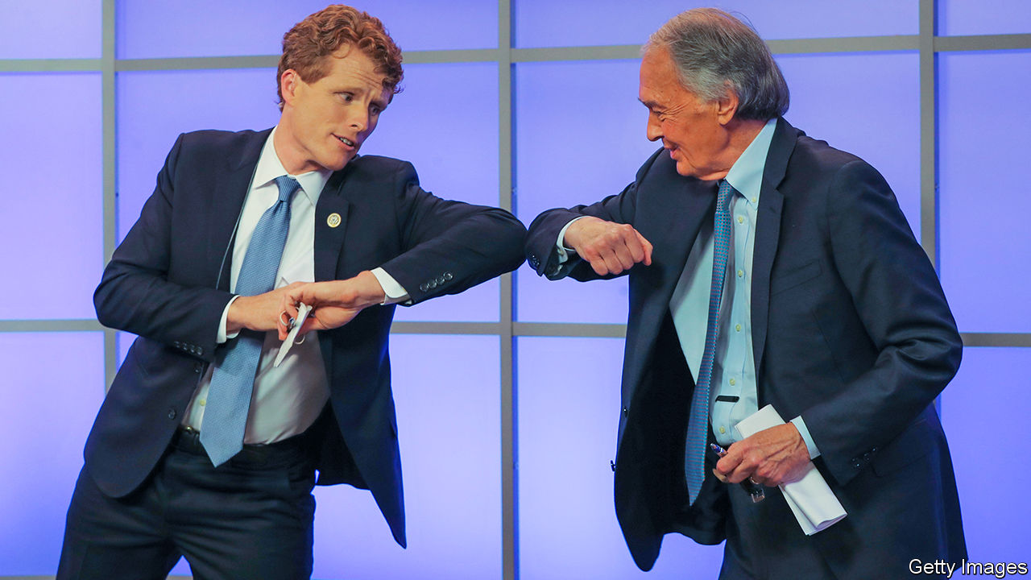

“JOE KENNEDY knows how a legacy is earned,” begins a new campaign ad for Joe Kennedy, a 39-year-old congressman who is running for the US Senate in Massachusetts. The ad weaves footage of Mr Kennedy helping his constituents with images of his famous family. His great-great-grandfather was a Boston mayor, his dad was a congressman, his great-uncle was president, another served as senator and his grandfather was attorney-general, a senator and a presidential candidate. A Kennedy running for the Senate in Massachusetts should be a shoo-in, especially one with an abundance of red hair. But the Kennedy name may no longer carry the same resonance it once did.

A University of Massachusetts Amherst poll indicates that young people are more attracted to his Democratic-primary opponent and incumbent, Ed Markey. Mr Markey is a Washington veteran. He served as a congressman for nearly four decades before becoming a senator in 2013. He has proved resilient, and his digital strategy has cleverly targeted younger voters. One clip of him shooting hoops while wearing khakis and old trainers has gone viral. Others star Alexandria Ocasio-Cortez, the progressive New York congresswoman widely known as AOC, who introduced the Green New Deal with Mr Markey. For the first time in his long career this rather cerebral politician has taken on a rock-star quality.

As well as AOC’s backing, Mr Markey has received that of Elizabeth Warren, the state’s senior senator. Mr Kennedy, meanwhile, has won the endorsement of Nancy Pelosi, the House speaker. That angered Ms Ocasio-Cortez, who implied the Democratic Congressional Campaign Committee (DCCC) was hypocritical in “cherry-picking” whom to support. Last year the DCCC said it would blacklist firms that help challengers to Democratic incumbents.

Despite arguments over who is more progressive, there is little to distinguish the two likeable politicians beyond their age (Mr Markey, at 74, is nearly twice as old as Mr Kennedy) and that famous last name. Perhaps that is why the campaign has taken on a nasty tone as the primary on September 1st draws near. In one ad, which has had 3m views, Mr Markey says: “With all due respect, it’s time to start asking what your country can do for you,” a play on John Kennedy’s inaugural speech in 1961. In a debate, Mr Markey accused Mr Kennedy’s father and brother of funding negative ads. Mr Kennedy has had to beef up security because of death threats, which his campaign blames on the “dangerous” atmosphere created by some of Mr Markey’s supporters.

Polls have pointed to a tight race, but recently Mr Markey has pulled ahead. Some people may decide not to vote because either candidate would be fine. Both have high approval ratings in their respective jobs. Mr Kennedy had at first been careful not to play on his family’s legacy because it might have turned off younger, progressive voters, some of whom see him as the embodiment of entitlement and privilege. As primary day approaches, however, he has started to lean into the legacy in an effort to persuade older supporters to vote. A Kennedy has not lost an election in Massachusetts since John Kennedy became a congressman in 1946. Mr Kennedy does not want to be the first. ■

Dig deeper:  
Read the [best of our 2020 campaign coverage](https://www.economist.com/us-election-2020) and our [presidential-election forecast](https://projects.economist.com/us-2020-forecast/president), then sign up for Checks and Balance, our [weekly newsletter](https://www.economist.com/checksandbalance/) and [podcast](https://www.economist.com/podcasts/2020/08/21/checks-and-balance-our-weekly-podcast-on-american-politics) on American politics.

This article was downloaded by calibre from <https://www.economist.com/united-states/2020/08/29/the-kennedy-name-no-longer-assures-victory-even-in-massachusetts>

|  |  |  |  |
| --- | --- | --- | --- |
| Previous | Articles | Sections | Next |

|  |  |  |  |
| --- | --- | --- | --- |
| Previous | Articles | Sections | Next |

#### Back to school

# Disrupted schooling will deepen inequality for American students

Learning and the pandemic

Aug 29th 2020 | WASHINGTON, DC

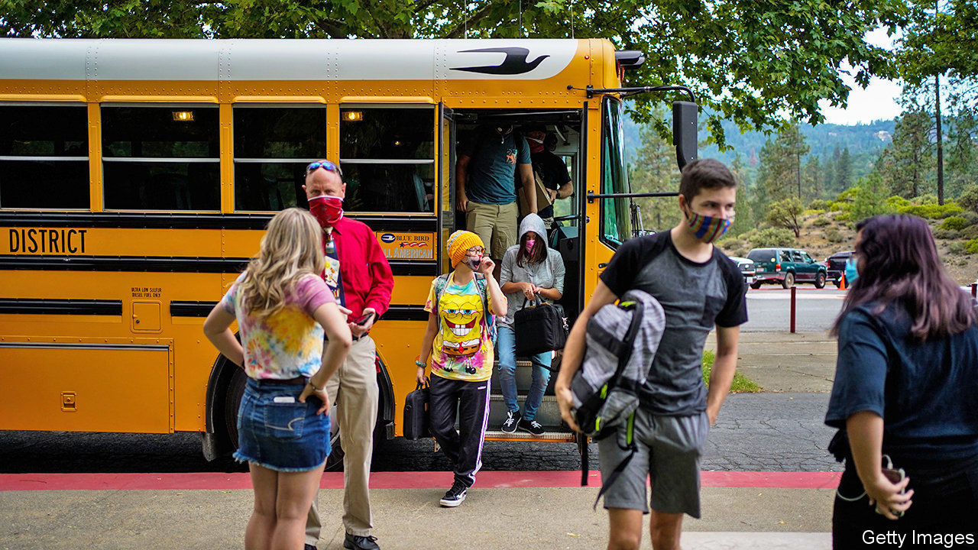

THE FIRST meeting between teachers in Montpelier, Vermont, before the start of the autumn term is usually festive—hugging over breakfast and coffee. This year they had to make do with an online videoconference. After a scramble in the spring (to set up online learning, pack lunches for poor pupils who relied on them and ship computers to those without them), the district plans to let younger pupils return for in-person learning on September 8th. High school will remain partly online because the building is too small to allow social distancing. The young pupils who can return will need to wear masks, keep their distance and have temperature checks before entering school buses or buildings.

Setting up these protocols took many 60-hour weeks over the summer holidays, says Libby Bonesteel, the superintendent. Her husband, a microbrewer, recently dedicated a new beer, “Our Impossible Ask”, to teachers. “Pairs well with late staff meetings, upended expertise, existential crisis and seemingly unending complications,” suggest the tasting notes.

Of the 50 largest school districts in America, 35 plan to start the coming term entirely remotely. The opportunity to squelch the virus over the summer has been lost, upending plans for “hybrid” education (part-time in-person instruction). This means more than just child-care headaches for parents. The continued disruption to schooling will probably spell permanent learning loss, disproportionately hurting poorer pupils.

“Achievement gaps will become achievement chasms,” warns Robin Lake, director of the Centre on Reinventing Public Education, a research group. Analysts at McKinsey, a consultancy, reckon that the typical American pupil would suffer 6.8 months of learning loss if in-person instruction does not resume until January 2021 (which looks plausible). This would fall heaviest on black pupils, who would regress by over ten months’-worth of instruction, and poor ones, who would fall behind by more than a year. There could also be 648,000 more high-school dropouts.

The true scale of the educational fallout will be unknown for years, because it manifests itself in future decisions like dropping out of high school or university. It will also remain murkier because typical barometers, such as the standardised tests administered in crowded school halls, have also been impeded. What evidence exists now does not look encouraging.

A team of five education scholars recently calculated that American schoolchildren in 2020 learned 30% less reading and 50% less maths than they would in a typical year. Despite that, the top third of pupils posted gains in reading. Data from Opportunity Insights, an economic-research outfit at Harvard University, show that after lockdowns began in March pupils from low-income neighbourhoods fell permanently behind on online maths coursework, whereas those from richer areas quickly rebounded (see chart).

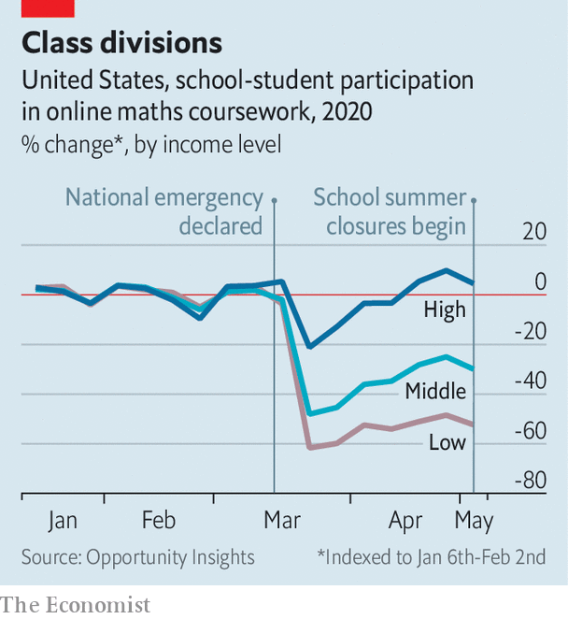

Disruptions to schooling tend to lower achievement while increasing inequality. But rarely do so many shocks pile up at once. First, schooling is now being conducted online. Previous attempts at virtual education in America have not looked promising. A study of virtual public schools in Georgia by Carycruz Bueno of Brown University found significantly reduced test scores in almost all subjects, and a ten-percentage-point drop in the chance of graduating from high school. Her results look worse for black and Hispanic children.

Then there is the problem of access to online classes. Nearly half of Native American pupils and 35% of black and Hispanic ones do not have access to either a computer or the internet at home, compared with 19% of whites. Worsening mental health among poorer families will also hurt achievement. Elizabeth Ananat of Barnard College and Anna Gassman-Pines of Duke University surveyed hourly service-sector workers in Philadelphia who had young children; half were screening positive for anxiety or depressive disorders.

When school closes poor pupils lose a social institution of last resort—one that educates, feeds, counsels and sometimes clothes them—whereas richer pupils are more insulated. A new industry of “learning pods”, where a cluster of families pool cash to pay for an in-person tutor, makes the governess model accessible to many. Scoot Education, whose normal business is providing substitute teachers for schools, quickly developed a sideline in learning pods in California. At least 100 such pods will be in place by the end of August, says James Sanders, the company’s CEO. For younger pupils the total cost of a pod, shared among all parents, is $349 a day.

To some, parents who pay for pods or other tutoring are complicit in deepening inequality. Yet pods are more a flashy symptom of educational inequality than the cause. “Rich families find a way to opportunity-hoard no matter what, even if this pandemic had not started,” says Sarah Cohodes, a professor at Teachers College at Columbia University. Some charities, like the Tennessee Tutoring Corps, have tried to spread access to tutors to less wealthy children, but efforts at scale (a federally funded national tutoring corps, say) look unlikely.

Failure to control the virus probably spells lower future incomes for millions of pupils. Without extraordinary interventions, the long-run effect of the pandemic on these students is predictable. The only question is how deep the damage will be. ■

Editor’s note: Some of our covid-19 coverage is free for readers of The Economist Today, our daily [newsletter](https://my.economist.com/user#newsletter). For more stories and our pandemic tracker, see our [hub](https://www.economist.com/news/2020/03/11/the-economists-coverage-of-the-coronavirus)

This article was downloaded by calibre from <https://www.economist.com/united-states/2020/08/29/disrupted-schooling-will-deepen-inequality-for-american-students>

|  |  |  |  |
| --- | --- | --- | --- |
| Previous | Articles | Sections | Next |

|  |  |  |  |
| --- | --- | --- | --- |
| Previous | Articles | Sections | Next |

#### Covid-19 in schools

# Other countries show that schools need not be pandemic hotspots

Learning from the world

Aug 29th 2020 |

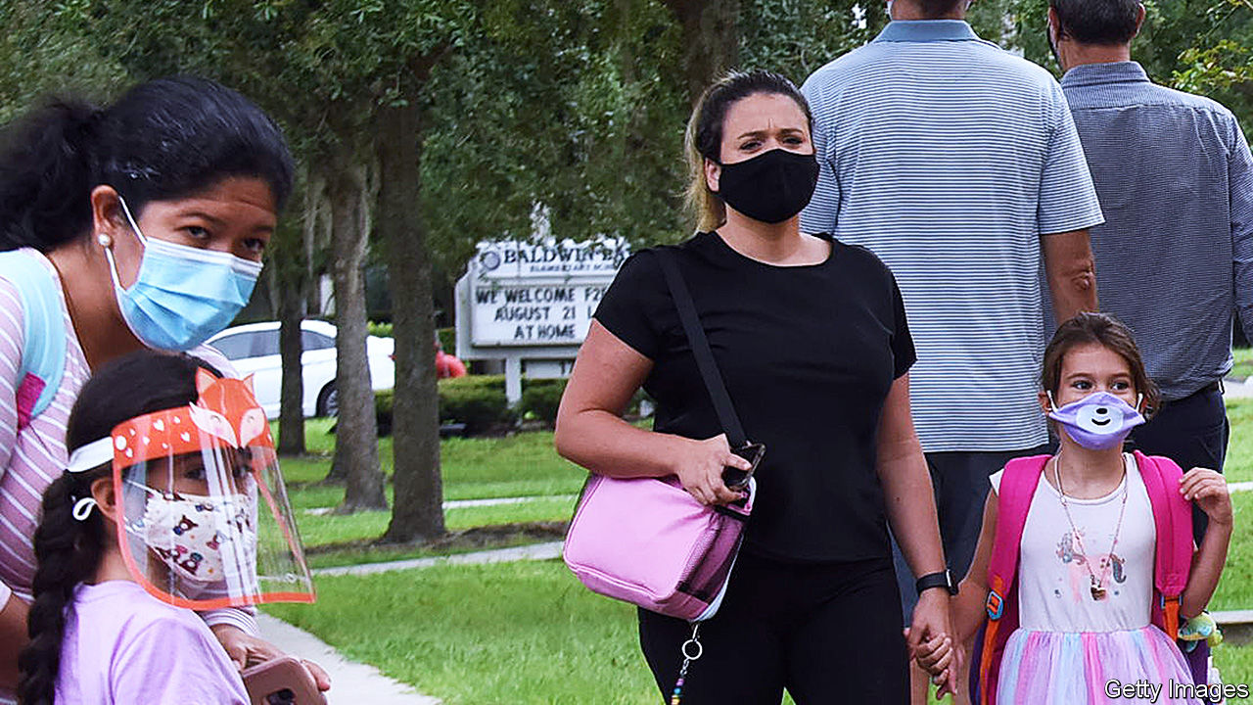

HOW MUCH of a risk is opening schools during the pandemic? Experience from a number of countries is starting to shed some light.

For the children themselves, covid-19 is not a big threat. They usually have mild symptoms or none at all. Among children with symptoms, only 0.1% of those younger than ten and 0.3% of those aged between ten and 19 end up in hospital, a study from Britain shows. For school-aged children, a covid-19 infection is less deadly than most flu infections.

The big worry is that children may spread the virus through school. Studies in households where someone introduced the infection usually find that younger children are much less likely to catch the virus than adults. The evidence for older children is mixed, with some studies concluding that they are as susceptible to infection as adults.

But even if children are infected less easily at home, when they mingle a lot chances are that many of them will pick up the virus. In an overnight summer camp in the state of Georgia in June at least half of the 346 children attending were infected.

Whether the sort of mingling that happens at school is also a recipe for disaster is best judged by looking at countries where schools have reopened. Data from England published on August 23rd are encouraging. Its schools reopened in June for some school years before closing for the summer a month later. In that period only 0.01% of preschools and primary schools had covid-19 outbreaks, affecting 70 children and 128 staff—out of 25,470 infections recorded in England as a whole. Of the 30 school outbreaks involved, the probable source in 20 was a staff member. Students were the source in eight cases, and in two cases the source was unclear.

That teaching is not exceptionally risky is also the conclusion from Sweden. Staff at its nurseries and primary schools, which never closed, were no more likely to become infected than those in other jobs.

Less clear is the role of secondary schools in infections. They have stayed shut almost everywhere. Outbreaks in France and Israel suggest that the virus could spread more easily in them than in primary schools. Older students may be easier to keep apart in classrooms, but good luck trying to stop them congregating afterwards.

America would struggle to contain school outbreaks as much of Europe has done, because infection rates in many states are too high and health officials are overwhelmed. Tough choices may be necessary. Britain’s prime minister, Boris Johnson, has warned that pubs might have to close (to keep infections down) so that children can go to school. In America, where any constraint on freedom goes against the grain, such trade-offs may be an even tougher sell.

Editor’s note: Some of our covid-19 coverage is free for readers of The Economist Today, our daily [newsletter](https://my.economist.com/user#newsletter). For more stories and our pandemic tracker, see our [hub](https://www.economist.com/news/2020/03/11/the-economists-coverage-of-the-coronavirus)

This article was downloaded by calibre from <https://www.economist.com/united-states/2020/08/29/other-countries-show-that-schools-need-not-be-pandemic-hotspots>

|  |  |  |  |
| --- | --- | --- | --- |
| Previous | Articles | Sections | Next |

|  |  |  |  |
| --- | --- | --- | --- |
| Previous | Articles | Sections | Next |

#### Lexington

# Hail to the king

Trump at the convention

Aug 29th 2020 |

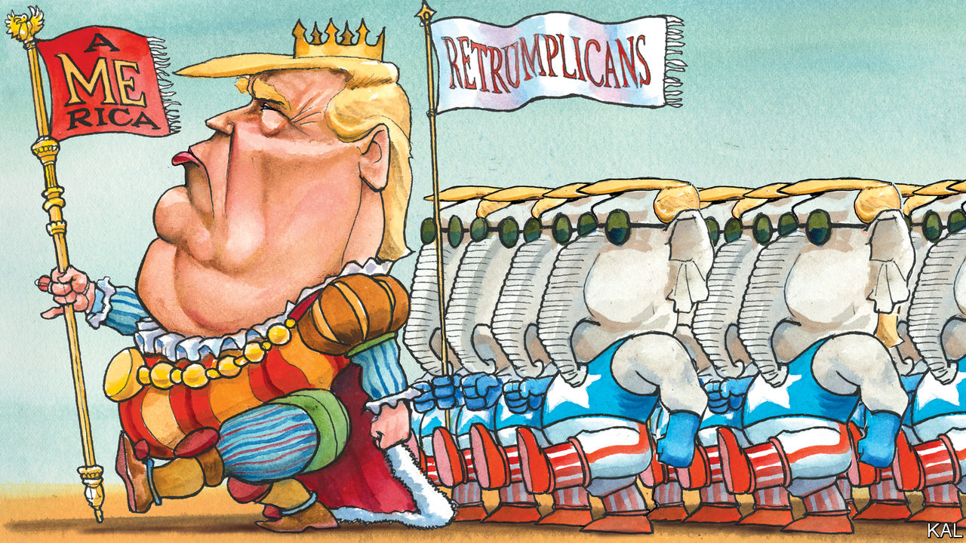

WHEN DONALD TRUMP appeared at the 2016 Republican National Convention in Cleveland, the party’s establishment was still shell-shocked by his nomination. Yet its politico, donor and lobbyist members consoled themselves with the thought that, given his probable loss to Hillary Clinton, they would soon have a chance to reunify their party in furious opposition, and reclaim it. While a few senior Republicans—including the governor of Ohio, John Kasich—condemned Mr Trump, most merely gave the convention a miss. Mr Trump’s main defeated rival, Senator Ted Cruz, addressed the gathering but did not endorse him. Seemingly by default, Mr Trump filled the vacuum with a cast of relatives, hyper-partisans and sycophantic opportunists.

Four years on, it turns out that that wasn’t by default. Half of this week’s RNC headliners were named Trump (including the president’s four adult children, wife and daughter-in-law). And though other members of the 2016 crew were unavailable, their replacements hit the same notes of hysterical fear and adulation. In place of Mike Flynn and Chris Collins, two prominent cheerleaders since convicted of crimes, Mr Trump employed attack-dogs such as Congressman Matt Gaetz, a Floridian mini-Trump—who warned viewers that Democrats “will disarm you, empty the prisons, lock you in your home and invite MS-13 to live next door.”

Deputising for Jerry Falwell junior, the president’s main evangelical fan in Cleveland, now mired in scandals (including an allegation that he enjoyed watching his wife have sex with a young boyfriend), Mr Trump had members of Billy Graham’s family laud him as a “fierce advocate” of faith. No opportunist has spoken for the president with more cynical zest than his eldest son’s girlfriend, Kimberly Guilfoyle, a Fox News presenter turned well-paid Trumpist megaphone, did this week. “The Best! Is Yet! To Come!” she yelled to an empty room. Mr Trump’s political showmanship is unchanged. Yet his standing within his party is transformed.

When he declared in Cleveland that America was half-destroyed and “I alone can fix it”, even many Republicans were nonplussed. Less than half had voted for him in their presidential primaries. Now almost all approve of him, many reverently, as the personality cult he launched in Ohio has subsumed the party.

Instead of unveiling a policy platform, as is customary, the Republican National Committee set independent thought aside this week and resolved to “support the president’s America First agenda”. Yet, halfway through the convention, it was harder than ever to fathom what that means. The only logic to the policies highlighted was tactical. To reassure the dwindling centre-right, one segment featured Mr Trump, the most anti-immigration (legal and illegal) president of modern times, praising hardworking immigrants at a naturalisation ceremony. Several speakers, while tumbling over each other to praise his achievements, also gave contradictory accounts of what they were. Senator Rand Paul lauded his opposition to “endless wars”; Mike Pompeo, the secretary of state, praised his sabre-rattling against Iran; Eric Trump claimed he had brought peace to the Middle East.

In contrast to Cleveland, a willingness to lacquer Mr Trump with praise was a condition for being allowed to speak—as demonstrated by former critics such as Nikki Haley, even though, when she was his ambassador to the UN, she observed the president being laughed at by world leaders. Yet the unfeigned reverence expressed for him by the many ordinary folk showcased in the convention was more unnerving. They included health-care workers who gave thanks for his management of a pandemic predicted to claim a quarter of a million American lives by the election.

Besides seeming profoundly un-American in its tone, such adulation represents the triumph of a four-year propaganda campaign that abandoned objective truth on day one and the normal limits of partisan self-promotion shortly afterwards. Its current iteration, to which the convention was largely dedicated, insists that Mr Trump inherited an economy on the brink of collapse, proceeded to build the “greatest economy our country has ever seen”, was unfairly assailed by the “China virus”, but is now in the process of making more American greatness, which Joe Biden would turn to ashes overnight. Fact-checkers identified more lies on the Republican convention’s first night than throughout last week’s Democratic one. In the midst of the worst plague in a century, worst social unrest in decades and one of the worst economic crises in the country’s history, three in four Republicans claim to believe America is in better shape now than it was four years ago.

As that should suggest, the Republican Party is not the only institution that has failed to check Mr Trump. The media have also succumbed. Conservative outlets have embraced his alternative facts. Left-leaning ones have uncovered them—yet their increasingly frenzied opposition to the president has fed the grievance culture that insulates his supporters from reality.

## System failure

The law and constitution have similarly trimmed the president’s excesses at best. Defended by an unprincipled attorney-general, Bill Barr, and a supine party, Mr Trump has faced no censure for his many abuses, including his alleged obstruction of investigations into Russia’s hand in his election and efforts to wring political favours from foreign leaders. His impeachment trial, in long-ago January, was hardly mentioned in either convention. He will presumably face no sanction for his additional transgressions this week, in using the White House and other government offices as campaign props, which the law forbids.

The big question, of course, is whether a majority of American voters will hold the line against Mr Trump. He currently trails Mr Biden by a decent margin. Yet in the context of the dishonesty, narcissism, contempt for office and incuriosity about the miseries facing millions he displayed this week, it is not wide enough.■

Dig deeper:  
Read the [best of our 2020 campaign coverage](https://www.economist.com/us-election-2020) and our [presidential-election forecast](https://projects.economist.com/us-2020-forecast/president), then sign up for Checks and Balance, our [weekly newsletter](https://www.economist.com/checksandbalance/) and [podcast](https://www.economist.com/podcasts/2020/08/21/checks-and-balance-our-weekly-podcast-on-american-politics) on American politics.

This article was downloaded by calibre from <https://www.economist.com/united-states/2020/08/29/hail-to-the-king>

|  |  |  |  |
| --- | --- | --- | --- |
| Previous | Articles | Sections | Next |

|  |  |  |
| --- | --- | --- |
| United States | Sections | Asia |

The Americas

Mexico: Bombshells on board

.

Sibling storms in the Caribbean: Storms Marco and Laura strike the Caribbean

.

|  |  |  |
| --- | --- | --- |
| United States | Sections | Asia |

|  |  |  |  |
| --- | --- | --- | --- |
|  | Articles | Sections | Next |

#### Bombshells on board

# A former official fires a legal missile at Mexico’s political class

Emilio Lozoya’s explosive allegations of corruption will test the country’s institutions, and its president

Aug 29th 2020 | MEXICO CITY

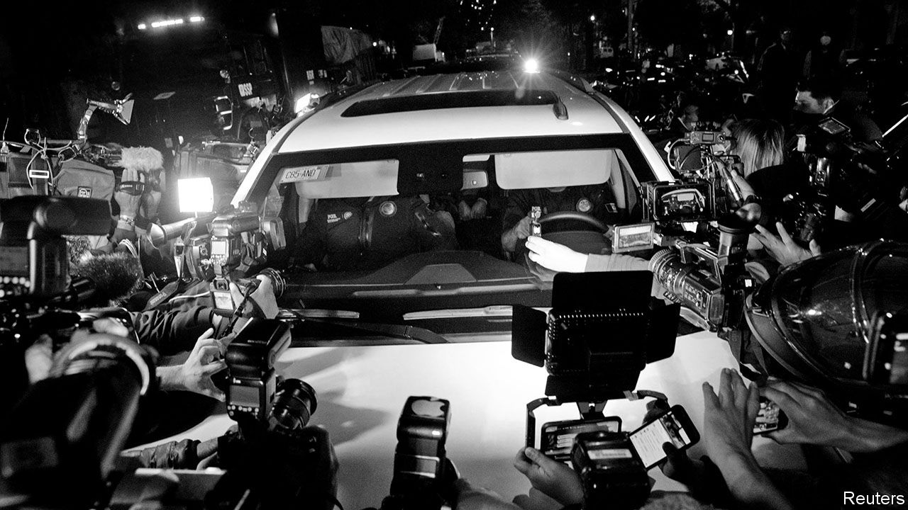

ONE OF THE rituals of Mexican politics is for a president to begin his term by locking up a supposed miscreant from the previous administration. Four of the six presidents from 1982 to 2018 did that. They incarcerated two union leaders, a former president’s brother and the head of Pemex, the state oil company. They presented these as giant victories in the fight against corruption. But they were not. Two of the jailbirds were acquitted, one was pardoned and the sentence of the fourth was overturned. Corruption continued to be rampant, uninvestigated and unpunished.

Many Mexicans regard the administration of Enrique Peña Nieto, which governed until December 2018, as the most corrupt in history. Rosario Robles, a minister in his government, is suspected of helping to siphon off $400m of the government’s money through ghost companies and has spent the past year in preventive detention. A construction firm with government contracts helped Mr Peña’s wife acquire a house worth $7m.

Those scandals helped Andrés Manuel López Obrador, a left-wing populist, win the presidential election in 2018 in a landslide. Mr López Obrador, often called AMLO, portrays himself as incorruptible and promises to “eliminate, not reduce” graft. Like past presidents, he has sought out wrongdoers from earlier administrations.

Last year, at the request of the attorney-general, a judge issued an arrest warrant for Emilio Lozoya, who was international-affairs co-ordinator for Mr Peña’s campaign and the boss of Pemex from 2012 to 2016. He returned from Spain in July this year.

The idea that Mr Lozoya would be just another presidential scapegoat was demolished in dramatic fashion. On August 19th the press got hold of his deposition, in which he offers to provide evidence of a corrupt mega-scheme involving 17 prominent Mexicans, including Mr Peña and two other former presidents. Mr Lozoya is seeking protection from prosecution in return.

On paper, the scandal he has revealed is the biggest in Mexican history. Without a proper investigation, on paper it will stay. That is all too likely. In part, that is because Mexico’s judiciary is politicised and inexpert. AMLO seems to share past presidents’ preference for trying his opponents in the court of public opinion.

Mr Lozoya describes his role as Mr Peña’s point-man in two linked schemes. The first was a $4m bribe from Odebrecht, a Brazilian construction company that corrupted officials across Latin America (see [article](https://www.economist.com/node/21791238)). Mr Peña’s presidential campaign spent most of that money on foreign consultants. The second was 56m pesos ($4.3m) to induce senators from the opposition National Action Party (PAN) to vote to open the oil sector to private investment. The architects of this scheme, says Mr Lozoya, were Mr Peña and Luis Videgaray, his finance minister and confidant.

Mr Lozoya suggests that his reward for his part in this skulduggery was his appointment as boss of Pemex, in charge of a multi-billion dollar budget. There he discovered more corruption, he says. Under Felipe Calderón, Mexico’s president from 2006 to 2012, Pemex sold ethane to an ethylene plant owned by Braskem, in which Odebrecht has a controlling stake, at an “inexplicable discount” of 25%. Mr Lozoya alleges that José Antonio Meade, the presidential candidate in 2018 for Mr Peña’s Institutional Revolutionary Party, approved the ethane contract as a member of Pemex’s advisory council.

Mr Lozoya claims that in 2013 Mr Videgaray bullied him into approving the purchase by Pemex of a fertiliser plant for $275m, well above its true value. The seller, Altos Hornos de México, a steelmaker, allegedly gave Mr Lozoya’s wife a seaside villa worth $1.9m 12 days after the deal went through. Nearly all the people Mr Lozoya accused have denied wrongdoing and many have sued him.

The allegations, which taint nearly all of AMLO’s main rivals over the past 20 years, play into his hands. They are acutely embarrassing for the two main opposition parties. To many they make Mr Peña’s energy reforms, which ended Pemex’s 75-year monopoly of drilling in an oil-rich country, seem illegitimate. AMLO has always denounced them (and championed Pemex) and may now try to revoke them. The scandal distracts from his mishandling of the covid-19 pandemic. Mexico’s death toll, 62,076, is the world’s third-highest.

There are reasons to doubt Mr Lozoya. His testimony could well keep him out of jail and protect his wife and sister, in whose names he registered houses and offshore companies. “People can say anything in exchange for reductions in sentences,” he observed in 2017, after he was accused of corruption by Odebrecht employees who were co-operating with Brazilian investigators. Perhaps that includes Mr Lozoya, his critics say.

Ricardo Anaya, the PAN’s presidential candidate in 2018, denies Mr Lozoya’s claim that in August 2014 he received a bribe of $600,000 in the congressional car park. Mr Anaya had left the chamber of deputies five months earlier to become general secretary of the party. Some who believe Mr Lozoya’s allegations doubt that he witnessed everything he says he did.

The case comes at a pivotal moment. Activists have spent the past decade drawing up anti-corruption and criminal-justice reforms and cajoling politicians to implement them. Criminal trials have shifted from the “inquisitorial” system used, for example, in France, in which the court takes an active part in establishing facts, to an “adversarial” one similar to that in the United States. Now investigators must use forensic equipment and, in corruption cases, dig through financial records. The reform is young; judges and prosecutors have yet to master their new roles.

In response to scandals in his administration, Mr Peña agreed to set up an “anti-corruption system”, featuring a strong, independent attorney-general, a dedicated anti-corruption prosecutor and a monitoring role for citizens’ groups. These institutions should have been primed to investigate Mr Lozoya’s claims. But Mr Peña gummed up the anti-graft machinery. He failed to make the attorney-general’s office independent and nominated anti-corruption magistrates to the federal administrative court without proper vetting.

AMLO has been no keener to oil the gears. The attorney-general he appointed, Alejandro Gertz Manero, advised his campaign. The government appointed the anti-corruption prosecutor, María de la Luz Mijangos, without soliciting applications from other candidates. Although the law gives her responsibility for investigating the allegations made by Mr Lozoya, she is playing no visible role.

A dutiful slog through the evidence, conducted by independent investigators, is not what AMLO seems to have in mind. He has often proposed holding a public vote on whether former presidents should be prosecuted, most recently at his morning press conference on August 24th. He has mused about holding it on the same day as congressional elections, due in July 2021. That is impossible to square with the attorney-general’s independence.

The leak of Mr Lozoya’s testimony has made the investigators’ job more difficult by subverting the presumption of innocence and, perhaps, provoking suspects to destroy evidence. For AMLO it serves as a prop. He leafed through the deposition in a video entitled “The neoliberal period in Mexico was synonymous with corruption”. At a press conference he showed a video of senators’ aides handling bags of cash. It demonstrated “the filth of the corrupt regime”, the president declared.

AMLO is personally honest and ostentatiously frugal. And there are no reports of thievery in his government on the scale Mr Lozoya alleges. But his political movement may not be as clean as he claims. A day after Mr Lozoya’s deposition came to light, videos emerged of AMLO’s brother, Pío, receiving bundles of money in 2015 from an official of the Chiapas state government. AMLO explained that the money was given by “the people” to finance Morena, the political party he founded. But it seems to violate a ban on supporting parties with large cash payments, which is supposed to ensure that criminals do not finance elections. “We are not the same as corrupt governments of the past,” AMLO insisted. Nevertheless, he agreed that the matter should be investigated.

Surveys show that Mexicans believe AMLO’s claim to be an anti-corruption crusader. But small-scale graft may have increased during his government. More Mexicans reported paying bribes in 2019 than two years earlier. AMLO has slashed the salaries of senior public servants, which increases the incentive to demand kickbacks.

Mr Lozoya’s accusations have kept Mexicans’ attention on the past. They further discredit a demoralised opposition, and set up Morena to do well in next year’s mid-term elections. Justice for the alleged miscreants may not be what the president wants most. For his purposes, it is enough to see them squirm.■

This article was downloaded by calibre from <https://www.economist.com/the-americas/2020/08/29/a-former-official-fires-a-legal-missile-at-mexicos-political-class>

|  |  |  |  |
| --- | --- | --- | --- |
|  | Articles | Sections | Next |

|  |  |  |  |
| --- | --- | --- | --- |
| Previous | Articles | Sections | Next |

#### Sibling storms

# Storms Marco and Laura strike the Caribbean

Aug 29th 2020 |

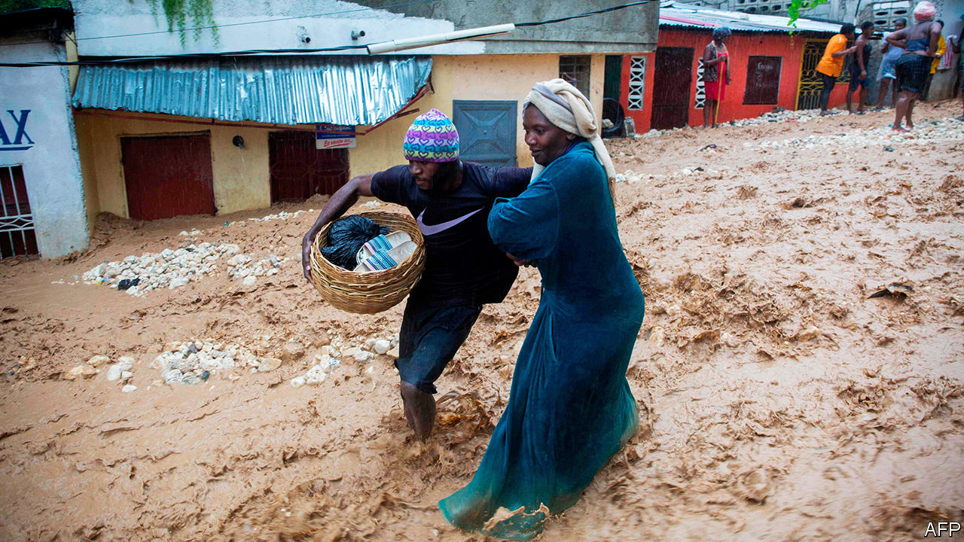

TWO STORMS battered the Caribbean before heading towards the United States. Marco led, becoming a hurricane over the Gulf of Mexico, followed by Laura, which strengthened to a category-four hurricane. The 12th named Atlantic storm this year, Laura arrived earlier than any other with that place in the sequence. It struck Haiti (pictured), where at least 21 people died, and the Dominican Republic, where four died.

This article was downloaded by calibre from <https://www.economist.com/the-americas/2020/08/29/storms-marco-and-laura-strike-the-caribbean>

|  |  |  |  |
| --- | --- | --- | --- |
| Previous | Articles | Sections | Next |

|  |  |  |
| --- | --- | --- |
| The Americas | Sections | China |

Asia

Japanese politics: After Abe

.

The Christchurch massacre: Dignity in the face of depravity

.

North Korea’s economy: Self-strangulation

.

Catering in the time of covid-19: Grounded beef

.

Banyan: Tough, but incompetent

.

|  |  |  |
| --- | --- | --- |
| The Americas | Sections | China |

|  |  |  |  |
| --- | --- | --- | --- |
|  | Articles | Sections | Next |

#### After Abe

# Speculation about the health of Japan’s prime minister is rampant

Who will succeed Abe Shinzo when he goes?

Aug 29th 2020 | TOKYO

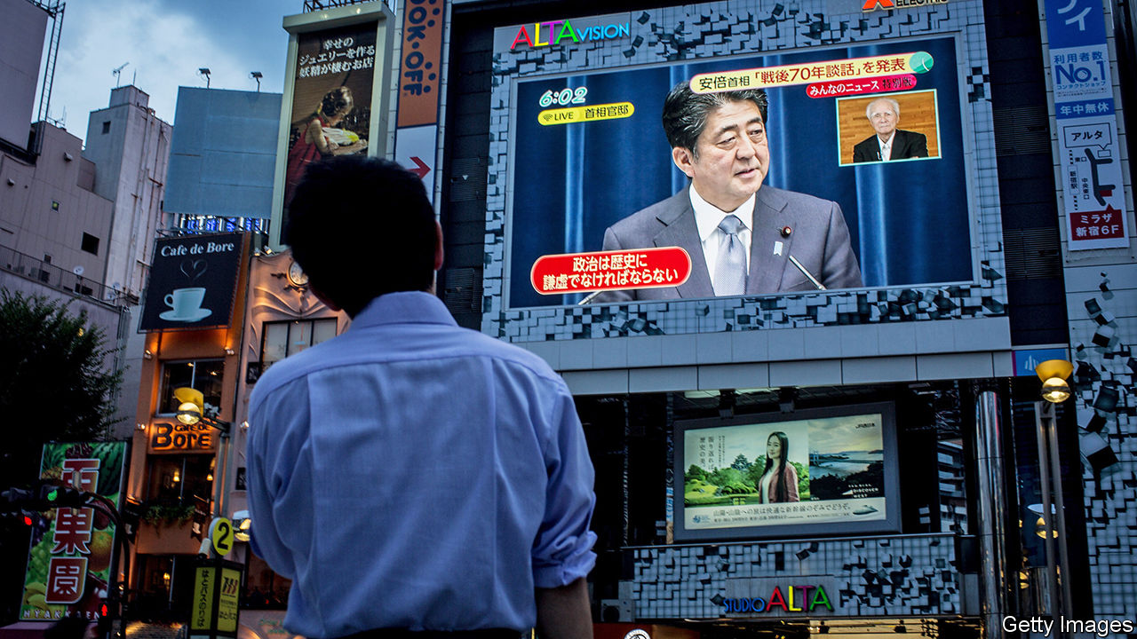

FOR ABE SHINZO August 24th was supposed to be a celebration. It was his 2,799th straight day as Japan’s prime minister, making him the longest-serving in the country’s history, surpassing a record set by his great-uncle, Sato Eisaku. Instead, Mr Abe spent the afternoon at Keio University Hospital in Tokyo undergoing medical checks and denying reports that he was about to step down.

Ill health has long dogged Mr Abe. His first stint as prime minister came to an abrupt end in 2007, after a turbulent year marred by, among other things, a flare-up of ulcerative colitis, a chronic intestinal disease. A new drug has helped Mr Abe manage the symptoms since he took up the job again in 2012. Yet as he has receded from public view in recent months, rumours about his health have proliferated. Japanese media have taken to analysing footage of his gait to see if it has slowed. It now takes him 21 seconds to walk down the corridor outside his office, compared with 18 seconds in April, reports TBS, a television station. The visit to the hospital on the 24th was his second in as many weeks. On August 28th Mr Abe plans a press conference to clarify the state of his health.

Aides admit that the stress of leading the country through the pandemic has taken a toll on Mr Abe, but they balk at the idea that he is too ill to carry on. His third and, by the party’s regulations, final term as leader of the ruling Liberal Democratic Party (LDP) lasts until September next year. A general election is due around the same time. On August 26th Suga Yoshihide, the chief cabinet secretary, declared that it was “premature to talk about ‘post-Abe’”. Nonetheless, the prime minister’s perceived frailty has fuelled exactly that kind of talk. Within the LDP, “many are sniffing blood,” says one of Mr Abe’s advisers.

The succession could play out in three ways. If Mr Abe is hospitalised or temporarily incapacitated, the deputy prime minister, Aso Taro, would become the interim leader. Mr Abe could step down early, allowing the LDP to elect a replacement to complete the duration of his current term. The party’s rules allow an emergency election at a meeting of its MPs, bypassing the normal party-wide vote. Or Mr Abe could stay on until the end of his term, reshuffling his cabinet or even calling an election to reassert control.

Mr Abe’s stamina is just one of many uncertainties. Two opposition parties, the Constitutional Democratic Party and the Democratic Party for the People, announced a merger earlier this month. Their support remains too shallow to challenge the LDP’s hold on power, but the LDP might favour an early election to deprive them of the chance to organise and make their mark. The Tokyo Olympic Games remain in limbo because of covid-19. Mr Abe seems to have thought of them as his swansong—but they may not happen at all.

Then again, if Donald Trump triumphs in November, calls for Mr Abe to stay on might increase, given his skill at buttering up the mercurial American president. Moreover, covid-19 has sent Japan’s economy into a tailspin, and Mr Abe’s poll numbers along with it: GDP shrank by a record 7.8% in the second quarter of this year compared with the first. Approval of Mr Abe’s government sits at 34%, the lowest since the start of his long second term. He might prefer to try to regain popularity in order to leave his successor on solid electoral footing—and to have bigger say in choosing that successor, his adviser notes.

Kishida Fumio, the LDP’s head of policy, is believed to be Mr Abe’s favourite. Voters see him as competent, moderate and thoroughly uninspiring. Ishiba Shigeru, a former defence and agriculture minister, staked out a rare position as an Abe critic. He has broad support among the party’s rank and file, but few backers among its MPs. (Mr Abe may resign early to avoid a party-wide vote and thus block Mr Ishiba’s rise, argues Toshikawa Takao, editor of Tokyo Insideline, a political newsletter.) Mr Suga is a master at managing the bureaucracy, but has little foreign-policy experience. Kono Taro, the current defence minister, and Motegi Toshimitsu, the foreign minister, both have aspirations for higher office, though their candidacies are seen as long shots.

The differences among them all are more of tone and tactics than of ideology. Finding differences on policy requires a microscope. Mr Kishida would carry Mr Abe’s flag, though he hails from a more centrist wing of the LDP, less wedded to Mr Abe’s priorities, such as revising the constitution. Mr Ishiba may favour more orthodox fiscal and monetary policy, but his room for manoeuvre would be limited after the pandemic. Mr Suga might devolve more power to local governments. Mr Kono casts himself as a maverick, having taken stances at odds with the party in opposition to nuclear energy and in favour of allowing the sons of female royals—or even (gasp!) the female royals themselves—to inherit the throne. Ultimately, the decision will come down to personalities and factional arithmetic. “The selection process is not really a policy choice,” says Sone Yasunori of Keio University.

Whoever replaces Mr Abe will inherit immense problems: gargantuan public debt, a shrinking population and an economy that has been limping along for decades. But he will also wield great authority. During his long reign, Mr Abe has centralised decision-making, establishing a national security council and shifting power away from the bureaucracy. “To navigate a turbulent world, you need a strong prime minister—that pattern is embedded,” says Tobias Harris of Teneo, a consultancy. “The institutional power will be there for a prime minister who manages to keep the LDP in his grip.” For now, however, the question is whether Mr Abe himself, not his as-yet-unknown successor, can maintain his grip on the party. ■

This article was downloaded by calibre from <https://www.economist.com/asia/2020/08/29/speculation-about-the-health-of-japans-prime-minister-is-rampant>

|  |  |  |  |
| --- | --- | --- | --- |
|  | Articles | Sections | Next |

|  |  |  |  |
| --- | --- | --- | --- |
| Previous | Articles | Sections | Next |

#### Dignity in the face of depravity

# The murderer of 51 Muslims in New Zealand last year is sentenced

He is the first person in New Zealand to be jailed for life without a chance of parole

Aug 29th 2020 | SYDNEY

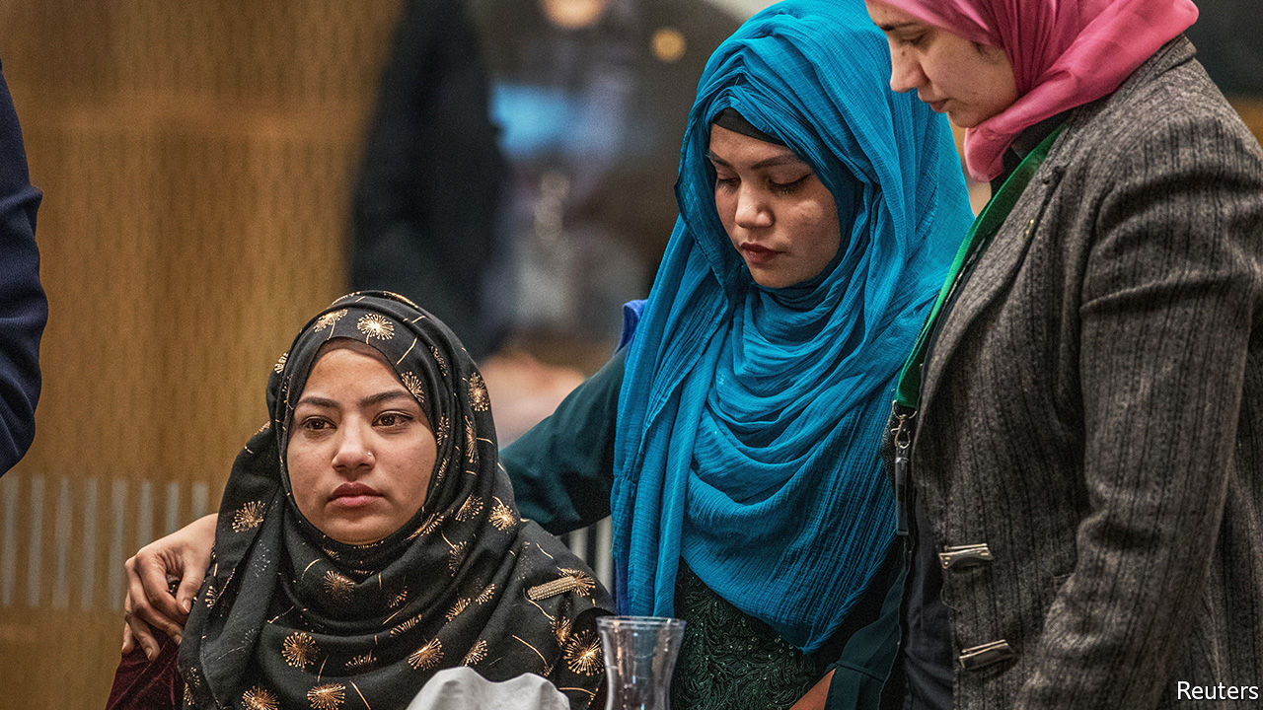

THE WHITE supremacist who murdered 51 Muslims in Christchurch in March last year expressed only one regret: that he had not been able to kill more. The mass shooting, which he live-streamed on Facebook, was the worst in New Zealand’s history. Its courts had never sentenced anyone to life in prison without parole. But on August 27th a judge ruled that Brenton Tarrant should spend the rest of his life in jail.

“Anything less would have been a disappointment” to most New Zealanders, says Paul Spoonley of Massey University. The attack forced the country to re-examine its reputation as an open and harmonious place. “Ever since,” he says, “we’ve been looking for a degree of resolution.”

Survivors were spared a drawn-out trial because Mr Tarrant, an Australian, pleaded guilty to all 51 counts of murder, 40 of attempted murder and one of terrorism. Still, Kiwis worried that he might make a spectacle of the four-day hearing on his sentence. The killer had sacked his lawyers and was representing himself. He had already inspired copycats in other countries. How could he be prevented from using his trial as a grandstand?

The High Court’s answer was to bar live reporting from the hearing. As it happened, Mr Tarrant was silent. The stand was given mostly to survivors of the attacks and relatives of the victims. Some 90 of them read statements about how his crimes had affected them. Several showed extraordinary grace. Janna Ezat described receiving her son’s body, with the skull smashed open and brain still bleeding, before explaining that her Muslim faith gave her “only one choice: to forgive you”.

Jacinda Ardern, the prime minister, asserts that New Zealand has “fundamentally changed” since the massacre. She banned semi-automatic weapons in the days that followed the attack. By Christmas, the government had bought back more than 56,000 firearms and 200,000 illegal gun parts in an amnesty. It is not clear how many Kiwis have kept guns, though, because the law has only just been amended to create a register.

Families are still waiting for other promised changes. Plans to broaden hate-speech laws to include religion have been resisted on free-speech grounds by New Zealand First, the coalition partner of Ms Ardern’s Labour Party. A royal commission is investigating whether the authorities could have prevented the attacks. In a submission to the inquiry, the Islamic Women’s Council of New Zealand noted that the security services had been warned about the growing threat of Islamophobia. If those complaints had been taken seriously, it asserted, Mr Tarrant might not “have got to the door of the mosques”.

Still, Muslims seem inclined to agree with the prime minister. “New Zealand before 15th March is not New Zealand after 15th March,” says Gamal Fouda, an imam of one of the mosques that was attacked. The mindset of both its police and people “are completely different”, he believes. Aliya Danzeisen of the Islamic Women’s Council notices “a change in how people interact with you”. New Zealanders, she says, are even more warm, friendly, tolerant and inclusive than before. ■

This article was downloaded by calibre from <https://www.economist.com/asia/2020/08/29/the-murderer-of-51-muslims-in-new-zealand-last-year-is-sentenced>

|  |  |  |  |
| --- | --- | --- | --- |
| Previous | Articles | Sections | Next |

|  |  |  |  |
| --- | --- | --- | --- |
| Previous | Articles | Sections | Next |

#### Self-strangulation

# As natural disasters strike, North Korea cuts itself off

The extent of the damage may never be known

Aug 29th 2020 | SEOUL

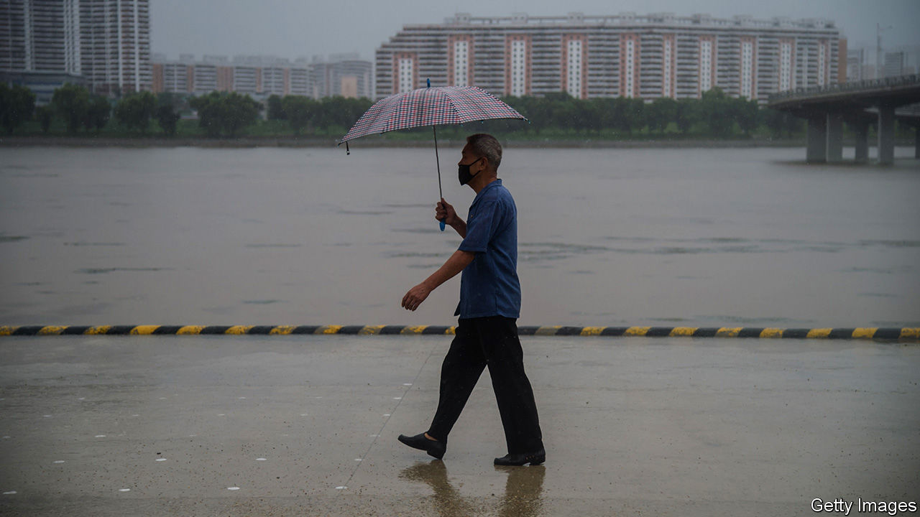

NORTH KOREAN dictators are not given to self-deprecation. Indeed, they seldom admit to being anything less than godlike, and lock up those who suggest otherwise. Yet in mid-August Kim Jong Un told a meeting of the Workers’ Party that, owing to multiple “unexpected difficulties”, his government had recently failed to improve the lives of the people and meet its economic goals. To remedy the situation, the report in the party newspaper went on, a party congress would be convened in January to adopt a new five-year plan.

Most economies have been hobbled by covid-19, but few are doing as badly as North Korea’s. Never healthy, it was made less so by international sanctions intended to stop Mr Kim’s nuclear-weapons programme. Floods, brought on by the wettest rainy season in years, have devastated crops. And to ward off the pandemic, the regime has imposed one of the world’s strictest quarantines.

North Korea shut its borders soon after the initial outbreak in the Chinese city of Wuhan in January. For months the authorities insisted that North Korea was covid-free, to widespread scepticism. In recent weeks they have quietly dropped that claim, asserting instead that a repentant defector who returned from South Korea was “suspected” of having brought the disease with him. Nonetheless, the border remains largely closed. Trade has all but ceased. The value of goods exchanged with China, North Korea’s main trading partner, amounted to just over $400m during the first half of the year, a reduction of two-thirds compared with the same period last year, according to a report released by South Korea’s unification ministry on August 25th. And the North is reportedly planning to tighten the quarantine ahead of celebrations to mark the 75th anniversary of the Workers’ Party in October.

The consequences were already visible in the spring, when even usually well-stocked shops in the capital ran short of many consumer goods. Staples such as cooking oil were rationed. There were bouts of panic-buying; some North Koreans asked foreign colleagues to purchase scarce items on their behalf in shops reserved for foreigners. Such shortages in Pyongyang suggest much worse conditions in the provinces, which are often deprived to ensure that the capital remains well-fed. Sporadic reports suggest that provincial street vendors, wary of raising prices in a crisis, have instead taken to cutting portion sizes.

Since then, things have got worse. Over the past two months the Korean peninsula has suffered one of the longest and wettest rainy seasons for many years. North Hwanghae province, where much of North Korea’s rice is grown, was particularly badly hit. In early August state media reported that the flooding in the province was likely to affect the harvest, raising concerns about food security later in the year (even in better times, the United Nations estimates that two-fifths of North Koreans suffer from malnutrition). As The Economist went to press the first typhoon of the season, which had already ravaged South Korea’s southern islands, had just made landfall in North Hwanghae, adding to the region’s woes.

In less unusual times humanitarian organisations would be gearing up to send water pumps and food aid to the affected areas to cushion the impact on ordinary people. Such efforts have never been straightforward given the regime’s obsession with “self-reliance”. But the North’s current determination to isolate itself even more than usual makes relief work almost impossible. Mr Kim, although keen to showcase his concern for “the people’s well-being” during a visit to flood-hit areas, has rejected offers of foreign help, ostensibly for fear that it might bring the virus into the country. Shipments of humanitarian goods have slowed to a trickle, owing both to sanctions and to the quarantine. The vast majority of foreign aid workers have been forced to leave in recent months, along with most diplomats. The few who remain are barred from leaving Pyongyang. As life in North Korea grows ever more miserable, the rest of the world is ever less likely to hear about it. ■

This article was downloaded by calibre from <https://www.economist.com/asia/2020/08/29/as-natural-disasters-strike-north-korea-cuts-itself-off>

|  |  |  |  |
| --- | --- | --- | --- |
| Previous | Articles | Sections | Next |

|  |  |  |  |
| --- | --- | --- | --- |
| Previous | Articles | Sections | Next |

#### Grounded beef

# Asian airlines are selling in-flight meals directly to the public

Nostalgic travel junkies are actually buying them

Aug 29th 2020 | SINGAPORE



MOST TRAVELLERS see the food as one of the least palatable aspects of air travel. Rubiyanto Haliman is not most travellers. A worker at an Indonesian shrimp hatchery who flew four to six times a month before the pandemic, he collects in-flight menus, magazines and tumblers, and likes to post pictures of aeroplane food to his Instagram feed—not in an ironic way. The past few months, with airlines largely grounded, have been difficult for him. He so misses the experience of flying that a couple of weeks ago he bought a few in-flight meals from Garuda, the national carrier. The food, which was delivered to his home, was packaged in white plastic containers and served with plastic cutlery, on a tray, just as it would be on a plane. The dishes—spinach and pastrami quiche and nasi daun jeruk (rice infused with coconut milk and lime leaf), each costing 30,000 rupiah ($2)—actually “taste better than normal in-flight meals,” he says.

Garuda is not the only Asian airline to flog its food to the land-lubbing public. Santan, owned by AirAsia, a big low-cost carrier, sells two Malay staples, nasi lemak and beef rendang (each $4) at its main hub in Kuala Lumpur, Malaysia. Thai Airways offers stir-fried tiger prawns ($8) and tandoori lamb chops ($9.25) in Bangkok. Hong Kongers can pick up $5 “stir-fried beef strip” and “Indian curry fish” from Cathay Pacific’s catering arm. Australians can choose from the voluminous menu of SnapFresh, an airline caterer, or buy a mystery meal from Gate Gourmet, a rival which sells “main meals combination” or “vegetarian combination” in bulk packs.

Santan began dishing up its food on the ground in December, when it opened a restaurant in Kuala Lumpur as part of a branding exercise. Most airline caterers pivoted to terrestrial retail after the pandemic forced the industry to make a hard landing. In June IATA, a trade body, forecast that the global air-transport industry’s revenues will fall by half this year. Marcello Massie, the general manager of PT Aerofood, Garuda’s caterer, says that revenue at the company has plummeted by 97% since the start of the pandemic. In April it decided to start selling food directly to “people who miss flying” in order to shift surplus stock and recoup at least some of its losses.

The grub is flying off the trolleys. Santan sells about 700 meals a day; SnapFresh roughly twice that. In June Gate Gourmet sold out. PT Aerofood is so pleased with “Fly with Meals”, as it calls its retail wing, that it is opening restaurants in three big Indonesian cities. It is a far cry from the 80,000-90,000 meals that Garuda normally serves each day, but it helps.

Reviews, however, are mixed. Zhenyu Wang, a software developer based in Brisbane, Australia, bought a ten-pack from Gate Gourmet not because he is a fan of plane food but because, at $1.80 per meal, it was a bargain. The Italian pasta was “no good” and the beef oily and salty. Too bad he didn’t get Gate Gourmet’s chicken mango curry. Scott Hamilton, an IT worker in Sydney, enjoyed it so much, he says, that “I would consider flying to somewhere just to eat this.” ■

This article was downloaded by calibre from <https://www.economist.com/asia/2020/08/29/asian-airlines-are-selling-in-flight-meals-directly-to-the-public>

|  |  |  |  |
| --- | --- | --- | --- |
| Previous | Articles | Sections | Next |

|  |  |  |  |
| --- | --- | --- | --- |
| Previous | Articles | Sections | Next |

#### Banyan

# Politics is spreading covid-19 in Indonesia and the Philippines

Presidents Jokowi and Rodrigo Duterte act tough, but can’t get things done

Aug 29th 2020 |

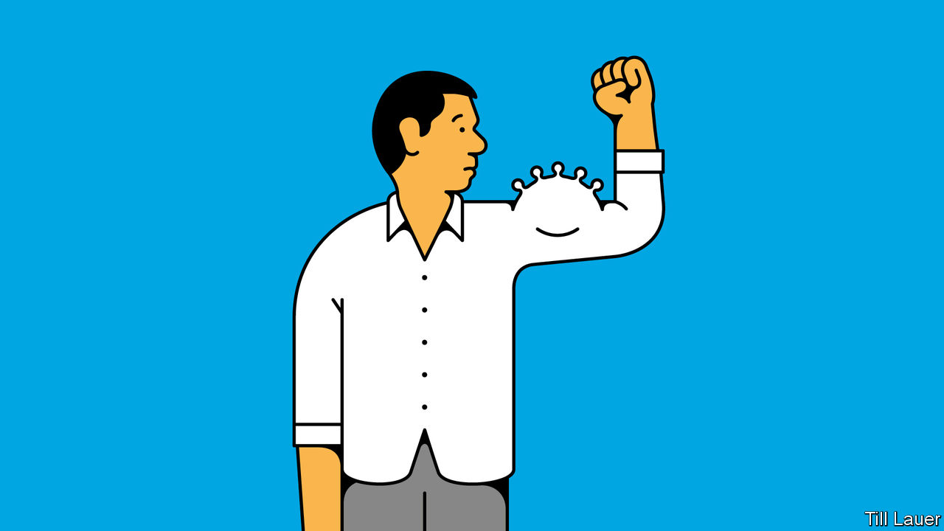

IN THE FACE of covid-19, world leaders have fallen into four camps. The first group denies there is a problem: think of Gurbanguly Berdymukhamedov of Turkmenistan, who fined his subjects for wearing face masks before ordering everyone to don them as a protection against “dust”. The second group recognises the threat and counters it with maximum coercion, regardless of civil liberties: think of Xi Jinping in China. The third group, which includes most democracies, handles the tricky trade-off between crushing the virus and crushing everything that is enjoyable in life reasonably well. The fourth group tries to act tough, but does so incompetently. Here, President Rodrigo Duterte of the Philippines and President Joko Widodo, or Jokowi, of Indonesia stand out. Their two archipelagic countries have fared far worse than the rest of South-East Asia, with around 200,000 and 160,000 known coronavirus cases respectively and still rising fast.

Mr Duterte is coarse, Jokowi soft-spoken: the two seem cut from different cloth. Yet both were mayors who won national power because voters saw in them something new. They were not from the usual dynasties that dominate their countries’ politics, nor did they spout the geekspeak of global elitists. As mayors they got stuff done: in Mr Duterte’s case, “fighting crime” in Davao by encouraging vigilantes to murder drug suspects; in Jokowi’s, by building things like expressways in Solo and Jakarta, the capital. Men of action, they promised to roll up their sleeves and apply their business model to the country.

Yet the simple-sounding approach crumpled at the first encounter with the virus. As cases rose, Jokowi dithered and flip-flopped over lockdown and distancing measures. Partly that was pandering to conservative Muslim leaders who have long accused him of insufficient piety. In April he faced pressure to allow the mudik, Muslim migrants’ annual return home to mark the end of Ramadan. Its eventual ban came too late to staunch covid-19’s spread. But, mainly, Jokowi feared popular unrest if he shut down the economy. Having asked to be judged on the economy, he was reluctant to see his beloved infrastructure projects halted. Either way, Jokowi was hardly the strong, resolute ruler.

Mr Duterte acted far more quickly, ordering a lockdown of greater Manila, the capital. He called on the army and police to shoot violators of lockdown rules—classic strongman stuff. But in practice, enforcing the rules has fallen more to local governments than to the security forces under the president’s control.

As it happens, local police and village watchmen armed with staves have often been as heavy-handed as the president could have wished. But that is pure coincidence. In practice, the local power-brokers in the periphery of the Philippines—mayors, plantation owners, armed insurgents or drug gangs with friends in the police—do what they like for their own benefit, regardless of what anybody in Manila, including Mr Duterte, instructs. The political apparatus simply is not suited to effective authoritarianism.

In both the Philippines and Indonesia, confinement in crowded slums has helped spread the virus. So, too, has the two countries’ reliance on inter-island transport. It has put a premium on efficient testing and contact tracing, yet efforts have been scrappy—highlighting how ineffectual the state is. That is despite Jokowi borrowing increasingly from the authoritarian playbook. In April his police chief instructed “cyber patrols” to apprehend people who criticise his handling of the pandemic. In early August he ordered by decree the nationwide enforcement of social-distancing and other public-health measures. Yet he fails to get things done. Bureaucrats are nervous about disbursing money to the neediest for fear of being accused of misspending state funds. Ministries competing for favour stand in for clear policy. Jokowi’s “new normal”—a supposed balance between public health and economic activity—risks serving neither.

Like Mr Duterte, Jokowi inherited a political system in which the presidential writ does not run far, and only then through personalised rule. Yet neither Mr Duterte nor Jokowi campaigned on overhauling the system to introduce more effective and accountable government. Nor did voters insist on it. Perhaps, dismayed by the immense cost of the pandemic, they will next time. But do not count on it. Many in the Philippines and Indonesia, for better or for worse, love a strongman.

This article was downloaded by calibre from <https://www.economist.com/asia/2020/08/29/politics-is-spreading-covid-19-in-indonesia-and-the-philippines>

|  |  |  |  |
| --- | --- | --- | --- |
| Previous | Articles | Sections | Next |

|  |  |  |
| --- | --- | --- |
| Asia | Sections | Middle East & Africa |

China

Podcasting: Listening in

.

Matronymics: In the name of the mother

.

Chaguan: System, heal thyself

.

|  |  |  |
| --- | --- | --- |
| Asia | Sections | Middle East & Africa |

|  |  |  |  |
| --- | --- | --- | --- |
|  | Articles | Sections | Next |

#### Listening in

# Podcasting provides a space for free thought in China

Amid a broader media clampdown, there are still a few corners where discussion is welcome

Aug 27th 2020 |

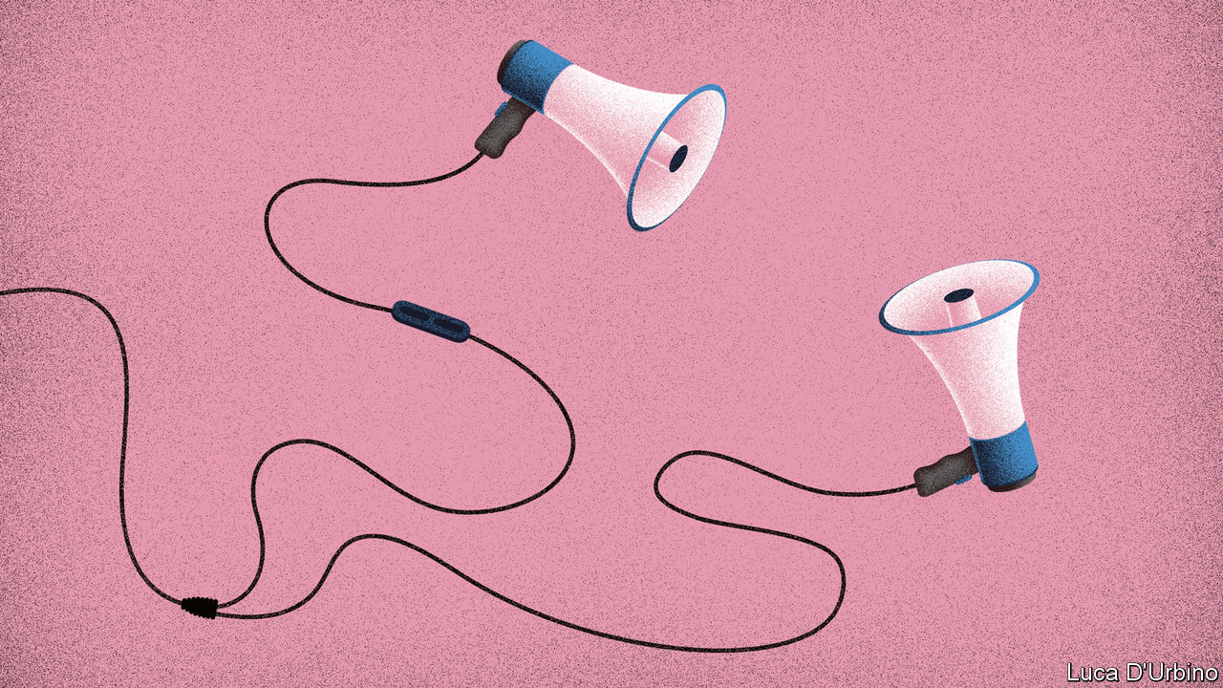

MUXI MAKES cables that charge smartphones in a factory near Shanghai. The work is boring, he says, but at least his boss lets him wear Bluetooth earphones. That way, for six days a week, 11 hours a day, as his hands fly across the assembly line, his mind fills. First, the 24-year-old listened to audiobooks. Then, online classes. Now, he prefers podcasts. As the Communist Party has tightened control over media, and China’s vapid pop culture has become ever more shallow in response, podcasts have become a niche where thinking people can find unexpected, and sometimes controversial, content.

The tone can be gauged from the podcasts’ names, the perennial dark humour of Chinese intellectuals seeping through. “The Weirdo” is one of Muxi’s favourites. Hosted by three former journalists, it strives to cater to those who live up to its title. Recent episodes have discussed the challenges that Chinese men face if they identify as feminists, and the problem of racism in China towards black people, both topics that are considered quite alternative. Muxi (not his real name) also enjoys “The Unemployable”, which tells stories about people who rebel against the pressures of modern life by becoming freelancers, taking gap years and travelling—actions rarely encouraged in a country where bosses extol a “996” working culture (9am to 9pm, six days a week).

China’s internet users have long relied on creativity to produce and consume the content they want. Twitter, Facebook, YouTube and Instagram are blocked, though the inquisitive use virtual private networks (VPNs) to reach them. China’s home-grown social-media giants, Weibo and WeChat, which both allowed relatively free discussion when first launched, are now strictly monitored by censors, as are the country’s other thriving platforms.

The podcasts provide something different, and deeper. A high-school student explains why she became a climate-change activist. A woman recalls being abused as a child by her father in rural China as the neighbours watched. A feminist grapples with her traditional Chinese wedding.

The shows are mostly popular with two different groups of people. The first is young urban intellectuals. More than 85% are graduates, and almost 90% of listeners are under 35, according to a survey conducted by PodFest China. “The hosts genuinely want to have discussions and are not obsessed with sensationalism,” says Eva Lin, a college student in the eastern city of Yantai, who loves the companionship podcasts provide to help her cope with depression. The second group is more diverse, but includes many from the other end of the social spectrum, like Muxi, who first travelled to the coast five years ago from a poor village 2,000km inland. “Sometimes I find the hosts’ views a bit elitist but most of the time I find myself agreeing,” he says.

Podcast content is usually less sensationalist than what is commonly found on Chinese social-media platforms. There are far better options for content creators in search of traffic and money, says Fang Kecheng of the Chinese University of Hong Kong. Most people prefer to watch live-streaming of people eating large bowls of noodles and selling lipstick, or more of the familiar boy-band clickbait. As everywhere else, stories about death, sex and money are popular, says Kou Aizhe, host of Story FM, one of China’s most popular podcasts. In one episode a man describes how his father, who suffered from mental illness, was poisoned to death by fellow villagers. In another, a Chinese documentary-maker tells a tale of featuring in a gay porn film. A third discusses agencies set up specifically to help women break up their husbands’ relationships with their mistresses.

## Big wide world

Listeners are especially curious about Chinese people around the world. As more of them work, study and travel abroad, Mr Kou has noticed that episodes about Chinese in far-flung places like Syria and Afghanistan are a hit. Story FM’s most popular show this year was about a Chinese Muslim man who went to Pakistan and within 15 days found and married his wife, before bringing her back to China. In a country of 1.4bn people, Mr Kou estimates his show gets around 700,000 listeners an episode. The fact that censors normally intervene only when content goes viral has given podcasts some space.

The covid-19 pandemic raised some problems, however. It is hard enough for podcasters to know where the political line is in normal times, let alone in a crisis, when it may move. For weeks during the outbreak’s early stages, podcasts shared stories about it. Many shows featured intimate interviews with doctors, journalists and residents of Wuhan after the city went into lockdown. Most of them were eventually deleted as the party recaptured control of the narrative.

Others have been censored, too. When “Loud Murmurs”, a podcast about popular culture, did a show about “One Child Nation”, an American documentary that was banned in China because it dealt with the one-child policy, the podcast went viral on social media. It was eventually censored but not before thousands had heard it. Another episode was censored, the host thinks, for mentioning China’s former president, Jiang Zemin, praising a well-known Canadian comedian’s fluent Chinese. “The thing about censorship in China is that it is a black box,” says Isabelle Niu, one of the presenters. “We didn’t know we weren’t allowed to talk about presidents.”

As a result, podcast hosts admit they self-censor. “I care most about reaching listeners inside China, the vast majority of whom don’t have VPNs. If that means I have to sacrifice some of my freedom of speech, so be it, this is the reality that we live in,” says Zhang Zhiqi, host of “Stochastic Volatility”, a popular podcast which recently had to rename and reinvent itself because of pressure from censors. Many of the messages Ms Zhang receives are from high-school and university students, often from poor regions of China.

All podcasts avoid directly discussing political issues deemed sensitive by the Communist Party, like the mass detention of Muslims in north-west China or the Hong Kong protests. But audio reporting suits intimate storytelling and you do not have to talk directly about politics to have a fascinating political discussion.

“As our industry grows and becomes profitable, we will see more censorship,” predicts Yang Yi, co-founder of JustPod, a podcasting company. “This is what happened to Weibo and WeChat as they grew.” Text and video in China are already carefully scrutinised by censorship algorithms. Podcasters worry about improved technology bringing greater scrutiny of audio output. If that happens, they will have to find new ways to provide their thought-provoking content. ■

This article was downloaded by calibre from <https://www.economist.com/china/2020/08/27/podcasting-provides-a-space-for-free-thought-in-china>

|  |  |  |  |
| --- | --- | --- | --- |
|  | Articles | Sections | Next |

|  |  |  |  |
| --- | --- | --- | --- |
| Previous | Articles | Sections | Next |

#### Matronymics

# More Chinese children are being given their mother’s surname

It’s not just about feminism

Aug 29th 2020 | BEIJING

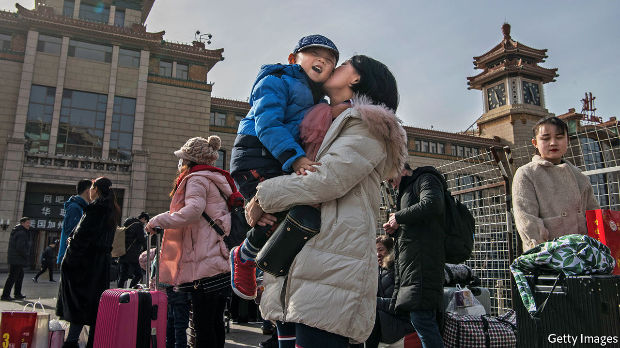

AS CHINA EMERGED from lockdown, a woman wrote a post on Weibo, a microblog, that has echoed through the long, hot summer. She was divorcing her husband, she said, because he would not allow her to change the surname of her child to her own. Details of the case were scant, but that did not stop it lighting up the internet, shining a new spotlight on the question of how far Chinese women have come. Phoenix Weekly, a magazine, launched an online poll that drew 47,000 respondents. Almost two-thirds said that a surname could come from either parent.

As in most traditional societies, Chinese parents have long preferred sons, and the usual practice of handing down the father’s surname remains a powerful symbol of that (though women have always retained their surname at marriage). But with social mores changing rapidly, more parents have started to give babies the mother’s surname, especially in wealthy urban areas. A paper last month in the Journal of Population Economics found that Chinese children with young, educated mothers from areas with normal sex ratios at birth were more likely than average to be given her surname, and such offspring were healthier and better educated than average. Almost one in ten newborns in Shanghai were given their mother’s name in 2018.

Some young couples have compromised and use both surnames in combination, somewhat like Westerners creating double-barrelled surnames (though only one of those names can be legally recognised in China). According to a survey in 2019, the surnames of more than 1.1m Chinese people now form such a combination, a ten-fold increase on 1990.

Government support for matronymics has been around since the mid-1990s. Giving the mother’s surname to offspring was encouraged within the one-child policy (which was relaxed in 2016), to persuade people to be content with an only daughter. To win them over, officials dug up Chinese texts about ancient matrilineal societies.

Some wonder, however, whether all of this is more to do with genealogy than with feminism. Qi Xiaoying of the Australian Catholic University says that grandfathers are urging their daughters to give their surname to one of their grandchildren now that families can have more than one, because it assures the continuation of the grandparents’ line. Ms Qi calls this “veiled patriarchy”. In-laws now fight over whose name will go to the son. She says matronymics are more popular in Chinese cities not because of an assertion of women’s rights, but because a generation of maternal grandparents has more wealth to hand down, especially if they are richer than their son-in-law’s parents.

At least the trend shows that a patronymic is not a foregone conclusion, says Ms Qi. A survey in 2017 in the south-eastern city of Xiamen found that 23% of second children in two-child families were given their mother’s surname. A couple in the city of Nanjing, surnamed An and Hui, called their children An Zihui and Hui Zi’an, both meaning “the offspring of An and Hui”. “Genealogy and feminism had nothing to do with it,” says Ms Hui. “It was just a way to show our love.”■

This article was downloaded by calibre from <https://www.economist.com/china/2020/08/29/more-chinese-children-are-being-given-their-mothers-surname>

|  |  |  |  |
| --- | --- | --- | --- |
| Previous | Articles | Sections | Next |

|  |  |  |  |
| --- | --- | --- | --- |
| Previous | Articles | Sections | Next |

#### Chaguan

# China needs to train more doctors

The Party praises covid-fighting medics, but fails to fix the health system

Aug 29th 2020 |

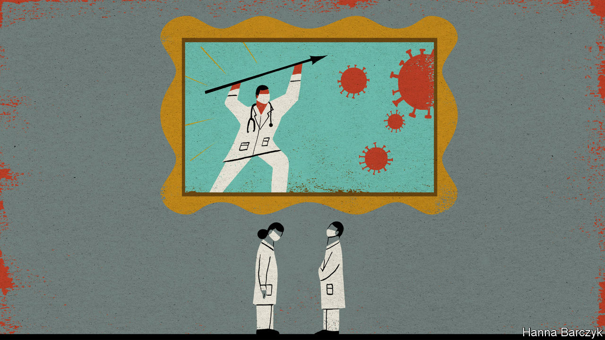

THE CHINESE LANGUAGE is rich in concise, sardonic sayings, many of which reflect universal truths. It also includes lots of phrases steeped in a world view that is distinct to China. One such is yi buguo erdai, meaning “no doctor’s child becomes a doctor”. This may be accompanied by a cynical shrug, perhaps after reading about the latest Chinese hospital boss arrested for bribe-taking or a fresh scandal involving fake medicines. The saying is also used on hearing news outlets describe another stabbing or assault of a doctor at work—for fully two-thirds of doctors told the Chinese Medical Doctor Association in 2017 that they had been attacked or threatened in a hospital, often by their patients’ angry relatives. Small wonder that in one survey after another, few want their children to be doctors.

Elsewhere, doctoring is such a family business that journals of medical ethics devote papers to the subject. One such study found that one in five American medical students has a parent who is a physician. In China the profession is neither very prestigious nor especially well paid: even senior doctors typically earn just over 100,000 yuan ($14,500) a year—hardly a fortune in a big city.

Then came covid-19. Communist Party leaders have declared their handling of the virus a triumph, and are willing to give doctors and nurses a share of the credit. Much of China feels normal now, even celebratory. Case numbers are so low that authorities are easing strict lockdowns and border closures imposed months ago, though they are in no hurry to dismantle digital tracing systems that oblige urbanites to scan QR codes with a smartphone when entering a public building or taking a train or aeroplane.

Early cover-ups, which saw officials in the city of Wuhan conceal the severity of the outbreak for weeks, punishing doctors who sounded the alarm, have no place in official narratives. Medals and honours have, however, been bestowed upon selected, stateapproved doctors and scientists who prodded the central authorities to act. A new art exhibition at the National Museum in Beijing, devoted to covid-fighting medics, opens with a giant portrait of Zhong Nanshan, a celebrated 83-year-old lung doctor who used his seniority to reveal in late January, on national television, that covid-19 was spreading between people. The doctor, depicted against a stormy sky, his eyes brimming with tears, is captioned: “Communist Party member, Zhong Nanshan”. Another artwork depicts young doctors from an elite Beijing hospital taking a break from volunteer service in Wuhan to express their patriotic fervour in a letter to the party chief, Xi Jinping. The show is reserved for Chinese nationals, so Chaguan has seen only photographs of his favourite work, a Tibetan scroll-painting, or tangka, showing three figures in traditional robes prodding leering, cartoon-like coronavirus spheres into a fiery pit, watched by a yak in a face-mask.

Propaganda about heroes in white coats has filled state media for months. It seems to have resonated. Zhang Shuyang, dean of China’s most highly regarded medical school, Xiehe, told state television that applications to her college and its sister academy at Tsinghua University, also in Beijing, are up 30% since last year.

Yet other experts on China’s health system express caution. Praising heroic doctors from well-known, elite hospitals does nothing to solve the big, structural problem with China’s health system, and may even make it worse. Access to good care is shockingly uneven, with a vast gulf of quality between big-city hospitals and the rest. That prompts the public to seek care at a few, overcrowded urban hospitals, sometimes queuing for days to see a doctor for a 90-second consultation. What China really needs is clinics in small towns and villages that people actually want to use.

Distrust of local medicine is well founded. In 2016 just 0.2% of rural doctors in village clinics held at least a bachelor of science degree in medicine. Even in township-level health centres, only just under half of doctors in general practice (known as family medicine in America) are university graduates.

China’s best medical colleges are trying to set eight years of training as a norm. But despite schemes offering tuition-free medical education to those willing to work in rural areas, most graduates want jobs in large cities. “You have got to develop adequate incentives for medical graduates to go back to the countryside and serve the people,” says Tang Shenglan of Duke University in North Carolina. Perhaps a third of medical graduates never practise as doctors. Big-city hospital jobs are hard to land, and county general hospitals struggle to recruit new graduates, who can earn more as pharmaceutical sales reps. In the profession overall, “morale is not high, honestly speaking”, says Professor Tang. Until China reforms the way that hospitals are financed, even doctors with “good hearts” will face pressure to earn revenues for their department (and performance-related pay for themselves and their colleagues) by over-prescribing drugs, tests and surgical operations.

## First, do no harm

Liu Tingfang, a professor of hospital management at Tsinghua University, worries that relations between anxious patients and harried hospital doctors are “not nice any more”. To repair them, the public needs to believe that hospitals care about more than making money, he says. For doctors to be respected, they must be better paid and allowed to seek more than one legal income source, as in the West. Otherwise, post-covid, “things will go back to where they were,” the professor frets.

Another Chinese saying holds that “seeing a doctor is hard and expensive”. Working patiently to retire that phrase is not as exciting as staging patriotic exhibitions about covid-fighting heroes. But it is the key to reducing cruel inequalities that too often make sickness a financial catastrophe, and poverty a death sentence. For years China’s priority has been shiny high-speed trains, Olympic stadiums and aircraft-carriers to awe the world. A true superpower would build a health system to match.■

Editor’s note: Some of our covid-19 coverage is free for readers of The Economist Today, our daily [newsletter](https://my.economist.com/user#newsletter). For more stories and our pandemic tracker, see our [hub](https://www.economist.com/news/2020/03/11/the-economists-coverage-of-the-coronavirus)

This article was downloaded by calibre from <https://www.economist.com/china/2020/08/29/china-needs-to-train-more-doctors>

|  |  |  |  |
| --- | --- | --- | --- |
| Previous | Articles | Sections | Next |

|  |  |  |
| --- | --- | --- |
| China | Sections | Europe |

Middle East & Africa

Mozambique: More misery, few answers

.

Migration: Cheques don’t check treks

.

Nollywood and the pandemic: Time to sharpen up

.

The Palestinians: Very brief holidays in the sun

.

Islam and dogs: Bone of contention

.

|  |  |  |
| --- | --- | --- |
| China | Sections | Europe |

|  |  |  |  |
| --- | --- | --- | --- |
|  | Articles | Sections | Next |

#### More misery, few answers

# The conflict in Mozambique is getting worse

An overwhelmed government is worrying others in southern Africa—and beyond

Aug 26th 2020 | JOHANNESBURG

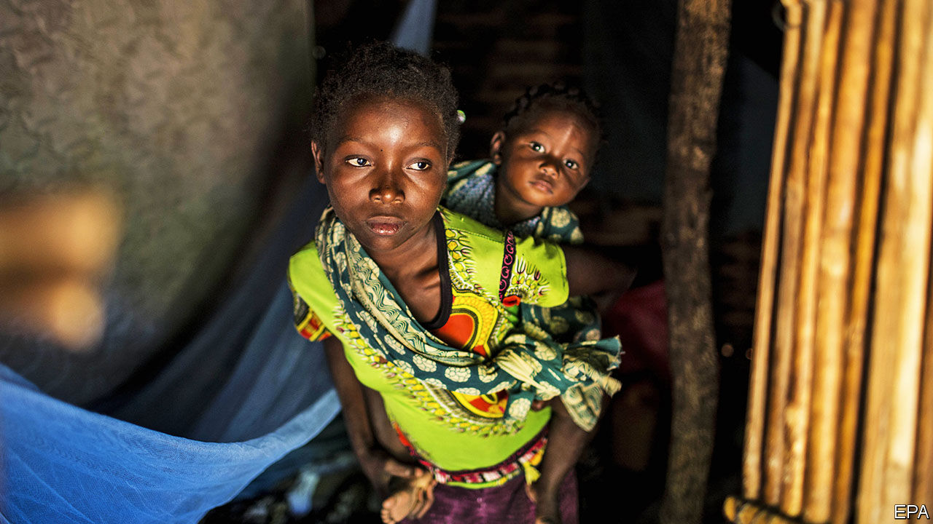

CABO DELGADO, the northernmost province of Mozambique, is known to some as cabo esquecido or “forgotten cape”. It has been an apt name. A Portuguese colony until 1975, Mozambique developed as two separate entities divided by the Zambezi river, explains Alex Vines of Chatham House, a think-tank in London. The north relied on agriculture and, along the coast, was influenced by Swahili culture. The south depended on South Africa and the gold trade. Many in Maputo have little grasp of what life is like in the poorer northern provinces. Mozambique’s capital is about 1,700km from Pemba, the capital of Cabo Delgado—farther than London is from Lisbon (see map).

But Cabo Delgado is no longer forgettable. A smouldering Islamist insurgency has set the province ablaze. There were almost as many attacks by the jihadists in the first half of 2020 as in all of 2019, which was bloodier than 2018, the first full year of the conflict. More than 1,500 people have been killed. At least 210,000 have had to leave their homes.

On August 5th the insurgents launched their latest assault on Mocímboa da Praia, a strategic port (and site of their first attack, in October 2017). They killed more than 50 soldiers in a single ambush and sank a small naval ship with a rocket-propelled grenade. On August 11th they took the port. The sophistication of the attack has raised concerns in Maputo and other capitals that the insurgency will spread to other parts of the country and perhaps beyond.

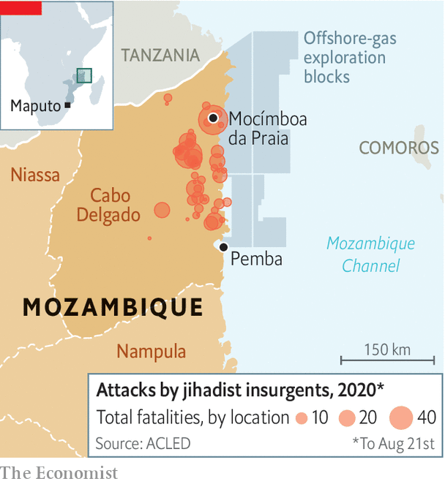

Much remains murky about the uprising. Ansar al-Sunna, the name analysts use to refer to the fighters, grew out of a sect that had grievances with local Sufi Muslims and links to extremists in east Africa. It recruits young people frustrated by the lack of opportunities in the licit or illicit economies. Few locals believe the discovery of huge amounts of natural gas off the coast of Cabo Delgado will benefit them, as opposed to the elites in and around the ruling party, FRELIMO.

In 2019 the insurgents were depicted in a video pledging allegiance to Islamic State (IS). The strength of the connection is debatable, however. The insurgents seldom refer to themselves as being members of IS. Their attacks tend to be on state institutions. They rarely issue propaganda and have no clearly stated aims. All of this suggests Ansar al-Sunna remains a mostly local affair. But it is launching more daring and complex operations.

At first the state dismissed the group as bandits. Now President Filipe Nyusi admits there is a problem, but his government is overwhelmed. Fighting within FRELIMO over the spoils of a war economy is intensifying. The country’s best soldiers are guarding facilities to liquefy and ship the gas. The rest are undertrained, underpaid and accused of human-rights abuses, which could worsen as the government begins to arm local militias. Most soldiers are not from Cabo Delgado and do not speak the local languages. Often they flee when insurgents attack.

So the government has turned to outsiders. Together they could be a cast of characters in a novel co-written by Tom Clancy and Wilbur Smith. First there was the aborted involvement of Erik Prince, who founded Blackwater, a controversial American security firm. Then, in 2019, came the Wagner Group, Russian mercenaries close to the Kremlin. It lost battles and retreated. In its wake came Dyck Advisory Group (DAG), a South Africa-based outfit led by Lionel Dyck, a former Rhodesian officer who became a commander in Robert Mugabe’s Zimbabwean army. Mr Dyck is admired in FRELIMO circles for leading an assault in Zimbabwe on the party’s arch-enemy, RENAMO, in 1985. Now DAG’s helicopters, with machineguns welded to the side, are trying to stop insurgent attacks.

Will neighbouring countries’ troops follow the mercenaries? After a (virtual) meeting of leaders of the Southern African Development Community on August 17th, the bloc released a statement saying that it would “support Mozambique in addressing the terrorism and violent attacks”. But Mozambique is reluctant to let nearby countries interfere too much. And the neighbours themselves are wary.

South Africa is said to have sent a small contingent of special forces to the province. This month it appointed Siphiwe Nyanda, a former chief of the South African Defence Force, as ambassador to Mozambique. It may adapt its navy’s operations in the Mozambique channel. Yet many within President Cyril Ramaphosa’s government are reluctant to get embroiled. Some worry about possible blowback from IS against South Africa.

Zimbabwe’s ruling party, Zanu-PF, is close to FRELIMO, but is distracted by its own imploding economy and infighting. Tanzania has belatedly increased security along its southern border. On August 12th the Mozambican government said that Tanzania had “deactivated” a group of insurgents trying to cross into Cabo Delgado. But for the most part John Magufuli, Tanzania’s president, has behaved as if Cabo Delgado is Mr Nyusi’s problem.

Non-African powers are increasingly worried, especially those with interests in gas. America has offered to help with military training but seems to have been rebuffed. France is scaling up its presence in Mozambique and rethinking how it uses its Indian Ocean islands of Mayotte and Réunion. Last year Total, a French firm, bought the stake held by Anadarko, an erstwhile American rival, in a liquefied natural gas (LNG) project in Mozambique. In July Total secured $15bn in loans for its operations there—the biggest project-finance deal in African history. On August 24th it was announced that the firm had finalised a “joint task-force” with the government to improve security for its LNG operations.

Mozambique’s strategy, if one can call it that, is to rely on piecemeal outside help to fight the insurgency while creating an armour-plated bubble around its LNG assets. That is a policy of “Iraqification”, says Jasmine Opperman of the Armed Conflict Location & Event Data Project, a non-profit organisation. There is no sign that the government is willing or able to tackle the conflict’s root causes, such as poverty and corruption. So a local fight is slowly becoming international. But the victims remain the people of Cabo Delgado. ■

This article was downloaded by calibre from <https://www.economist.com/middle-east-and-africa/2020/08/26/the-conflict-in-mozambique-is-getting-worse>

|  |  |  |  |
| --- | --- | --- | --- |
|  | Articles | Sections | Next |

|  |  |  |  |
| --- | --- | --- | --- |
| Previous | Articles | Sections | Next |

#### Cheques don’t check treks

# The idea that aid and development slow migration is wrong

Up to a point, they seem to have the opposite effect

Aug 29th 2020 |

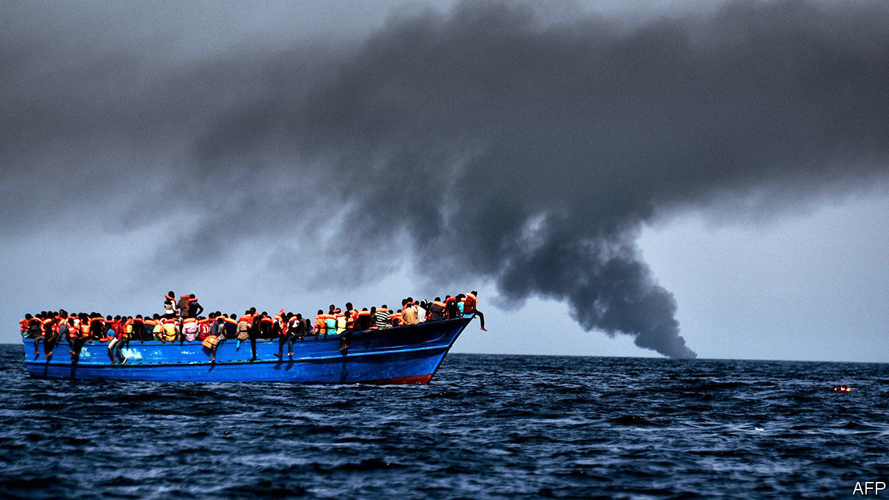

WHEN THE number of irregular migrants crossing into Europe spiked in 2015, policymakers scrambled to stem the flow. One of the more humane ideas they latched onto was an old one: to slow migration by targeting its “root causes”. Growth and opportunity at home, the thinking went, would dull people’s enthusiasm to up sticks. So the European Union set up a multi-billion-euro trust fund for Africa. And indeed, irregular migration to Europe, while still a big issue, has fallen considerably from its peak five years ago.

However, the extra aid probably had little to do with that drop. A handful of new studies suggest that neither aid nor economic development in poor countries reduces migration.

Start with the work of Paul Clist of the University of East Anglia and Gabriele Restelli of the University of Manchester, who looked at the relationship between the number of migrants trying informally to cross into Italy between 2003 and 2016 and the amount of aid Italy and others gave to the migrants’ home countries. They used statistical regressions to strip out the influence of other factors, such as conflict. Aid, they found, does very little to deter irregular migration—and sometimes does the opposite. For example, controlling for aid from elsewhere, Italy could expect to receive one new asylum-seeker for every $162,000 it doled out in bilateral aid. To actually deter a single migrant from a country like Iraq would cost $1.8m in aid, the authors found. Deterring migrants who come through official channels is even costlier, between $4m and $7m per head.

The notion that as people in poor countries get richer emigration decreases does not hold up either, according to Michael Clemens of the Centre for Global Development, a think-tank, and Mariapia Mendola of the University of Milan Bicocca. They found that people preparing to emigrate to rich countries earn, on average, 73% more than those staying put. The truly poor cannot afford plane tickets or fees to traffickers. Migration, says Mr Clemens, is like going to university: it is an investment that wealthier and better-educated families are more able and likely to make.

Migration, in fact, goes hand-in-hand with a country’s development. In another study Mr Clemens found that as poor countries grow richer their emigration rate rises. This trend continues until they have an annual income per head of about $10,000 (see chart). Income per head in sub-Saharan Africa is about a third of that.

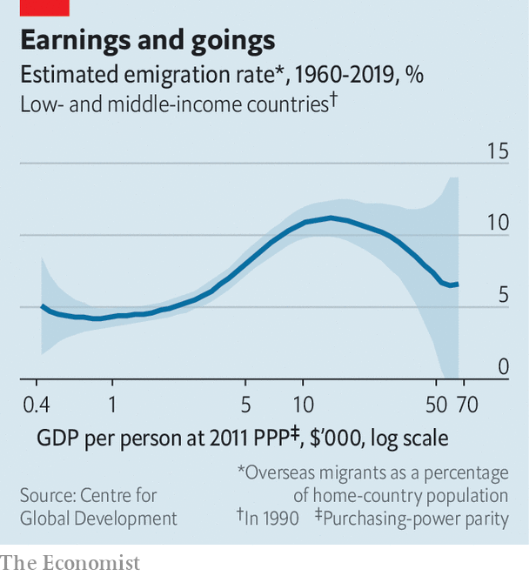

None of this means that aid to poor countries should be cut. Foreign assistance used sensibly improves health care and education, and reduces poverty. Those are worthwhile goals in their own right. Aid can also make countries more stable and reduce their vulnerability to conflict or disaster—perhaps lowering the chance of a future sudden surge of emigration. But spending on aid to stop migration is like buying a car for the cup-holders, says Mr Clist—it misses the point.

Rather than trying to create programmes to deter migrants, aid agencies could instead spend on schemes to channel them towards legal pathways, which tend to be safer, and which give the host country more control over who comes. The European Union says this is one of the four pillars of its approach and a focus of the trust fund. Yet a review by Oxfam, an NGO, found that just 1.5% of the fund is allocated to supporting legal-migration schemes.

The irony is that Europe needs migrants. Its working-age population is projected to decline by almost 30% by 2100. African migrants could help solve this problem. In any event, Europe will struggle to stem the flow. ■

This article was downloaded by calibre from <https://www.economist.com/middle-east-and-africa/2020/08/29/the-idea-that-aid-and-development-slow-migration-is-wrong>

|  |  |  |  |
| --- | --- | --- | --- |
| Previous | Articles | Sections | Next |

|  |  |  |  |
| --- | --- | --- | --- |
| Previous | Articles | Sections | Next |

#### Nollywood blues

# Nigeria’s film industry has taken a viral knock

But covid-19 may force it to sharpen up

Aug 29th 2020 |

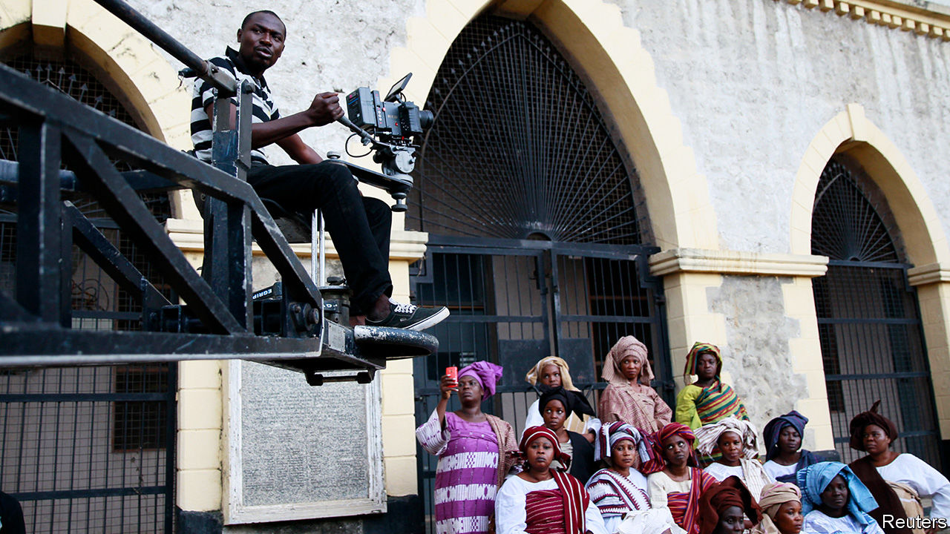

IN THE PAST two decades Nigeria’s film industry has blossomed into a mighty national asset. Its romances, family sagas and tales of derring-do are lapped up by many millions of viewers at home, across the rest of Africa and in the African diaspora. It employs more than a million people and generates nearly $2bn a year from cinema tickets and DVD sales, TV rights, royalties and fees. Lagos, Nigeria’s commercial capital and film hub, is said to produce more films than there are stars in the sky.

Films like “Ije”, “The Wedding Party” and “2 Weeks in Lagos” have premiered at the poshest international festivals, from Toronto to Cannes. Netflix has set up partnerships. In 2018 it released its first Nigerian film, “Lionheart”. In June it teamed up with EbonyLife Films, based in Lagos, to embark on a string of Netflix-branded projects. “Death and the King’s Horseman”, a play premiered in 1975 by Africa’s first Nobel laureate in literature, Wole Soyinka, is to be adapted for the screen.

But covid-19 has given Nollywood a nasty viral knock. Emem Isong, a leading producer, laments the obstacles facing her latest TV series, “City Crimes”. She was only two weeks into her six-week filming schedule when a government-imposed lockdown forced her to stop. When production resumed in June, she had to cut her crew in half, buy protective equipment and contactless thermometers, expand accommodation (the crew normally share rooms) and disinfect her locations. The production took much longer. Her budget jumped by a third. She sorely wishes she had taken out an insurance policy.

Yet the pandemic may nudge the industry to tackle some of its shortcomings and improve its chaotic infrastructure. “Maybe this will motivate people to get their own production lots where you can accommodate artists and put all safety measures in place,” says Shaibu Husseini, a veteran film critic. There is a dearth of good film studios. Moses Babatope, who founded Filmhouse Cinema and FilmOne, a distribution and production company, looks forward to many “better practices”.

For one thing, Nollywood would benefit from a national umbrella organisation, overseen by government, that would set standards and would have protected the industry better against covid-19. There are a good two dozen associations and guilds within the industry, but no unifying body like those in Hollywood. The Nigerian government recently set up an ad hoc committee, including actors and comedians, to co-operate against the pandemic. “The industry is so individualistic in its approach,” says Mr Husseini. “Nollywood needs a collective front.”

That is a challenge. Some of Nigeria’s 200 ethnic groups, especially the big ones, have their own film associations. Hausa-language cinema, based in the northern Nigerian state of Kano, has its own label: “Kannywood”. “There are so many sub-sections,” says Mr Babatope. “For too long the mentality has always been about being giants in our little corners, as opposed to collective, harmonious growth...As we get better, as we get more investments, as we get more attention, you’ll find out that the best practices will rub off on us.” ■

Editor’s note: Some of our covid-19 coverage is free for readers of The Economist Today, our daily [newsletter](https://my.economist.com/user#newsletter). For more stories and our pandemic tracker, see our [hub](https://www.economist.com/news/2020/03/11/the-economists-coverage-of-the-coronavirus)

This article was downloaded by calibre from <https://www.economist.com/middle-east-and-africa/2020/08/29/nigerias-film-industry-has-taken-a-viral-knock>

|  |  |  |  |
| --- | --- | --- | --- |
| Previous | Articles | Sections | Next |

|  |  |  |  |
| --- | --- | --- | --- |
| Previous | Articles | Sections | Next |

#### A glimpse of the seaside

# Israel lets the Palestinians go to the beach

But that may not ease their frustrations

Aug 29th 2020 | TEL AVIV

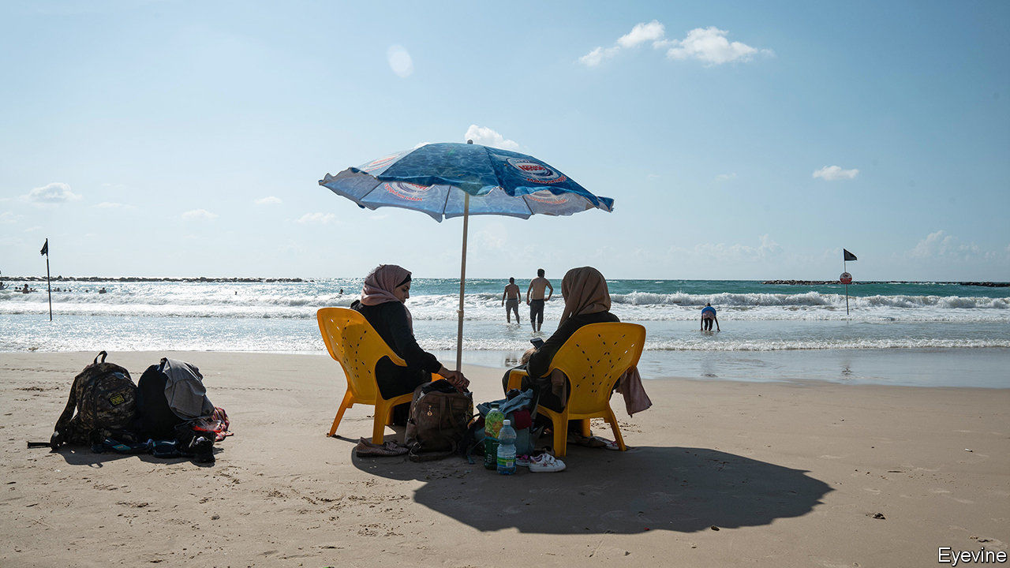

THERE ARE no lifeguards at the southernmost beach in Tel Aviv, just before the rocky promontory where Jaffa begins. That doesn’t bother Palestinian children paddling in the shallow water. Few of them can swim. Some don’t even own bathing costumes. But many are seeing the sea for the first time—enough to bring them great joy. After their parents dry them off, families may take a stroll around the central square in Jaffa. Then it is back to the landlocked West Bank.

Such scenes have played out several times this summer on beaches up and down Israel’s Mediterranean coast. Only about 70,000 Palestinians out of the roughly 3m who live in the West Bank have work permits that allow them to travel outside the territory, which is under partial Palestinian control. But on some Saturdays Israel’s security forces turn a blind eye to families slipping through gaps in the security barrier that surrounds most of the territory. On the other side of the fence, friends and family members who live in Israel or unofficial tour operators are waiting to whisk them to the beach.

Israel appears to be trying to ease some of the hardship for the Palestinians, who have had a rough year. Unemployment in the West Bank, already high, spiked as covid-19 forced the Palestinian Authority (PA) to lock down the economy. The virus also led Israel to issue fewer travel permits for the Eid holidays. Then came the news this month that the United Arab Emirates (UAE) had agreed to establish full diplomatic relations with Israel, becoming only the third Arab country to do so. Hanan Ashrawi, a prominent politician, echoed the feelings of many Palestinians when she said it was like being “sold out by your friends”.

The Palestinians look increasingly isolated. They cut ties with America in 2017, after President Donald Trump recognised Jerusalem as Israel’s capital; the Palestinians want to share it as the capital of a future state of their own. They recalled their ambassador to the UAE this month. Earlier in the year the PA said it would stop co-ordinating with Israel because of its plans to annex parts of the West Bank, which Israel’s prime minister, Binyamin Netanyahu, says are “still on the table”. But the truth is that the PA needs Israel’s help to fight covid-19 and keep Hamas, the violent Islamist movement that runs Gaza, at bay. So co-operation continues behind the scenes.

Gaza has beaches, but precious little else. The territory has been under blockade by Israel and Egypt since 2007, when Hamas seized power. The situation seemed about to improve earlier this year, when Israel lifted some restrictions and some infrastructure projects were planned. But the progress quickly stalled.

Lately Gaza has been stuck in a vicious cycle. It begins with Palestinian militants attacking Israeli towns along the border with rockets or balloons carrying incendiary devices. Israel hits back with air strikes on Hamas positions. The cycle ends when Israel allows an emissary from Qatar to enter Gaza with suitcases full of cash that is meant to alleviate the suffering. Now there are also growing fears of a coronavirus outbreak in the territory.

Israel is hoping that frustration in the West Bank does not similarly boil over; hence the lax border controls. But there are risks. Would-be attackers could exploit the lack of security checks. Busloads of beachgoers might spread coronavirus. And a day at the beach may not soothe everyone’s frustrations. “I used to work here renovating houses,” says Marwan Halawa, a Palestinian from Hebron. “Tel Aviv has changed a lot.” His friend Issa is less wistful: “This is a Palestinian beach, no matter what they say in Abu Dhabi.” ■

This article was downloaded by calibre from <https://www.economist.com/middle-east-and-africa/2020/08/29/israel-lets-the-palestinians-go-to-the-beach>

|  |  |  |  |
| --- | --- | --- | --- |
| Previous | Articles | Sections | Next |

|  |  |  |  |
| --- | --- | --- | --- |
| Previous | Articles | Sections | Next |

#### Bone of contention

# Are dogs acceptable pets, Muslim scholars ask?

Egypt’s Grand Mufti says they are. Others are dogmatically opposed

Aug 29th 2020 |

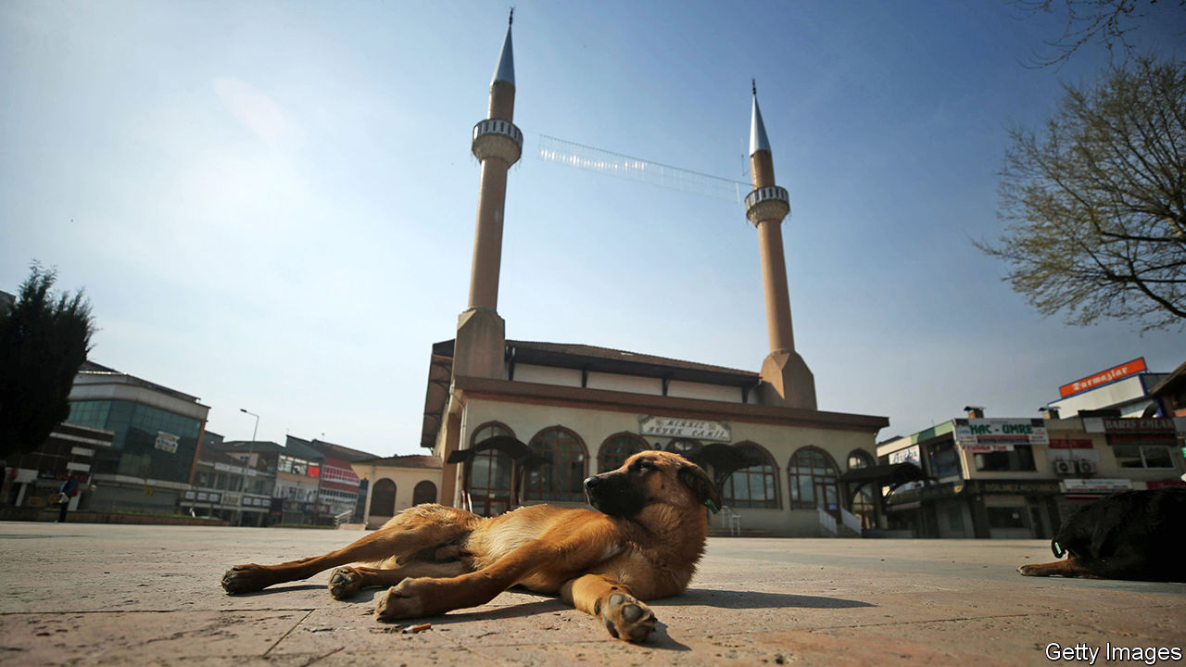

AMONG THE many controversies that divide Muslim thinkers, the status of dogs is a minor one. But every now and then the debate is renewed. Earlier this month Egypt’s grand mufti, Shawki Allam, weighed in on the side of man’s best friend. Whereas some interpretations of Islam deem dogs impure, Mr Allam says: “It is possible to coexist with a dog and still worship God.” Citing the Maliki school of Islam, he claims that every living animal is pure.

Conservative clerics are not rolling over, though. They cite certain hadith (sayings of the Prophet Muhammad) to support their dogmatically anti-dog position. Angels will not enter a house if there is a dog present, says one. Another warns that a Muslim keeping a dog will lose out on some of the spiritual rewards from his good deeds. Yet there are caveats. Angels don’t seem to mind if the dog is outside. And dogs used for herding, hunting, farming and guarding appear to be exempt from the rules.

Perhaps the most contentious issue is a dog’s saliva. “Cleanse your vase which the dog licked by washing it seven times and the first is with earth (soil),” goes another hadith. But Mr Allam says that if you perform wudu (ablution) and a dog licks you, there is no need to rewash before praying. What about dog fur? Many scholars think it is clean and, therefore, petting is okay. But fierce debate ensues if the fur is wet.

The Koran itself says little about dogs. Scholars claim that the Prophet prayed among canines. A few years ago Osama al-Azhari, a religious adviser to Egypt’s president, Abdel-Fattah al-Sisi, was photographed shaking the paw of a dog. Conservatives growled. But Mr Azhari pointed to the story of the Seven Sleepers: a group of young men who hide in a cave to escape religious persecution. They take a 300-year nap while their dog, stretched out at the entrance of the cave, keeps watch. (Conservatives note that the animal was not in the cave.)

The current debate in Egypt may be more about power than pups. Mr Sisi wants to assert more control over Islam via Dar al-Ifta, the state’s Islamic advisory body led by Mr Allam, and at the expense of al-Azhar, a conservative seat of learning. Lately Dar al-Ifta has espoused relatively progressive views in order to win over the public. Mr Allam’s ruling on dogs was preceded by a condemnation of sexual harassment. In general, Mr Allam says he wants to make it easier for Muslims to practise their faith.

Islam is hardly the only religion to feature confusing and contradictory texts—or to have mixed feelings about canines. Dogs are often used as a symbol of evil in the Bible. They are also portrayed negatively in the Talmud. To many Muslims, the whole debate is a mastiff waste of time. Last year Iran tried to ban people from walking dogs in public. But the restriction had little bite, and many Iranians ignored it. More and more Egyptians appear to be keeping dogs as pets. Cats are also popular companions. Admired in Islam for their cleanliness, there is no debate about them.

This article was downloaded by calibre from <https://www.economist.com/middle-east-and-africa/2020/08/29/are-dogs-acceptable-pets-muslim-scholars-ask>

|  |  |  |  |
| --- | --- | --- | --- |
| Previous | Articles | Sections | Next |

|  |  |  |
| --- | --- | --- |
| Middle East & Africa | Sections | Britain |

Europe

Germany’s refugee influx: Did they handle it?

.

Green-fingered Bulgarians: Constant gardeners

.

Montenegro’s election: Not very Christian

.

French higher education: Saclay sacré

.

Charlemagne: The Pampers index

.

|  |  |  |
| --- | --- | --- |
| Middle East & Africa | Sections | Britain |

|  |  |  |  |
| --- | --- | --- | --- |
|  | Articles | Sections | Next |

#### Did they handle it?

# Five years after arrival, Germany’s refugees are integrating

But those whose claims are rejected are stuck in legal limbo

Aug 25th 2020 | BERLIN AND GÖTTINGEN

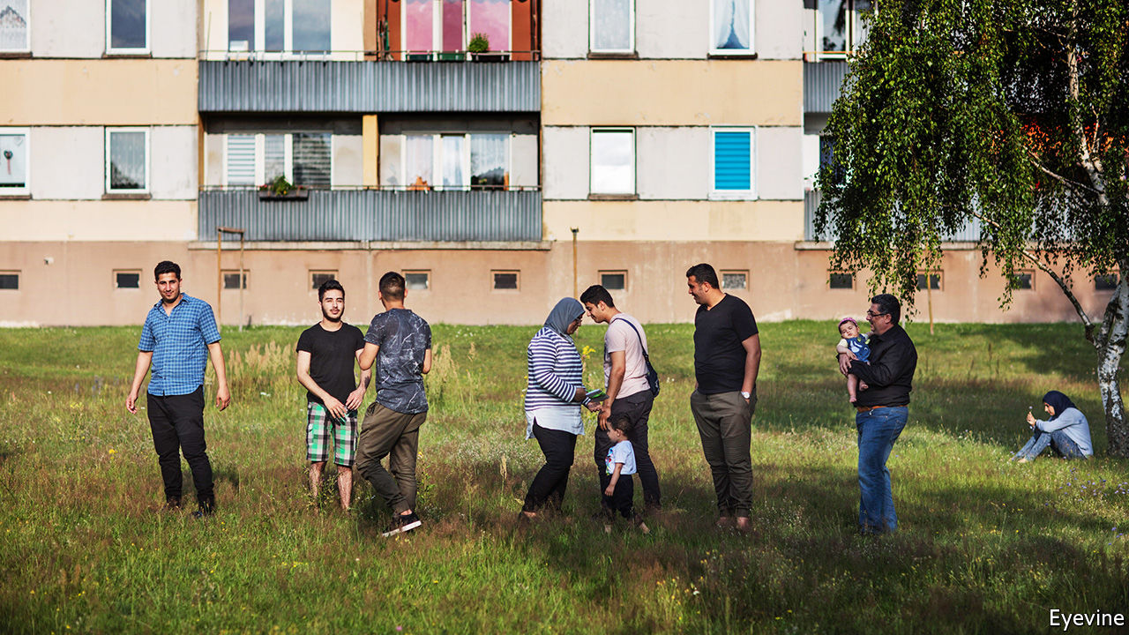

ASKED WHAT he makes of his new home, Safwan Daher, a Syrian refugee, chuckles: Duderstadt, a town near Göttingen that few Germans could find on a map, is “boring”. No matter. Mr Daher has an enjoyable computer-programming job that pays for a flat with three bedrooms. He keeps one empty, hoping his parents will leave Syria and join him. In his spare time he hangs out with his brother, a student at Göttingen University. The next step is German citizenship, for which he has just applied.

Karam Kabbani, an activist who fled Aleppo after Bashar al-Assad’s thugs tortured him, has had a rougher time. Nervously chain-smoking, he describes an anguished five years bouncing from one agency to another, forced to take dead-end jobs, with no help offered for his psychological scars. He plans to leave Germany when he can. “Germans are very closed people,” he says. “No one wants to help.”

On August 31st 2015, with a growing number of asylum-seekers reaching Germany, Angela Merkel declared: “Wir schaffen das” (roughly, “We can handle this”). A few days later the chancellor opened the borders to migrants stranded in Budapest, amplifying the wave: perhaps 1.2m reached Germany before Balkan border closures and a deal with Turkey in 2016 stemmed the flow. Initially Germany handled the migrants well. Yet five years on, its experience of integrating them has been mixed.

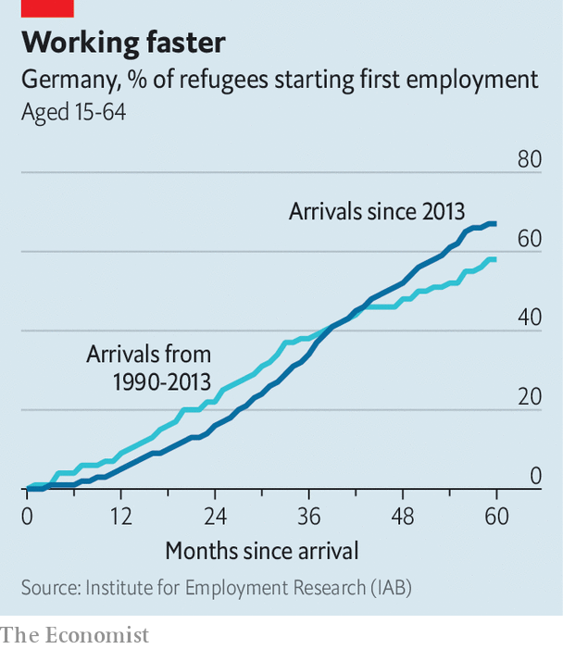

Start with jobs. In 2015 an influx of mainly young migrants looked a neat fit for German firms facing an ageing labour force. Daimler’s boss foresaw an “economic miracle”. Rules were eased for asylum-seekers looking for jobs, and the government pushed 1.1m through integration and language courses. By 2018 43% of the working-age asylum-seekers who arrived between 2013 and 2016 were in work or training (compared with over 75% for the same age group in Germany as a whole)—better than the wave of refugees from Yugoslavia in the 1990s. (A stronger labour market helped.) Jobs came slowly at first, but accelerated as people emerged from integration courses, which hints at better to come. “These numbers are not perfect, but they are hopeful,” says Marlene Thiele, who runs a project at the German Chamber of Commerce to help firms hire refugees.

The headline figure conceals some awkward details. Barely half the refugees in Germany’s labour force today work in skilled jobs, although over 80% did in their home countries, calculates Herbert Brücker at the Institute for Employment Research, the research arm of the Federal Employment Agency. Many wash dishes in restaurants or make beds in hotels, with few prospects for advancement (and a high chance of covid-related layoffs). Women in particular have struggled, especially those from cultures that think their place is in the home. Many newcomers, especially from countries like Eritrea and Iraq, were functionally illiterate when they arrived and are still years away from entering the job market. Control for age, and average migrant earnings are around two-thirds the native German level.

Migrants were dispersed all over Germany; most live outside cities. That was a test for Germany’s decentralised government, which gives lots of power to local officials. (“In Berlin integration is just an abstract question,” grumbles Rolf-Georg Köhler, Göttingen’s mayor.) A study of 92 municipalities funded by the Robert Bosch Foundation found that many were quite adaptable, for example launching their own language courses while waiting for the bureaucratic wheels to turn in Berlin. Civil society was crucial. Mr Köhler credits the local sport association with speeding integration: the language of football is universal. Over half of Germany’s population has worked in some way with refugees. “We can activate a whole network if we need to,” says Bettina Briesemeister, who runs a refugee housing centre in Göttingen.

The flip side is confusion and inefficiency. Officials are sometimes unclear which layer of government is responsible for a policy, and states and municipalities swap ideas surprisingly rarely. More than 600 under-resourced “foreigners’ offices” are responsible for matters like work permits and deportations. The bureaucratic maze is disconcerting. “Ask any refugee what they fear most, and it’s the letterbox,” says Mr Kabbani: it invariably contains demands, appointments or warnings from official bodies they have never heard of.

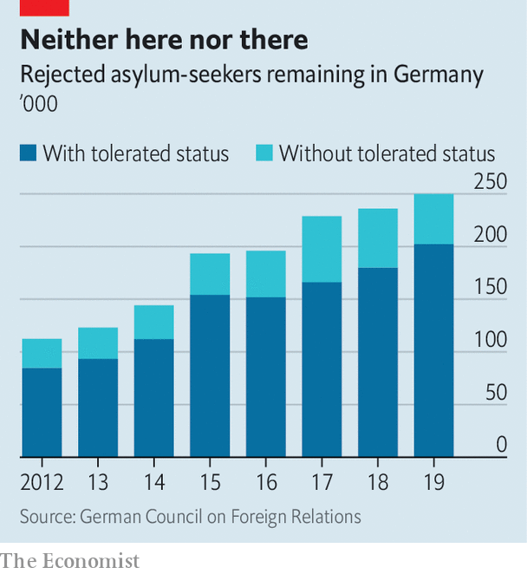

Like many European countries Germany has struggled to deport failed asylum-seekers. More than 200,000 people have been granted Duldung (“tolerated”) status, meaning they have no right to be in the country but do not face immediate deportation. Perhaps a further 50,000 have no legal status. To stop them from slipping into idleness or worse, under new rules some may work or take on apprenticeships. But insecurity persists. One such rejected asylum-seeker, Mohammad Walizada, an Afghan who had worked with an American de-mining firm in Kabul, now has a legal job in a phone shop on Sylt, a North Sea island. But he has given up on his goal of getting a doctorate in Germany. “I have no hopes, it’s just survival,” he says.

“There is a huge difference in integration outcomes between people that receive protection and those that are in Duldung or rejected,” says Victoria Rietig of the German Council on Foreign Relations. Just 3% of those with Duldung status can move freely throughout Germany, which is no help when looking for a job. And because Germany has no birthright citizenship rule, their children are usually given the same status, and risk being deported to a country they have never known. “It’s this population we should be worried about,” says Ms Rietig. Germany seems afraid both of enforcing its rules and of making it too easy for failed asylum-seekers to find alternative ways into German society. As the numbers grow, the dilemma worsens.

Yet the country remains paralysed by the political battles of five years ago. The migrant crisis jolted the radical-right Alternative for Germany into third place at the 2017 election. A poll last year found a majority of Germans thought the country should accept no more refugees. These days the borders are quieter and the issue has gone off the boil, but fresh waves of migrants from Europe’s troubled neighbourhood can hardly be ruled out. “Mama” Merkel, as she is known to many refugees, long ago abandoned her “Wir schaffen das” mantra for a more paradoxical claim: that her decision to leave the borders open was correct, and must never be repeated.

Ahmad Denno, a well-integrated Syrian who is completing a degree in Berlin, identifies three types of German: those who treat him normally; racists who want him to leave; and those for whom he is permanently on probation. Asked if he could ever feel at home here, he shrugs. “For some, I could never be German. For others, I already am. I don’t feel like an outsider here. I’m just looking for a normal, safe life.” ■

This article was downloaded by calibre from <https://www.economist.com/europe/2020/08/25/five-years-after-arrival-germanys-refugees-are-integrating>

|  |  |  |  |
| --- | --- | --- | --- |
|  | Articles | Sections | Next |

|  |  |  |  |
| --- | --- | --- | --- |
| Previous | Articles | Sections | Next |

#### International plotters

# Bulgarians have been Europe’s gardeners longer than you think

Doing Europeans’ dirty work ever since the Ottoman Empire

Aug 29th 2020 |

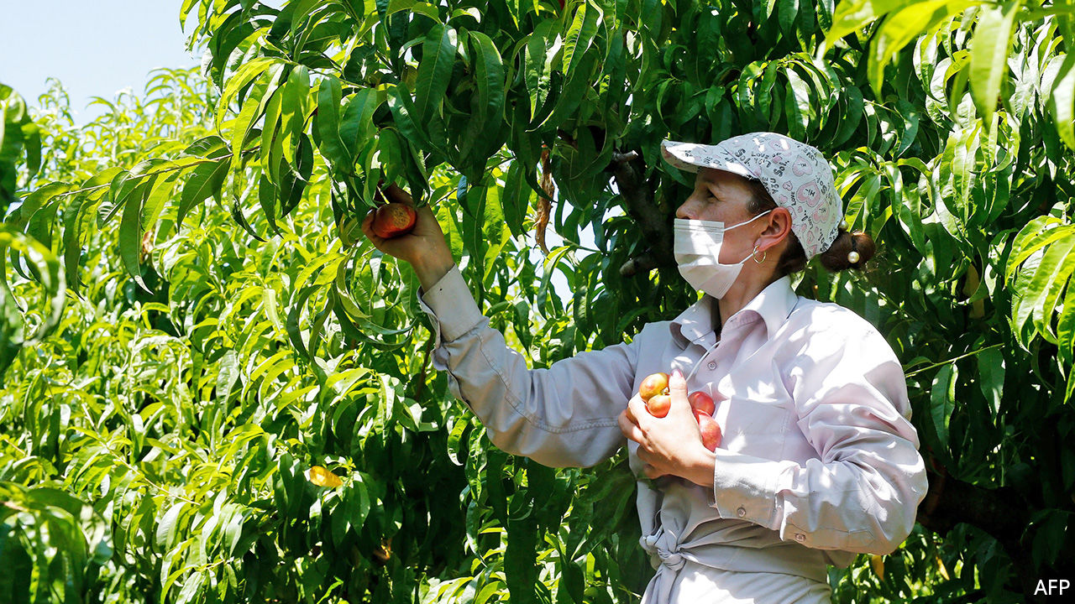

IF YOU ARE enjoying a succulent piece of fresh fruit in Europe this summer, the chance is high that you have a Bulgarian to thank for it. Every year tens of thousands of workers from the eastern Balkan country fan out to pick, pluck, dig and water on farms in Britain, Germany, Italy, Spain and elsewhere. When covid-19 shut borders this spring, western European farmers panicked, and governments rapidly surrendered to their demands to let the Bulgarians in.

Most Europeans assume this migration began after the cold war, when Bulgaria freed itself from Soviet domination. In fact, says Marijana Jakimova, a historian, it dates back to the late 17th century. The Ottoman empire, which then ruled the Balkans, employed Bulgarians to accompany its troops and grow vegetables for them. The Ottomans’ invasion of central Europe was beaten back at Vienna in 1683, but their Bulgarian camp-followers began a lasting tie to the region’s agriculture.

In the late 19th century, as Vienna and other Austro-Hungarian cities boomed, Bulgarians set up market gardens on their outskirts. In 1918 Austria-Hungary collapsed but, anxious to keep Vienna fed, the Austrians granted privileges to their Bulgarian gardeners. The interwar years were a golden age for them. They left home in spring to work in Austria, Czechoslovakia and elsewhere, and returned home as the nights grew long.

A gloomier chapter of the story began in 1938, when Adolf Hitler signed an agreement with Bulgaria to send farm workers to the Third Reich. During the war thousands more came to replace Germans sent to the front. After 1945, many of those who returned to newly communist Bulgaria were executed as collaborators. But others settled as refugees in Austria’s Burgenland, establishing farms which supply Viennese markets to this day.

The communist decades were actually a hiatus in this Bulgarian tradition of seasonal work abroad. (It even has a name in Bulgarian: gurbet.) After 1989 Bulgarians resumed the practice, at first illegally in Spain and Italy, later with work permits, and finally without hindrance after their country joined the EU in 2007. These days Bulgaria itself faces labour shortages, and wages are shooting up. Still, picking peppers at home earns only the national minimum wage: €1.87 ($2.21) per hour. The hourly wage for harvesting asparagus in Germany is €9.35. Long live gurbet.

This article was downloaded by calibre from <https://www.economist.com/europe/2020/08/29/bulgarians-have-been-europes-gardeners-longer-than-you-think>

|  |  |  |  |
| --- | --- | --- | --- |
| Previous | Articles | Sections | Next |

|  |  |  |  |
| --- | --- | --- | --- |
| Previous | Articles | Sections | Next |

#### Not very Christian

# Serbian Orthodox priests say Montenegro's government backs satanists

This election President Milo Djukanovic’s campaign is more bitter than usual

Aug 29th 2020 |



MONTENEGRO IS ONE of those countries whose landscape—glittering mountain peaks, azure seas—is every bit as magnificent as it looks in tourist brochures. The campaign for its general election on August 30th, however, has been ugly. The government’s supporters accuse the main opposition coalition of being “clerical fascists”. The opposition call on voters not to back “unbelievers”. How things came to this pass requires a bit of explanation.

President Milo Djukanovic has ruled Montenegro since 1989, whether as president, prime minister or head of the ruling party. His party will probably win this time too. But things have not been entirely placid. In 2016 the government said it had foiled an election-day coup plot led by opposition leaders and backed by Russia. This year Mr Djukanovic has been rattled by recurrent protests, which draw tens of thousands of people waving Serbian flags and led by priests. You might think Montenegrins would be upset about the economy: tourism generates a fifth of GDP, which may shrink by 9% this year because of covid-19. Indeed, many protesters are fed up with poor government services, corruption, nepotism and other ills. But rather than addressing such concerns, the big parties are arguing about religion.

Last December the government passed a law stipulating that unless religious groups can prove their title to property owned before 1918, when Montenegro became part of the new country of Yugoslavia, it belongs to the state. Priests of the Serbian Orthodox Church, the country’s main denomination, accuse the government of attacking religious freedom and promoting a “satanic cult”, by which they mean the small Montenegrin Orthodox Church, which they say Mr Djukanovic favours. Whether or not the new law is a land grab, says Kenneth Morrison, a historian, the dispute has become a struggle for the country’s political soul.

About 75% of Montenegrins are Serbian Orthodox, and since 1918 the issue of whether they should simply be considered Serbs (and hence whether their state should be part of Serbia) has waxed and waned. Now it has returned in a different form. Serbian nationalists have begun talking of the “Serbian world”, much as Russian nationalists call their area of influence the “Russian world”. This does not necessarily mean that Montenegro and ethnic-Serb parts of Bosnia and Kosovo should be fused with Serbia, but that they should stay firmly in its sphere of influence.

Montenegro’s opposition is divided between those who fly Serbian flags and those who don’t. When protesters chant “Montenegro, Serbia—one family”, they remind Bosniaks (Muslims by heritage), Albanians and Croats, who together are 18% of the population, that as much as they may not like Mr Djukanovic, they dislike Serbian nationalism even more. This, with added vote-buying and fraud, has made a democratic transfer of power in Montenegro rather theoretical. No government has ever changed hands in an election. ■

This article was downloaded by calibre from <https://www.economist.com/europe/2020/08/29/serbian-orthodox-priests-say-montenegros-government-backs-satanists>

|  |  |  |  |
| --- | --- | --- | --- |
| Previous | Articles | Sections | Next |

|  |  |  |  |
| --- | --- | --- | --- |
| Previous | Articles | Sections | Next |

#### Saclay sacré

# How France created a university to rival MIT

After years of pooh-poohing global college rankings

Aug 29th 2020 | PARIS

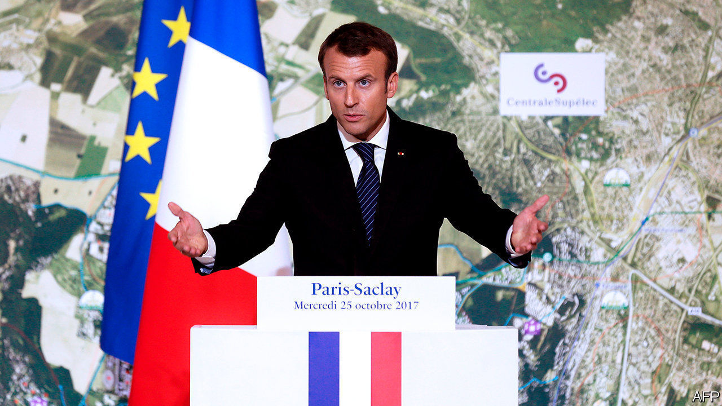

A HUGE MODERNIST university campus is emerging amid farmland on a plateau south of the French capital. The University of Paris-Saclay, officially launched this year, merges some 20 higher-education and research institutions. It has a teaching and research staff of 9,000, catering to 48,000 students—more than Harvard or Stanford. Specialised in science, it is France’s attempt to create, in President Emmanuel Macron’s words, an “MIT à la française”. Such ambition once seemed fanciful. Yet in August Paris-Saclay stormed into the Shanghai world university ranking, grabbing 14th place overall and 3rd in Europe after Cambridge and Oxford. It took the top international spot in maths.

France’s two-tier higher-education system baffles outsiders. Three-fifths of its 2.7m students are enrolled in universities. These are public. Until recently they did not select undergraduates at entry; they charge no tuition bar a small enrolment fee, and are often sneered at as second-rate. An elite minority, meanwhile, attend selective grandes écoles, for which entrance exams require at least two years of post-secondary-school cramming. To confuse matters further, research is traditionally carried out not in universities or grandes écoles but in specialised public institutes.

Over the years, this unusual structure has led to much French frustration about foreign perceptions. The country has world-class engineering schools, economics departments and mathematicians. After America, France has more Fields medal-winners for maths than any other country. Yet its fragmented system—partly down to the deliberate splitting of big universities after the 1968 student protests—has left it under-performing in world rankings and lacking global star appeal. In 2007 Valérie Pécresse, then the universities minister, began to give them more independence in order to encourage collaboration and scale. An international jury was invited to award big public budgets to promising merger projects. Over a decade later, these new giant rebranded universities, including Paris-Saclay, are the result.

Like all mergers, forming Paris-Saclay entailed years of squabbling. Originally, Polytechnique, France’s top engineering grande école, was to join. But it feared losing its reputation for excellence if engulfed by a much bigger university. Researchers from all member institutions had to agree to publish under the new name in order to achieve scale and renown. As bickering continued, a national audit concluded in early 2017 that the entire merger project was “deadlocked”. Later that year the newly elected Mr Macron stepped in, realising that the new university would have to go ahead without Polytechnique. Its ensuing success, says Laurent Bigorgne, director of the Institut Montaigne, a think-tank, “is almost the revenge of the universities over the grandes écoles.”

Sylvie Retailleau, president of Paris-Saclay, points out that those grandes écoles and niche scientific-research institutes that did join have in fact retained a separate identity, a bit like faculty departments. “Respect for diversity is our strength,” she says, even if it will take time to get used to a new dual identity and gain recognition from the Parisian elite with its powerful alumni networks. In the meantime, Paris-Saclay is enjoying its moment. A decade ago, French educationalists would lecture outsiders on how meaningless world rankings were for their higher education. Now the French have begun to crack the system, and are praising the result.■

This article was downloaded by calibre from <https://www.economist.com/europe/2020/08/29/how-france-created-a-university-to-rival-mit>

|  |  |  |  |
| --- | --- | --- | --- |
| Previous | Articles | Sections | Next |

|  |  |  |  |
| --- | --- | --- | --- |
| Previous | Articles | Sections | Next |

#### Charlemagne

# The Pampers index: what nappy prices reveal about Europe

Huge disparities show the boast of a single market is full of it

Aug 29th 2020 |

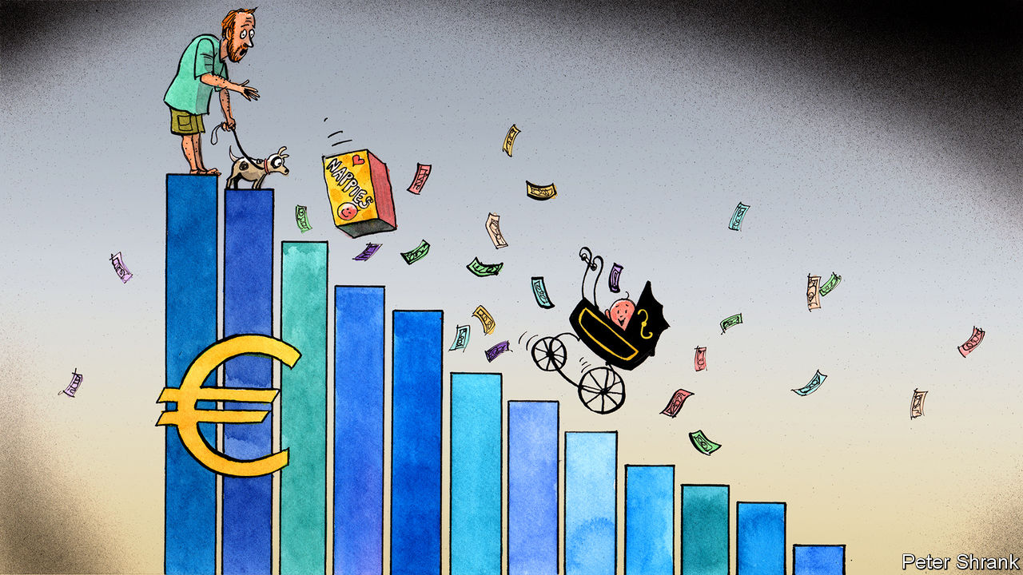

THE PARENTS of a screaming new-born baby typically have no time to spare. But if they live in Europe, they should spend a few minutes shopping around for nappies. Three enormous boxes of Pampers come to €168 ($198) on Amazon’s Spanish website. By contrast, the same order from Amazon’s British website costs only €74. (Even after an exorbitant delivery fee is added, the saving is still €42.) If sleep-deprived parents are too groggy to work out how much they could save in a year, they could pep themselves up with a new coffee machine. The swankiest Nespresso model will set them back €460 on Amazon’s French website, but can be snapped up for €301 on the German version. They could then boast about their canny shopping on Samsung’s newest phone, which varies in price by up to €300 depending on which domain is used.

The EU may have a single market, but its products do not have single prices. In an integrated market, prices are supposed to come together over time. Yet this process has stalled in the EU. Prices for exactly the same products still diverge, often starkly and even among rich countries. It is a long-term trend: prices stopped moving together in 2008. Big steps of integration such as the introduction of the euro, which drew them closer together, are now rare. Wages in eastern Europe are not growing as rapidly as they were. Services, which are often hard to trade across borders, make up a greater proportion of the EU economy. Mollycoddled companies still dominate some industries. It is common to see someone stocking up on painkillers in the Netherlands, where they can be bought in any supermarket, before hopping on a train to Belgium, where pharmacies enjoy a monopoly and a mark-up.

Some price differences are inevitable. A store in central Paris will charge more for the same goods than one in a hypermarket on the edge of a medium-size town. Sometimes price divergence is necessary in a bloc that contains both Germany (GDP per head of €39,130) and Bulgaria (€8,237). And given that retail is still dominated by brick-and-mortar stores and their websites, markets remain stubbornly national even online. The upshot? One study showed that online prices varied by 20% for items like electronics and up to 40% for clothing between EU countries.

Yet for nappies, a tradeable good which can be bought online anywhere in Europe, the persistence of big price gaps is especially odd. Prices per nappy range from €0.11 to €0.61 within the bloc, according to one survey. The Economist uses the price of a Big Mac to compare currencies around the world. Something similar could work with the single market. Call it the Pampers index: a rough measure that shows which EU citizens are paying over the odds.

Arbitraging these differences away is not simple. Borders matter in trade and they still exist in the EU. Cross a state border in America and not much changes, for most businesses; cross a border in the EU and they face a new legal regime in a foreign language, with a different consumer culture. Nor is it an easy process for consumers. It is one thing to fire up Google Translate to read a news article, quite another to double-check what zur kasse gehen means in the middle of a €1,000 purchase. America is far more integrated, sigh EU officials. As a result, big online retailers like Amazon offer a shopper in Alabama the same price as one in California.

Delivery charges within the EU are often steep, as any discriminating Spanish parent will soon find. Getting products from where they are cheap to where they are expensive is often painfully slow or prohibitively costly, particularly if they are bulky, like nappies. It is worse in small countries. (Your correspondent once lugged the entire discography of the Rolling Stones, on vinyl, from London to Brussels so that a friend from a Baltic state could avoid a €110 charge.) Nor is there much motivation for suppliers to fix the problem. Sellers are unenthusiastic about products from low-price markets leaking into high-price ones.

The EU has taken some action. It is now illegal for websites to block consumers from other countries without good reason. This came after EU officials picked a fight with Disney, when it emerged that Disneyland Paris stopped customers outside France from getting the cheapest deals. And the union has created a database of delivery-company charges, hoping sellers will use it to drive prices down. Such interventions seem to be having an effect. In 2010, barely one in ten EU citizens bought something from a website in a different country; in 2018, 28% did. But the union could do more. Indeed, rather than making it easier for lorries to zip across borders, the EU recently tightened its rules to placate western European countries which complained that national labour rules were being undercut. Eastern European countries cried protectionism.

## A superpower . . . with super savings!

During a crisis, concerns about lopsided prices can seem petty. The EU is suffering the deepest recession in its history. The pandemic has revealed major flaws in its structure, and fixing them takes priority. But the EU has always been a mix of big things (continental peace) and small things (cheap flights). Lately the union’s geopolitical ambitions seem to take up more of its leaders’ time than the mundane business of cross-border trade. The single market should not become a forgotten child of European integration. Sometimes pricey Pampers are as important as high politics.

Consumers have to do their bit, too. The EU is sometimes criticised for being a top-down institution, confusing voters with grand projects they do not necessarily want. Change can come from other directions. Each country has its own version of the “booze cruise”, a British term for piling into France to buy cheap wine. Luxembourgers head to German supermarkets for better prices. Swedes nip over to Norway to stock up on cheap nappies. Doing so online is much easier, yet most people still do not bother. Online arbitrage could become an unlikely engine of European integration. But it would be up to citizens. As with nappies, some things must start at the bottom. ■

This article was downloaded by calibre from <https://www.economist.com/europe/2020/08/29/the-pampers-index-what-nappy-prices-reveal-about-europe>

|  |  |  |  |
| --- | --- | --- | --- |
| Previous | Articles | Sections | Next |

|  |  |  |
| --- | --- | --- |
| Europe | Sections | International |

Britain

Housing: Generation rent grows up

.

Fading Sinophilia: Flying dragon, passing fashion

.

The Labour Party: Middle-class hero

.

Politics and music: Last fight of the Proms

.

The hospitality business: Turning the tables

.

Books: The old stories

.

School uniforms: The new school tie

.

Bagehot: Learning German

.

|  |  |  |
| --- | --- | --- |
| Europe | Sections | International |

|  |  |  |  |
| --- | --- | --- | --- |
|  | Articles | Sections | Next |

#### Housing

# Generation rent grows up

The shift in housing tenure towards renting creates a problem that Conservatives find hard to handle

Aug 29th 2020 |

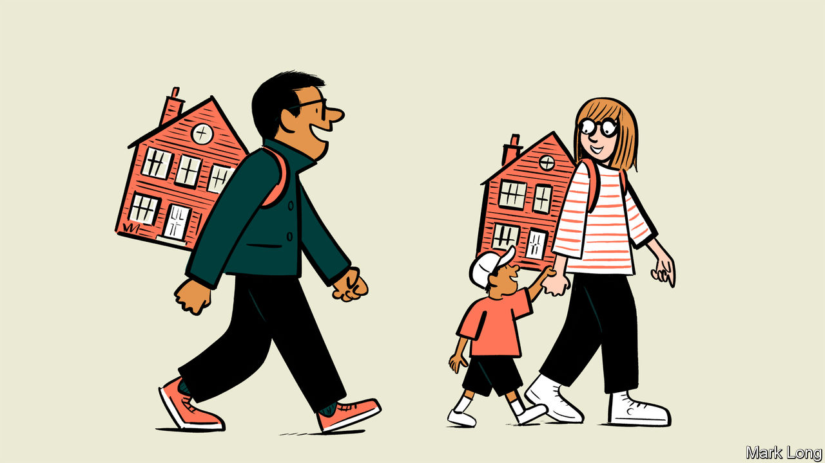

“IDEALLY,” WROTE George Orwell in “The Road to Wigan Pier”, his account of pre-war poverty, “the worst type of slum landlord is a fat wicked man, preferably a bishop, who is drawing an immense income from extortionate rents. Actually, it is a poor old woman who has invested her life’s savings in three slum houses, inhabits one of them, and tries to live on the rent of the other two—never, in consequence, having any money for repairs.”

When Orwell was writing, almost 60% of Britons rented their homes from private landlords. After the second world war the private rental sector (PRS) shrank to insignificance, thanks to the rise of social housing and the subsequent liberalisation of mortgage lending. But rising house prices and the need for a substantial deposit have reversed the trend (see chart).

As renting has grown, renters have changed. Back in the mid-1990s around one in 20 families with children lived in the PRS. Now more than one in five do. More than half of all private renters are now over 35. A form of tenure once confined to urban centres and university cities has spread to the suburbs and small towns. Some of the fastest growth in the five years to 2017, the most recent period with reliable data, came in places such as Purbeck and Hertsmere.

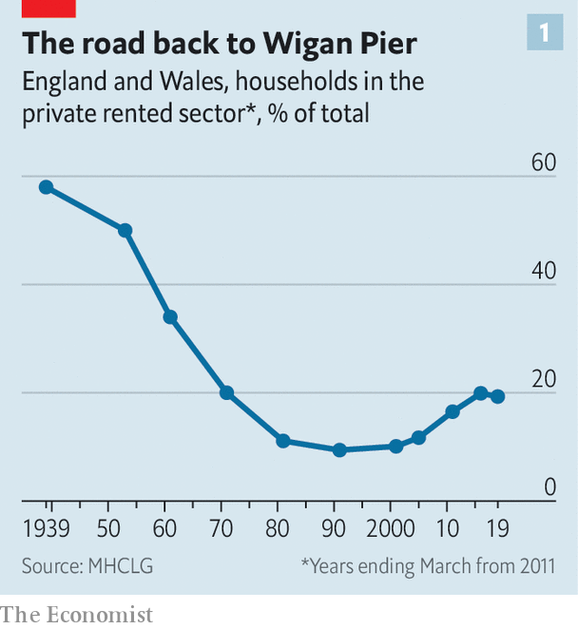

That presents the Conservative Party with a problem. Since Lord Salisbury espoused “villa Toryism” in the 1880s, it has been the party of home-ownership. Margaret Thatcher gave this purpose new vim by selling off social housing. The notion that home ownership makes people conservative, by giving them a stake in the social order, is embedded deep in the Tory soul. But economics and politics both argue for measures that favour renting. A large rental sector encourages mobility and thus helps promote growth. At the same time, today’s renters are the kind of people whose votes the government wants.

That long-term conundrum is overshadowed by the acute problem that the crisis has created. Housing charities estimate that some 200,000 private tenants have slipped into rent arrears over the past six months. In the early days of the pandemic, the government put in place a temporary ban on evictions from rental properties that was due to expire on August 24th. Three days beforehand, it extended the moratorium for another four weeks.

This hand-to-mouth decision-making suggests that the government is struggling to deal with the problem. That’s partly because Britain has not only a lot of tenants nowadays but also a lot of landlords. While one in five English households rents privately, more than one in ten households own more than one property. Most landlords let fewer than five properties. For most, their rental property is a substitute for a pension or a supplement to one. They tend to be the older, better-off voters who make up the bedrock of Boris Johnson’s political coalition—the contemporary equivalent of Orwell’s old ladies.

But landlords are outnumbered by tenants, many of them families, whom British housing policy has taken little trouble to accommodate. Labour governments have focused on social housing, Conservative ones on home-ownership. Renting is treated as a waiting room in which future homeowners spend some of their 20s before knowing the joys of being responsible for their own boiler. Tenants’ groups complain of a host of issues—repairs badly or tardily done, the common ban on keeping pets—that make it hard for renters to treat their accommodation as a home. With money cheap, the cost of a buying has fallen compared to renting (see chart), but rising deposit requirements put a purchase beyond most renters’ means.

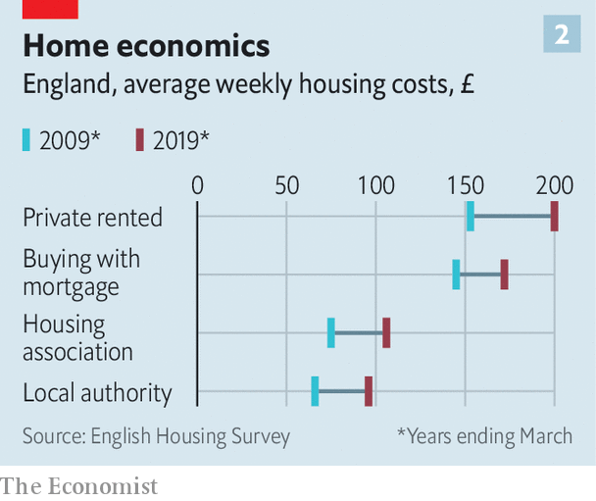

The big issue is security of tenure. The norm in England—the issue is devolved, so Scotland and Wales have gone their own ways—is a 12-month lease with no obligation to renew. Most continental European countries offer much more security. Germany, for instance, gives tenants who behave themselves an indefinite right to remain in their homes.

Opponents of greater security for tenants argue that it would decrease the supply of properties as landlords would worry about not being able to get them back. Proponents argue that the opposite would happen: longer leases would attract families seeking security and give institutions the security they seek, thus encouraging investment in the sector. There are few such investors in Britain, which is why the market remains dominated by Orwell’s old ladies. Countries with the largest rental sectors tend to be those which also offer greater security of tenure.

England’s near-neighbours are moving in a continental direction. Tenancies were made more secure in Wales in 2016, Scotland went for German-style open-ended tenancies in 2017 and Ireland substantially extended eviction notice periods in 2019. In England, the government has pledged to remove “section 21” evictions, under which a landlord can evict a tenant without giving a reason, but has done nothing about it. Even if it does, rolling year-long leases would remain the norm.

Offering tenants more security would put the Conservative Party at odds with its property-owning supporters, and also with its worldview. As the 2019 manifesto said, home ownership is “one of the most fundamental Conservative values”. The Tories’ answer is to increase the supply of homes—or “build, build, build”, as Mr Johnson’s new slogan puts it—to allow more people to buy. Previous Conservative governments have tried that, and been frustrated by their nimby supporters.

The Tories’ blinkered vision of housing tenure offers Labour an opportunity. In 2019 Labour embraced Scottish-style open-ended tenancies but combined that with rent controls which, history shows, destroy rental markets. The political space for a sensible offer to tenants in England lies open. In these uncertain times, the promise of more security to a fifth of the country could win Labour plenty of friends.■

This article was downloaded by calibre from <https://www.economist.com/britain/2020/08/29/generation-rent-grows-up>

|  |  |  |  |
| --- | --- | --- | --- |
|  | Articles | Sections | Next |

|  |  |  |  |
| --- | --- | --- | --- |
| Previous | Articles | Sections | Next |

#### Learning languages

# Why studying Chinese is in decline

Mandarin is out of fashion

Aug 29th 2020 |

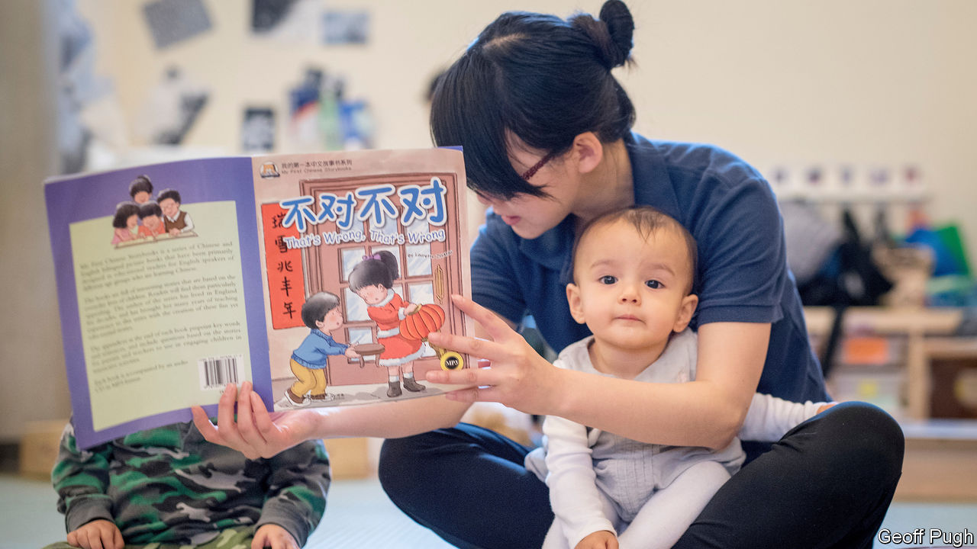

“I LOVE CHINA,” declared Boris Johnson, then mayor of London, in 2013, exhorting British children, his own included, to study Mandarin. Seven years on, he is a lot less keen on China, and the vogue for studying Mandarin seems to be fading.

When Mr Johnson was declaring his Sinophilia, well-to-do parents saw Mandarin as a good investment in their children’s future. In 2015 Hatching Dragons (pictured), Britain’s first bilingual English-Mandarin nursery, opened its doors to 32 little linguists; it has since taught over 500 children, for around £1,881 a month per child. But Cennydd John, the nursery’s chief executive, laments that there is “almost no option” for children to continue their bilingual education once they leave at the age of five. Fewer than 3% of primary schools in England offer Mandarin.

Many independent schools followed the fashion: 24% of them offer Mandarin, compared with 4.4% in state schools. But finding a school that offers Mandarin is no longer the priority it was for parents three years ago, says Ralph Lucas, editor in chief of The Good Schools Guide. Part of the reason is that “the perception of China as a place where you would want your child to make a career has taken a severe knock”. Learning Mandarin to a useful level is difficult, and China “doesn’t seem like the big golden opportunity it was before”. Recent events, such as the crackdown on democracy in Hong Kong, further “take the gloss off” the idea of investing in a Chinese education.

That shift shows up in exam figures. In 2015, 3,099 students took a Chinese A-level and 3,710 took a GCSE. In 2019 those figures had dropped to 2,272 for A-level and 3,201 for GCSE, according to the Joint Council for Qualifications, an organisation which represents the eight largest national providers of qualifications.

Advocates of learning Mandarin say that a more complex geopolitical situation is exactly why children should be practising their tones. But those who have invested the hours (and the cash) don’t always reap the rewards. “The only real advantage of me speaking Chinese was having a much better understanding of how difficult it was for my Chinese colleagues to operate in English,” says Alex Wilson, who worked in public relations in Beijing and Shanghai. Graduates from the School of Oriental and African Studies can expect to be earning £27,000 five years after graduating if they studied Chinese, or £38,000 if they studied economics. Yun Zhen is studying for a Masters in Education at the University of Reading and hopes to be a Mandarin teacher. But “honestly, I don’t see many opportunities,” she says. Now she’s looking for teaching experience in “any subject”.

The difficulty of learning Mandarin will always attract academic kids and pushy parents. Mr John of Hatching Dragons notes that parents increasingly “see bilingual immersion for its cognitive benefits. For them, Chinese is (almost) secondary to the linguistic input”. The idea that Mandarin itself is a hot ticket is fading. Better to train the children in a computer-programming language. “Compared to how much more employable you can make yourself by learning something like Python, which you can learn in a few months,” according to Mr Wilson, “Mandarin seems like an inefficient use of resources.”■

This article was downloaded by calibre from <https://www.economist.com/britain/2020/08/29/why-studying-chinese-is-in-decline>

|  |  |  |  |
| --- | --- | --- | --- |
| Previous | Articles | Sections | Next |

|  |  |  |  |
| --- | --- | --- | --- |
| Previous | Articles | Sections | Next |

#### The Labour Party

# Keir Starmer, middle-class hero

The Labour Party leader is a hit in the Tories’ backyard

Aug 29th 2020 |

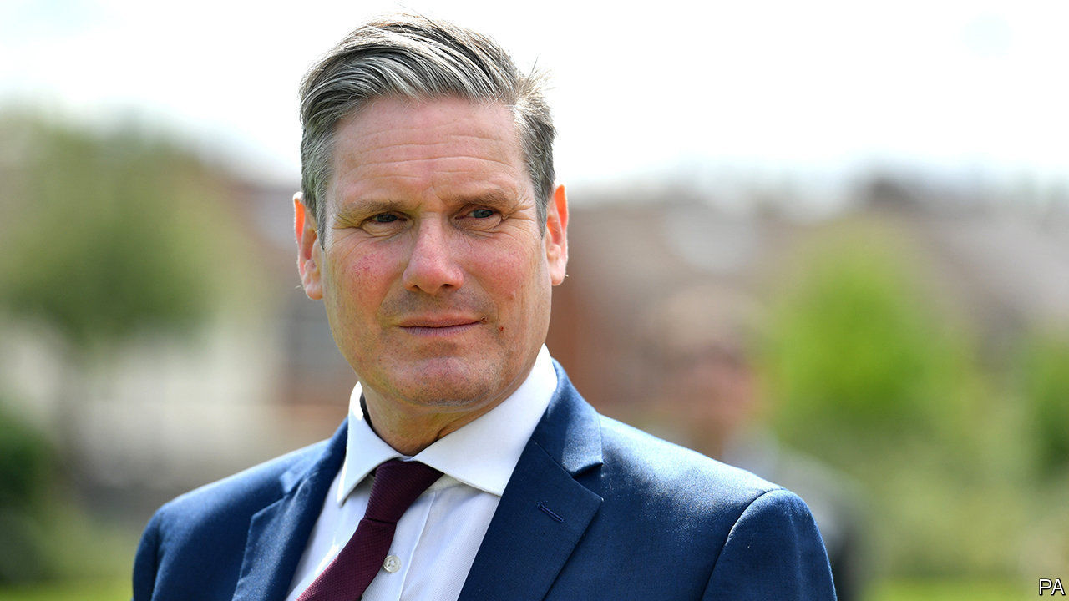

“KEIR IS AN absolutely fantastic fit for here,” says Andrew Western. It’s a striking claim, for Altrincham and Sale West, a constituency south of Manchester, is not natural terrain for the Labour Party. Sir Graham Brady, a Tory bigwig, has represented the medieval market town since 1997, and his party hasn’t lost since 1924. The area is home to footballers, their wives and their actor pals, and bristles with charming restaurants, hair salons and Scandi furniture shops. It has some of the country’s best GCSE results and the lowest levels of deprivation, and house prices to match. Little wonder that the Sunday Times, the newspaper of the skiing-and-sourdough classes, recently crowned it the best place to live in Britain.

Yet the ground is slowly shifting. Labour took control of the council last year. Sir Graham’s majority fell from more than 13,000 in 2015 to 6,139 in 2019. Mr Western, the Labour candidate, lost, but his vote held up and he was spared the abuse that greeted his colleagues in nearby towns as the party’s supporters revolted against Jeremy Corbyn. “It was a lovely campaign.” One reason for his warm reception was Brexit, which Sir Graham supported, but 62% of local voters opposed. Another was an influx of liberally-minded media workers and architects to neighbourhoods once home to firemen and gasfitters, a byproduct of Manchester’s boom.

It’s trendy in the Tory Party to sniff at the middle classes. The Daily Telegraph denounces the “callous metropolitan bourgeoisie” with a gusto more familiar to the Morning Star. But Britain has lots of them, and they like Sir Keir Starmer, a former human-rights barrister. Labour is supported by 45% of managerial and professional voters likely to turn out, and 30% of low-skilled manual workers (known as “ABs” and “DEs” in the jargon), according to a recent survey by Ipsos MORI, a pollster. The Tories have 35% and 48% of those groups respectively. Graduates are much more likely to approve of Sir Keir, while those without qualifications like Mr Johnson.

Labour has been gentrifying for a long time, but it has accelerated under Sir Keir. Tony Blair’s victory in 1997 is often regarded as a conquest of the middle classes, yet he won 59% of the DEs to 31% of the ABs. In the last election, Labour won a bigger share of DE than AB voters, while the Conservatives won more of both than Labour did.

Jeremy Corbyn lost in part because the anti-Brexit camp fragmented. Sir Keir is winning Remainers back, with four in ten of those who voted Liberal Democrat last year now backing Labour. One arm of Sir Keir’s coalition, says Paul Hilder, the head of Datapraxis, an electoral research firm, may be what he identifies as “older establishment liberals”—middle-aged professionals who like the EU and David Cameron, and couldn’t stomach Jeremy Corbyn.

Altrincham poses a conundrum for the Labour Party: whether to embrace the change or fight against it. Labour needs to gain 120 seats to win the next election. In 67 of them, including former industrial towns such as Bury, Redcar and Bolton, it has been losing support to the Tories since 2015, notes Alan Wager of King’s College London. Yet in 53 others—places like Altrincham, Wycombe and Chingford—it has been inching forward on the backs of graduates, renters and professionals.

Sir Keir’s allies say he must focus on winning back the former, and reverse the realignment that put Mr Johnson in power, because speaking for industrial towns is the party’s historic mission. There are too few seats like Altrincham to form a path to government, they argue.

But the grand realignment could continue. Mr Johnson may tighten his grip on Bolton, while Brexit and a culture war alienate the liberal, well-heeled commuter towns which have long voted Tory. Mr Western doubts that his party would throw its energy into unseating Sir Graham when there are seats like Leigh nearby to win back from the Tories. But he says, “in 15 or 20 years, this is a genuine bellwether.” ■

This article was downloaded by calibre from <https://www.economist.com/britain/2020/08/29/keir-starmer-middle-class-hero>

|  |  |  |  |
| --- | --- | --- | --- |
| Previous | Articles | Sections | Next |

|  |  |  |  |
| --- | --- | --- | --- |
| Previous | Articles | Sections | Next |

#### Last fight of the Proms

# Britons never, never, never shall be free of the culture wars

An inconsequential but convenient fight for the government

Aug 26th 2020 |

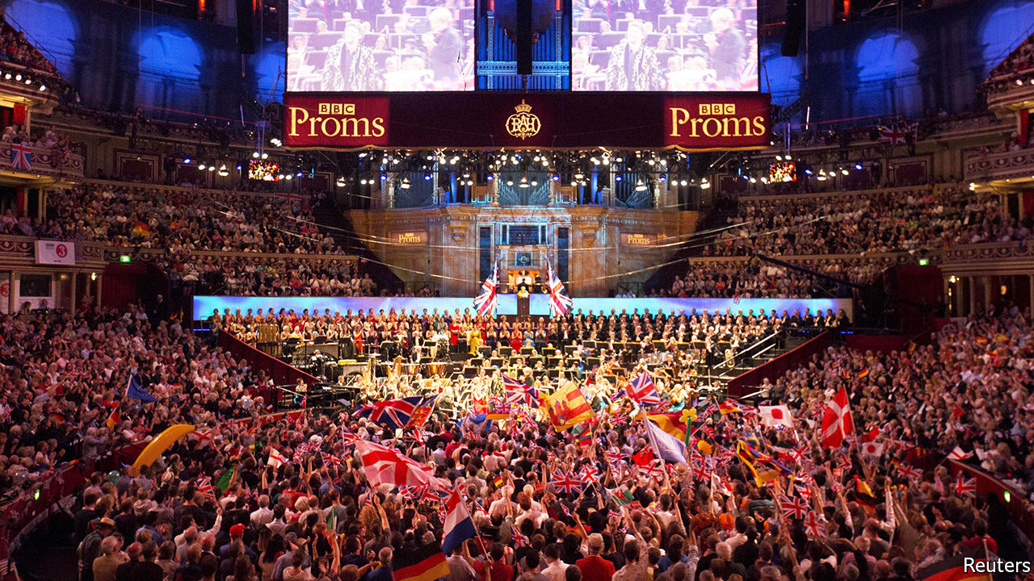

“SURRENDER!” thundered the Daily Mail, outraged by the decision of the BBC to drop two patriotic songs, “Rule, Britannia!” and “Land of Hope and Glory”, from the running order of the Last Night of the Proms, the September 12th finale of an annual series of broadcast concerts. Orchestral versions will be played, and the BBC, which was said to have deemed the anthems racist, maintains that the words are being dropped only because covid-19 means there will be no audience to belt the numbers out. Yet a choir will sing some of the other pieces, and there is a certain wokeness elsewhere in the programme. “Jerusalem” is to have a new arrangement referencing other countries of the Commonwealth; its composer, Errollyn Wallen, has dedicated it to the “Windrush generation” of Caribbean migrants caught in a bureaucratic foul-up.

The BBC, which next week gets a new director-general, Tim Davie, wants to attract younger, more diverse audiences. The average BBC1 viewer is over 60. Younger people, who spend more time watching YouTube than television, balk at paying the £157.50 ($208) annual TV licence fee. But the Proms is an odd place to woo them. Only 8% of people think the songs in question should be dropped, and 9% that they should be performed without lyrics, according to YouGov. Those people will probably not tune in.

There are misunderstandings on both sides of the argument. Traditionalists exaggerate the Proms’ pedigree. Though the concerts began in 1895, the party atmosphere of the Last Night, with its boisterous crowds and Union Jacks, began only after it was regularly televised in the 1950s. Reformers have some things wrong too. “Rule, Britannia!”, which sounds like 19th-century triumphalism, dates from 1740. “The song was an exhortation to naval greatness, rather than a celebration of it,” writes Sir David Cannadine, a historian (hence Britannia “rule”, not “rules”, the waves).

This week’s skirmish, which has distracted from the government’s various covid-19-related foul-ups, is the best thing that has happened to Boris Johnson for some months. With the economy battered by the virus and facing a no-deal Brexit in January, it makes sense to focus on culture. Mr Johnson, who had a career writing liberal-baiting Daily Telegraph columns before he was prime minister, is particularly good at it.

But Labour under Sir Keir Starmer is not the sitting duck that it was when led by Jeremy Corbyn, who appeared uncomfortable even singing the national anthem. This week the party affirmed that “the pomp and pageantry of the Last Night of the Proms is a staple of British summer”. The memo did not, apparently, reach Neil Coyle, one of the party’s MPs. “These fat old racists won’t stop blaming the EU when their sh*t hits the fan. Here they come blaming others,” he tweeted of the BBC’s critics.

This article was downloaded by calibre from <https://www.economist.com/britain/2020/08/26/britons-never-never-never-shall-be-free-of-the-culture-wars>

|  |  |  |  |
| --- | --- | --- | --- |
| Previous | Articles | Sections | Next |

|  |  |  |  |
| --- | --- | --- | --- |
| Previous | Articles | Sections | Next |

#### Turning the tables

# The worst is yet to come for Britain’s food-and-drink industry

“Eat out to help out” was a huge success. But restaurants and pubs still face a difficult autumn

Aug 29th 2020 |

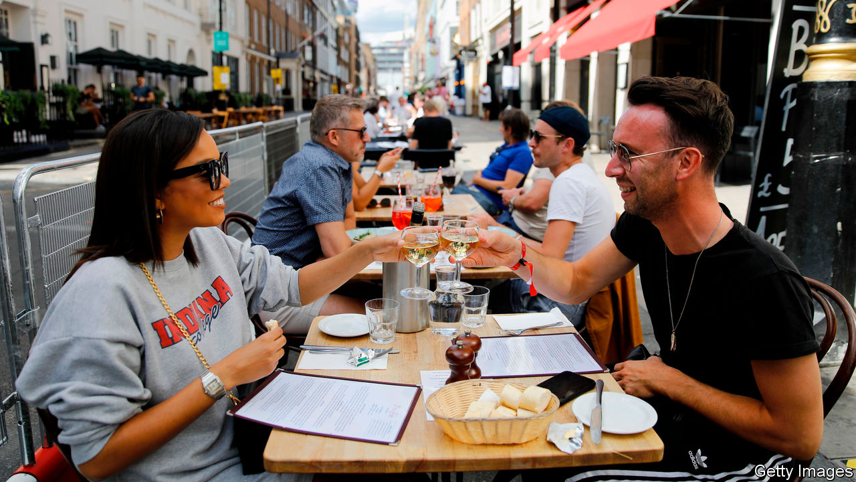

DECADES FROM now when the grandchildren of the covid generation ask, wide-eyed, “What did you do during the great pandemic of 2020?” the wizened elders will pause to reflect on hardships past and they will answer: “I did my bit for the country. I ate a lot of steak-frites.”

Brits have taken to “eat out to help out”, a government scheme which offers a 50% discount on restaurant meals—up to £10 ($13) per person, from Mondays to Wednesdays in August—with an enthusiasm exceeding even the wildest expectations of the hospitality industry. On the scheme’s first day food sales were up by 100% over the previous Monday, according to CGA, a hospitality industry researcher. Some 64m meals were consumed at 84,000 venues over the first nine days, at a cost of £336m to the exchequer.

Yet the key achievement of the scheme is not that it has driven Britons into pubs and restaurants on discount days, but that it reintroduced Brits to the practice of eating out. The cash incentive was a boost, but the psychological effect was more important. “What people have been saying in surveys is if the chancellor is giving you a discount, it’s the right thing to do,” says Kate Nicholls of UK Hospitality, an industry body. Nearly 40% of those who used the scheme had come out for the first time since venues reopened on July 4th. Once people returned, they were reassured that it was safe to do so again.

Moreover, fears that weekend business would be displaced to earlier in the week proved unfounded. Bookings have grown consistently. Undiscounted meal bookings have picked up too (see chart). That suggests trade will not return to its pre-scheme doldrums once “eat out” comes to an end on August 31st. In the week to August 25th, according to OpenTable’s data, bookings in Britain were up by 31% year-on-year, compared with 21% in Germany, which handled the pandemic well, and a drop of 49% in America, which did not.

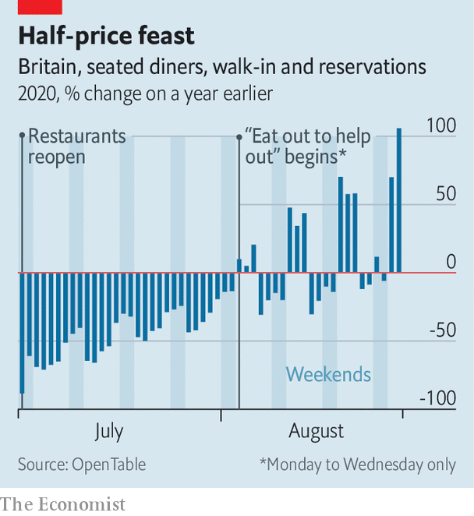

Yet the hospitality industry faces a series of challenges starting in September. The first is rent. Most hospitality venues pay rent in advance on a quarterly basis. Many have had their rent reduced or deferred. But many will have to cough up nine months of rent at the end of September. That is likely to cause a wave of bankruptcies in the sector.

For those that get through the rent crunch, October will bring colder weather and fewer customers. And current government rules allow members of up to six households to gather outdoors, but only groups of two households to meet indoors.

That is in addition to ongoing worries. Social distancing measures have reduced capacity at most venues. Nine in ten hospitality businesses are operating at 80% or less; half are operating at 50% or less. City-centres remain deserted, wreaking havoc on venues that rely on commuters and office-workers. According to Nick Mackenzie, the boss of Greene King, a brewer that also runs some 2,700 pubs, trading is down by an average of 20% overall, rising to 65% in central London and 80% in the City of London.

Another headache is data protection: most venues are taking customers’ details to help the government’s test-and-trace efforts, but some are doing it sloppily, for example by leaving an open register on the counter than anyone can photograph. Still, the industry has been fortunate that no big new outbreaks have been traced to pubs or restaurants. Consumer confidence, like the industry’s recovery, is a fragile thing.■

Editor’s note: Some of our covid-19 coverage is free for readers of The Economist Today, our daily [newsletter](https://my.economist.com/user#newsletter). For more stories and our pandemic tracker, see our [hub](https://www.economist.com/news/2020/03/11/the-economists-coverage-of-the-coronavirus)

This article was downloaded by calibre from <https://www.economist.com/britain/2020/08/29/the-worst-is-yet-to-come-for-britains-food-and-drink-industry>

|  |  |  |  |
| --- | --- | --- | --- |
| Previous | Articles | Sections | Next |

|  |  |  |  |
| --- | --- | --- | --- |
| Previous | Articles | Sections | Next |

#### Books

# Reading, especially of the classics, is booming

The old stories are the best

Aug 29th 2020 |

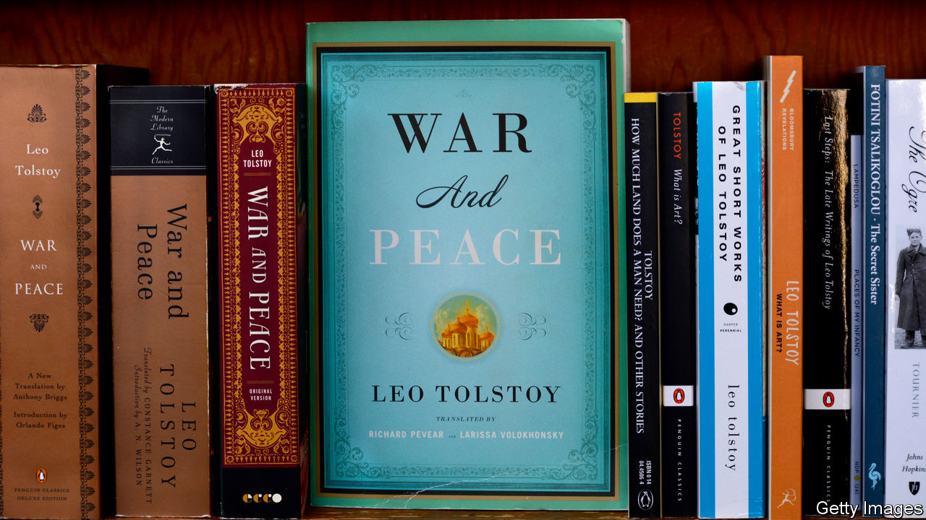

A NORTH LONDON book club, which includes a top civil servant, a senior Bank of England official and one of the country’s best-known publishers, normally picks the latest novels to dissect. But when lockdown began in late March its six members decided to take on “Madame Bovary”, Gustave Flaubert’s masterwork about the danger of getting carried away by social and romantic ambition. The shift in the book club’s tastes was a reaction to the anxious zeitgeist, says one of its members. “We wanted a book that had stood the test of time. Something rock solid.”

This book club was not alone in turning to the classics in times of crisis. The British almost doubled the time they spent reading books, from around three-and-a-half hours a week, according to Nielsen, a research firm, to six during lockdown, and with bookshops closed and publishing schedules interrupted, many people found themselves browsing their shelves and opening volumes they already owned but had never got round to reading. There was much talk of poetry, and of immersion in the Russian greats.

These new habits seem to have stuck. A fortnight after lockdown ended, over a third of people said they were reading more than before lockdown, while a tenth said they were reading less. Almost 2.2m books—a year-on-year increase of 9%—were sold in Britain in the eight weeks to August 15th.

Sales of the classics soared. Everyman, which specialises in reprints of classic titles, says that its sales in July were up by 31% year-on-year. “In uncertain times, people want…wisdom, the ancients, the great sages,” according to David Campbell, the firm’s publisher. “And the classics are the greatest books ever written.” Economic turmoil may also have contributed to healthy sales. “Recessions are very good for publishing. People don’t go out and buy a new car or go on a fancy holiday. So they do something else with their leisure time. Books are very cheap, and they’re a huge source of solace and pleasure.”

Weighty tomes are doing particularly well. After Marcus Aurelius’s “Meditations”, Everyman’s bestselling titles are a two-volume edition of Tolstoy’s stories, then 1,400 pages of Montaigne. Faber & Faber reports that its most popular title in lockdown, after Sally Rooney’s “Normal People”, was “A Fine Balance”, Rohinton Mistry’s 600-page Indian epic set in a city by the sea, published in 1995.

Taking advantage of the popularity of the classics, HarperCollins is planning to relaunch “Master and Commander”, Patrick O’Brian’s series of 20 novels set against the backdrop of the Napoleonic war, the first of which was published 50 years ago. The new campaign, shaped by the fiction market’s increasing tilt towards women, will present them not as naval adventures for boys but as social commentary about friendship, loyalty, love and confinement: less the offspring of Horatio Hornblower, more Jane Austen at sea.

But a crisis that has proved a boon for older titles may be a curse for new ones. Many publishers delayed publication of books they had originally planned for the summer—especially debut novels, which need the complex ecology of bookshops, reviews and festival events to get noticed. The result is a crowded autumn. Almost 600 books are due to come out on September 3rd, the unofficial start of the British publishing season. Competition among first-time novelists will be particularly fierce. The longlist for the Booker Prize for Fiction includes eight debut novels—the largest number ever. Those that do not benefit from that sort of leg-up will struggle to get attention. ■

This article was downloaded by calibre from <https://www.economist.com/britain/2020/08/29/reading-especially-of-the-classics-is-booming>

|  |  |  |  |
| --- | --- | --- | --- |
| Previous | Articles | Sections | Next |

|  |  |  |  |
| --- | --- | --- | --- |
| Previous | Articles | Sections | Next |

#### Schoolwear and politics

# Bringing down the cost of school uniforms

Schools love a posh uniform; parents and politicians less so

Aug 29th 2020 |

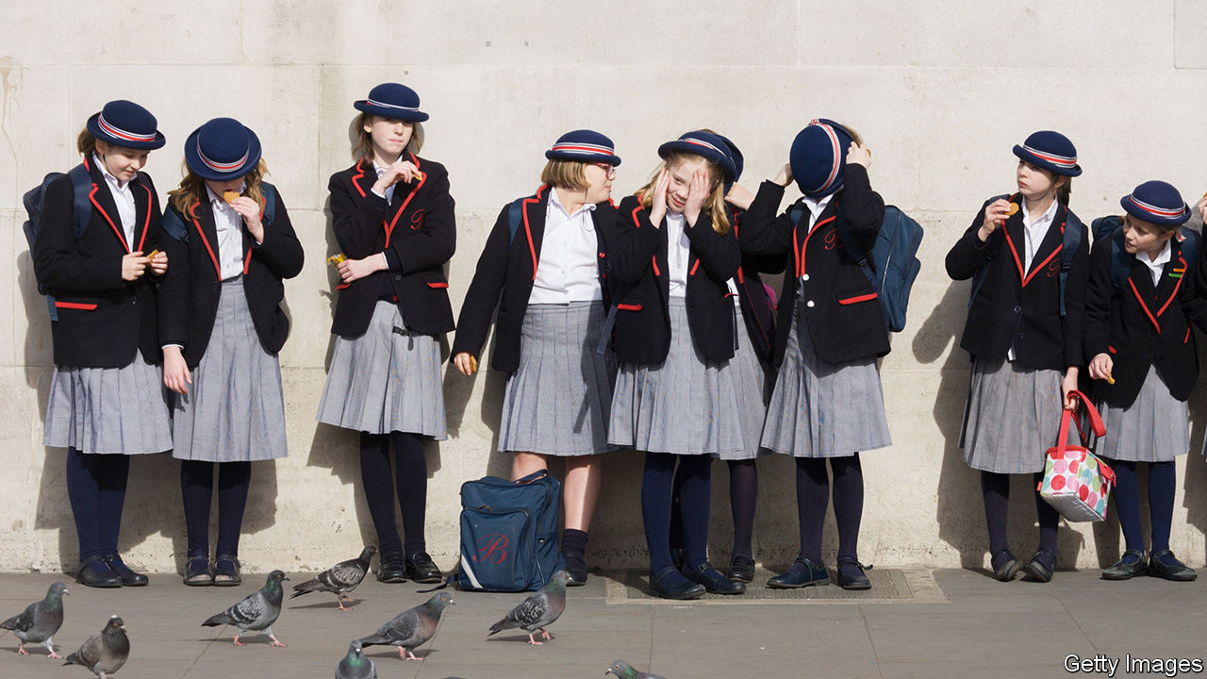

FOR THE many British families who have been struggling to look after children while clinging on to their professional lives, the prospect of schools reopening next week is a heartening one. But there is one aspect of the rentrée to which no parents look forward: the school-uniform bill. The Children’s Society, a charity, reckons that the cost of a state-educated pupil’s secondary-school uniform is now £337 ($445), up from £316 in 2015.

Michael Gove, a former education secretary, is partly responsible. He wanted state schools to adopt blazers and ties, along with the house systems beloved of private schools, which demand further accessories in ugly colours and stripes. These Hogwartian habits were initially adopted in the 19th century to foster team spirit among future empire-builders; modern proponents argue that making poor and rich children wear the same clothes oils the wheels of social mobility.

The transformation of state schools into independent academies has encouraged schools to develop their own identities. Despite government guidance advising them to opt for clothing available in supermarkets, schools have been branding everything from shirts to scarfs. Such items have to be bought in specific shops, and the absence of competition allows retailers to bump up prices.

The Children’s Society says two-thirds of secondary-school parents now have to buy two or more items from a specific supplier. “Most schools only have one shop you can buy the school uniform from,” says Andrea Grant. “You’ve got no choice.” She has set up Old School Uniform, a website where parents sell or give away uniforms. Other parents have gathered in Facebook groups that offer second-hand kit.

Protests against the rising cost of uniforms have driven Mike Amesbury, a Labour MP, to introduce a bill to stop schools relying on a single uniform supplier and cut down on the amount of items the school brands with its logo. Retailers and supermarkets could sell standard blazers, onto which school logos could be sewn. The bill has government support, and it is on its way to becoming law.

The government does not normally support Labour MPs’ bills, but the Conservative Party is worried that schools are putting extra pressure on the “just about managing”, a polite name for the working class coined during the premiership of Theresa May, Boris Johnson’s predecessor. Keeping that vote is central to its plans for retaining power in 2024. Monopolies are “simply not compatible with an agenda that focuses on supporting children from less well-off backgrounds in the seats won by the Conservatives in 2019,” says Tom Richmond, a former adviser to Mr Gove who runs EDSK, a think-tank that focuses on education.

Uniform suppliers are not happy. Matthew Easter, co-chair of the Schoolwear Association, a trade body, believes that the widely cited Children’s Society figures are misleading. The association’s survey of retailers estimates a uniform’s annual cost to be just £101. He argues that if a single retailer has to supply a school’s uniforms, then it will make sure that all items are available all year round. If no retailer has that responsibility, supplies may become uncertain and children may end up wearing mismatched items.

Whether that would matter much is open to question. The Education Endowment Foundation looked at the costs and benefits of 35 measures which might, or might not, enhance children’s performance. Uniforms were among the least effective. But parents like them. Mrs Grant dressed her daughter in uniform even though the school does not have one. “When they’re wearing the school uniform, parents don’t have to think about ‘oh, I haven’t got any branded items or fashionable accessories’, they’re just wearing their school uniform,” she says.

For some schools, no opportunity to extend the range of uniform items goes unmissed. Holmes Chapel Comprehensive School in Cheshire has made covid-19 face-masks compulsory. Their navy blue masks must be bought from their uniform supplier, Sam Dale & Son, at £3 a pop. ■

This article was downloaded by calibre from <https://www.economist.com/britain/2020/08/29/bringing-down-the-cost-of-school-uniforms>

|  |  |  |  |
| --- | --- | --- | --- |
| Previous | Articles | Sections | Next |

|  |  |  |  |
| --- | --- | --- | --- |
| Previous | Articles | Sections | Next |

#### Bagehot

# Whatever the question, the answer is Germany

Even the British right has got the Teutonic bug

Aug 29th 2020 |

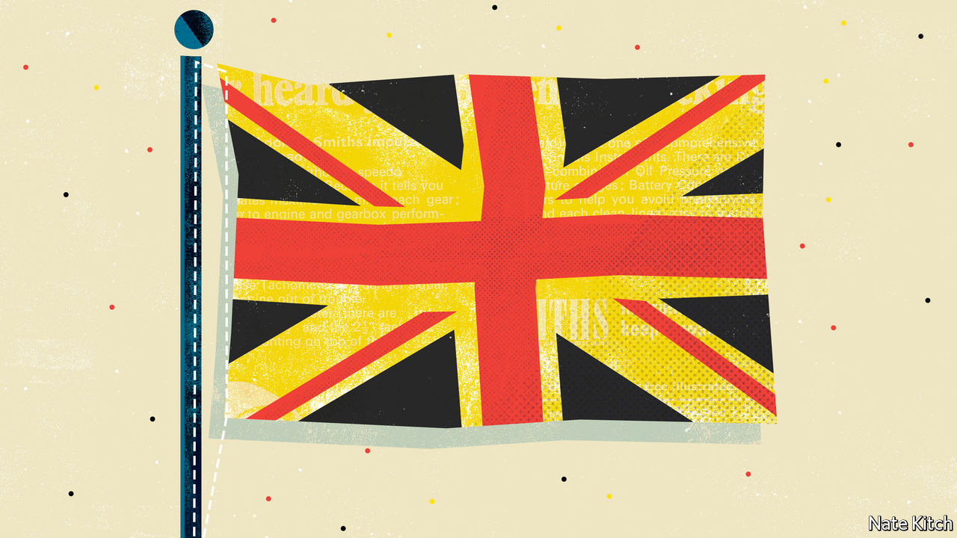

“WHY THE Germans do it better”—the title of a new book by John Kampfner, a respected journalist—speaks volumes about the current state of the British psyche. The government is replacing Public Health England, the body that was supposed to stop Britons from dying of covid-19, with a new outfit modelled on the Robert Koch Institute, the body at the centre of Germany’s public-health system. James Kirkup, head of the centrist Social Market Foundation, says his aim is to “make Britain more like Germany”. Other thinkers are less explicit, but pore over the details of Germany’s technical-education system or social-insurance market.

That Britain should turn to Germany for ideas is not surprising given the long, binding ties between the two states. Britain imported its royal family from Hanover in 1714 and German-born Prince Albert did as much as his wife to shape Victorian England. The idea of the welfare state came from Bismarck. The post-war German constitution was mostly the work of the British and Americans.

Competition combined with closeness means that Britain has a long-standing weakness for “Germans do it better” arguments. Before the first world war advocates of national efficiency insisted that Britain needed to invest more in science and education to escape being crushed by the German chariot. From the 1960s, left-wingers urged that Britain should learn from Germany’s model of stakeholder capitalism.

Nevertheless, today’s surge of enthusiasm for the Teutonic model is striking. It comes after a long period of Anglo-Saxon triumphalism in which the British got into the habit of dismissing the Germans as dinosaurs. “As economic growth stalls yet again,” The Economist observed in June 1999, “Germany is being branded the sick man (or even the Japan) of Europe.” The spread of Germanophilia to the right is new. It springs from Boris Johnson’s determination to spread prosperity throughout Britain’s regions and improve technical education—issues on which Thatcherism has little to offer but Germany has much to contribute.

This ideological change has coincided with a generational shift. Margaret Thatcher’s Tories saw Germany as a problem to be solved and the EU as a German racket. Today’s Tory elite is more likely to regard it as an example of high civilisation and social order. Michael Gove, the Cabinet Office minister, likes to visit Bayreuth to listen to Wagner. Dominic Cummings is an enthusiastic student of Bismarck. Even today’s top civil servants are infected. Two recent appointees to top Whitehall jobs, Simon Case, permanent secretary at Number 10, and Alex Chisholm, permanent secretary at the Cabinet Office, are both Germanophiles.

Enthusiasm for Germany is also driven by profound cultural anxiety. Britain gambled its future as a United Kingdom and a member of the EU on the results of two referendums—and, with support for Scottish independence above 50%, the kingdom may yet break up. The political system has been shaken by the rise of the Brexiteer right and the Corbynite left as well as the downfall of David Cameron and Theresa May in rapid succession. Mr Johnson’s government seems determined to set records in incompetence. The covid-19 epidemic has heightened enthusiasm for a country that has managed it far better than Britain. Germany has lost fewer than 10,000 people to the disease compared with Britain’s toll of more than 40,000, and its economy suffered far less damage as a result.

## Vive la Unterschied

Some argue that Britain has nothing to learn from Germany because the two are so different: Britain has a service economy (with strengths in finance and the creative arts), whereas Germany has a manufacturing one (with a messy financial sector and not much of a creative one). This is nonsense: people and countries have more to learn from those whose strengths are different from theirs. German ideas have been successfully transplanted in the past: the University of Warwick built one of the world’s best manufacturing research centres by borrowing German methods for building ties between universities and industry.

But Britain should proceed down the Teutonic path with caution. Its rose-tinted view of Germany tends to blind it to the country’s flaws. The left’s enthusiasm for “stakeholder capitalism” ignores the corruption and collusion it has fostered. Germany’s finance and service sectors are weak. The fashion for creating national champions by trying to merge companies (such as the failed tie-up between Deutsche Bank with Commerzbank) is doomed.

And learning German lessons demands a seriousness that British politics lacks. Trying to copy the Robert Koch Institute is a good example of its shallowness. Germany’s successful public-health system is built on a deep, powerful layer of local government which does not exist in Britain. The institute sits on top of, and provides services to, local public-health departments. There is no point in having the cherry without the cake.

Learning from another culture is difficult under any circumstances, but it is hard to think of a government that is less equipped for a Teutonic transplant than the current one. Changing cultures and institutions—to decentralise power, for instance, and to raise the status of technical education—will require a degree of patience, steadiness and co-operation which the people currently in charge in Britain lack.

German politicians are notably dull. Angela Merkel knows whereof she speaks when she says that in government “you can’t solve the tasks by charisma”. Mr Johnson relies on charisma, Mr Cummings is more inclined to cudgel than co-operate, and the government as a whole keeps U-turning all over the place in the most un-German manner possible. Mr Gove and the Labour Party leader, Sir Keir Starmer, are somewhat more Teutonic types. For its German moment, Britain may have to wait until another prime minister comes along. ■

This article was downloaded by calibre from <https://www.economist.com/britain/2020/08/29/whatever-the-question-the-answer-is-germany>

|  |  |  |  |
| --- | --- | --- | --- |
| Previous | Articles | Sections | Next |

|  |  |  |
| --- | --- | --- |
| Britain | Sections | Special report |

International

Mental health: The common tragedy

.

|  |  |  |
| --- | --- | --- |
| Britain | Sections | Special report |

|  |  |  |  |
| --- | --- | --- | --- |
|  | Articles | Sections | Next |

#### The common tragedy

# Worldwide covid-19 is causing a new form of collective trauma

Neighbours will have to confront it together

Aug 29th 2020 | BEIJING, CODOGNO, HONG KONG, MANAUS, NEW YORK, PARIS AND QUITO

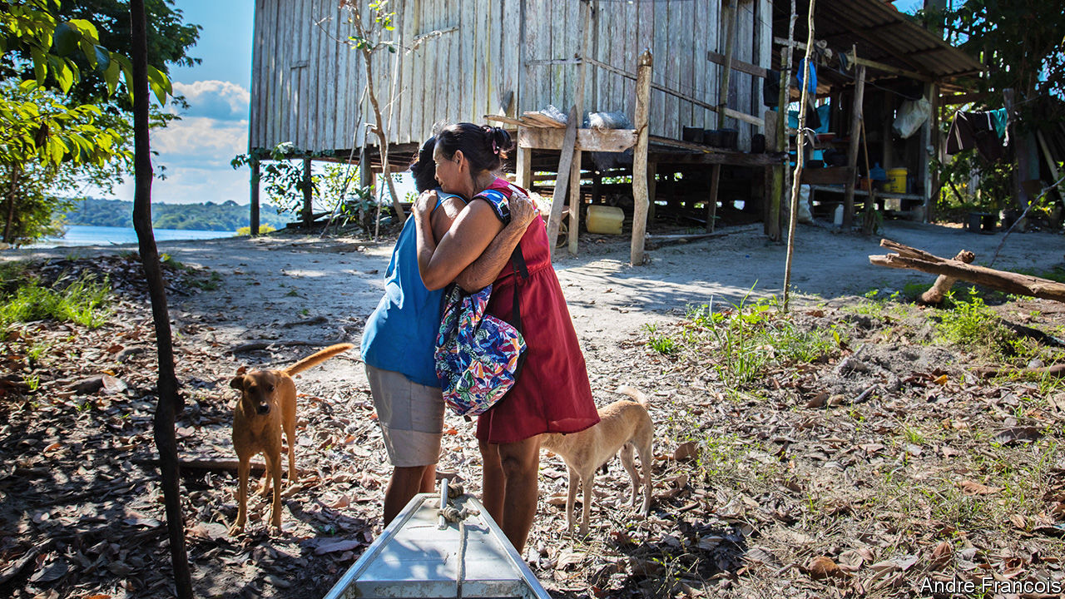

Editor’s note: Some of our covid-19 coverage is free for readers of The Economist Today, our daily [newsletter](https://my.economist.com/user#newsletter). For more stories and our pandemic tracker, see our [hub](https://www.economist.com/news/2020/03/11/the-economists-coverage-of-the-coronavirus)

THE NIGHTMARE began in earnest for residents of Parque das Tribos when their cacique, or local chief, died of covid-19. Messias Kokama had battled politicians, developers and drug gangs to transform a dusty informal settlement on the outskirts of Manaus, a city of 2m people deep in the Brazilian Amazon, into a haven for some 600 indigenous families from 35 ethnic groups. He was 53 and said he wasn’t afraid of the virus. His death on May 13th shook the community.

By then, hospitals in Manaus were turning people away and cemeteries were digging mass graves. Ambulances wouldn’t come to Parque das Tribos (“Tribes Park”) because the city and the federal indigenous agency each claimed that indigenous city-dwellers fell to the other institution. Such neglect exacerbated their grief. Every few days another elder would start gasping for air. Those who made it back from hospital told horror stories of frigid wards packed with dying patients and doctors who didn’t speak their language. One resident fled the ICU. “He said he would rather die in a hammock than surrounded by tubes,” said his daughter-in-law, Cláudia Baré. Five weeks later, he did.

The pandemic has now subsided in Parque das Tribos. Burials in Manaus have fallen from more than 150 per day to the pre-pandemic norm of around 35. Sunbathers once again pack Ponta Negra beach on the banks of the Rio Negro. It scarcely seems imaginable that just two months ago, boats were arriving at the port with covid-19 patients who had died on the journey. Yet the chaos of the past few months is giving way to a second crisis. Lingering trauma and continued hardship will take much longer to overcome. Mr Kokama’s daughter, Mirian, is being treated for depression. His son, Miqueias, who is 33 and took over as chief, barely sleeps.

For some, the second half of 2020 will bring much-needed relief. For the time being the number of new recorded global infections has plateaued. In many countries it has dropped dramatically. Yet for those places hit hardest, a full recovery will depend on more than getting the virus under control. In a world paralysed by death, survivors are everywhere: ICU patients who faced the horror of covid-19 first-hand, doctors and nurses who cared for them, relatives forced to mourn over WhatsApp and Zoom, families who lost their livelihoods. Mental-health professionals say that no single event since the second world war has left so many people in so many places traumatised at once. How people fare in the months and years ahead will depend partly on how their countries—and, more importantly, their communities—respond.

## Stress en masse

In 1972 a dam burst at a coal mine in West Virginia and 132m gallons of sludge ripped through the Buffalo Creek valley, killing 125 people and destroying thousands of homes. The victims’ lawyers hired Kai Erikson, a sociologist, to study the aftermath of the flood. It had swept away not only physical belongings, but also relationships, routines, tradition and trust. He called this devastation “collective trauma”.

The way Mr Erikson saw it, traumatic experiences harm individuals, of course. But they can also change group dynamics. People stop trusting each other. It becomes harder to bring people back together and easier to open new wounds. If nothing is done, this can permanently damage a society—and even destroy it. In Buffalo Creek untreated grief and neglect en masse led to the demise of several towns.

Though the term may have been new, the experience of collective trauma was not. Mass trauma has now been identified in the context of wars, natural disasters and terrorist attacks. Research shows that people and communities are typically very resilient. Yet exposure to death puts them at greater risk of lasting affliction. Violence and disasters owing to negligence—such as the Buffalo Creek flood or the explosion on August 4th at a warehouse in Beirut that killed some 150 people—are more likely to lead to trauma than “acts of God” such as hurricanes or earthquakes.

Pandemics do not fall neatly into either category. During the Severe Acute Respiratory Syndrome (SARS) outbreak in Hong Kong in 2003, nearly 40% of the population experienced increased stress, 16% showed signs of trauma and only 25% believed they were very likely to survive if they contracted the disease even though the death rate was around 10% of people infected. A review of studies involving patients treated for SARS found that a third went on to develop symptoms of post-traumatic stress disorder (PTSD), a condition that can result in vivid flashbacks and difficulty sleeping. But past epidemics are imperfect proxies for covid-19. Its unprecedented reach across the globe and into nearly every aspect of life makes it more like a world war.

There were no large-scale psychological studies during the first or the second world wars, though the Holocaust would become the event most deeply associated with mass death and grief. Researchers in the early 2000s found roughly half of Holocaust survivors were still suffering from PTSD. Many had other disorders such as schizophrenia. Even among non-Jewish Europeans who were children during the war, 10-40% still had PTSD symptoms. In communities of survivors, research has shown that “inherited trauma” can be passed to subsequent generations, by growing up flooded with their parents’ memories, and possibly, through genes.

The suffering caused by covid-19 falls far short of the horrors of the Holocaust. Still, Krzysztof Kaniasty, a psychologist and disaster expert, points out that the pandemic presents nearly all the risk factors for PTSD. It has caused sudden death, life-changing events, large-scale social ruptures and chronic stressors like uncertainty and the added hassles of daily life.

The luckiest will suffer mildly from one or two of these effects. Yet more than at any other point in recent history, millions of people have been slammed by all of them. In the first large-scale survey of a developed country struck by covid-19, published in July by Psychiatry Research, 29% of 15,530 Britons surveyed met the criteria for a general psychiatric disorder. In Spain, where a shortage of protective kit has meant nearly a sixth of all covid-19 infections are of health workers, more than half are showing signs of PTSD. Another study found 86% of Bangladeshis are dealing with covid-related stress, resulting in insomnia, irritability and family problems.

There are signs of hope. In the long run people fare better when they perceive strong social support in the aftermath of a catastrophe and worse when they feel neglected or excluded. “Strong communities buffer against adverse traumatic effects,” says Joshua Morganstein of the Uniformed Services University in Bethesda, Maryland. His studies of health workers in Florida after hurricanes in 2004 and 2005 found lower rates of PTSD and depression among those who reported living in places with tight-knit social circles, which are better able to organise in times of crisis.

## Adverse learning conditions

On February 21st the first case of covid-19 in Italy was diagnosed at a small hospital in Codogno, a serene town with cobbled streets not far from the river Po. Its inhabitants were soon experiencing drama of a sort they had seen only in films. Roadblocks were thrown up around the newly declared “red zone” and residents besieged pharmacies for personal protective equipment (PPE), which quickly ran out. “It was like being in a war with an invisible enemy,” says Rosa Cavalli, whose family owns one of the pharmacies.

But within days, 100 people were working as volunteers at an operation centre run by Italy’s disaster-response service. The struggling community radio station, which was renamed “Red Zone Radio”, began putting out twice-daily bulletins to counter fake news and conspiracy theories. “There was an initial moment of disorientation,” says Nicoletta Porcu, a psychologist who formed part of a crisis group with colleagues. But the outpouring of support helped the town emerge strengthened from the trauma.

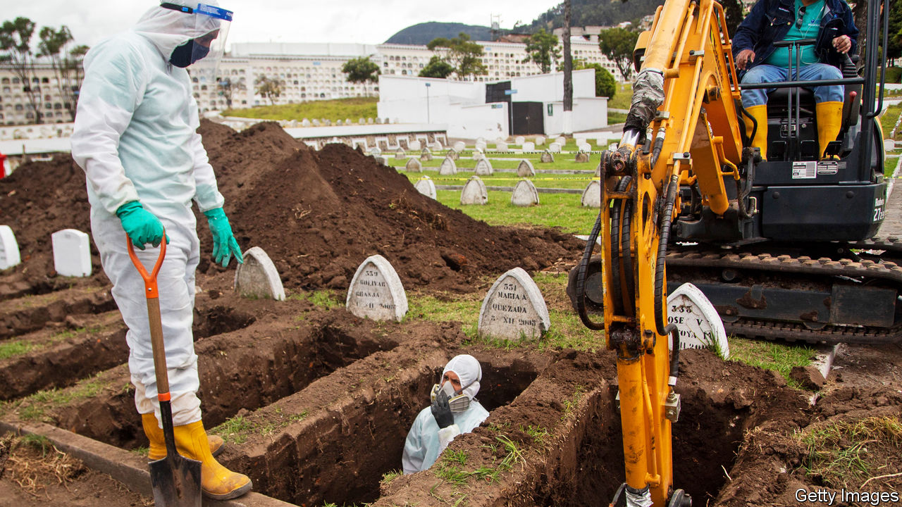

Mr Kaniasty, the professor, has found that “received support” that might come in the form of a donation is less important for psychological outcomes than “perceived support”, the feeling that people can rely on their neighbours. As Codogno came out of lockdown in June, the degree of compliance with distancing rules—necessary for recovery—was astonishingly universal. The parish priest, Monsignor Iginio Passerini, was taken aback during confession to hear a young boy list among his sins that of having lowered his face mask outdoors.

Mass tragedies can teach groups of people how to avoid or mitigate them in future. Such “adversarial growth” helps explain why commuters in Hong Kong wore masks before any covid-19 cases had been reported. Most credit the territory’s scarring experience with SARS, which included tragic mistakes. But it also raised the profile of doctors. A record number of students applied to study medicine. The government added isolation wards in hospitals, trained infection specialists and stockpiled PPE.

Such investments paid off this year. Not a single covid-19 death was reported among Hong Kong’s hospital workers. The response earned the unpopular government a ratings boost, but a controversial security law has undermined public trust and may compromise its mass-testing strategy.

Covid-19 is easier to deal with than some traumas. It moves more slowly and is more dispersed than a natural disaster, buying governments time. Unlike a war or a terrorist attack, there is no direct human enemy to blame. Some find comfort in the fact that the whole world is going through hardship at once. When Wayne Bai, a worker at a telecoms company in Wuhan, made a business trip the day after the city’s lockdown lifted, he was denied a room at seven hotels. But his annoyance faded as the virus spread across the globe.

This universality has drawbacks, of course. One is that poor countries cannot turn as readily to rich ones for money or supplies. Aid workers who usually arrive after disasters would have been welcome in Guayaquil, Ecuador, where funeral services collapsed in late March, leading to a pile-up of bodies in homes. Zaida Rovira of the public ombudsman’s office recalls trying to console a 70-year-old who had spent four days with his brother’s body in the room they shared. At the Guasmo hospital, relatives had to enter refrigerated containers to look through hundreds of unlabelled corpses. More than 70 remain unidentified. Only recently did staff start collecting DNA samples after admitting sending photos of the bodies to relatives on WhatsApp may have led to misidentification.

Guayaquil, a tropical business hub of 2.7m people, is still counting the dead. They may top 10,000, which would give it one of the highest death rates of any big city. Yet it disappeared from headlines in April and has had to deal with its trauma alone. Most family members have received no psychological support. This points to yet another important characteristic of covid-19—its mental-health burden falls unequally in different parts of the world.

This exacerbates suffering in areas that failed to implement lessons from prior traumas. Parts of New Orleans where black people died of covid-19 at rates two to three times higher than white people were the same areas ravaged by Hurricane Katrina in 2005. Then, racist housing policies had herded minorities into low-lying areas. Now, a higher share of minorities work in front-line jobs cleaning hospitals or stocking shelves. They also have more underlying health problems like diabetes, often caused by poor access to primary care.

## The remains of the pain

Good leadership can bring people together in a crisis. Polarising leadership has the opposite effect. In Brazil President Jair Bolsonaro has echoed his American counterpart’s claim that the economic fallout of covid-19 is a greater trauma than the death toll. In both countries social distancing is a political statement. Even when hospitals were full in Manaus, less than half of people stayed at home. The local governor tried to cast himself as responsible, but people stopped trusting him after his health secretary was arrested on charges of embezzlement tied to a fake respirator company, which she denies. Corruption was more blatant in Guayaquil. The ombudsman’s office is investigating reports that morgue staffers demanded $700 from relatives to return bodies, though most family members are too traumatised to sue.

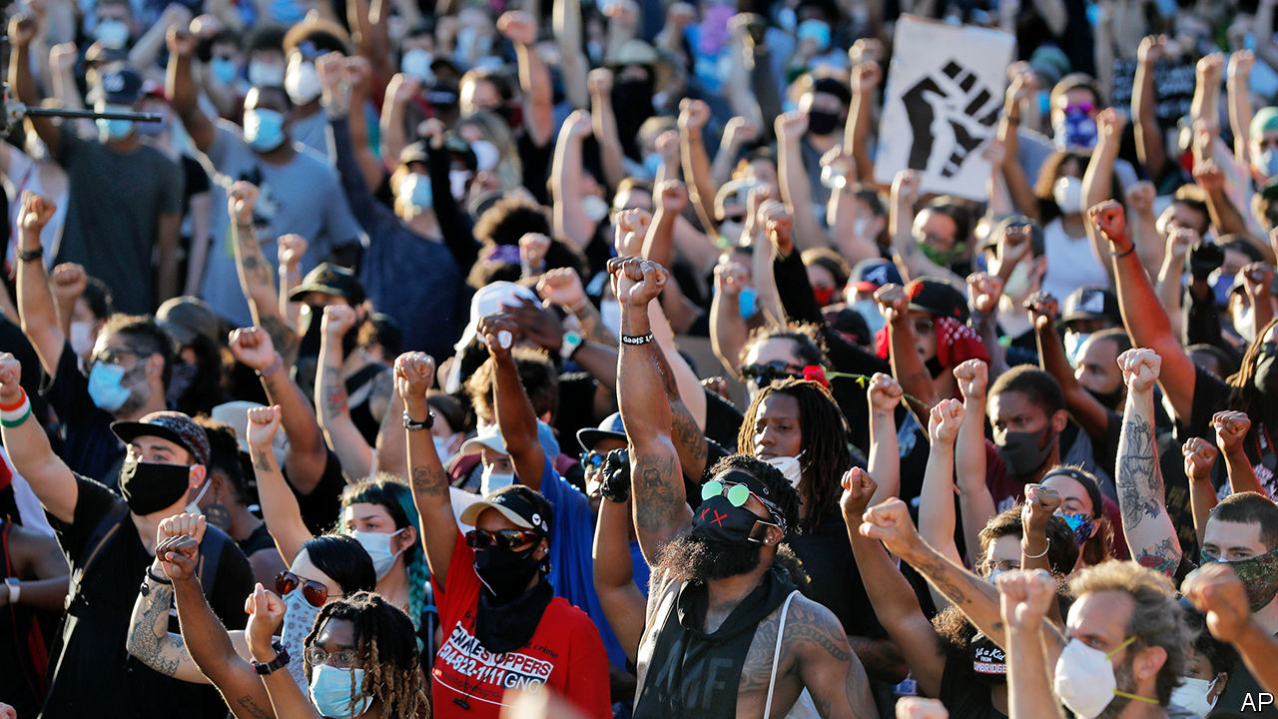

Chaos at the top makes it harder to grapple with a harsh reality. Some stop believing altogether. Psychologists who set up a hotline in Manaus were surprised to discover that even callers who had lost relatives downplayed the virus’s role, claiming other ailments ultimately killed them. Many believe online conspiracy theories, such as one claiming the state had exaggerated the death toll to receive more federal money and another alleging that the coffins buried in mass graves were filled with rocks. Sônia Lemos, who ran the hotline, said locals were going through collective denial. “It’s a defence mechanism that saves people from feeling responsible.”

There is a danger that political divisions, social distancing and economic woes will over time lead to a loss of togetherness in the same way that displacement after the Buffalo Creek flood gave “a degree of permanence to what might otherwise have been a transitional state of shock”, in the words of Mr Erikson. Communities cannot grieve together because the disaster is ongoing and the threat has yet to disappear, says Judith Lewis Herman, a psychiatry professor at Harvard Medical School. She describes three stages of healing: re-establishing safety, remembrance and mourning, and reconnecting with others. Social distancing complicates all of them.

And so like the pandemic itself, the psychological fallout will require assessment and adaptation. Many doctors are still focused on saving lives, but governments and mental-health professionals should start thinking about “psycho-social” interventions. In France “medical and psychological emergency units” offer one model. They were launched to respond to mental-health concerns after a terrorist attack in 1995. People are offered psychological support immediately, near the scene, just as they would be offered paramedical services. Four years after 86 people were killed in Nice in a terrorist attack, the city has broadly returned to normal, says Frédéric Jover, the psychiatrist then running the unit. But empty streets this spring brought back ghastly memories. Nice reactivated its unit to help people struggling with bereavement, anxiety and isolation.

The fact that covid-19 is slower than a bomb or a flood gives governments and NGOs an opportunity to identify and deal with mental-health issues before it is too late. Fuelled by national protests against racism and police violence, advocacy groups in Louisiana are proposing policies for a “racially and economically equitable” covid-19 recovery. New York City’s health department is hosting virtual town-hall meetings for African-Americans, including webinars about bereavement.

But it will not be easy to sustain the recent surge in community organising and mutual-aid networks (such as WhatsApp groups to bring groceries to old people) that have sprung up across the country. Fatigue and forgetting can lead social networks to deteriorate, says Sarah Lowe of the Yale School of Public Health. “Often people are still recovering when resources are cut off.” One of her studies found that a year after Hurricane Sandy, which hit New York City in 2012, mental-health outcomes were similar across demographic groups. But two years on, the poor were faring worse.

Poor countries spend much less on mental-health services and their citizens have fewer resources to get help. So healing will have to come from the ground up. This will require the creation of spaces—physical or virtual—for people to come together. In Parque das Tribos Ms Baré organised a WhatsApp group to distribute food baskets. A local nurse used her free time to go door-to-door checking on covid-19 cases and eventually persuaded the city to send a mobile-health station. Mr Kokama’s family petitioned the courts for permission to bring his body back for a 30-minute, closed-coffin ceremony.

His friends and neighbours gathered on a recent Sunday, the first time since the funeral, settling into lawn chairs to watch local dance groups perform to raise money on Facebook Live. “This is still a cry for help,” said Luciana Vasconcelos as she painted her friend’s face red and black. She added that Parque das Tribos owes its existence to a kind of collective trauma: indigenous people leaving the forest for the city in search of a better life. A speaker boomed out traditional lyrics with modern beats, and a mobile phone on a tripod filmed the dancers, some in T-shirts, others in beads, all beaming with a stubborn sort of hope.■

This article was downloaded by calibre from <https://www.economist.com/international/2020/08/29/worldwide-covid-19-is-causing-a-new-form-of-collective-trauma>

|  |  |  |  |
| --- | --- | --- | --- |
|  | Articles | Sections | Next |

|  |  |  |
| --- | --- | --- |
| International | Sections | Business |

Special report

Dementia: The perils of oblivion

.

The science: Plaque blues

.

Care: God’s waiting rooms

.

Going abroad: The last resort

.

Financing care: Alms for oblivion

.

Ethics: Still human

.

|  |  |  |
| --- | --- | --- |
| International | Sections | Business |

|  |  |  |  |
| --- | --- | --- | --- |
|  | Articles | Sections | Next |

#### Dementia

# As humanity ages the numbers of people with dementia will surge

The world is ill-prepared for the frightening human, economic and social implications

Aug 27th 2020 |

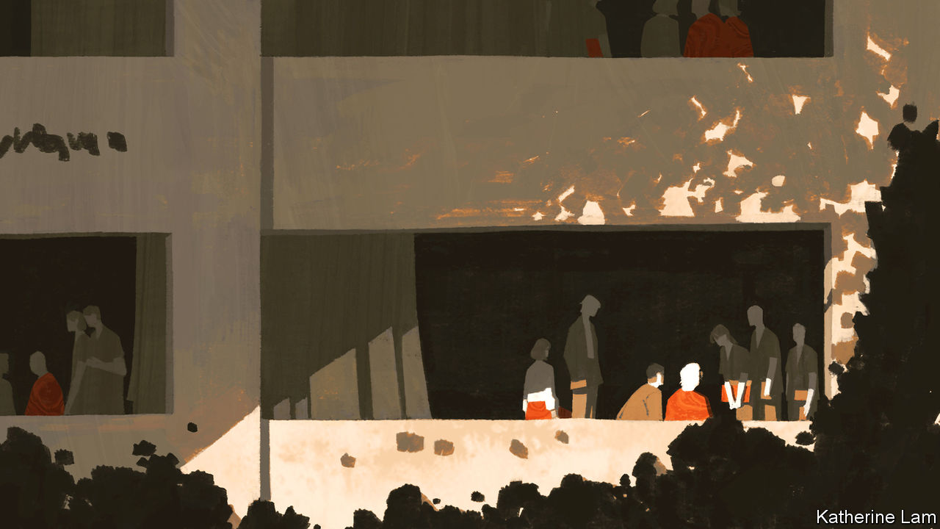

A FEW DAYS shy of her 90th birthday, tortured by leg ulcers and arthritis, Vera, one of some 850,000 Britons with dementia, has kept herself alive, it seems, to meet her first grandchild, due any moment now. But when the happy day comes and the baby is brought to her, she is confused. She recognises her daughter-in-law, but is puzzled by the bundle in her arms. “That’s nice, dear,” she says. “But why have you brought me a coconut?”

Dementia is a cruel condition, robbing people of their deepest joys and hopes. It may start as a “mild cognitive impairment” (MCI): forgetfulness or “senior moments”. But as it progresses, attacking mental agility and eating away memory, it steals much of what counts as identity. When severe, people become incapable of looking after themselves. They lose the ability to read, cook and shop. They forget to drink and get dehydrated, or become incontinent. They suffer delusions, or become frightened or angry, or they sink into an apathetic slump. They require care for all their waking hours, and often supervision when asleep.

The covid-19 pandemic has been a huge ordeal for people with dementia. The loss of routine and social contacts under lockdown have hastened cognitive decline. Dementia patients have proved highly susceptible to the virus—in Britain some studies suggest it has been the commonest “pre-existing condition” in those dying from covid-19. And deaths where “dementia” has been identified as the cause have also risen. In April it came second only to covid-19. Those with dementia often have conditions that make them vulnerable—above all, being old, but also being overweight, depressed, smoking, having high blood pressure or diabetes. And dementia makes it hard to understand the danger of the virus, or to remember social-distancing or hygiene precautions. Many have endured the pandemic in care homes, which have accounted for nearly half of all deaths from covid-19 in the rich world.

Dementia affects more than 50m people worldwide, a number that is rising fast. It has many causes and is imperfectly understood. But nobody doubts that its prevalence increases with age. By some estimates, 1.7% of 65- to 69-year-olds have dementia, and its incidence (the number of new cases) doubles every five years to the age of 90. Another estimate is that at the age of 85, between a third and a half of people have dementia.

In this sense dementia is collateral damage from one of humanity’s triumphs: increased lifespans. A hundred years ago life expectancy at birth was not much more than 30. By 1960 it had reached 52. Today it is about 70 for men and 75 for women, and in rich countries, over 80 apiece. Nonagenarians and even centenarians are no longer rare. Despite covid-19 medical progress will continue, further lengthening lives. Yet dementia is stubbornly resistant to efforts to find a cure. It was long seen as a natural part of growing old, the last of the seven ages of man defined by Shakespeare’s Jaques: “second childishness and mere oblivion”. Kate Swaffer, an Australian diagnosed with dementia in 2008 who chairs Dementia Alliance International, a campaigning group, sums up the advice she got: “Go home and prepare to die.”

Another estimate is that, at the age of 85, between a third and a half of people have dementia

Dementia used to be called “senile dementia” or simply “senility”. But a small minority of sufferers are not old at all. In 1906 Alois Alzheimer, a German psychiatrist, conducted an autopsy on Auguste Deter, a woman who had developed dementia in her 40s. He noticed abnormalities also found in the brains of older people with dementia. Of the dozens of forms of dementia identified, the pathology known as “Alzheimer’s disease” is the commonest, accounting for between 60% and 80% of cases. Next, each accounting for 5-10%, are vascular dementia, caused by an inadequate flow of blood to the brain, and Lewy body dementia.

All forms of dementia become more prevalent in old age, and so will become more widespread as life expectancy rises. As people in less well-off parts of the world enjoy longer lives, that is where three-quarters of new cases will arise. In 2015 the OECD estimated that by 2030 the number of cases of dementia would increase by 50% in rich countries and 80% in poorer ones. Some 82m people will have dementia by 2030 and 152m by 2050. Encouraging recent research in America and parts of Europe suggests that changing lifestyles may be bringing down the incidence of age-specific dementia. But it appears to be rising elsewhere, so global projections are unlikely to be revised downwards.

Dementia disproportionately affects women, even allowing for their longer life expectancy. In America two-thirds of people with Alzheimer’s are female, and 60% of carers at home are women. China has more people with dementia than any other country—an estimated 9.5m people (it includes Taiwan in its total). India, a younger country, with a median age of 28 compared with China’s 38, and lower life expectancy (70 compared with 77) had some 4m in 2018, mostly undiagnosed, a number that may reach 7.5m by 2030. Other places with big numbers are the European Union, with an estimated 9.1m in 2018, America (about 6m) and Japan (5m).

Set against the size of the world’s population, these numbers may seem manageable. That is illusory. Nowhere in the world, rich or poor, is equipped to deal with the scale of the problems created by dementia. No cure exists, and even the most hopeful new therapies will have only a mild impact. So all these dementia patients will need to be cared for—often for many years.

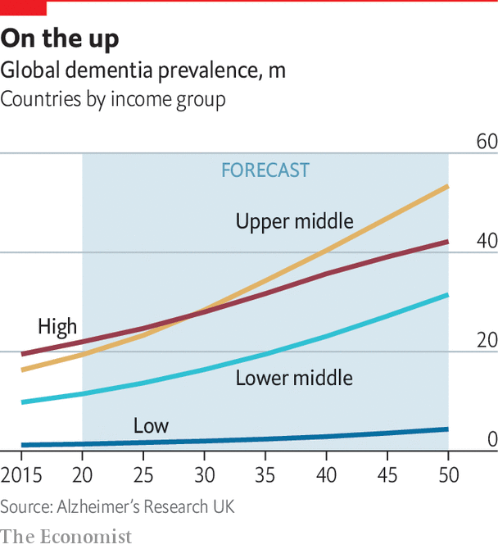

Humane care will require vast numbers of people, and huge sums of money. An estimate cited by the World Health Organisation (WHO) put the annual global cost of caring for people with dementia at $1trn in 2018, rising to $2trn by 2030, a total “that could undermine social and economic development globally and overwhelm health and social services, including long-term care systems specifically”. In Japan, governments have for decades tried to create systems to deal with the problem, but officials admit they are unsustainable. There will be neither money nor carers enough to cope. In 2018 the average lifetime cost of care for an American with dementia was put at nearly $350,000, with 70% being the costs of care at home by families. Many poorer countries have yet to confront the problem at all.

The covid-19 pandemic has shown the fragility of many health-care systems, and drawn attention to the large numbers of people with dementia who occupy hospital beds mainly because of a lack of alternative facilities to care for them. When the virus is defeated, dementia will continue to spread. In her book “Where Memories Go”, a memoir of her mother who had Alzheimer’s, Sally Magnusson, a journalist, calls dementia “perhaps the greatest social, medical, economic, scientific, philosophical and ethical challenge of our times”. Hyperbole? Yet many politicians seem to agree with Ms Magnusson.

In 2013 David Cameron, Britain’s prime minister, used his chairmanship of the G8 to convene a “dementia summit”. Other leaders have adopted the cause. Moon Jae-in, South Korea’s president, campaigned on a pledge to get the state to take on more of the burden of dementia care. In 2017 the WHO published a “global action plan on the public-health response to dementia”.

So dementia could hardly be said to be below the radar. In Britain, for example, 52% of people know somebody with the condition. And it has not spared the famous: Ronald Reagan and Margaret Thatcher had dementia, along with many other statesmen, sports stars and writers.

## Eminently forgettable

Yet campaigners working for dementia charities around the world have a point when they argue that theirs is an underfunded cause. Covid-19 is likely only to make things worse, as the pandemic sucks in money and medical expertise. Already dementia research receives far less money than cancer or coronary heart disease (CHD). A global study in 2018 found 250,000 papers on dementia compared with 3m on cancer. That matches funding in Britain, according to the charity Alzheimer’s Research UK, where dementia attracts 7.4% of the sums that go into cancer, and 12% of the money for CHD. And everywhere, the costs of long-term care for people with dementia can be crippling—and are not usually covered by health insurers.

The comparative neglect of dementia has several causes. One is that it often falls between different government agencies. In the absence of useful medical interventions, health ministries do not want the strain of looking after untreatable and perhaps otherwise healthy people on their budgets. Often the provision of long-term care is the responsibility of local governments, so its availability and quality vary wildly.

More fundamentally, the old notion that dementia is a natural part of the ageing process is deep-rooted—held by two-thirds of people and even by 62% of medical practitioners, according to a survey last year by Alzheimer’s Disease International (ADI), an advocacy group. It also found that one in five people attributed dementia to bad luck and almost 10% to God’s will. As many as 2% blamed witchcraft. That belief, held in some African countries, where those with dementia may be shunned or persecuted, is the starkest example of the stigma attached to dementia. No other disability, Ms Swaffer points out, is treated in the way hers was dismissed. As ADI puts it in its 2019 annual report: “When a person has dementia, the condition takes over as the main descriptor of who they are. The stigma cancels the individual’s personality or personal history.”

On top of the stigma the condition brings, there is another reason why people prefer not to confront the dementia emergency: fear. Knowing how likely they are to develop it, and seeing the difficult lives of those who already have, they prefer to look the other way—and just hope that a cure will one day be found.■

This article was downloaded by calibre from <https://www.economist.com/special-report/2020/08/27/as-humanity-ages-the-numbers-of-people-with-dementia-will-surge>

|  |  |  |  |
| --- | --- | --- | --- |
|  | Articles | Sections | Next |

|  |  |  |  |
| --- | --- | --- | --- |
| Previous | Articles | Sections | Next |

#### The science

# The search for a cure for dementia is not going well

But behavioural changes can reduce the risk of developing it

Aug 27th 2020 |

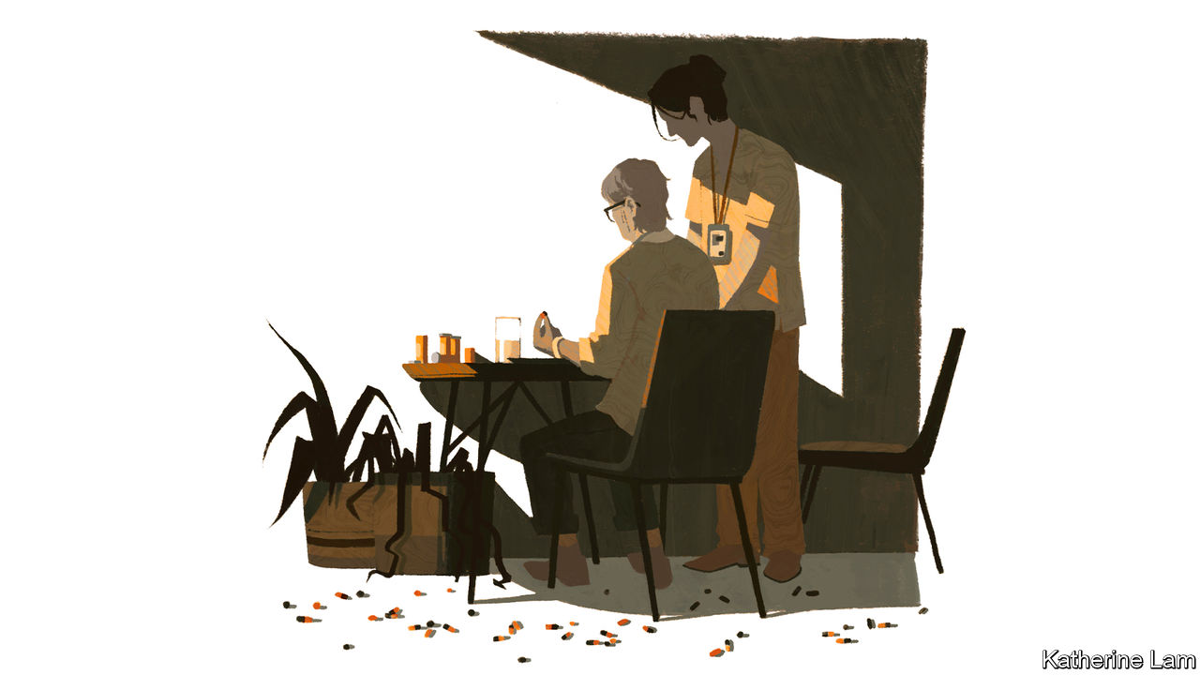

PERFORMING HIS autopsy on Auguste Deter in 1906, Alois Alzheimer noticed three unusual features of her brain. It was at least a third smaller than normal. Many neurons, the nerve cells, had vanished. He also saw abnormal deposits inside the remaining cells, especially in the cerebral cortex, the thin outer layer of grey matter. Between a third and a quarter had been invaded by dense knotty bundles, now known as “neurofibrillary tangles”, caused by a build-up of a protein called tau. And across the cortex were deposits of another protein, since identified as beta-amyloid, which collect between neurons and disrupt their functioning.

Despite decades of research, Alzheimer’s still has no vaccine and no cure. Some fear that the covid-19 crisis will now squeeze the financial and scientific resources available for dementia research. In the pandemic, research has anyway suffered because clinical trials became difficult. Miia Kivipelto, a Finnish neuroscientist who led a study showing how changes in ways of life could slow or arrest cognitive decline, had to suspend her follow-up research. And many people have become wary of seeking diagnosis or help, for fear of infection, or of laying claim to health-care resources needed elsewhere.

Most research into Alzheimer’s has focused on ways to attack one of the proteins, beta-amyloid. The approach is often called “the amyloid hypothesis”. But it is not known if the proteins cause the disease or are just among its symptoms. Many elderly brains have large accumulations of beta-amyloid and tau, but no memory loss or other signs of dementia. So proving the hypothesis has been tricky. Over 200 drugs have been tested, but not one disease-modifying treatment has been found. A paper in 2014 by Jeff Cummings, of the Cleveland Clinic at the Lou Ruvo Centre for Brain Health in Las Vegas, looked at clinical trials for Alzheimer’s drugs from 2002 to 2012. The failure rate, he concluded, was 99.6%.

Four drugs have been developed (three “cholinesterase inhibitors”, and an “NMDA receptor”) that have limited effects in some patients. Takeshi Iwatsubo, professor of neuropathology at the University of Tokyo, explains that the drugs attack the symptoms but not the disease, and can have unpleasant side-effects, such as nausea and diarrhoea. So debatable are the benefits that in May 2018 the French government stopped reimbursing payments for them.

Those working on dementia are used to big drug companies announcing setbacks, or even that they are giving up—as Pfizer did in 2018. One problem is that most testing has been conducted on those who already have the condition, when it may be too late to stop its advance. Mr Iwatsubo says the build-up of beta-amyloid precedes the onset of mild cognitive impairment (MCI) by 15-20 years. So it was disappointing when, in February, Eli Lilly and Roche released results from a test of anti-amyloid drugs among those genetically predisposed to early-onset Alzheimer’s. Cognitive tests showed that neither produced a significant benefit over a placebo.

In March 2019 Biogen, an American firm, and Eisai of Japan announced that they were ending two clinical trials among people with MCI or early-onset Alzheimer’s. They were testing aducanumab, another anti-amyloid drug. But then, in October, Biogen said a fresh look at the data showed that the drug had worked in some cases. “Patients…experienced significant benefits on measures of cognition and function such as memory, orientation and language.” The firm has now applied for approval of the drug by America’s Food and Drug Administration (FDA). Last November China conditionally approved Oligomannate (GV-971), a drug produced by a company from Shanghai, Green Valley. This was the first drug to have got so far in the approval process in 17 years. Derived from marine algae, it was reported to have been shown in trials to reduce amyloid accumulation and improve cognitive functioning.

Reactions to these new drugs have ranged from the celebratory (Paola Barbarino, ADI’s boss, called the change of mind about aducanumab a “ray of sunshine”) to the cynical. The value of Biogen’s shares, it was noted, fell by nearly 30% the day it declared the trials a failure and rose by 26% when it said it would seek approval after all. And the data from the Chinese study, Western scientists grumbled, were scanty and its conclusions hard to credit.

Even if a drug is approved, who will pay for it? The worst that could happen, says Edo Richard, a neurologist at the University of Amsterdam, is approval of a drug that works a bit for some people. So prevalent is Alzheimer’s that private and public insurers would face tremendous pressure to cover it. But the drug will be extremely expensive, at least in its first, patent-protected years. Others argue that, since insurers will approve a treatment only for patients for whom it is effective, the problem may not be so acute.

The best progress in treating the condition is likely to come from combinations of drugs that deal with different aspects of the brain. Dr Kivipelto, the Finnish neurologist, believes in the “cocktail” approach of combining drugs and behavioural therapies that tackle different aspects of dementia’s pathology. That includes potential genome editing, using CRISPR technology.

By the time people are diagnosed with dementia, it is usually quite advanced. So another thrust of the scientific campaign is to find ways of catching the condition earlier. Several techniques are employed, besides cognitive testing. One is to identify those with a genetic predisposition to Alzheimer’s. Three genes have been implicated in the rare, inherited, early-onset form of Alzheimer’s. For the more common sort, several genes have been found to increase the risk, particularly one form of the ApoE gene, ApoE4, which also appears to raise the risk of heart disease and covid-19. This can be detected by a blood test.

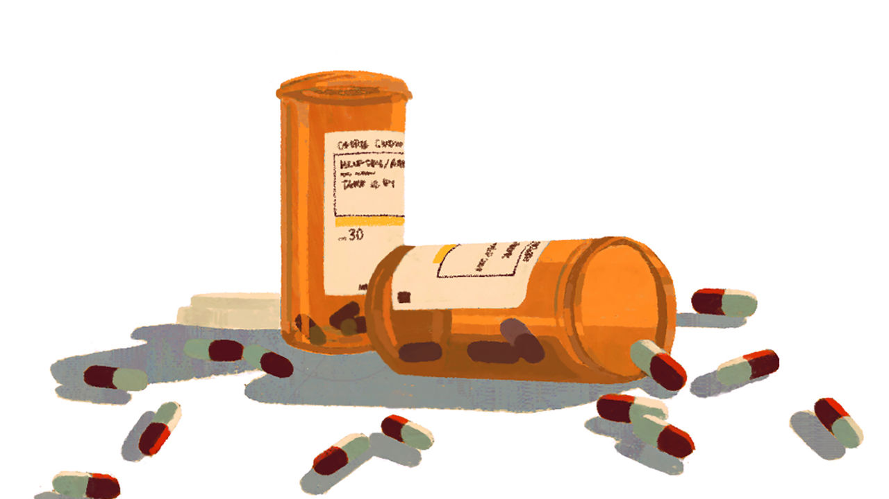

However, all it indicates is a somewhat higher risk, not the presence of the disease. For this two other sorts of “biomarker” are used. One is to measure levels of amyloid and tau in a person’s cerebrospinal fluid. This requires a lumbar puncture (the insertion of a needle into the lower spine). The other is a scan, usually a magnetic-resonance imaging (MRI) scan, to look at the size of the brain, along with a positron-emission tomography (PET) scan that can measure the build-up of amyloid.

Scanners are expensive and often unavailable. So the search is on for a simpler and cheaper approach. Many believe a blood test offers the best prospects. At the Alzheimer’s Association’s annual conference in July, hopes were raised by a test that could distinguish between Alzheimer’s and other neurodegenerative conditions, and spot those at risk years before symptoms appear. This measures a form of tau called p-tau217, and was found to predict Alzheimer’s with 96% accuracy. It is already possible, using the technique of mass spectrometry, to measure the level of beta-amyloid in the blood. But it is not known how this relates to levels in the brain. A trial in America last year found that the test matched the result of a PET scan 88% of the time, a hopeful result but not accurate enough for a clinical diagnostic test. The success rate rises to 94% if two other risk factors are considered: age and the presence of the ApoE4 gene.

Others look to the use of data and artificial intelligence (AI). Kurokawa Kiyoshi, a professor of medicine at the Graduate Institute for Policy Studies in Tokyo, argues that “data tech is progressing much faster than biotech”. Data research should allow more extensive mapping of correlations between physical conditions and behaviour and the later onset of dementia. Even without AI, scientists can detect evidence of dementia from how people use words. In her final novel, Iris Murdoch, who went on to develop severe Alzheimer’s, uses a more limited vocabulary and simpler language than in earlier works. Doctors analysing Ronald Reagan’s public pronouncements say signs of Alzheimer’s could be detected in his speech patterns years before his diagnosis in 1994.

Dementia could be prevented or delayed in 40% of cases by attacking 12 risk factors

Nowadays, the way people use digital technology—navigation apps, for example, since impaired spatial awareness and sense of direction are often early signs of dementia—may provide an early indication of cognitive decline. This raises the uncomfortable spectre of tech giants tracking their customers’ mental decay. Those worried will be only partly reassured by studies showing that the use of digital technology helps slow the process.

Even in the absence of data from apps, many factors have been linked to an increased or reduced risk of dementia. A study presented at the July Alzheimer’s Association conference estimated that dementia could be prevented or delayed in 40% of cases by attacking 12 risk factors. It added three (excessive drinking or incurring head injuries in middle life, and exposure to air pollution in old age) to nine already identified (including smoking, high blood pressure, obesity, hearing loss, less education and diabetes).

## Hearts and minds

“What is good for the heart is good for the brain” is a bromide often trotted out. So public-health campaigns intended to reduce the chances of developing heart disease, cancer and diabetes will also reduce dementia rates. Such is the fear of the disease that this should reinforce efforts to promote healthy ways of life. What else works against dementia is not certain, but it includes retaining social contacts and keeping an active mind (though learning something new such as a language is more effective than doing a familiar puzzle like a crossword every day).

Dr Kivipelto’s study in Finland (known as the “FINGER” trial), published in 2015, showed that changing ways of life could significantly reduce the rate of mental decline. Conducted among a group of 60- to 77-year olds with higher risk factors for dementia, it monitored and changed lifestyles and put them through “cognitive training”—computer-based mental gymnastics. She speculates that for some, part of the benefit may have come from learning to use computers and the internet for the first time.

There is evidence that the age-specific incidence of dementia is going down as lifestyles change, notably in Europe—and going up in others, such as China and Japan. A study published in the journal Neurology earlier this month followed nearly 50,000 people in America and Europe (clinically representative of no more than 16% of the world’s population) from 1988 to 2015. It found that 8.6% developed dementia. But the risk of being among them had, remarkably, fallen by an average of about 13% a decade, from about a one in four chance for a 75-year-old in 1995 to less than one in five now.

Yet however wholesome a person’s way of life and however much they stretch their minds by learning Tibetan or reading The Economist, they cannot eliminate the risk of dementia. For the foreseeable future, there is no cure and the world will keep growing older. So how to look after people with dementia, and how to pay for it, will be ever more pressing questions. ■

This article was downloaded by calibre from <https://www.economist.com/special-report/2020/08/27/the-search-for-a-cure-for-dementia-is-not-going-well>

|  |  |  |  |
| --- | --- | --- | --- |
| Previous | Articles | Sections | Next |

|  |  |  |  |
| --- | --- | --- | --- |
| Previous | Articles | Sections | Next |

#### Care

# The big question about dementia care is who is going to do it

The best care is “people-centred”, ie, labour-intensive

Aug 27th 2020 |

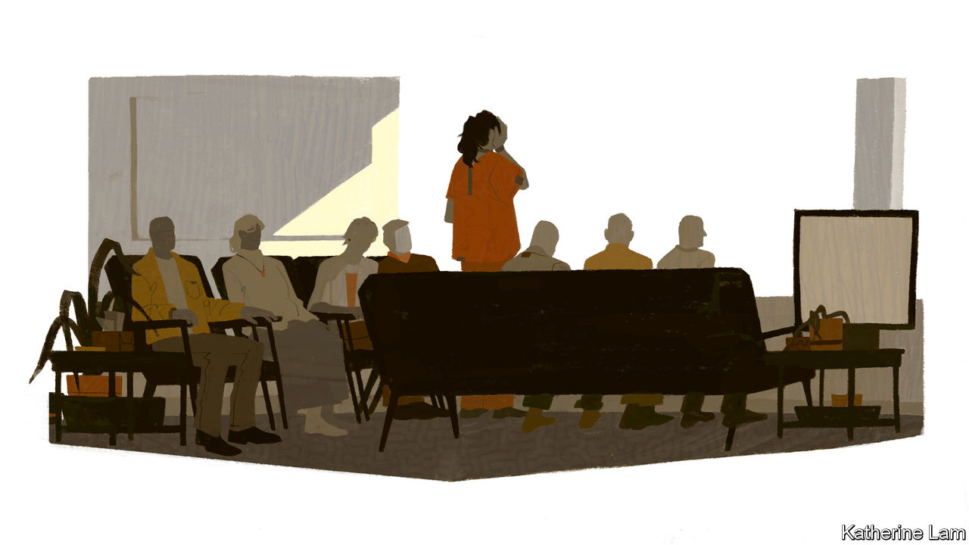

IN A TWO-STOREY building in a suburb of Tokyo, eight old people are sitting around tables in a spotless living room with a kitchenette attached. They are enjoying a quiz game, which entails shouting out the word that completes a well-known phrase or saying. One woman is first to all the answers, with nobody else getting a look-in. But, say staff at this care home, one of 280 run by Nichi Gakkan, a medical-services company, she forgets what happened ten minutes ago. The residents’ spartan rooms, with just a few keepsakes from home, have their photographs on the door, to make it easier to go to bed in the right one.

The house has 18 beds. All residents have dementia—mostly Alzheimer’s, but some cases of vascular dementia and one of the rarer fronto-temporal sort. The youngest is 69; half are over 90. They are encouraged to help with chores, such as folding their own laundry. Volunteers teach ikebana (flower arranging) and origami (paper folding). They watch, or sit through, a lot of television.

Most have families. But some never visit. To be honest, says one of the staff, it makes little difference. Residents often do not recognise loved ones. The best that can be hoped for is to offer a “safe and ordinary everyday life”. This is a top-of-the-range facility, with a lower ratio of residents to staff than in many other care homes: four people on duty in the day and two from 5pm to 8am. The cost is met by public insurance, residents’ pensions and savings, or by their families. Occasionally a resident has to leave for a cheaper home. Mostof them are here till they die.

Japan has the world’s oldest people, with 28% of the population aged 65 and over and 2.4m people over 90, including more than 70,000 centenarians. (In America, with a population two and a half times as big, 16% of the population are 65 or over, and there are 97,000 centenarians.) Japan also has the highest percentage of people with dementia of any country: about 4%, or 5m people. Since life expectancy at birth is high (81 for men, 87 for women), birth rates low (seven births per 1,000 people in 2019) and immigration tiny, this percentage is only going to grow.

Just behind Japan demographically are greying western European countries such as Italy and Portugal, and the Asian tigers: Hong Kong, Singapore, South Korea and Taiwan. These trends of longer lifespans and lower fertility rates will, barring disaster, be followed by the rest of the world. So how Japan copes with a problem that every country will have to confront is instructive.

It has advantages—notably prosperity, but also traditions of social cohesion and respect for the elderly, and sophisticated companies alert to the business opportunities in ageing. Nichi Gakkan, for example, was founded in 1968 to focus on medical administration and education. It moved into long-term care, which now accounts for 60% of its business, in 1996, ahead of a new insurance scheme that the government launched in 2000. Its home in Tokyo is a fine example of humane, dignified care for people with dementia, of whom it houses 130,000 across Japan. However, as the country’s demographic imbalance worsens, the shortage of places for the infirm elderly and those with dementia will become more acute. In 2018 Tokyo was reckoned to be short of 140,000 residential places for old people. Across Japan it is estimated that the number of care workers will need to increase sevenfold by 2030 from today’s 1.5m. On this basis, more than a tenth of the workforce will be working as carers.

This is a global phenomenon. Around the world, similar problems are sure to develop. In America in 2017, 1m sufferers from dementia (nearly one-fifth of the total) were in residential care. In Britain around 312,000 are in care homes, a number expected to rise to 417,000 by 2025 and 667,000 by 2040. So severe is the shortage of appropriate residential care that, before the covid-19 pandemic, a quarter of beds in National Health Service hospitals were said to be occupied by people with dementia.

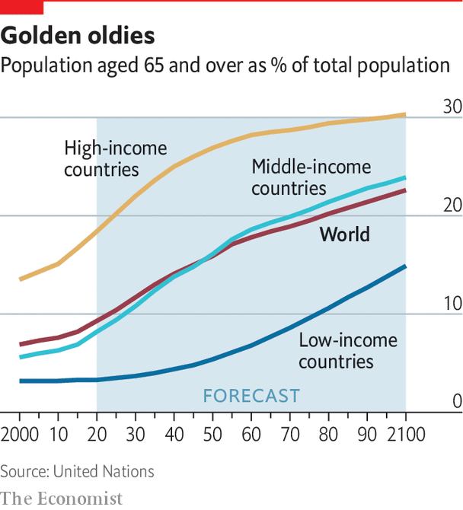

Many care homes are gruesome places, in which sedated residents sit or lie vacantly while overworked staff struggle to fulfil routines for administering medicine, food and exercise, and a television blares in a crowded living room. Efforts are being made to improve such homes, with more emphasis placed on treating residents as individuals. “Reminiscence therapy”, in which people are helped to remember events, people and places through sight, touch, taste, smell or sound can have remarkable results. Music seems especially potent. After caring for her mother and writing her book on dementia, Sally Magnusson founded a charity called “Playlist for Life”, devoted to producing musical life-soundtracks for people. So dementia care need not be grim.

In a much-praised example in the Netherlands, Hogeweyk, a “dementia village” in Weesp near Amsterdam, earlier this year housed 169 people with advanced dementia in 27 separate houses in one compound. Residents choose between four “lifestyles”—traditional, urban, formal and cosmopolitan—with decor, cuisine and activities adapted accordingly. It has its own grocery shop and a restaurant that is open to the public. Eloy van Hal, a founder of the centre, describes it as a shift from a medical and institutional model to a “social-relational, non-institutional” one. It is on the site of a conventional care home, and no bigger. Operating costs are no higher and can be covered by the Dutch long-term-care insurance scheme. Mr van Hal says the aim is that nothing should identify it as a “care home”. But it still has a flag outside advertising itself as such, and residents cannot go out at will.

In the Netherlands and elsewhere, much is done to help people with dementia stay at home for as long as possible. This is what they and their families often prefer. It also usually costs less than residential care. The average stay in Hogeweyk is just over two years, partly thanks to the support available to people in their own homes until they suffer serious impairment. Yet care at home can still place strain on caregivers. According to the OECD, the prevalence of mental-health problems among carers is 20% higher than among non-carers. In Japan there has been alarm over a series of “nursing murders”, in which caregivers have killed their charges. The stresses of tending for an invalid at home are also cited as a factor in many suicides.

Some places in Japan are bolstering care at home not just with visits from professional carers but by making daily life more “dementia-friendly”. According to the government, 12m people across the country have been given rudimentary training as “dementia supporters”. In Matsudo, a suburb of Tokyo, the local government and volunteers organise “dementia cafés”, weekly get-togethers for those with relatively mild dementia, for whom day-care facilities are not yet suitable. A volunteer at one describes how some people have been coming for two years and show no obvious signs of mental deterioration. The municipality is also trying to make the world outside safer. “Orange Patrols”, groups of five or six mostly elderly volunteers in hi-vis jackets, keep a lookout for endangered schoolchildren and disoriented old people.

People with dementia are also encouraged to carry a QR code on them, perhaps stuck to a walking-stick or hat, or on a lanyard. If somebody finds them looking lost (and, thanks to a vigorous public-information campaign, knows what to do) a smartphone scan of the code will reveal details about them. Takeuchi Wataro, of Mapple, a map and guidebook firm that sells codes on stickers at ¥1,800 ($17) for ten, says he was inspired by coming across a confused old man walking blithely across a six-lane highway.

## Home improvements

Looking after someone at home may not be possible for 24 hours a day. In Britain a surge in the number of dementia cases ending up in hospital seems linked to the closure of day-care centres, which offered both a social outlet that helps slow cognitive decline, and a much-needed respite for carers at home. Even better, some places offer overnight stays when needed.

Another way to keep people at home longer is through technology. In some public-housing blocks in Singapore, neighbours or family members of the vulnerable elderly will be alerted if, say, a tap in a washbasin has not been used for a while. Researchers at the UK Dementia Research Institute’s Care Research & Technology Centre, based at Imperial College London, are experimenting with taking this further. Infra-red and radar sensors installed in the homes of those with dementia, devices worn by them as watches, or hearing-aid type brain-scanners can all provide data giving early warning of signs of trouble. They might pick up indications of worsening dementia or a sickness. For example, blood-pressure and temperature measurements and frequent visits to the lavatory might indicate a urinary-tract infection (a common reason for people with dementia to end up in hospital, because they can be slow to respond to the symptoms).

As the numbers with the condition rise, in most countries it will be hard to find enough carers

There are also, inevitably, apps for dementia. “Refresh player” and “Refresh studio”, from a tech firm called “How do I?” offer “personalised memory support”, including videos on how to perform day-to-day tasks, such as run a bath or boil a kettle, which appear when a smartphone taps a code on a sticker on a once-familiar but now sometimes baffling object. They can also jog memories with videos or photos supplied by family and friends. Japan is pioneering the use of robotics in caring for the elderly. Toys such as Paro, a furry seal used as a “therapy animal”, and Pepper, a humanoid robot deployed in hundreds of care homes to play games, talk and demonstrate exercise moves, can help.

Nobody pretends that these can be a substitute for human care, especially for the bewildered. But they are at least a partial answer to the question that will determine the future of dementia care: who is going to do it? There are wonderful examples of “people-centred” care for dementia sufferers. But most are extremely labour-intensive (see [article](https://www.economist.com/node/21791110)). And as the number of cases rises inexorably, in most countries it will be hard to find enough people willing and able to take on the job.

This is partly a simple function of demography as society ages. But it is also partly because care workers often endure low status and low pay, a sad truth highlighted in the covid-19 pandemic as society leant on them more heavily than ever. In Britain, for example, under the new immigration policy the government is introducing for the post-Brexit world, most jobs in care will not pay high enough wages to allow employers to recruit overseas. Yet the industry relies on about 350,000 immigrant workers. A trade union has warned of a shortage of up to 500,000 workers in an industry that already has 8% of vacancies unfilled.

The ranking of such jobs as “unskilled” seems short-sighted. Camilla Cavendish, a journalist and policy wonk now again advising the government, led a review in 2013 of support workers in Britain’s health and social-care services. In a recent book (“Extra Time: Ten Lessons for an Ageing World”), she writes: “Care work is undervalued, underpaid, emotionally draining and physically exhausting. Yet it is, in my view, highly skilled. It requires enormous maturity and resilience; deep wells of kindness, too.”

Japan, in contrast, has been making it easier for foreign workers to come in for a few years. But cultural and language barriers are high, and the country starts from such a low base of immigration that this will not make much of a dent in its shortfall.

Adelina Comas-Herrera, a researcher at the London School of Economics, is leading a study into care in poorer countries (“Strengthening Responses to Dementia in Developing Countries” or STRiDE). She argues that what is needed, given the looming labour crunch, is a new model of collaborative care. This might involve using what institutional infrastructure exists for new purposes, especially in poor countries with few arrangements in place. In Vietnam, for example, the ruling Communist Party has a nationwide network of offices. Community centres might be transformed to offer a form of day care. Such adaptation may be better than building dementia-care services from scratch.■

This article was downloaded by calibre from <https://www.economist.com/special-report/2020/08/27/the-big-question-about-dementia-care-is-who-is-going-to-do-it>

|  |  |  |  |
| --- | --- | --- | --- |
| Previous | Articles | Sections | Next |

|  |  |  |  |
| --- | --- | --- | --- |
| Previous | Articles | Sections | Next |

#### Going abroad

# Might dementia tourism to lower-wage economies become a trend?

It will remain a niche market; but shows how the best care needs a lot of carers

Aug 27th 2020 | CHIANG MAI AND PHUKET



IN 2001, WHEN Martin Woodtli’s mother was diagnosed with Alzheimer’s, he was living in his native Switzerland. His father, who had a history of depression, had found himself living with a partner who no longer always knew who he was. He killed himself the next year. An only child, Mr Woodtli quit his job with a refugee-integration service, to become a full-time caregiver. He looked at care homes, but did not like them. His neighbours were sympathetic, but rather disapproving of a man in his 40s ditching his career to “waste his life” in this way. He thought of moving with his mother to Chiang Mai, a town of 127,000 in northern Thailand, where he had once worked on an AIDS project for Médecins Sans Frontières, an NGO.

He sought help from nurses through a local hospital, but then realised that his mother needed companions more than trained medical care, and for 24 hours a day. She was soon well looked after. He found a job, but it would have meant moving. He began to wonder if in fact he already had one: his experience with his mother might be the basis for a business.

It was. He found other clients, and a number of properties in a “village”—a Chiang Mai suburb. Now he runs a small but successful operation. Fourteen Europeans with dementia live there, mainly Swiss and Germans, all with access to 24-hour attention from one of the three carers dedicated to each of them, an unthinkable arrangement for all but the richest of the rich in Europe. In normal times (but not during the pandemic) they eat breakfast and lunch together in one of the houses and evening meals on their own. They have a swimming pool and a shop, used by the whole village. The Swiss wife of one resident lives nearby and describes the enormous improvement in her husband since their arrival. His bouts of physical aggression are over; he is taking less medication.

It is as close to a normal life as those with severe dementia are likely to find—except that it is far away from the homes and culture (and language) they knew. Their families, says Caleb Johnston of Newcastle University, who with Geraldine Pratt of the University of British Columbia in Vancouver, has researched the business, can be defensive. Yet guilt over having shipped their elderly to the other side of the world, where visiting is much harder, may be assuaged by the higher standards of care available at much lower cost.

Mr Woodtli is the unlikely founder of a mini-industry, in facilities marketing dementia care to foreigners, of which there are perhaps a dozen. Others, such as one run by two more Swiss expatriates, Carlo and Anita Somaini, on the island of Phuket, look more like luxury holiday resorts—but theirs has two emergency rooms for its 16 guests. The Somainis are branching into home care, offering home visits from trained dementia nurses.

Scaling up such operations is hard. Vivobene, a “long-stay resort with integrated care” 18km outside Chiang Mai, had some 50 residents, just over half with dementia. Carers outnumbered residents. It offered patient-centred care, based on the ideas of the late Thomas Kitwood, a British pioneer in dementia research, which call for a flexible approach based on individual needs, not a uniform set of daily targets (for walking, washing and eating). But a disagreement with the owners led the Swiss-directed medical and other staff to leave, taking most of the nursing residents with them to a new facility, to be known as “VivoCare”.

The number of dementia tourists in Thailand may be 150, mainly Americans, Britons, Germans and Italians. (Other countries such as Costa Rica, Mexico and the Philippines also have care homes for expatriates.) Mr Woodtli criticises some for merely adapting a failed model of large-scale care centres from the rich world. Rather, the method he devised for his mother shows what can be done to offer dementia patients the best individual care with a large number of skilled, dedicated, low-wage carers—and how far out of reach that is for most of the world.

This article was downloaded by calibre from <https://www.economist.com/special-report/2020/08/27/might-dementia-tourism-to-lower-wage-economies-become-a-trend>

|  |  |  |  |
| --- | --- | --- | --- |
| Previous | Articles | Sections | Next |

|  |  |  |  |
| --- | --- | --- | --- |
| Previous | Articles | Sections | Next |

#### Financing care

# No country has found a sustainable way to finance dementia care

And most have not even tried

Aug 27th 2020 |

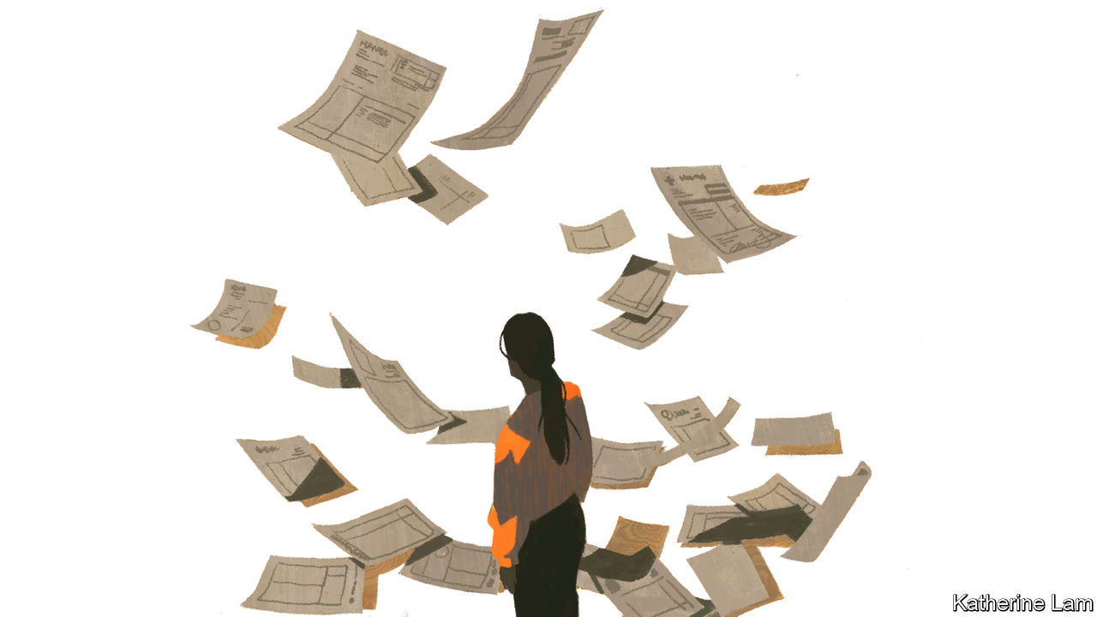

IT IS IMPOSSIBLE to quantify the most important of the costs of dementia: the losses to people living with the condition. In a forthcoming book, “The Great Demographic Reversal”, Charles Goodhart and Manoj Pradhan, two economists, suggest that surveys could be used to undertake a cost-benefit analysis of plans to spend more on dementia. A sample of adults could be asked how much annual income they would be prepared to pay to reduce the risk of developing dementia, as it mounts with age.

The results would be at best subjective and indicative, but better than nothing, which is all that is available now. Other costs—to those caring for people living with dementia and to the economy—are, in theory, more measurable. But the estimate cited earlier for the global cost of dementia, an annual $2trn by 2030 (up from $604bn in 2010 and $1trn in 2018), is little more than a guess. It relies on extrapolation from countries with good data to others with hardly any at all. And, as Marco Blom of the Alzheimer’s Society in the Netherlands points out, straight-line projections are likely to be exaggerated: 60-65% of the costs, he says, go to labour. There will be too few workers for their number to increase in tandem with rising dementia.

In ADI’s World Alzheimer Report in 2015, Martin Prince of King’s College London and others divided the costs between direct medical spending, social care and informal care. Direct medical costs were the smallest of the three, about one-fifth of the total, compared with twice as much for the other two. The distribution changes with a country’s income. More spending in the developing world falls on informal care in the family or village. In high-income countries 38% of costs are in informal care; in low-income countries, 69%. Partly for this reason, and because wages are higher, global costs are concentrated in rich countries. Although nearly 60% of people with dementia are in low or middle-income countries, 87% of the costs arise in high-income ones. In fact 62% of the costs are incurred in the G7 rich countries alone.

Every country must ask how these costs are to be met. With health budgets overwhelmed by covid-19, and public borrowing climbing to unprecedented heights to counter the virus’s economic impact, the question is harder to answer than ever. Should the government’s share, in public services or subsidies, be financed out of taxation? If so, the expected rise in spending is so large that tax rates might have to rise to politically unappealing levels. So more countries are looking at a special earmarked tax or at insurance. But that does not resolve the question of how costs should be divided between the state and individuals and their families, or how much families should pay directly towards care: everything they can afford, or only up to some limit?

As in so much else to do with old age, Japan has had little option but to confront the issue. Since 2000 it has had a universal long-term-care insurance system. This was modelled in part on a scheme introduced five years earlier in Germany, which has a private, compulsory scheme (the insurance is obligatory, but the insurers are private). But, unlike Pflegeversicherung (care insurance), Japan’s does not operate on strict insurance principles, with premium income covering costs. Rather, half of spending is covered out of general taxation. Nor does it allow people to take cash instead of services, ie, payment for care provided at home.

In the Japanese scheme (which Britain is said to be eyeing with interest), everyone aged 40-65 pays a premium, currently averaging ¥6,000, or about $57, a month. Regardless of income or wealth, those aged over 65 can claim benefits, after an assessment of needs based on a questionnaire and a doctor’s report. Beneficiaries must meet 10% of all costs themselves. In 2018, 5.5m people received benefits, about 15% of the over-65 population.

Officials at the Ministry of Health, Labour and Welfare concede that the scheme is not financially sustainable. Raising premiums will not be enough. Either other taxes will have to rise, or benefits must be cut, by increasing co-payments from beneficiaries or by means-testing. Lowering the age at which people contribute to below 40 is not being considered. It would be another tax on the young in a society already unduly skewed towards the old.

According to figures from the OECD, Japan spends a total of 1.8% of GDP on long-term care. That is above the OECD average, but far below the Netherlands, which spent 3.7% of GDP in 2018. And that was a decline from 3.9% of GDP in 2013, after a revamp of the scheme in 2015. In the Netherlands dementia accounts for a greater share of health spending (5.5% in 2011) than in most countries. The Dutch have had mandatory universal long-term-care insurance since 1968. Contributions and co-payments were linked to income. But coverage was generous compared with almost everywhere else. In 2000-13 spending on long-term care increased by an average of over 4% a year. The system came to be seen as unsustainable. Economies were made, including a tightening of admission criteria for residential care, to rule out those with relatively mild impairments. Some group homes had to close, or be converted into nursing homes.

A central element of the reform in 2015 was to separate three sorts of coverage, with different sources of financing, depending on the level of institutional and home-care need. This has stemmed spiralling costs. But it has created its own problems, since the barriers between different types of care are fuzzy, and the municipalities responsible for providing services have an incentive to shunt people into the third category, where the burden falls on the central government. The scheme is complex to navigate.

At least the Dutch have tried to tackle the issue. In America, Medicare, a public-health programme for those aged 65 and over, covers hospital care, some doctors’ fees and many medicines, but no more than 100 days of skilled nursing care. Residential care is not covered. And the cost of private long-term-care insurance is beyond the reach of many of those who will need it.

## Social carelessness

In Britain the issue of social care for those who need it has become a political football. Many Britons wrongly believe that the National Health Service covers them for all eventualities. In fact, though they are entitled to free treatment for cancer or other physical diseases, they must bear the costs of their own social care, down to the last £23,250 ($30,300) they have, after selling their homes. This strikes many people as unfair, and is frequently bemoaned as a “dementia lottery”, since the costs of social care for those with dementia are likely to be far higher than for others. Making matters worse, as the years have gone by, less money has been available for this means-tested system, even as the number of old people needing it has grown.

Repeated efforts have been made to tackle what has long been portrayed (more urgently since covid-19 infiltrated so many care homes) as a social-care emergency, both for people needing care and for those struggling to provide it. One, a commission led by Sir Andrew Dilnot, an economist, produced a report in 2011 that came close to producing legislation in 2015. It suggested that the state should put a cap on people’s total lifetime liability for the cost of social care (£35,000) and be responsible for anything above that. It would be, in Sir Andrew’s words “social insurance, collective provision with a relatively large excess”. But he points out that only about one in ten people needs such a big excess.

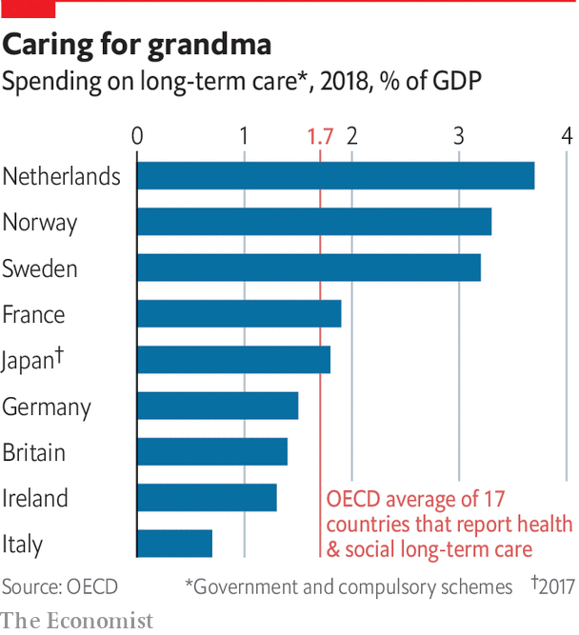

The suggestion was shelved as British politics was seized by the paroxysms of a series of elections and Brexit. In the 2017 election the Conservative Party’s proposals for what became derided as a “dementia tax” (it would have raised the £23,250 savings limit to £100,000) were partly blamed for its disappointing performance. In his first speech as prime minister in July 2019, Boris Johnson promised: “We will fix the crisis in social care once and for all, with a clear plan we have prepared.” He was rumoured to be contemplating a voluntary-insurance model. Speaking on a podcast last year for the King’s Fund, a British health-care think-tank, Sir Andrew said he found that improbable, since such a model has worked nowhere else. In March, when Mr Johnson’s chancellor of the exchequer delivered his first budget, consideration of social-care finance was deferred, as he understandably concentrated on the threat from covid-19. Few could argue with his priorities. However, campaigners for people with dementia complain that there is always an issue more urgent than theirs.

Ageing is going to require increasing amounts of labour to be redirected towards elderly care

If the governments of elderly, well-off Western countries are unable to make adequate financial arrangements to look after their old people, it is unsurprising that in the developing world preparations for a future in which people live longer and need more care in their later years are also limited. In China, the biggest of all, private insurance is virtually unavailable and “public financing for long-term care is minimal”, according to a note from the World Bank last year. It is confined to basic support for a minority of people who have no income and no family to support them, though some local governments also provide subsidies. Public spending on elderly-care services amounts to about 0.04% of GDP. Since 2016, 15 cities across the country have been running pilot schemes to test a long-term-care insurance facility. But it does not normally cover mental-health problems or dementia.

Financing the cost of care is just one aspect of the economic shift that ageing populations will bring. As Mr Goodhart and Mr Pradhan put it in their book, “the basic problem is that ageing is going to require increasing amounts of labour to be redirected towards elderly care at exactly the same time that the labour force starts shrinking.” They point out that, combined with other changes, such as the rising ages at which people marry and women have their first child, this has transformed life cycles. In the “old” cycle, 40 or 50 years ago, people could expect to spend the ages from 40 to 60 working with no surviving elderly relatives and no dependent children. In the new one, from 30 to 50, people will be both working and supporting children. From 50 to 67, they will still be working but will have parents dependent on them. In China, as those born under the “one child” policy from 1980 reach old age, many sets of four grandparents will have but one grandchild between them.

The diversion of much of the labour force to the care industry means that the rest of it will have to raise its productivity to compensate. In most rich countries there will be a chronic shortage of workers willing and able to take on jobs in the care sector. The authors agree with Japan’s health ministry: finance is a huge problem. But the real crisis will be a lack of carers.■

This article was downloaded by calibre from <https://www.economist.com/special-report/2020/08/27/no-country-has-found-a-sustainable-way-to-finance-dementia-care>

|  |  |  |  |
| --- | --- | --- | --- |
| Previous | Articles | Sections | Next |

|  |  |  |  |
| --- | --- | --- | --- |
| Previous | Articles | Sections | Next |

#### Ethics

# Too often the basic rights of people with dementia are overlooked

But trying to respect them can raise painful ethical dilemmas

Aug 27th 2020 |

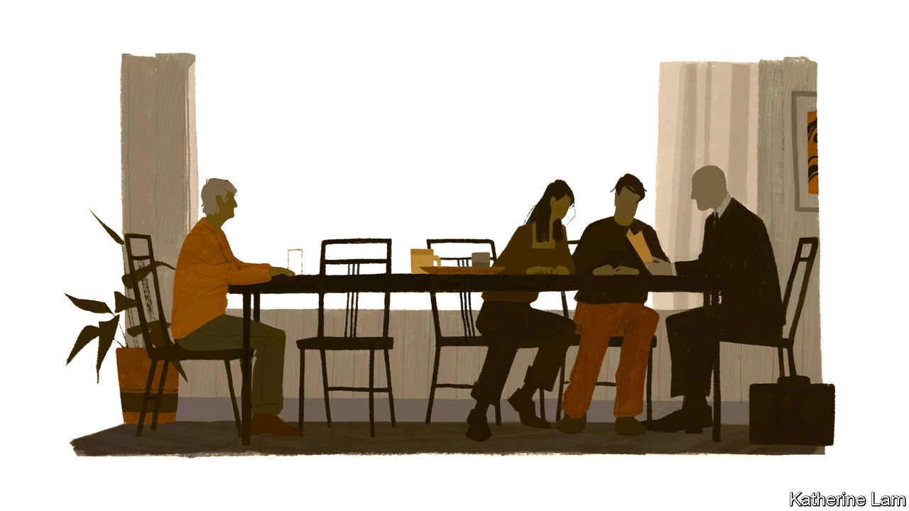

A FEW MONTHS before Vera mistook her grandson for a coconut, her son came by with someone she did not recognise. He was indeed a stranger, a local solicitor. He gave her a paper to sign, having first checked that she was fully aware of what she was doing, indeed, “as sharp as two tacks”. Thus did she sign away her money, property and decision-making rights to her son, this writer. The solicitor was right to think that he had only benevolent intentions. But this was a process, like many others, in which the rights of people with dementia can easily be forgotten.

The dilemmas start with diagnosis. With no cure on offer, and diagnostic tools crude and capable of getting it wrong, not everyone thinks people should be told they have early-stage dementia. Some may cope perfectly well with MCI and lose confidence only if given a diagnosis that sounds like a brain-death sentence. But most charities argue that early diagnosis is both their right, and helpful in making care arrangements—and indeed plans to hand over decision-making in good time.

In fact, relinquishment of legal rights is covered by strict laws, and is used more often to protect than to exploit. At some point, people with advanced dementia need help in making even basic decisions. But some countries now ensure greater protection for those signing away their rights. South Korea has amended its guardianship law from one with only the option to surrender all legal rights into one where “full” guardianship is a choice, with others allowing specific sorts of decisions to be delegated.

The problem is at its most acute in countries where euthanasia or assisted suicide is allowed

These decisions can be matters of life and death. Suppose somebody wants to live but refuses life-saving medicine. Or suppose they cannot bear the thought of becoming totally dependent, helpless and confused and sign an instruction that they do not want to be revived if seriously ill, but then change their mind. Susan Cahill, of Trinity College, Dublin, argues in her 2018 book, “Dementia and Human Rights”, that often “the ‘best guess’ of a trusted and chosen supporter, based on all the knowledge gathered about the person’s past and present wishes, hopes and aspirations for her life, values and beliefs, is the most that can be achieved.”

The problem is most acute in countries where euthanasia or assisted suicide is allowed. In 2017 in the Netherlands 6,585 people died in one of these ways, with 166 having early-stage dementia and three advanced dementia. That so few reached the advanced stage is not surprising. People often write “advance euthanasia directives” (AEDS) saying they want to die if they can no longer recognise members of their own family. But by then, they may not grasp that they are going to die and be unable to repeat their wish; or, such is the human capacity for adaptation, they may have reconciled themselves to impaired cognition and no longer want to die. The law permits euthanasia in cases of “unbearable suffering”. But for severe dementia, that may be impossible to prove.

The Dutch law was tested last year. Prosecutors brought charges to seek clarification, rather than punishment, for a doctor who was seen to have acted with the best intentions. The patient was a 74-year-old woman with severe Alzheimer’s, who four years earlier had written an AED requesting euthanasia rather than go into a care home. But she added that she wanted “to be able to decide [when to die] while still in my senses and when I think the time is right.” With the consent of her family, the doctor gave the woman a sedative before the final act. But she woke up and had to be restrained to receive the lethal injection.

Such choices are agonising, pitting the rights of a person with unimpaired faculties against those of the same person with advanced dementia. The consequence, as can be seen from the Dutch numbers, is that people have to choose a shorter life than they might otherwise have lived, to be sure of being able to decide when to end it. The only cure for dementia, after all, is death.

Ethical dilemmas such as these seem insoluble. But that they are being confronted is a sign that attitudes to dementia are changing. Whether the condition is seen as an inescapable part of the ageing process, or as a symptom of a common disease, there is a tendency to let it define a person. Of all the stigmas it carries, perhaps the worst is the prejudice that people with dementia are less than fully human. They are often talked about, in their presence, even by those who love them, as if they are not there.

So many covid-19 victims have had dementia that the pandemic might have prompted soul-searching about these attitudes. Yet it has not. Many families worry that, when patients are selected for access to scarce medical resources, those with dementia come last, based on questionable assumptions about their quality of life. If and when a covid-19 vaccine becomes available, the same issue will arise: will those with dementia be first to get it, as among the most at risk? Or will preference be given to other vulnerable groups? Nobody is going to argue that those with dementia matter less than others. So public debate on these issues is almost non-existent.

Before covid-19, campaigners had reason to believe that they were making progress with the argument that dementia is not an inevitable feature of ageing but a disability that should be treated as such. And it seemed that governments were accepting that dementia is a global emergency, arriving with the remorseless logic and unstoppable force of demography: longer lifespans and a shrinking share of the population of working age. Covid-19 may have made a difference in the cruellest of ways, by killing hundreds of thousands of people with dementia, and, more hopefully, by encouraging public-health campaigns to resist a return of the pandemic that will, incidentally, protect more against dementia. Yet the fundamental problems will remain: most important, not enough people to care for the tens of millions with dementia, but also not enough resources for understanding, ameliorating or curing the condition, or for looking after people who have to live with it.

Optimists may point to the covid-19 pandemic to argue that it shows how much can be achieved when the scale of an emergency is recognised and resources are thrown at it. Perhaps more realistically, it has given one more reason for policymakers to be more preoccupied by another looming emergency instead.■

This article was downloaded by calibre from <https://www.economist.com/special-report/2020/08/27/too-often-the-basic-rights-of-people-with-dementia-are-overlooked>

|  |  |  |  |
| --- | --- | --- | --- |
| Previous | Articles | Sections | Next |

|  |  |  |
| --- | --- | --- |
| Special report | Sections | Finance & economics |

Business

Hollywood and China: Red carpet

.

German blue chips: Ascend and deliver

.

Health care: Left to their own devices

.

Energy utilities: Lit

.

Bribery: A closer look at greasy palms

.

Palantir Technologies: A prickly patriot

.

Schumpeter: For your eyes only

.

|  |  |  |
| --- | --- | --- |
| Special report | Sections | Finance & economics |

|  |  |  |  |
| --- | --- | --- | --- |
|  | Articles | Sections | Next |

#### Red carpet

# Hollywood’s Chinese conundrums

China’s box office is poised to become the world’s biggest. What does that mean for Hollywood—and America’s soft power?

Aug 29th 2020 |

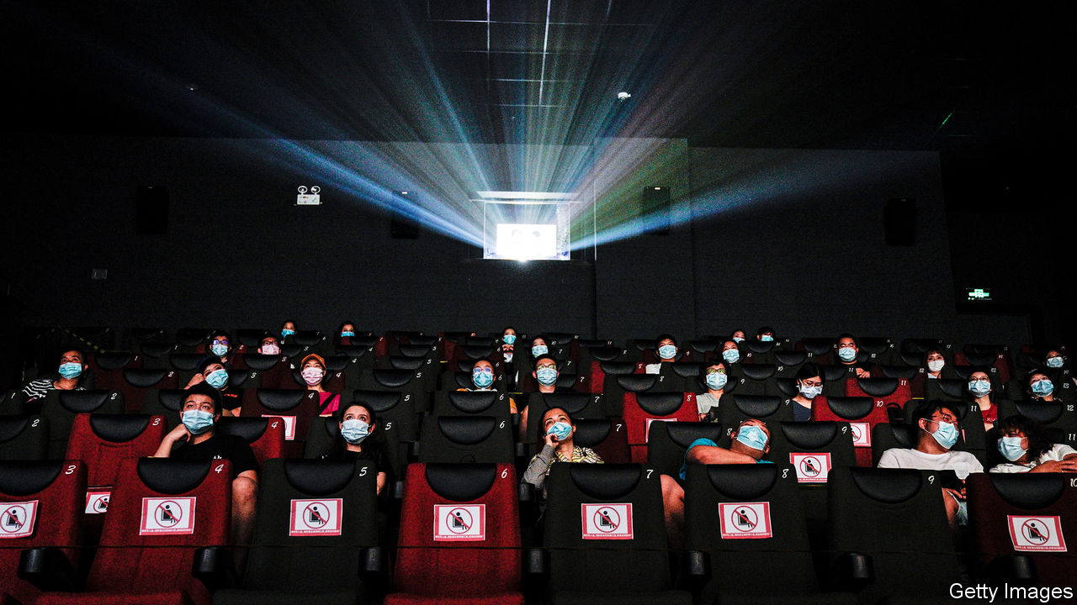

HORDES OF INVADERS gallop into China, armed with sinister, supernatural powers. As they thunder towards the capital, it falls to a simple country girl to foil the attack. Over mountains and across deserts, dodging arrows and unleashing batteries of fireworks, in 115 action-packed minutes plucky Hua Mulan sees off the dastardly foreigners and brings honour to China.

“Mulan”, which opens on September 4th, is a tale of invasion in more ways than one. Disney, Hollywood’s biggest film studio, has spent five years and $200m on the live-action remake of its 22-year-old animation, in the hope of conquering the Chinese box office. The film is calibrated to appeal to Asian as well as American audiences, from its plot (Mulan’s sidekick, a wisecracking dragon who irritated the Chinese, was written out of the story) to its promotional campaign (Disney touted its release in the form of a classical Chinese poem). “Shang-Chi and the Legend of the Ten Rings”, Disney’s first Chinese-themed superhero movie, is due next year. There is already talk of a “Mulan” sequel.

Hollywood has reason to look across the Pacific. In the past 15 years China’s box-office takings have risen 35-fold, to $9.7bn. That is not far off America’s $11.1bn. This year receipts have sunk as covid-19 forced cinemas to shut. But they may fall a bit less precipitously in China, which after early cover-ups has controlled the virus better than America, where most theatres remain closed (and where “Mulan” is going straight to streaming). China may emerge from the pandemic with the world’s biggest box office (see chart 1).

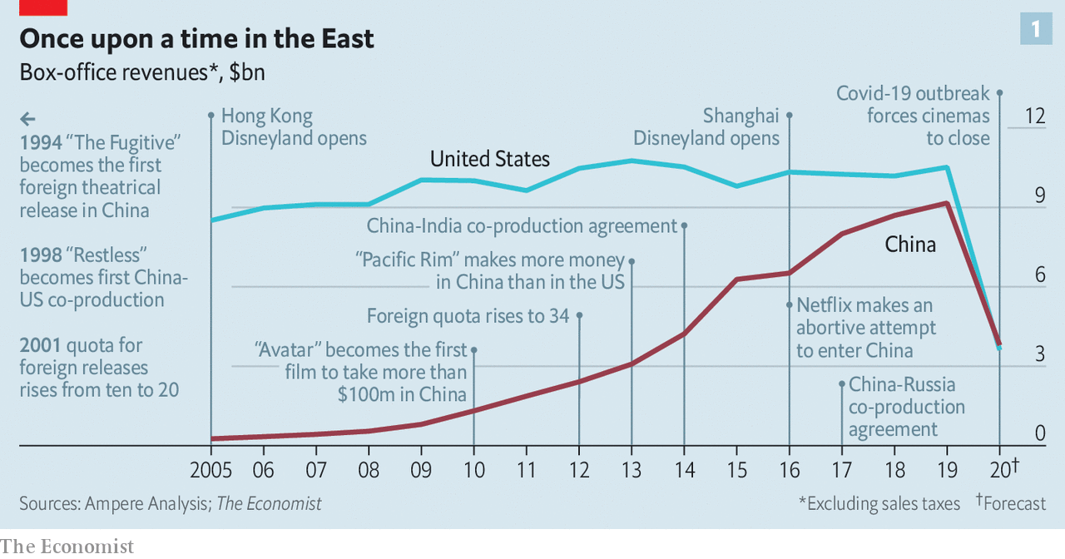

The country was becoming central to Hollywood’s business before covid-19. America’s blockbusters have increasingly relied on Chinese audiences to recoup their vast production budgets and American studios have tapped Chinese investors for finance. Between 2010 and 2019 Disney’s share of revenues from Asia nearly doubled to 11.5% and now rivals that from Europe. Hong Kong and Shanghai each has a Disneyland. Universal (owned by Comcast, a cable giant) is building a theme park in Beijing. Sony, a Japanese conglomerate with a big entertainment division that includes Columbia Pictures, last year earned 10.2% of its revenues in China, up from 6.7% five years earlier.

However, Hollywood’s desire to capture both Eastern and Western imaginations—and wallets—increasingly faces two sets of problems in China. First, mainland studios are giving Tinseltown a run for its money on their home turf. And China’s censors are becoming more active in shaping the tales that Hollywood tells, imbuing America’s soft power with Chinese characteristics and angering American politicians. The great screen romance between Hollywood and China is turning into more of a drama.

China raised the curtain on regular Hollywood releases in 1994. The market was tiny—“The Fugitive”, the first American film to be shown in cinemas that year, made just $3m—and the bureaucracy stifling. Imports were limited to ten a year. Their makers were allocated just 13% of a film’s box-office takings. The rest reserved for cinemas and distributors.

Slowly the rules were relaxed. In 2001 the foreign-film quota doubled to 20. A decade later it rose to 34, and producers’ revenue share went up to 25%. Foreign studios also discovered co-production. Movies made in partnership with a Chinese company qualify as domestic and are thus exempt from the quota system. They also entitle the studio to as much as 43% of the box office and better release dates; usually only domestic films are awarded slots during the four main holidays—spring, summer, national day and Chinese new year—when around half the year’s tickets are sold.

At the same time, China’s growing middle class was developing a taste for cinema. In 2005 China had 4,000 theatre screens, slightly more than Britain at the time. Last year it had nearly 70,000, according to Omdia, a market-research company, almost equal to America and Europe combined.

## Blow-Up

By 2007 American studios ruled the Chinese box office, making 16 of the 25 highest-grossing films, according to Box Office Mojo, part of IMDbPro, a data company. In 2013 “Pacific Rim”, a robots-versus-monsters romp produced by Legendary Pictures, became the first American blockbuster to take more money in China than at home. After that, recalls Peter Loehr, former head of Legendary’s China division, Hollywood studios that did not yet have offices in China quickly established them.

As Chinese audiences flocked to watch American films, Chinese media and tech companies rushed to invest in them. In 2016 Dalian Wanda Group, a conglomerate, bought Legendary for $3.5bn. It also snapped up real estate next to the Beverly Hilton hotel in the heart of Tinseltown. In 2013, at the launch of its own huge studio in Qingdao, the Oriental Movie Metropolis, Dalian Wanda paid stars including Leonardo DiCaprio and Nicole Kidman to attend. This marked the start of a “three-year feeding frenzy, where everybody was happy to take these idiots’ money”, recalls one former Hollywood bigwig. Like the Japanese and the Arabs before them, he says, the Chinese discovered that when you hand out dosh, “people here will take it from you, in exchange for allowing you to come to a party with some semi-famous people”.

In the past few years, though, Chinese studios have grown less infatuated with Hollywood—and more sophisticated. They have splurged on sound stages and other studio infrastructure. Hengdian World Studios in Zhejiang, Shanghai Film Studio and August First Film Studio in Beijing, as well as Dalian Wanda’s Movie Metropolis, have been enlarged and upgraded. Co-productions with Americans have sharpened Chinese film-makers’ skills and given them international contacts, notes Wendy Su of the University of California, Riverside. Special effects, where the West remains in the lead, can be farmed out. “The Eight Hundred”, a recently released war drama produced by Beijing-based CMC Pictures, subcontracted its visual effects to companies including DNEG, a British firm, and Rising Sun Pictures, an Australian one.

Rao Shuguang, secretary-general of the (Communist Party-led) China Film Association, says that along with “substantial” improvement in quality, China is exploring new genres. This month film authorities issued new guidelines for science-fiction films, which they used to frown upon. Sci-fi is to “disseminate scientific thought” and “raise the spirit of scientists”.

Chinese films, sci-fi or otherwise, are certainly getting more entertaining. “The Wandering Earth”, a sci-fi thriller made by the China Film Group Corporation (CFGC) took around $700m last year. So did Beijing Enlight Pictures’ “Ne Zha”, an animated tale of demons and spirits based on a 16thcentury novel. These slick, home-grown blockbusters pushed Disney’s “Avengers: Endgame”—the highest-grossing movie in history by worldwide receipts—into third place at China’s box office. In a reversal of fortunes from a decade ago, 17 of the 25 highest-grossing films in China were Chinese, including eight in the top ten; only eight were American (see chart 2).

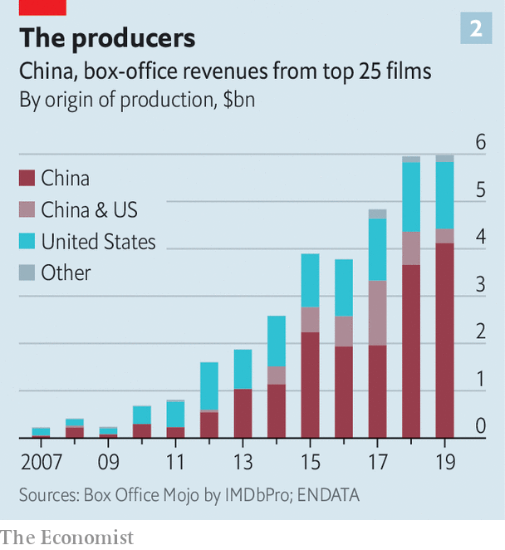

Audiences in big Chinese cities like Beijing and Shanghai can relate to Western fare, says Lei Ming of ABD Entertainment, an audience-analysis firm, but people in smaller, provincial cities do not. And they are the fastest-growing audience: third-tier and fourth-tier cities, roughly those with fewer than 3m residents, account for 40% and rising of China’s box office, according to Maoyang, a ticketing platform.

Now Hollywood’s commercial challenges are increasingly compounded by political ones. Peter Shiao, who in 1998 produced the first Sino-American co-production, “Restless”, talks of a “climate of increasing suspicion on both sides”.

Under Xi Jinping, China’s party chief since 2012, a period of relative openness to outsiders has given way to a more nationalistic sentiment. In an effort to make China a “strong cultural nation”, Mr Xi’s government has not only put the brakes on extravagant foreign investments, forcing Dalian Wanda to sell its Hollywood digs, among other things, but also made it harder for American studios to do business in China. It is strictly enforcing rules that require co-productions to have at least one-third of their investment from Chinese partners, at least one scene shot in China and a cast that is at least one-third Chinese.

These days co-productions are “almost impossible to approve”, Mr Shiao laments. Disney, which had hoped its Shanghai theme park might buy it more access to Chinese television, has been disappointed. In 2016 Netflix tried to enter China but hit snags with technology and, above all, content control; for instance, censors considered “BoJack Horseman”, a cartoon about an alcoholic, anthropomorphic horse, an example of “funeral culture”. “The Chinese have no intention whatsoever of allowing non-Chinese media brands to operate in China,” sighs one person involved in that unhappy experiment. One American producer fears that China might target Hollywood in retaliation for President Donald Trump’s swipes at Chinese companies like Huawei, a telecoms giant, and TikTok, a hit video app. Mr Trump’s campaign to force TikTok’s sale to American investors led its American boss, Kevin Mayer (himself a former Disney executive) to quit this week after only three months in the job.

## Good Will Hunting

For American critics the biggest concern is over China’s attempts to bend Hollywood’s stories to its will. Communist censors have long harried film-makers, banning not just the “three Ts” of Tiananmen, Tibet and Taiwan, but themes such as time-travel and the supernatural; China blocked “Pirates of the Caribbean: Dead Man’s Chest”, objecting not to the piracy but to the ghosts. Films that break these or other unwritten rules may be banned, sent back for edits or, for lesser offences, get a duff release date or curtailed advertising budget, the size of which is regulated in China. In an internal email from 2014 disclosed by WikiLeaks, a senior Sony executive wrote of “censorship really hassling us” about a scene in “RoboCop” where the cyborg hero’s human remains are exposed. “Don’t think we can make a stand on it either way, too much money on the line,” he summed up.

Some censor-pleasing tweaks are harmless, like Paramount Pictures’ removal of dirty laundry from a Shanghai skyline in “Mission: Impossible III” (2006). Others can be consequential. “Abominable” (2019), an animated co-production by DreamWorks and Pearl Studio about a lost yeti, featured a map endorsing China’s bogus claim to the South China Sea but no mention of Tibet—never mind that the entire film is about a journey to Mount Everest. Then there are films that are not being made. “Not many people are going to want to go out and make any movies about the Uighurs,” admits one former Hollywood executive, referring to China’s persecuted Muslim minority.

In July William Barr, America’s attorney-general, accused Hollywood of handing China “a massive propaganda coup”, citing Paramount’s decision to remove a scene in “World War Z” in which characters speculate that a deadly virus may have originated in China. Ted Cruz, a Republican senator, has proposed that studios which kowtow to the Chinese Communist Party should be banned from filming with America’s armed forces. Stan Rosen, a China expert at the University of Southern California, wonders if studio chiefs may soon be called to give evidence before Congress.

Studio executives complain privately that every industry dealing with China faces ethical dilemmas, and that bashing liberal Hollywood is just Republican electioneering. But criticisms are not limited to conservative voices. Last month PEN America, a free-speech organisation, concluded in a report that “Hollywood’s decision-makers are increasingly envisioning the desires of the CCP [Chinese Communist Party] censor when deciding what film projects to greenlight, what content these films contain, who should work on the films, and what messages the films should implicitly or explicitly contain.”

China may be especially keen to shape Hollywood’s storytelling because it struggles to break through with its own narratives beyond its borders. Since the early 2000s American studios have made more money at the international box office than at home. These days about two-thirds of their ticket revenues come from abroad. Chinese productions, by contrast, seldom make much money outside China. “Wolf Warrior 2” (2017), China’s highest-grossing film, produced by CFGC and others, took less than 2% of its $870m haul overseas. (Its tagline—“Anyone who offends China, no matter how remote, must be exterminated”—will not have helped.)

Global audiences will not flock to Chinese blockbusters soon. For one thing, there may be fewer of them to see in the coming years. Cecilia Yau of PwC, a consultancy, expects investments in film-making to decline as a result of covid-19. Chinese films make 80-90% of their money at the cinema, estimates Mr Lei of ADB Entertainment, so lower theatre attendance means lower returns for investors.



In America, by contrast, a film’s takings at the theatre are usually eclipsed by what it earns through television rights, merchandising, video-game licensing and so on. It therefore makes sense for American studios to produce films and send them straight to streaming, as Disney is doing with “Mulan” in many markets. Disney’s films are in effect merely the intellectual-property engine that drives a much larger machine. Before social-distancing edicts obliterated businesses that rely on crowds, it made an annual operating profit of $2.7bn directly from its films and another $6.8bn from the parks, cruises and products that piggyback off them. These profits should return after the pandemic.

That ought to put American studios in a better position than Chinese rivals to keep telling stories in a world of declining cinema attendance—a trend that long predates covid-19. The average American visited the cinema 3.5 times last year, down from five times at the turn of the century. In China ticket sales have begun to slow as more people plump for local streaming services such as iQiyi and Tencent Video.

## Project Power

What the shift to streaming means for American soft power is less clear. One possible effect is that East and West will consume less culture in common. At the cinema audiences often soak up stories from all over the world. As they turn to streaming they could do the same; Netflix is replete with local productions. But they more often consume content tailored to their country—and in China, almost exclusively so. The cultural and commercial tussle for global imaginations goes on for now. But one day it may see Americans and Chinese mutually retreat to their own, national, small screens instead.■

This article was downloaded by calibre from <https://www.economist.com/business/2020/08/29/hollywoods-chinese-conundrums>

|  |  |  |  |
| --- | --- | --- | --- |
|  | Articles | Sections | Next |

|  |  |  |  |
| --- | --- | --- | --- |
| Previous | Articles | Sections | Next |

#### Ascend and deliver

# Delivery Hero is Germany’s newest blue chip

The food-delivery firm could last longer in the DAX 30 index than the firm it replaced

Aug 27th 2020 | BERLIN

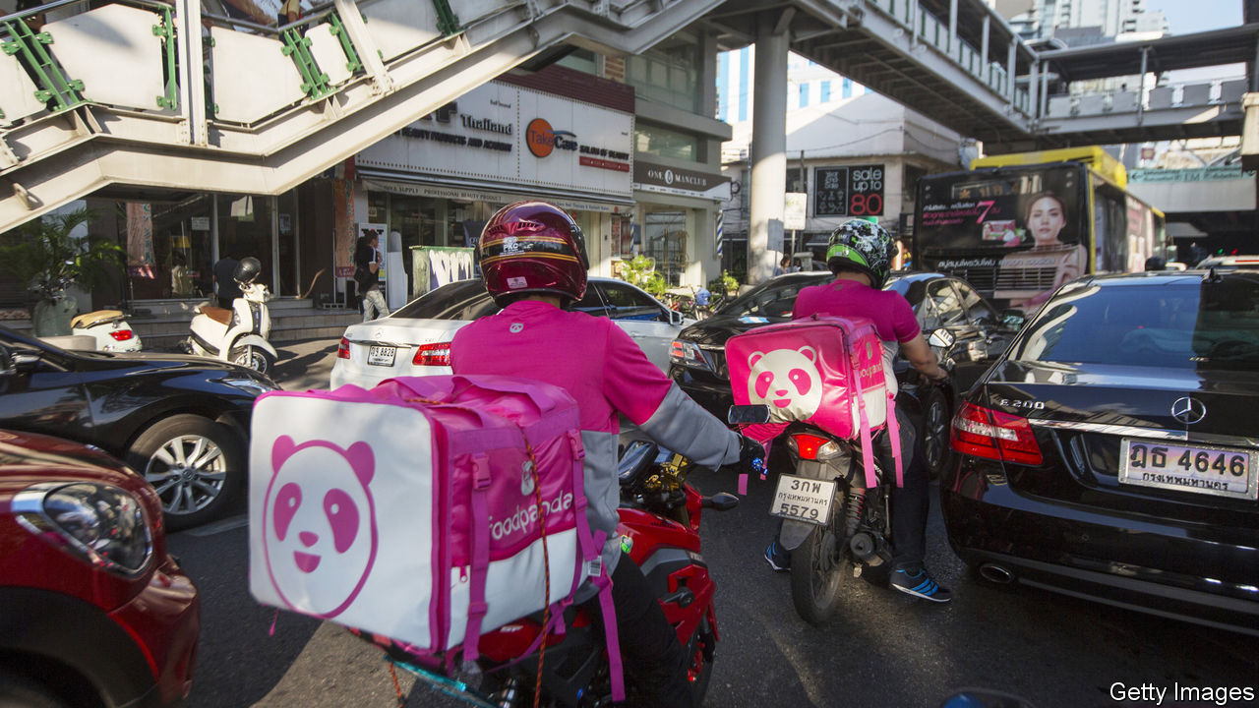

JOINING THE index of Germany’s 30 biggest listed companies is usually a cause of celebration for the joiner rather than of controversy. Yet the arrival of Delivery Hero in the DAX 30 on August 24th ignited a fierce debate. How, critics grumble, can a food-delivery company that has never made money or paid a dividend, and no longer even does business in Germany, sit alongside Siemens, a 173-year-old engineering behemoth, and Volkswagen, Europe’s biggest carmaker, in the elite group of the bluest of German blue chips?

The simple answer is that membership of theDAX is determined mainly by market value and turnover of shares, with no profitability test (unlike America’s S&P 500 index of big firms, which requires four consecutive quarters in the black, among other criteria). And in that respect, Delivery Hero qualifies handily. Niklas Ostberg, its Swedish chief executive, boasts that the firm’s market capitalisation of €18.7bn ($22bn) is higher than that of several DAX members. Its share price has tripled over the past couple of years and it has attracted investments from the world’s richest companies, including Alibaba and Amazon, two global internet giants.

Ironically, a big reason for investors’ enthusiasm is Delivery Hero’s non-German focus. A few years ago it offloaded its German businesses, Foodora, Lieferheld and Pizza.de, to Takeaway, a Dutch competitor. Since then it has eyed expansion in the Middle East and Asia. At the end of last year 50% of the company’s revenue came from the Middle East and north Africa, 30% from Asia and 12% from Europe. “It is today essentially an emerging-markets business,” says Monique Pollard of Citigroup.

Many food-delivery firms do not operate their own fleets of vehicles but instead match consumers with restaurants and riders. That means they must share their cut with both restaurants and riders. “It is very hard to make a profit with the three-way-split model in Europe,” explains Andrew Gwynn of Exane BNP Paribas. But the model works in emerging markets where order sizes are large and delivery workers’ wages low.

Delivery Hero could become a viable business, if it manages to keep its focus on the developing world and stay on top of the next wave of consolidation, which began with the combination of Just Eat and Takeaway, two European firms, earlier this year, and their proposed takeover of America’s Grubhub in June. At the very least it has a decent shot at staying in the DAX longer that firm it replaced. Wirecard, a payments-processor bankrupted earlier this year by a huge accounting fraud, was booted out of the index barely two years after its own ascension. ■

This article was downloaded by calibre from <https://www.economist.com/business/2020/08/27/delivery-hero-is-germanys-newest-blue-chip>

|  |  |  |  |
| --- | --- | --- | --- |
| Previous | Articles | Sections | Next |

|  |  |  |  |
| --- | --- | --- | --- |
| Previous | Articles | Sections | Next |

#### Left to their own devices

# Covid-19 has been a mixed blessing for makers of medical equipment

Medtronic, an American medical-device giant, offers an illustration

Aug 29th 2020 | NEW YORK

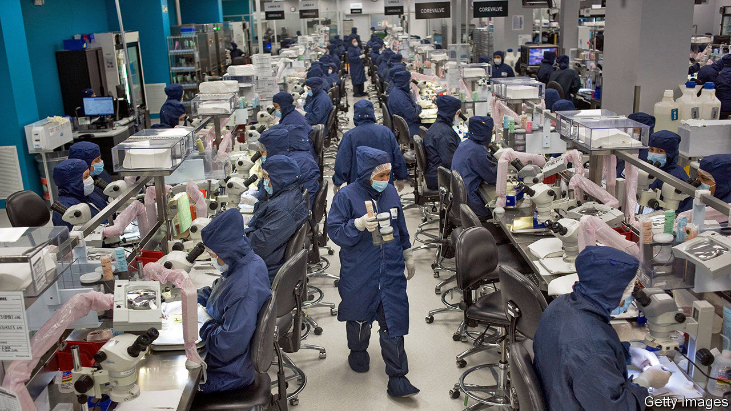

FEW INDUSTRIES have whipsawed in the covid-19 recession as violently as medical-device makers. The pandemic led to a collapse in elective medical procedures requiring their sophisticated kit, dealing a powerful blow to sales. At the same time, the crisis created opportunities for firms making ventilators and testing kit.

For an illustration of how this dynamic has played out, consider Medtronic. On August 25th the American giant, with a market capitalisation of $138bn, reported its financial results for the three months to July. On the face of it, its performance was abysmal. Revenues fell by 17% compared with the same quarter a year ago, to $6.5bn. Net income plunged by nearly half. Citing the pandemic, the firm refused to provide earnings guidance.

And yet investors and analysts cheered. One reason is that they had feared worse: Medtronic handily beat forecasts for both revenues and earnings. Another is that sales of ventilators shot up five-fold, cushioning overall revenues. Geoff Martha, the firm’s boss, now expects a return to “normal growth” within a few quarters.

The revival at Medtronic might augur a broader return to form for medical-device firms. Matt Miksic of Credit Suisse, an investment bank, notes that these companies came into the crisis “with the wind at their backs”. They were propelled by strong growth in global revenues. Last year KPMG, a consultancy, had forecast global sales to rise from to $795bn in 2030, from $371bn in 2015. Tim van Biesen of Bain, a consultancy, points to a pre-pandemic boom in sales of highly profitable devices used in orthopaedics, neurosurgery and cardiovascular procedures. As result, in the past five years share prices have outpaced both Big Pharma and the S&P 500 index of large firms (see chart).

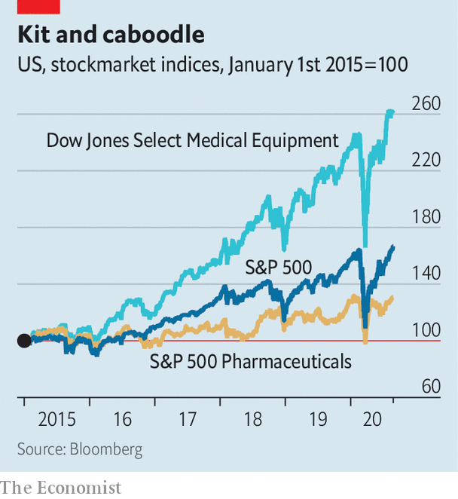

Whether or not this outperformance can last depends in large part on the path of the pandemic. To flog their lucrative devices and associated services, kit-makers rely on an army of highly trained sales representatives to win over doctors and train them. A survey by Bain found that nine in ten medics wanted in-person interactions with device salespeople before covid-19. As Mr van Biesen explains, many surgeons value advice from top-flight reps, who know their company’s cutting-edge technologies better than doctors do, during complex surgeries. Some even depend on those reps to lay out preferred instruments before operations. Now Bain finds that more than 60% of surgeons foresee restrictions on such in-person contacts.

A prolonged period of restricted access could affect the industry in unexpected ways. Big companies may lose business from ambulatory-care centres, reckons Mr van Biesen. These tend to be smaller than hospitals, more cost-conscious—and less wedded to both expensive brands and their sales reps. But Mr Miksic thinks that in specialities like spinal surgery, where a high degree of on-site service is common, the lack of access may entrench incumbents and hobble upstarts. This week Medtronic boasted that it was gaining market share in its largest businesses. If the firm “is finding a new gear”, as Mr Martha crows, it is thanks to old-gear sales. ■

This article was downloaded by calibre from <https://www.economist.com/business/2020/08/29/covid-19-has-been-a-mixed-blessing-for-makers-of-medical-equipment>

|  |  |  |  |
| --- | --- | --- | --- |
| Previous | Articles | Sections | Next |

|  |  |  |  |
| --- | --- | --- | --- |
| Previous | Articles | Sections | Next |

#### Lit

# Businesses compete to battle California’s blackouts

Green companies vie not just to generate power but also to store and manage it

Aug 29th 2020 | NEW YORK

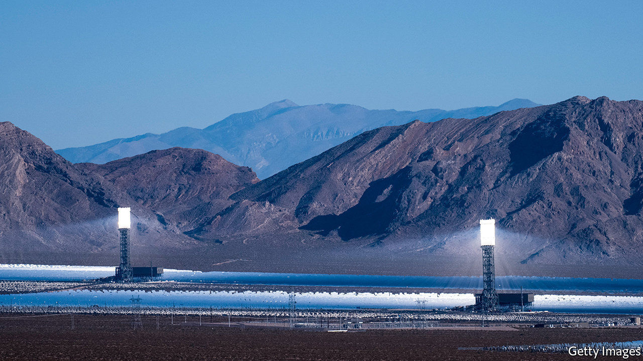

DEPENDING ON WHOM you ask, California is a leader in clean energy or a cautionary tale. Power outages in August prompted stern critiques from Republicans. “In California”, Donald Trump tweeted, “Democrats have intentionally implemented rolling blackouts—forcing Americans in the dark.” In addition to provoking outrage and derision, however, the episode is also likely to inspire investment.

The Golden State has long been America’s main testing ground for green companies. Californians buy half of all electric cars sold in America. Theirs is the country’s largest solar market. As California deals with heat waves, fires and a goal of carbon-free electricity by 2045, the need for a reliable grid is becoming ever more obvious. For years firms competed to generate clean power in California. Now a growing number are vying to store and manage it, too.

August’s blackouts have many causes, including poor planning, an unexpected lack of capacity and sweltering heat in not just California but nearby states from which it sometimes imports power. Long before the outages, however, electricity operators were anxious about capacity. California’s solar panels become less useful in the evening, when demand peaks. In November state regulators mandated that utilities procure an additional 3.3 gigawatts (GW) of capacity, including giant batteries that charge when energy is abundant and can sell electricity back to the grid.

Too few such projects have come online to cope with the surge in demand for air-conditioning in the scorching summer. But more are sprouting across the state. On August 19th LS Power, an electricity firm backed by private equity, unveiled a 250-megawatt (MW) storage project in San Diego, the largest of its kind in America. In July the county of Monterey said Vistra Energy, a Texan power company, could build as much as 1.2GW of storage.

The rooftop solar industry stands to benefit from a new Californian mandate that requires new homes to install panels on their roofs from this year. Sunrun, the market leader, is increasingly pairing such residential installations with batteries. In July, for instance, the company said it had won contracts with energy suppliers in the Bay Area to install 13MW of residential solar and batteries. These could supply power to residents in a blackout or feed power into the grid to help meet peak demand. Sunrun is so confident in its future that it has bid $3.2bn for Vivint Solar, its main rival.

Another way to stave off outages is to curb demand. Enel, a European power company, has contracts with local utilities to work with large commercial and industrial clients. When demand rises, Enel pays customers to reduce energy consumption, easing demand on the grid. A company called OhmConnect offers something similar for homeowners.

Even as such offerings scale up, the need for reliability means that fossil fuels will not disappear just yet. On September 1st California’s regulators will vote on whether to delay the retirement of four natural-gas plants in light of the outages. The state remains intent on decarbonising its power system over the next 25 years. But progress may not move in a straight line. ■

This article was downloaded by calibre from <https://www.economist.com/business/2020/08/29/businesses-compete-to-battle-californias-blackouts>

|  |  |  |  |
| --- | --- | --- | --- |
| Previous | Articles | Sections | Next |

|  |  |  |  |
| --- | --- | --- | --- |
| Previous | Articles | Sections | Next |

#### A closer look at greasy palms

# Bribery pays—if you don’t get caught

A new report tries to quantify the returns to multinationals from kickbacks they pay

Aug 29th 2020 |

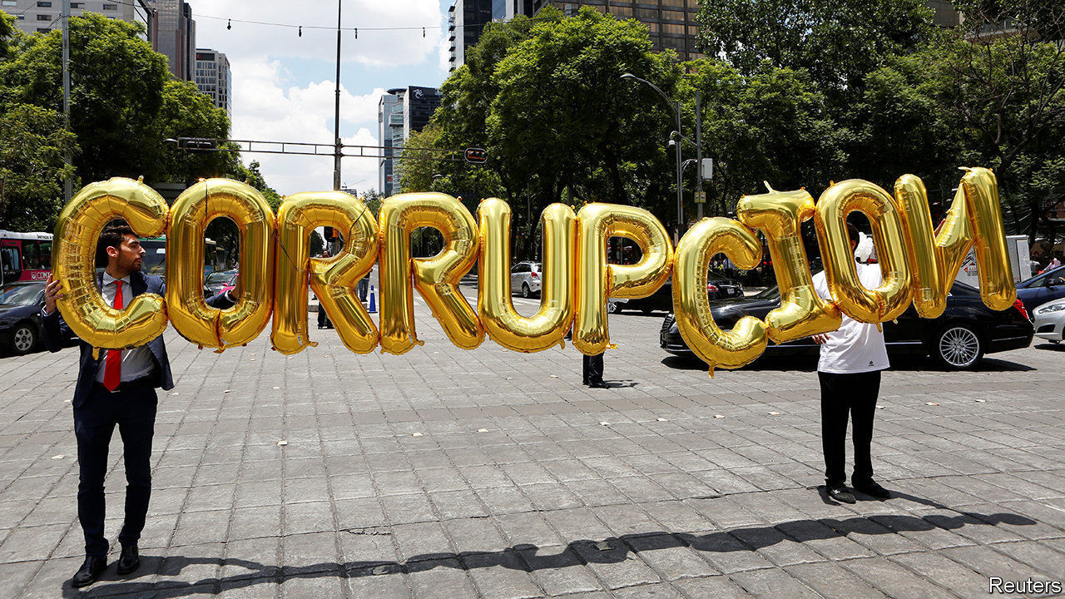

MANY BIG companies may be struggling with depressed sales, but these are busy times for bribery-busters. Mexico is abuzz over allegations by an ex-boss of Pemex, the state oil giant, that several senior politicians received bungs from companies including Odebrecht, a Brazilian construction firm (see [article](https://www.economist.com/node/21791232)). The scandal is the latest in a string of graft cases to make headlines this year, starting with Airbus’s record $4bn settlement in January over accusations of corruption for making illegal payments in various countries.

Corporate bribery is hardly new. In surveys, between a third and a half of companies typically claim to have lost business to rivals who won contracts by paying kickbacks. But such perceptions-based research has obvious limitations. A new study takes a more rigorous approach, and draws some striking conclusions.

Raghavendra Rau of Judge Business School at the University of Cambridge, Yan-Leung Cheung of the Education University of Hong Kong and Aris Stouraitis of Hong Kong Baptist University examined nearly 200 prominent bribery cases in 60 countries between 1975 and 2015. For the firms doing the bribing, they found, the short-term gains were juicy: every dollar of bribe translated into a $6-9 increase in excess returns, relative to the overall stockmarket.

That, however, does not take account of the chances of getting caught. These have risen as enforcement of America’s 43-year-old anti-bribery law, the Foreign Corrupt Practices Act (FCPA), has been stepped up and other countries have passed similar laws. The number of FCPA cases is up sharply since the financial crisis of 2007-09, according to Stanford Law School (see chart). It has dipped a bit under President Donald Trump, who has criticised the FCPA for hobbling American firms overseas, but remains well above historic levels. Total fines for FCPA violations were $14bn in 2016-19, 48 times as much as in the four years to 2007.

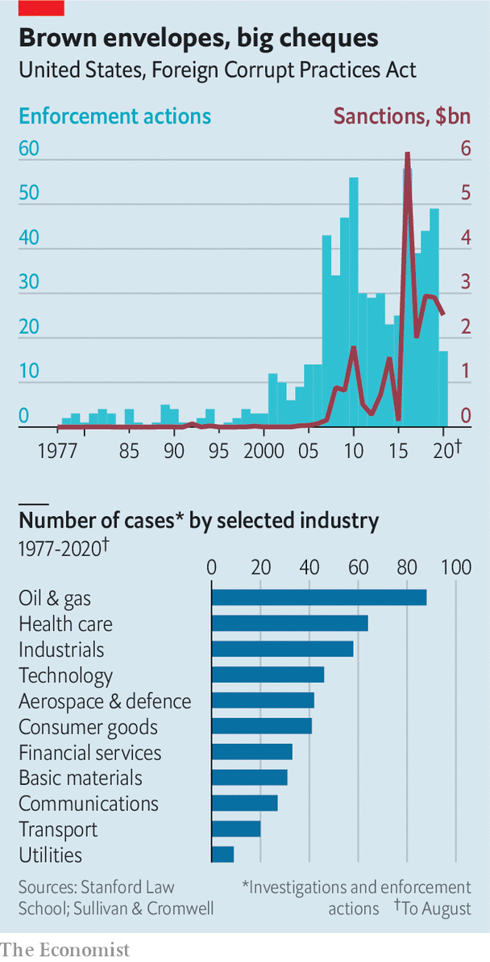

The authors also tested 11 hypotheses that emerged from past studies of bribery. They found support for some, for instance that firms pay larger bribes when they expect to receive larger benefits, and that the net benefits of bribing are smaller in places with more public disclosure of politicians’ sources of income.

But they punctured other bits of received wisdom. Most striking, they found no link between democracy and graft. This challenges the “Tullock paradox”, which holds that firms can get away with smaller bribes in democracies because politicians and officials have less of a lock on the system than those in autocratic countries, and so cannot extract as much rent. Such findings will doubtless be of interest to corruption investigators and unscrupulous executives alike. ■

This article was downloaded by calibre from <https://www.economist.com/business/2020/08/29/bribery-pays-if-you-dont-get-caught>

|  |  |  |  |
| --- | --- | --- | --- |
| Previous | Articles | Sections | Next |

|  |  |  |  |
| --- | --- | --- | --- |
| Previous | Articles | Sections | Next |

#### A prickly patriot

# Palantir’s stockmarket prospectus reveals both losses and promise

A secretive software-maker says hello to the stockmarket—and goodbye to Silicon Valley

Aug 29th 2020 | SAN FRANCISCO

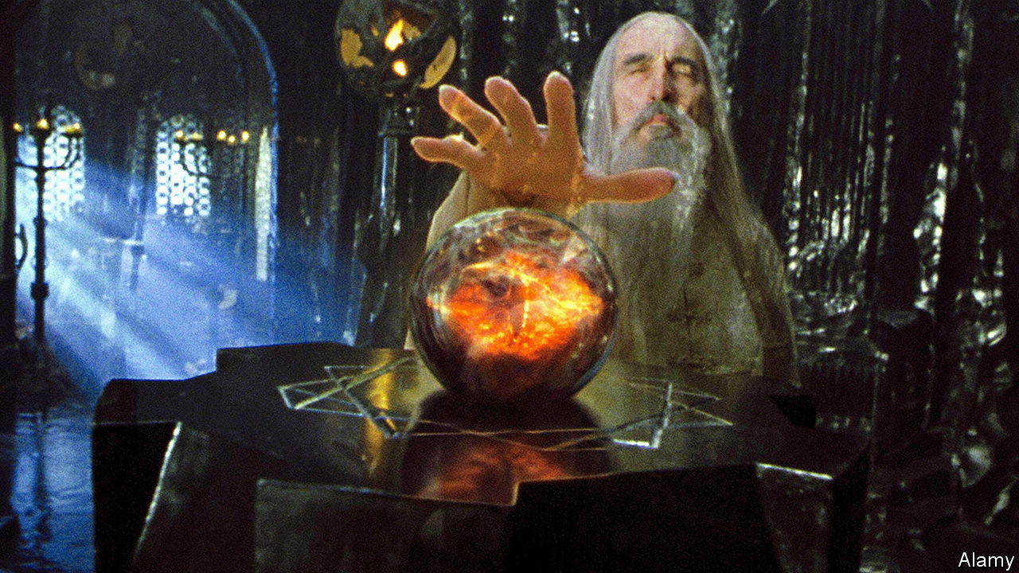

“ONE NEVER really knows who one’s enemy is.” The words of Jürgen Habermas, a noted Frankfurt School philosopher, are a good point of departure for understanding Palantir Technologies. On August 25th the controversial software firm, named after a magical orb in J.R.R. Tolkien’s “Lord of the Rings” that lets users see and speak across space and time, filed the paperwork to list on the New York Stock Exchange. Its direct offer of existing shares to public investors, without raising fresh capital, could happen within a month.

The company sells programs that gather disparate data and organise them into something usable for decision-makers, from soldiers in Afghanistan to executives at energy firms. More than a technological project, it is a philosophical, even political one. In the early 2000s its co-founder and boss, Alex Karp (who used to sit on the board of The Economist’s parent company), wrote a dissertation about aggression in politics at Frankfurt’s Goethe University, though not under Mr Habermas, as is often claimed. And Palantir itself is a child of the 9/11 terrorist attacks of 2001, which America’s sundry law-enforcement outfits failed to avert because they did not share data. In a preface to the prospectus, bleak by the upbeat standards of the genre, Mr Karp writes of government agencies that “faltered” and crises that “expose the systemic weaknesses of the institutions on which we depend”. Fixing these shortcomings is the company’s raison d’être. It could prove lucrative. But it invites attacks from rivals and critics.

Like most startups that plan to go public these days, Palantir is haemorrhaging red ink. The 17-year-old firm has yet to turn a profit. Last year it lost $580m on revenue of $742m. It spends more on sales and marketing than on research and development (see chart). But its venture-capital backers, who have poured $3bn into the firm over the years, most recently valuing it at perhaps $26bn, can draw comfort from things moving in the right direction. In the first half of 2020 revenue rose by 49%, year on year, while losses got smaller. Sales may exceed $1bn for the full year, thanks to the use of Palantir’s products to analyse pandemic data. It will vie with Snowflake, another data business about to list, for the year’s biggest software flotation.

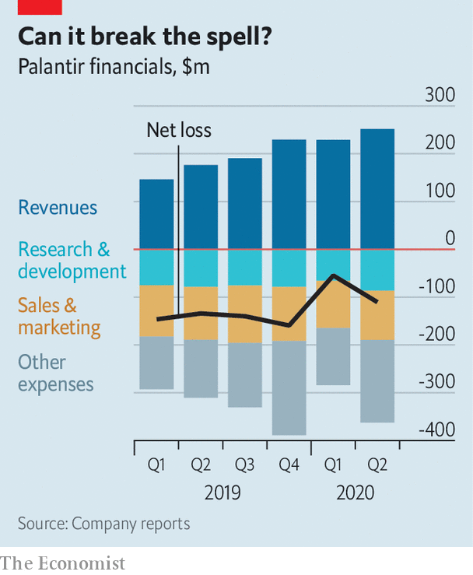

Palantir’s longer-term prospects are murkier. Successful corporate-software firms develop programs and services that can be offered without much customisation to many clients. This is trickier in the data business, where every company has a unique digital footprint. When Palantir got going, it was in effect a professional-services firm, chiefly creating bespoke data-analysis systems for the likes of the CIA and the Department of Defence. In recent years it has developed more generic products for corporate clients. But its scepticism of standardisation means it continues to deploy plenty of engineers to tweak them. This increases costs and is likely to limit how big and profitable it can get, says Mark Moerdler of Bernstein, a brokerage.

Palantir’s origins bring other challenges, too. Because it came of age before the rise of computing clouds, its software often still inhabits customers’ data centres, making it less nimble than younger cloud-based rivals like C3.ai and Databricks. Working for the government, particularly its spookier agencies, has also created a secretive and proprietary culture that is not an easy fit with the sort of partnerships that other tech firms often successfully use to expand their business. And it remains heavily reliant on government contracts. Between January and June 55% of revenue came from official sources, up from 45% in the same period last year. It has only 125 clients, with the biggest three (unnamed) ones accounting for nearly a third of sales.

Closeness to the state also points to Palantir’s biggest risk: politics. From its post-9/11 beginnings it has seen itself as an instrument of national security. “If we are going to ask someone to put themselves in harm’s way, we believe that we have a duty to give them what they need to do their job,” Mr Karp writes in his missive. One of his co-founders is Peter Thiel, a famed venture capitalist of strong libertarian bent with an authoritarian streak—and an occasional supporter of President Donald Trump.

This—combined with work for Immigration and Customs Enforcement, a federal agency despised by progressives for its heavy-handed treatment of migrants, or the Pentagon’s Project Maven, to analyse drone footage—has made Palantir one of the most hated firms in left-leaning Silicon Valley. “I’ve had my favourite employees yell at me,” said Mr Karp earlier this year, from a barn in New Hampshire where he was self-isolating even before the pandemic. Some engineers have left. Others are demanding high salaries to remain; in the first half of the year Palantir paid $182m in stock-based compensation, 38% of revenue. Though being in bed with America’s law enforcers and spies won’t scare off other government customers, corporate clients may take fright, particularly abroad. As the prospectus concedes, “Our reputation and business may be harmed by news or social media coverage.”

Palantir, which has recently decamped from Silicon Valley to Denver, is trying to make a virtue of the culture clash. It paints itself as a patriotic problem-solver, eschewing the techno-Utopian pretensions of the West Coast’s engineering elite. They may know more than most about software, Mr Karp writes. “But they do not know more about how society should be organised or what justice requires.” That, he implies, is the role of elected governments; the prospectus rules out dealing with Communist China. An unusual sales pitch in tech. But a plausible one. ■

This article was downloaded by calibre from <https://www.economist.com/business/2020/08/29/palantirs-stockmarket-prospectus-reveals-both-losses-and-promise>

|  |  |  |  |
| --- | --- | --- | --- |
| Previous | Articles | Sections | Next |

|  |  |  |  |
| --- | --- | --- | --- |
| Previous | Articles | Sections | Next |

#### Schumpeter

# Telegram tries to blend security with usability

Protests in Belarus have boosted the app’s profile

Aug 29th 2020 |



THE OFFICIAL story is that Alexander Lukashenko, Belarus’s president, won a sweeping victory. On August 9th some 4.7m people, 80% of Belarusian voters, cast their ballots for him. Just 10% voted for Svetlana Tikhanovskaya, a former English teacher who replaced her jailed dissident husband on the ballot. But few in the benighted country believe the official account, which is why Belarus has seen nearly three weeks of protests demanding Mr Lukashenko’s resignation.

As has become de rigueur in the 21st century, many of the demonstrations are co-ordinated online. One app in particular, Telegram, has become a vital tool. Users share inspiring videos and plans for marches. One message shows employees of the National Academy of Sciences protesting in defiance of their bosses, and proposes a rally in support. Another reminded readers that August 25th marked the 29th anniversary of Belarus’s independence from the Soviet Union, set out the day’s celebrations, and promised a message from Ms Tikhanovskaya.

It is not just Belarus. Telegram, with more than 400m monthly users, has been used by Black Lives Matter protesters in America, as well as anti-government demonstrators in Hong Kong and Iran. Silicon Valley venture capitalists flaunt it as a symbol of fashionable edginess. Pavel Durov, its creator, makes no secret of his sympathies. A message in his public channel, which has 356,000 subscribers, shows a poster claiming that memes can “topple regimes”. It is a sentiment straight from the internet’s idealistic early days, when the assumption was that freedom and democracy would flow down the wires alongside the bits and bytes. Telegram did not respond to The Economist’s request for comment.

Although Telegram remains behind WhatsApp and WeChat, which boast 2bn and 1.2bn monthly users, respectively, it is booming. In April it said it had added 100m users in the preceding 12 months. It has three selling points. The first is simply that it is a rather good piece of software, slick and easy to use. It was the most-downloaded chat app in Belarus before the protests and recently took the top spot from WhatsApp in Russia, according to SensorTower, an app-analytics firm. As with WeChat, Telegram users can design third-party programs to run on top of its service, letting people while away the time with video games, quizzes and the like. Whereas WhatsApp chats are limited to 256 participants, Telegram’s user-created public channels can host unlimited numbers. One of the most popular is “Hindi HD movies”, which points its 6m subscribers towards pirated copies of popular films.

Telegram’s second virtue is its promise to protect users from governments’ prying eyes. Experts debate exactly how secure Telegram is. Like WhatsApp, it offers “end-to-end encryption”, which prevents third parties, including the app itself, from deciphering messages. But unlike WhatsApp, this is not Telegram’s default setting, and it does not work with many of the app’s features. Messages are still encrypted, but Telegram retains a copy of the key. Authorities that persuade the firm to divulge that key could read a user’s messages. (Telegram says this has never happened and that it would resist if it did.) The app also relies on its own custom cryptography rather than battle-tested code favoured by experts.

Telegram’s third, and perhaps main, attraction is that it is not owned by Facebook (as WhatsApp is) or Tencent (the Chinese giant which controls WeChat). The app trumpets its independence from internet titans, which netizens view with growing suspicion. Its business model is simple: it does not have one. It says that running costs are covered by Mr Durov, who made a fortune with VKontakte, a popular Russian social-media platform he founded in 2006. Profit, the firm declares, “will never be an end-goal”, and “commercial interests will never interfere with our mission.” Such claims are lent credibility by Mr Durov’s background. At VKontakte he refused to hand over details of opposition politicians’ websites. He was fired by the board in 2014 as part of a claimed takeover by allies of Vladimir Putin, Russia’s president. Mr Durov bought citizenship of St Kitts & Nevis, and began work on Telegram.

However, preserving privacy and security is becoming trickier. Encrypted chat apps are viewed with suspicion even in democracies. America and Britain have repeatedly threatened to ban end-to-end encryption, because it frustrates the work of the police and intelligence agencies.

Autocrats, for their part, have learned how to harness chat apps to spread misinformation, as well as genuine news. The Hong Kong protests saw Telegram channels dedicated to posting the personal addresses of prominent dissidents. By seizing demonstrators’ phones and forcing them to reveal passwords the police can get their hands on lists of contacts to be arrested or intimidated. A booming market for private hacking allows governments to buy software that can bypass encryption by breaking into phones and reading information straight off their screens. One knowledgeable observer says it would be foolish to assume that big chat apps are not targeted by national spy agencies. That goes for Telegram, too.

## Returns from senders

If Telegram persuades users that it is both more fun and safer than WhatsApp and WeChat, it could nibble away at their supremacy. But for that to happen, it must first survive. It is unclear how long Mr Durov’s money will last. Since 2017 Telegram has tried to raise $1.7bn by selling its own cryptocurrency. America’s Securities and Exchange Commission halted the sale on the grounds that Telegram was dealing in unregistered securities and ordered it to return most of the cash to investors. That has put paid to plans for an alternative to bitcoin that may, if boosters are to be believed, one day supplant VISA, Mastercard or WeChat’s e-payments. Telegram thinks it can nevertheless get by even once the Durov largesse runs out, by charging for non-essential upgrades. Prospective regime-topplers are keeping their fingers crossed that it is right. ■

This article was downloaded by calibre from <https://www.economist.com/business/2020/08/29/telegram-tries-to-blend-security-with-usability>

|  |  |  |  |
| --- | --- | --- | --- |
| Previous | Articles | Sections | Next |

|  |  |  |
| --- | --- | --- |
| Business | Sections | Schools brief |

Finance & economics

Stock exchanges: Big fish

.

King of the hill: Ant Group IPO filing shows its might

.

Phil Hogan: Exit bruiser

.

Norges Bank: An expensive dream

.

Lebanon’s insurers: Broken cover

.

Housing in Seoul: The high-rise life

.

Buttonwood: Pinky v Blinky

.

Free exchange: Razing hopes

.

|  |  |  |
| --- | --- | --- |
| Business | Sections | Schools brief |

|  |  |  |  |
| --- | --- | --- | --- |
|  | Articles | Sections | Next |

#### Big fish

# In twenty years, exchanges have gone from clubby firms to huge conglomerates

They control everything from the software powering back offices to the data pored over by investors

Aug 27th 2020 |

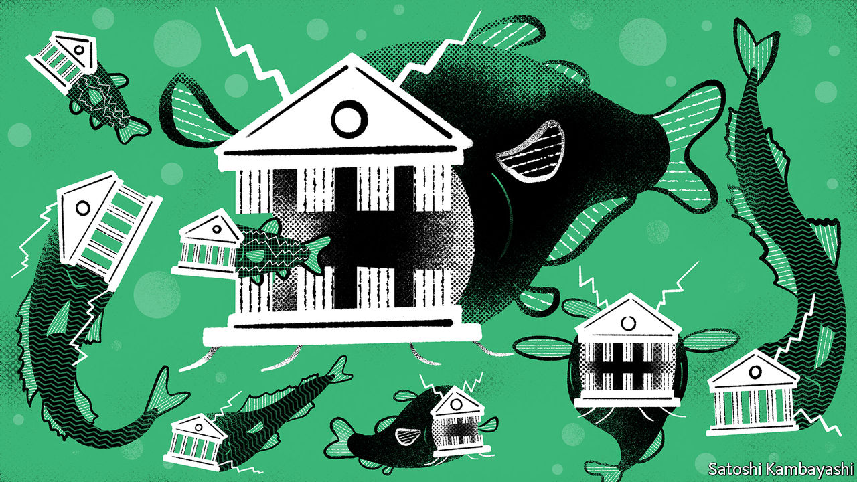

THE HONG KONG Stock Exchange (HKEX) resembles a financial estuary, says Charles Li, its boss. China’s capital flows mix with the open seas of global markets. In 2014 HKEX sought to ride the waves by launching Stock Connect, a conduit allowing offshore and mainland punters to invest in each other’s markets. Later it eased its listing rules for firms with dual share classes. All that has helped make HKEX more hospitable to the tech firms that exchanges covet. It has just landed another big catch. On August 25th Ant Group, the fintech affiliate of Alibaba, a Chinese e-commerce giant, filed for a listing that may raise $30bn in Hong Kong and Shanghai (see [article](https://www.economist.com/node/21791253)). That would make it the largest initial public offering ever.

The news made a splash. But it is easy to forget that, in the two decades or so since they themselves listed, HKEX and other exchanges have become big fish too, by exploiting the benefits of network effects, data and scale that Big Tech is best known for. The London Stock Exchange, which was worth less than $2bn when it went public in 2001, now has a market capitalisation of $41bn. The New York Stock Exchange (NYSE) is now part of Intercontinental Exchange (ICE) which is worth $57bn (see chart 1). HKEX’s market capitalisation has grown nearly sixty-fold, to $61bn. Their revenues similarly boomed.

Once crusty monopolies, exchanges have continually stretched their business models. They still run the match-making infrastructure that allows billions of shares and trillions of dollars to change hands daily. Stacey Cunningham, who helms NYSE, says it received over 300bn messages across its systems on peak days this spring; that is more than 50 times the number of daily Google searches. But after two decades of epic bidding wars and political drama, exchanges are also remarkably powerful financial conglomerates, controlling everything from the software powering banks’ back offices to the data pored over by investors. The race for dominance means that, today, a small group of elite exchanges are far ahead of the rest.

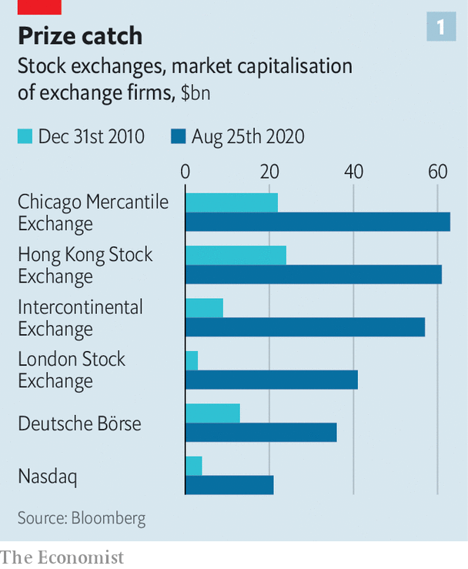

Stock exchanges used to be owned by their members, which were mostly banks and brokers. When the biggest went public in the 2000s, they earned their crust by charging fees on equity issuance and transactions. The exchanges sought to diversify by expanding abroad and becoming trading venues for other assets, like derivatives and currencies. Most moved into clearing and settlement facilities, too.

For much of that period, “eat or be eaten” was the industry’s motto. In 2007 NYSE bought Euronext, a group that included the Amsterdam and Paris exchanges. ICE bought NYSE in 2013 (and spun out Euronext). Yet the strategy soon came up against antitrust and political vetoes. Attempts to marry Toronto’s stock exchange with LSE, LSE with Deutsche Börse, Deutsche Börse with NYSE, have all collapsed. Most recently, in 2019, an opportunistic bid by HKEX for the LSE fell through.

With deals proving tricky the firms have found crafty ways to expand. As passive funds came to prominence, trading venues set their sights on benchmarks tracked by these funds. In 2010 Chicago Mercantile Exchange (CME), a big derivatives market, acquired Dow Jones, which assembles many of America’s most widely followed indices. LSE has a number of benchmarks that cover both sides of the Atlantic. (Updates to such indices—like the ejection of ExxonMobil, an oil firm, from Dow’s flagship index on August 25th—can cause mountains of money to shift).

Now the elite exchanges have turned their attention to data. On August 6th ICE said it had agreed to pay $11bn for Ellie Mae, which tracks the mortgage industry. LSE is awaiting approval of its $27bn bid for Refinitiv, a market-data firm. The hunt, says David Schwimmer, LSE’s boss, is only beginning. Whereas trading volumes are cyclical, indices and data are typically sold via more stable subscriptions. Oliver Wyman, a consultancy, expects trading revenues to stagnate or even decline, but those from crunching data to grow by over 5% annually in coming years.

Twenty years ago the fear was that new entrants would eventually topple the exchanges’ de facto monopolies. But the incumbents have kept the challengers at bay. Customer complaints about their fat fees once enticed startups, such as IEX, an exchange that pledges fairer pricing. The rise of “dark pools”—venues that match buyers and sellers anonymously—also posed a threat. But seven years since it was founded, IEX’s market share is stuck at 1.8%. The share of trading volume accounted for by dark pools in America has stabilised at 12%.

The result is a pyramidal hierarchy, a good gauge of which is an exchange’s revenues. At the base are the minnows, in poor countries or small developed ones, which lack liquidity or scale and are struggling to diversify. Some should merge or close, but governments will keep them alive. “Every nation wants to have a strong airline, a good beer and a stock exchange,” says Nick O’Donnell of Baker McKenzie, a law firm.

The next tier consists of exchanges with regional heft, and revenues exceeding $500m. Their reliance on trading in an era of tensions between America and China means they must team up or play to their strengths as neutral turf in order to thrive. On August 20th Singapore Exchange said it would work with LSE’s benchmark business to develop index derivatives focused on Asian and emerging markets. Euronext has acquired Nord Pool, a power market.

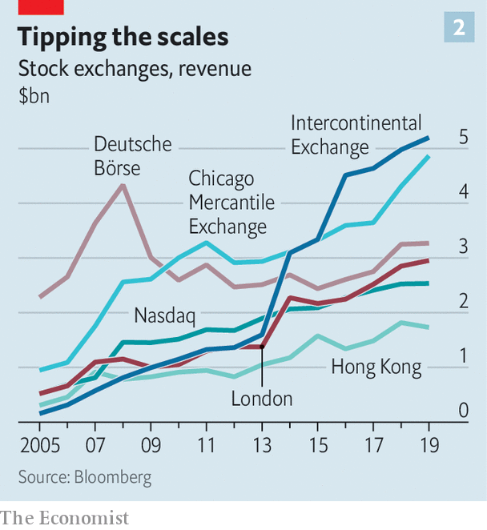

At the top of the food chain, with revenues at or exceeding $3bn, sit the giants: CME, Deutsche Börse, ICE and LSE. These have assured demand for big volumes, and will continue to reap the rewards of diversification. Two candidates are on the verge of promotion into the top league. Nasdaq, once famous only for its tech listings, now makes software that powers more than 130 other exchanges. HKEX enjoys the strongest tailwinds. It stands to win from China’s capital-market liberalisation, its growing tech nous and mainland firms’ desire to be closer to their home market. Geopolitics could also help, as Ant’s decision not to list in America may already show.

In time, Mr Li reckons, “almost all” Chinese companies listed in America will come back to Asia. Stock Connect, which makes up 7-8% of daily trading on HKEX, could end up accounting for a quarter of it. Being at the confluence of China’s rivers of capital and the sea of global funds should be a lucrative business. ■

This article was downloaded by calibre from <https://www.economist.com/finance-and-economics/2020/08/27/in-twenty-years-exchanges-have-gone-from-clubby-firms-to-huge-conglomerates>

|  |  |  |  |
| --- | --- | --- | --- |
|  | Articles | Sections | Next |

|  |  |  |  |
| --- | --- | --- | --- |
| Previous | Articles | Sections | Next |

#### King of the hill

# Ant Group IPO filing shows its might

Born a payment service, it is now a major conduit for credit

Aug 27th 2020 |



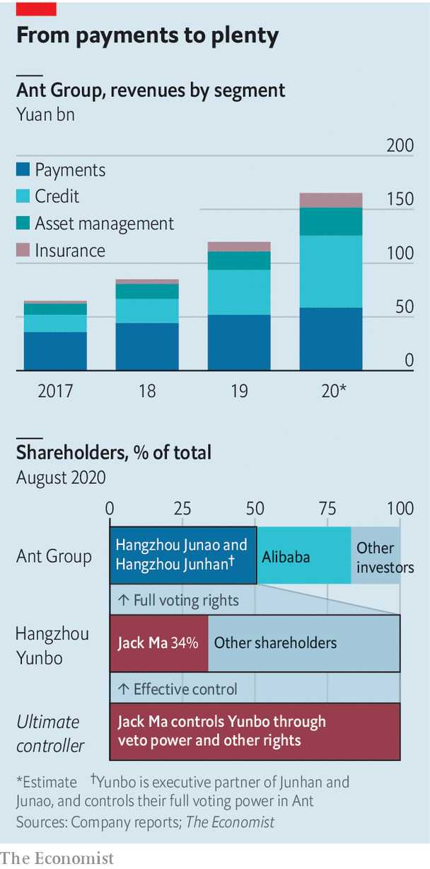

ANTS ARE normally small but mighty. This one is big but sprightly. On August 25th Ant Group, a Chinese financial-technology company, filed for a joint listing in Hong Kong and Shanghai, targeting a valuation of more than $200bn. It began life as Alipay, a payment service on Alibaba’s e-commerce platforms. It then launched China’s go-to app for mobile payments and has since grown into a major conduit for loans and investments. One thing is unchanged: Jack Ma, Alibaba’s founder, still controls it.■

This article was downloaded by calibre from <https://www.economist.com/finance-and-economics/2020/08/27/ant-group-ipo-filing-shows-its-might>

|  |  |  |  |
| --- | --- | --- | --- |
| Previous | Articles | Sections | Next |

|  |  |  |  |
| --- | --- | --- | --- |
| Previous | Articles | Sections | Next |

#### Exit bruiser

# Phil Hogan, Europe’s trade commissioner, resigns

A controversy over a quarantine forces him out

Aug 27th 2020 | WASHINGTON, DC

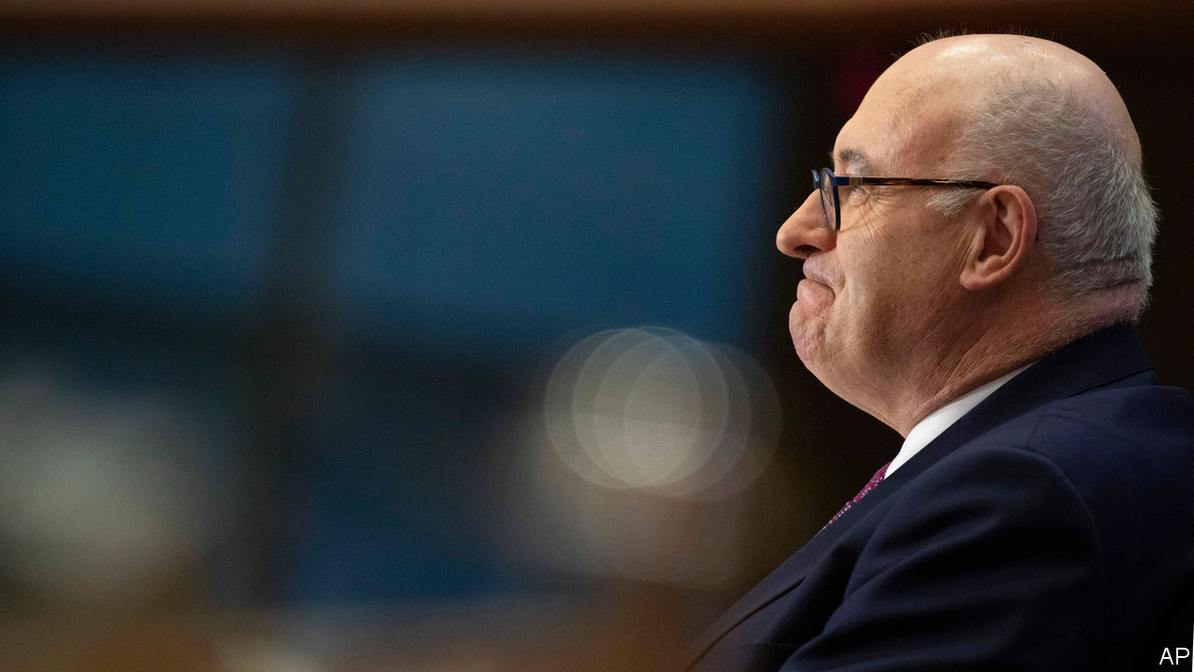

TOP TRADE negotiators are renowned for being astute and tough. When Phil Hogan took over as the European Commission’s negotiator last year, he was seen a bruiser, and a worthy match for Robert Lighthizer, his American counterpart. But on August 26th, less than a year into his tenure, Mr Hogan departed the ring.

The cause was an injudicious trip to Ireland, during which the government claims he breached covid-19 public-health guidelines. For a start, he did not go into quarantine for 14 days upon his arrival. Then he attended a golf-society dinner along with other public figures, which created a furore in Ireland and led to the resignation of a minister who also attended the event. In his resignation letter Mr Hogan said that the controversy “was becoming a distraction” from his work.

The outcome may come as a surprise. Commissioners are sacked only rarely, and mostly for blatant corruption. Ursula von der Leyen, the president of the European Commission, was clearly in a tough spot. Officials in Brussels are supposed to sit above national politics, and forcing Mr Hogan to jump risked the appearance of submitting itself to a national capital. But allowing him to stay would have ignored bubbling anger in Ireland.

Mr Hogan had grand plans when he took office, including ensuring that the transatlantic trade relationship did not deteriorate on his watch. He had begun conducting a “major” review of EU trade policy, strengthening its trade defences, and trying to cobble together a fix for the broken system of solving disputes at the World Trade Organisation (WTO).

For all these aspirations, Mr Hogan’s list of achievements looks a little thin. His relationship with Mr Lighthizer got off to a rocky start. Even after a micro-deal agreed on August 21st, Europe’s exporters face tariffs on billions of dollars’ worth of their wares, in retaliation for subsidies for Airbus, a European planemaker. A collaboration with Mr Lighthizer to work out a common response to China’s economic distortions appeared to have stalled. (And a botched bid to lead the WTO earlier this year did not exactly cover Mr Hogan in glory. It ended after he realised that he would probably not have the support of all the EU’s 27 member countries.)

Arguably, the odds in all this were stacked against him. Achieving much within the Brussels bureaucracy in less than a year—and in the middle of a pandemic—is a tall order. No European trade representative will ever have as much power to put pressure on trading partners as Mr Lighthizer has been given by President Donald Trump. And America’s engagement with its allies over China has been shallow, rather than a true collaboration.

Mr Hogan’s resignation note said that he hoped history would judge his achievements favourably. Perhaps the best that can be said is that they look more impressive when you consider his constraints. ■

This article was downloaded by calibre from <https://www.economist.com/finance-and-economics/2020/08/27/phil-hogan-europes-trade-commissioner-resigns>

|  |  |  |  |
| --- | --- | --- | --- |
| Previous | Articles | Sections | Next |

|  |  |  |  |
| --- | --- | --- | --- |
| Previous | Articles | Sections | Next |

#### An expensive dream

# Nicolai Tangen pays a big price for his new gig

The incoming boss of Norway’s oil fund sells off his sizeable personal investments

Aug 29th 2020 | BERLIN

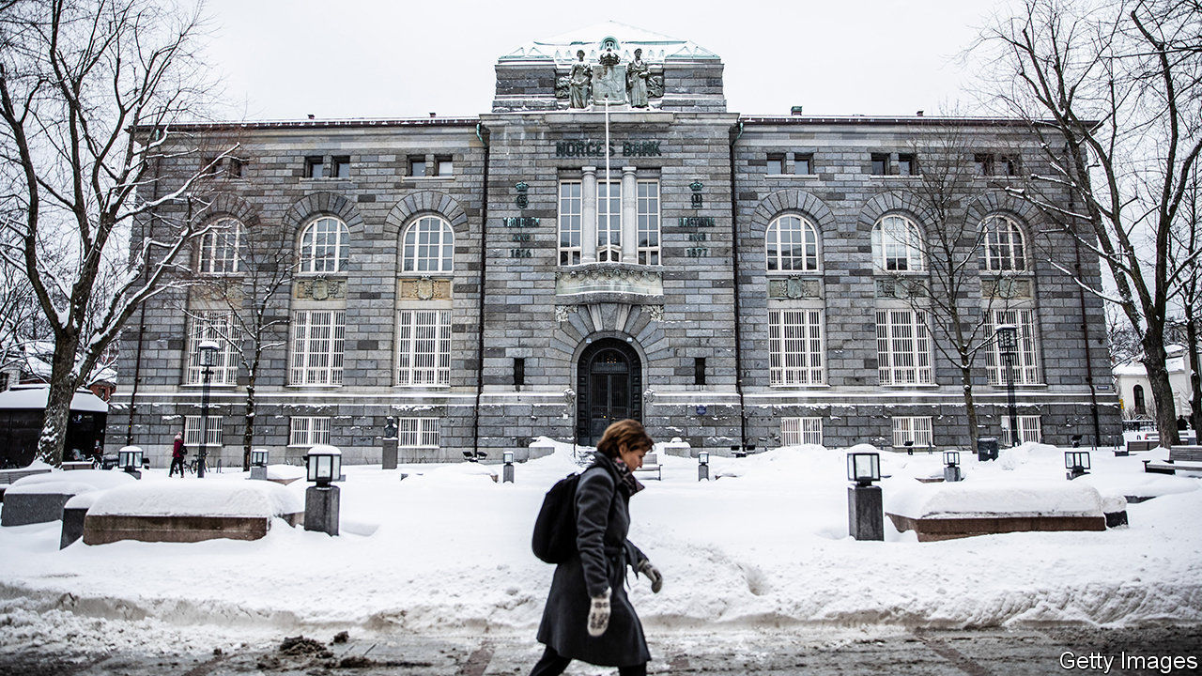

THE BIGGEST crisis in the 24-year history of the world’s biggest sovereign-wealth fund was defused at the very last minute. On August 24th Norges Bank Investment Management (NBIM) announced that Nicolai Tangen, its incoming boss, would liquidate his entire stake in AKO Capital, the $20bn hedge fund he founded. He will transfer it to AKO Foundation, a charity he set up in 2013. He will also sell his personal investments and park the proceeds in a bank account. Although Mr Tangen had previously ruled out selling up, he gave in to mounting political pressure in order to begin what he has called his “dream job” on September 1st.

The controversy, which has lasted months, has probably done most damage to the reputation of the central bank. (NBIM, which has holdings worth around 10trn Norwegian kroner, or $1trn, sits within it.) The bank broke “guidelines, rules and laws” when it selected Mr Tangen, according to the main supervisor of NBIM. His name never appeared on the bank’s official list of candidates for the fund’s top job, though he had been considered a serious contender for months. And the central bank may not have given enough thought to how to resolve potential conflicts of interest; Mr Tangen’s old fund holds shares in some of the same companies as NBIM.

Mr Tangen had planned to mitigate potential conflicts of interest by reducing his stake in AKO from 78% to 43%, appointing a trustee to exercise his vote and give away any dividends that would accrue during his tenure at NBIM. But that was not enough for Norwegian lawmakers. On August 21st the parliamentary finance committee concluded that the sovereign-wealth fund’s boss was not permitted to “have any ownership or interests that create or may appear to create conflicts of interest that [weaken] the trust and reputation of Norges Bank”.

On the same day Jan Tore Sanner, the finance minister, asked Oystein Olsen, the central bank’s governor, to find a solution. The result was Mr Tangen’s parting with stakes worth about 10bn kroner. “I think it’s fair to say that Olsen owes me a beer,” he joked at the press conference announcing the divestment. Many Norwegians had expected Mr Tangen to turn down the job rather than sell his holdings.

Some concerns about Mr Tangen’s appointment relate to his past as a buccaneering fund manager. “I worry that he will introduce more risk into the management of the fund,” says Karin Thorburn of the Norwegian School of Economics. The fund typically gets a mandate from parliament that includes a reference index determining its allocation of bonds and equities and its regional split, as well as a tracking error that fixes how much NBIM can deviate from the reference index. Mr Tangen could push for a bigger tracking error to give him the room for manoeuvre he was used to in his previous job.

None of this makes for a relaxed start to the new job. Mr Tangen will have to restore public trust in the management of the fund, which for most of the 12-year tenure of his predecessor, Yngve Slyngstad, had been well-regarded. Mr Olsen may be in an even less enviable position. He has saved his job for the time being, but many expect him to resign after a face-saving period, before his tenure ends in December 2022. As one dream is realised, another may be coming to an end. ■

This article was downloaded by calibre from <https://www.economist.com/finance-and-economics/2020/08/29/nicolai-tangen-pays-a-big-price-for-his-new-gig>

|  |  |  |  |
| --- | --- | --- | --- |
| Previous | Articles | Sections | Next |

|  |  |  |  |
| --- | --- | --- | --- |
| Previous | Articles | Sections | Next |

#### Broken cover

# The explosion at Beirut’s port will blow a hole in insurers’ balance-sheets

The worst scenario for insurers is also the most likely: that the blast was an accident

Aug 27th 2020 | BEIRUT

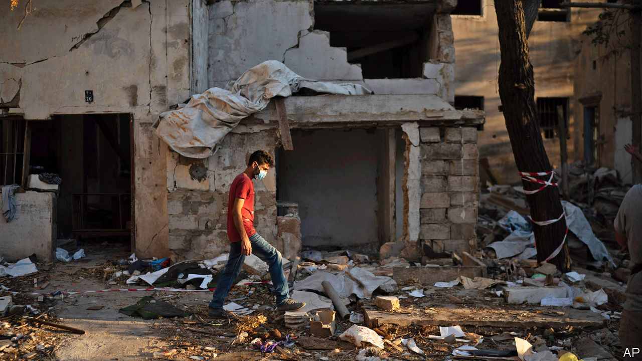

A HOMEOWNER IN Achrafieh does not care if the investigation is a sham, only that it rules that the explosion was an accident. Otherwise his insurance policy will pay nothing. The owner of a ruined boutique down the hill in Mar Mikhael would prefer the opposite result: her policy covers terrorism, unlike most, and will compensate her for an estimated $100,000 in repairs and lost inventory. The manager of a car-rental firm wonders if his explosion cover will include one of the largest non-nuclear explosions in history, since his vehicles were flattened by falling debris, not the blast itself.

The explosion that ripped through Beirut on August 4th, caused by 2,750 tonnes of ammonium nitrate stored improperly for years at the port, devastated much of the city centre. More than 200 people are dead or missing, thousands wounded, and an estimated 300,000 are homeless. The damage to property could reach $15bn. A chunk of that will land on insurance companies in Lebanon, with consequences for banks and foreign reinsurers.

In 2018 Lebanese insurers paid out around $90m to settle property and casualty claims. Insured losses at the port alone could now run to $250m. Victims have filed 2,500 claims for $425m in damages across the city, according to Raoul Nehme, the caretaker economy minister. Insurers expect the number of claims to quadruple and the final price tag to hit $3bn. That is almost double the annual revenue of Lebanon’s 52 insurers, which wrote $1.7bn in gross premiums in 2018.

Claims are frozen until the government finishes investigating the blast. Insurers would largely be off the hook if it were a deliberate act (there is no evidence to suggest it was). An act of war would trigger force-majeure clauses, and most policies do not cover terrorism. The worst scenario for insurers is also the most likely: that the blast was an accident. That would trigger another set of claims, as insurers seek to collect from the owners of the warehouse where the ammonium nitrate was stored.

Whatever the final bill, some Lebanese insurers will struggle to pay it. Written premiums fell by 4% in 2019 as an economic crisis forced some policyholders to drop their coverage. This year has been worse. Several insurers are subsidiaries of the country’s insolvent banks. Arope, one of the ten biggest non-life insurers, is owned by Blom, Lebanon’s second-largest bank, which saw net profits fall 77% last year. Other lenders in the country, such as Byblos and Credit Libanais, also offer insurance products.

Foreign reinsurers will be stuck with part of the bill. Hannover Re expects to book a “major loss”, an event with more than €10m ($11.8m) in claims. Sven Atloff, a member of its board, says it is still impossible to tell whether the total cost will be in the low tens of millions of euros, or even exceed €100m. The firm’s net income was already down by 39% in the first half of 2020 because of covid-related losses. Munich Re also expects a sizeable hit.

For Lebanese firms there is an added wrinkle: whether they can get the cash to pay claims, many of which must be paid in dollars. (Though still officially pegged to the greenback, the Lebanese pound has lost 80% of its value on the black market in recent months.) A banking crisis that began in October has left dollars scarce; foreign-currency withdrawals are tightly restricted. The central bank may have to stop subsidising wheat and fuel imports in November because it is close to its minimum required reserves.

Several policyholders say their insurers have offered to pay them with bank cheques, which can still be freely deposited. But the cheques lose up to two-thirds of their value once withdrawn from banks in devalued local currency, typically converted at a “quasi-official” rate, and converted to dollars on the black market. After months or years of delay, the policies of many of the blast’s victims may give them a payment barely worth the paper they are written on.■

This article was downloaded by calibre from <https://www.economist.com/finance-and-economics/2020/08/27/the-explosion-at-beiruts-port-will-blow-a-hole-in-insurers-balance-sheets>

|  |  |  |  |
| --- | --- | --- | --- |
| Previous | Articles | Sections | Next |

|  |  |  |  |
| --- | --- | --- | --- |
| Previous | Articles | Sections | Next |

#### The high-rise life

# Efforts to rein in house prices are fuelling discontent in Seoul

Measures aimed at speculators are hurting first-time buyers

Aug 27th 2020 | SEOUL

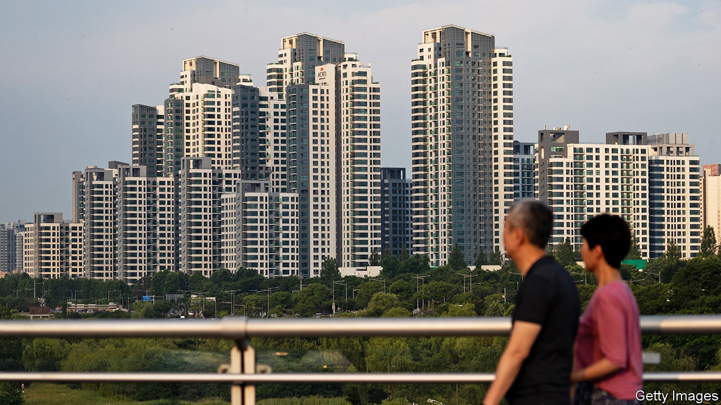

JUDGING FROM the chatter on the streets of Gangnam, it is a bad time to buy property in the South Korean capital. “It’s been a nightmare looking for an apartment,” says Lee, a 30-year-old who lives in a rented studio in the glitzy district in southern Seoul. “I think about what to buy and where and a month later the price has gone up by 20%.” Although he has a good job at a big company and is planning to buy with his girlfriend, he worries they’ll have to keep renting for now. “The government says they want to fight the rich, but actually they’re hitting the middle class.”

In recent months such complaints have become more common. Greater Seoul is home to half of South Korea’s population and to the vast majority of attractive jobs, schools and entertainment options. Few people with any ambition can afford not to move there. But affording the move is hard. Residential property prices in the capital have risen by around 40% over the past three years, according to official statistics; in that time, the prices of flats have gone up by 52%, suggests analysis by KB Kookmin, a bank. The rises have been fuelled in large part by demand for scarce high-quality flats in popular districts such as Gangnam.

The government, spying a speculative bubble, has introduced around two dozen measures to cool the market over the past three years. In December it banned mortgages on properties worth more than 1.5bn won (around $1.3m), roughly the price of a mid-size flat in Gangnam. It has also lowered the maximum loan-to-value ratio for flats worth more than 900m won from 40% to 20%. Last month it announced plans to increase property taxes for expensive homes and owners of multiple properties, as well as capital-gains levies on short-term sales. The overall effect, though, has been muddled and counterproductive. Young people such as Mr Lee, who are keen to get on the property ladder, are particularly disgruntled by politicians’ failure to make good on their promises to make housing affordable.

In part the problem is that the government’s efforts to cool the market have been offset by monetary easing by the central bank. In order to cushion the economic fallout from covid-19, the Bank of Korea has cut interest rates, encouraging some South Koreans to pile into property. Meanwhile, the tax proposals have angered existing investors, and are likely to restrict supply. Parallel efforts to alleviate the shortage of high-quality housing by building more of it have been slow to get off the ground. Prices, therefore, have continued to rise.

The government’s caps on mortgage availability have hit first-time buyers, particularly those looking to buy in affluent areas. The government says it wants to help “end-users” of apartments and punish “speculators”, says Song In-ho of the Korea Development Institute, a think-tank. But its attempts to deter the latter have also hurt the former.

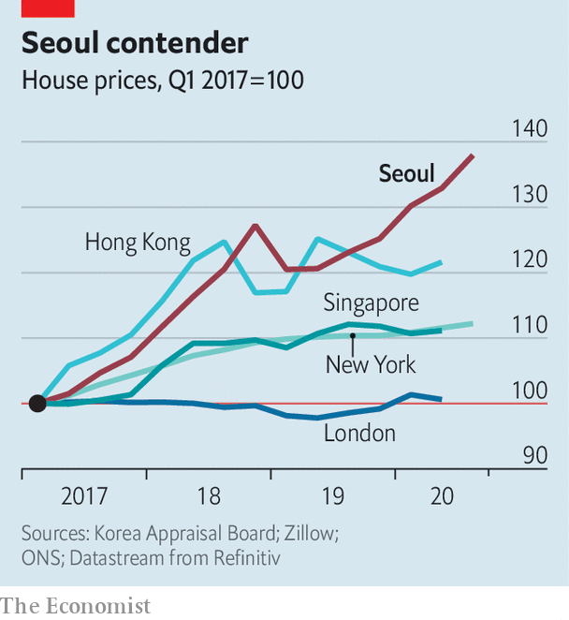

The discontent is exacerbated by the peculiarities of the rental market. Two-fifths of people living in Seoul own their homes; the rest are tenants. Because South Koreans tend to invest the bulk of their savings in property, four-fifths of landlords are other private households rather than corporations or public institutions, compared with nearly two-thirds in Japan and just over half in Britain.

Roughly half of all tenancies are based on a unique system known as jeonse, or “key money”. Under a jeonse contract, the tenant pays the landlord a deposit of between 60% and 80% of the purchase price to live rent-free for two years. The deposits have helped landlords finance further property purchases. But they make it hard for anyone without the savings to find anywhere affordable to live, even if they rent. Seoul may seem cheaper than cities such as London or Hong Kong when prices are compared to incomes. But it is less affordable than it looks.

There are other strains. Household debt is high, having risen rapidly in the past. “The economy as a whole is far too exposed to the property market,” reckons Hahm Joon-ho, a former member of the Bank of Korea’s monetary-policy board now at Yonsei University in Seoul. “If prices fell suddenly, it would be very bad.”

In the short term, then, the government’s inability to bring down prices may be no bad thing. No one wants to see a sudden house-price crash at a time when the economy is already suffering a pandemic-induced slowdown. The economic fallout from the virus could curtail household incomes. That might delay the economic recovery as people cut back on their spending in order to service their loans, although interest-rate cuts should provide some relief.

In the longer term, though, the problem of affordability will have to be dealt with. Increasing supply is likely to be a much more promising way of bringing house prices down than intricate policy interventions, says Mr Hahm. There is no sign that Seoul will become less attractive as a place to live, or that prospective homeowners will become less exacting in their tastes. “More and more people want to live in high-quality apartments. Seoul does not have enough of those—and so we need to build more.” ■

This article was downloaded by calibre from <https://www.economist.com/finance-and-economics/2020/08/27/efforts-to-rein-in-house-prices-are-fuelling-discontent-in-seoul>

|  |  |  |  |
| --- | --- | --- | --- |
| Previous | Articles | Sections | Next |

|  |  |  |  |
| --- | --- | --- | --- |
| Previous | Articles | Sections | Next |

#### Buttonwood

# For fixed-income investors, hell is other bondholders

As Argentina shows, investors have much to fear from their less predictable brethren

Aug 29th 2020 |

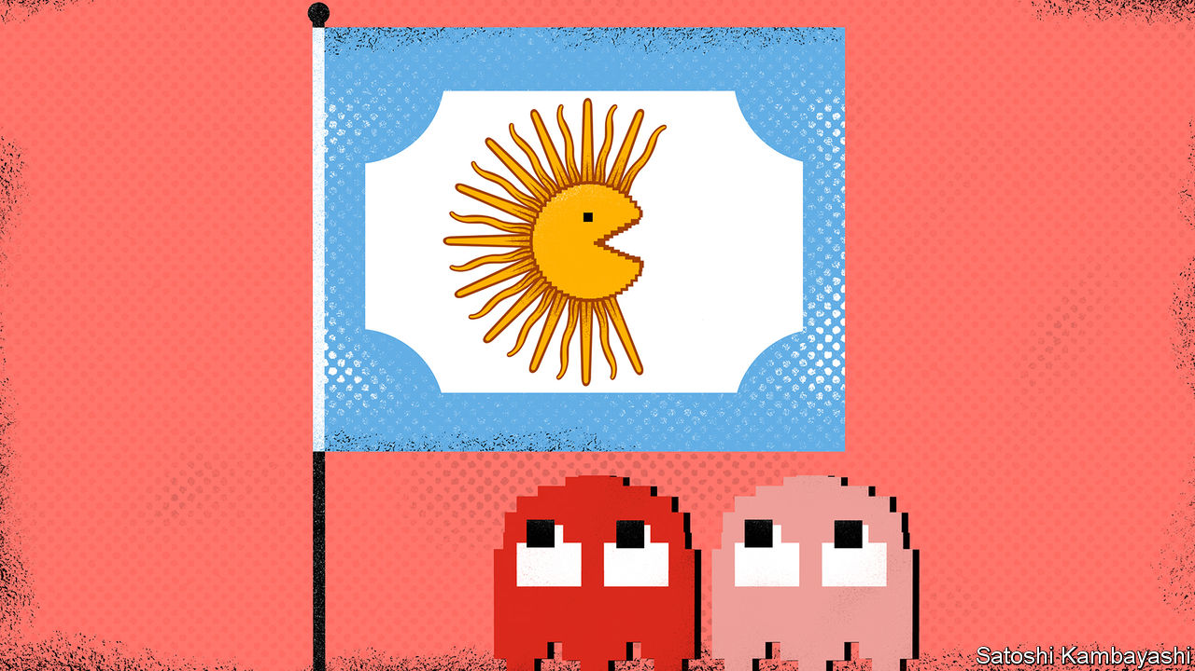

ALTHOUGH OLD enough to feel nostalgic about classic video games, Buttonwood was never a fan of Pac-Man. Yes, eating pellets and eluding colourful ghosts made a change from shooting waves of space invaders. But the game never grabbed him. And its name made no sense. The original, "Puck Man", was apparently altered to stop arcade vandals changing the P to an F.

Emerging-market investors may share those cool feelings. To them, “Pac-Man” is the name for a divide-and-rule strategy pursued by governments seeking to puck their bondholders. Fear of the tactic haunted Argentina’s $65bn-debt talks, which have eventually come to a deal that most bondholders looked likely to accept by August 28th, after The Economist went to press.

A government that cannot pay its debts typically offers to swap its bonds for new ones with gentler terms. Under modern “collective-action” clauses, it can group together any bond series it wants to exchange and take a vote of all their holders. If a large majority agree to the swap, it becomes binding for all. This stops a few mercenary creditors free-riding on the generosity of others by holding out for a better deal, hoping that the government will pay them more once it has paid everyone else less.

The absence of such provisions allowed a colourful group of hold-outs to chase Argentina for almost 15 years after its default in 2001. At one point, NML Capital, a hedge fund, managed to prevent Argentina paying any creditors until it paid them all, a legal feat that upset other bondholders almost as much as it upset the government.

Creditors do not always see eye to eye. A stingy minority may antagonise everybody else. Similarly, a pliable minority who are desperate for a deal may not share the interests of the harder-headed majority. The Pac-Man strategy exploits this difference. Consider the following case, based on a blog post by Mitu Gulati of Duke University and Mark Weidemaier of the University of North Carolina at Chapel Hill. Suppose the government needs two-thirds of investors (weighted by principal) to agree to swap 200 bonds. The bonds are equally split into two varieties, pink and red. About 67% of pink bondholders support a swap. But only 33% of red ones do. If all vote together, the swap fails (only 100, or half, vote in favour).

Suppose instead the government first makes an offer to pink investors. This separate offer will succeed and become binding on all pink bondholders, including the 33% who voted against. Next, the government makes a second, slightly sweeter offer to both red and pink. All pink holders will support the second offer, because it is a little better than the earlier deal to which they are all now bound. With 100% of pink votes in its pocket, the government needs only a third of the red votes to get a two-thirds majority of the two groups combined. The swap succeeds. A government that could not gobble up two ghosts at once can devour both—after first chewing and regurgitating one.

In practice, the Pac-Man strategy is not easy. Votes are hard to predict. And Argentina had to clear a second threshold to swap its newer bonds. As well as winning a two-thirds majority overall, it had to win a 50% share of each legally distinct bond included in the swap. If the 50% bar was not met for even one bond series, the entire swap would fail.

To overcome this problem, Argentina proposed "redesignation". It would make an offer, count the votes, and then, if necessary, declare some bonds ineligible for the swap after all, allowing it to disregard their votes.

Creditors immediately cried foul, arguing that redesignation was underhand and unfair. But although Argentina’s proposal breached the spirit of its contracts, it did not violate the letter. It merely interpreted the terms to its best advantage—something its more troublesome bondholders, such as NML Capital, have previously done with brio. The government’s proposal this year was “aggressive, creative, and right there in the documentation”, says Anna Gelpern of Georgetown University. Instead of complaining, creditors should have said, “Oh crap, you read the contract better than I did.”

In the end, redesignation was not necessary. Argentina sweetened its offer enough to win over the creditors (and agreed to make redesignation harder in the future). By seeking compromise, the government proved something Pac-Man fans have always known: you can sometimes stop a ghost from chasing you for a bit by taking a step in its direction.

This article was downloaded by calibre from <https://www.economist.com/finance-and-economics/2020/08/29/for-fixed-income-investors-hell-is-other-bondholders>

|  |  |  |  |
| --- | --- | --- | --- |
| Previous | Articles | Sections | Next |

|  |  |  |  |
| --- | --- | --- | --- |
| Previous | Articles | Sections | Next |

#### Free exchange

# Psychological scars of downturns could depress growth for decades

Research presented at the Jackson Hole conference models the effect

Aug 29th 2020 |

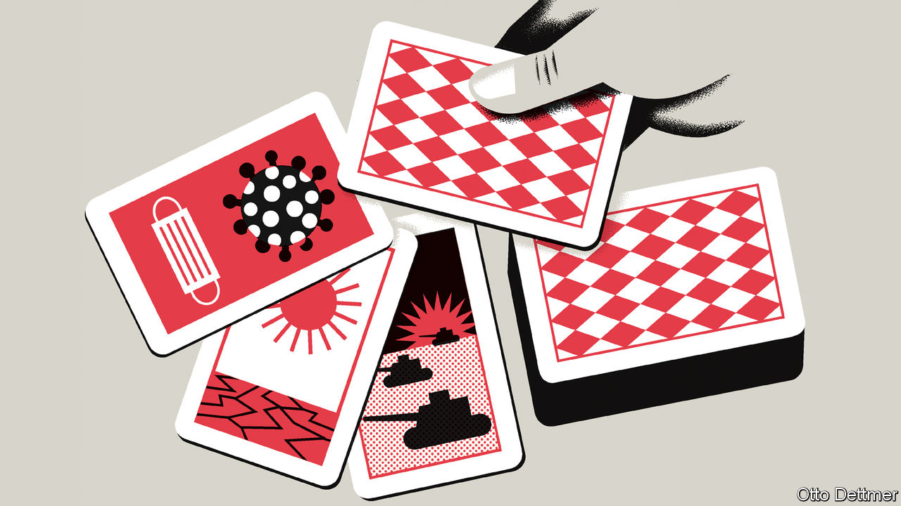

FOR THE past 40 or so years, economists, central bankers and other eminences have gathered against the imposing backdrop of Wyoming’s Teton mountains every August, in order to chew over the great monetary challenges of the day. Not this year. As The Economist went to press the proceedings of the Jackson Hole symposium, organised by the Federal Reserve Bank of Kansas City, were unfolding online, thanks to covid-19. Those tuning in are all too aware of the economic damage wrought by the pandemic. But the headaches are only beginning. As one of the papers due to be presented at the conference explains, covid-19 is likely to reshape people’s beliefs about the world in ways that will complicate the already daunting task of restoring beleaguered economies to health.

The notion that a severe economic shock might do long-run damage is not new. Since the Depression macroeconomists have understood that deep downturns might tip an economy into a “liquidity trap”, in which interest rates fall to zero and monetary policy cannot easily provide a stimulating kick. Without a powerful dose of fiscal stimulus, the economy stays mired in a slump. Or a brutal recession may lead to “hysteresis” in the labour market, causing, say, a lasting increase in the unemployment rate. People out of work for long spells may become so disconnected from the labour market, as their skills and motivation erode, that even when demand recovers they struggle to find jobs. (In the 1980s Olivier Blanchard of the Massachusetts Institute of Technology and Lawrence Summers of Harvard University argued that this explained why unemployment was much higher in Europe than in America.) Both sorts of scarring could restrain economies as they leave the shadow of the pandemic.

Yet research also suggests that traumatic economic episodes can exert a drag on growth simply by altering people’s beliefs about the future. For example, Ulrike Malmendier of the University of California, Berkeley, and Leslie Sheng Shen of the Federal Reserve studied consumption patterns in the aftermath of downturns and find that periods of economic hardship and spells of unemployment tend to depress people’s consumption for some time, even after controlling for income and other variables. Consumers not only spend less but tend to opt for lower-quality or discounted items. Young people are especially affected, potentially prolonging the dampening effect on the economy. Pandemics unquestionably count as potentially scarring economic traumas. In one recent study of 19 of them, going back to the 14th century, Òscar Jordà, Sanjay Singh and Alan Taylor of the University of California, Davis, conclude that such outbreaks depress real rates of return for decades. They find that rates decline, on average, for about 20 years, and do not return to their previous level for 40 years. This effect, they speculate, could reflect the human toll exacted by past pandemics, which shrank the workforce and reduced the return on new capital investment. But they also reckon that an increase in saving by wary households could have a depressing effect.

New work by Julian Kozlowski of the Federal Reserve Bank of St Louis, Laura Veldkamp of Columbia University and Venky Venkateswaran of New York University, due to be presented at the conference, suggests that covid-19 could leave similar economic scars. As the authors explain, people’s investment decisions are shaped by their beliefs about the future. Their risk outlook is in turn influenced by their experience, and the addition of an extreme negative shock—like covid-19—to that stock of experience can lead to a mass revision of beliefs that lasts throughout their lifetimes. No doubt, even before the coronavirus spread this year, some people might have thought that highly disruptive pandemics could occur, based on experts’ warnings and an awareness of history. But the tangible, persistent and severe harms associated with an actual pandemic inform beliefs about the likelihood of another similar shock in a way that abstract knowledge cannot.

The authors build a model in order to assess how this effect on beliefs might influence the recovery from covid-19. After a very severe initial economic shock from the pandemic, output recovers but does not return to the previous growth trajectory. Part of that long-run depressing effect can be accounted for by “capital obsolescence”: the fact that some of the existing capital stock can no longer be used as efficiently as before, or at all. Office space, for instance, may be used less intensively, as a precaution. But people also revise down their expectations of the return on future investments because they expect pandemics to become more likely. This leads to less investment, other things equal, and slower growth. In the long term GDP is as much as 4% below its pre-crisis level. The authors reckon that the present discounted value of losses associated with capital obsolescence and changing beliefs may be as much as ten times larger than the cost of the initial shock. And most of the long-term loss stems from revisions to beliefs.

## Give me a reason to believe

Psychological scarring could seriously complicate the policy response to covid-19. A rise in precautionary saving and decline in investment appetites will further depress interest rates, when their extremely low level is already constraining the size of the economic boost that monetary policy can provide. And pandemics are not the only shocks that could affect beliefs about risk. Those stemming from climate change also loom.

Governments do have tools to lessen the psychological damage wrought by crises. Spending on public goods like infrastructure could help, by raising the return to complementary private investments. So, too, might a more robust safety net, by limiting the cost to individuals of economic bets gone bad. A full recovery, though, might also require work to reduce the likelihood and potential harm of future shocks in the first place, through better pandemic preparedness, say, and efforts to slow climate change. Anything less leaves the job of rehabilitating the economy unfinished. ■

This article was downloaded by calibre from <https://www.economist.com/finance-and-economics/2020/08/29/psychological-scars-of-downturns-could-depress-growth-for-decades>

|  |  |  |  |
| --- | --- | --- | --- |
| Previous | Articles | Sections | Next |

|  |  |  |
| --- | --- | --- |
| Finance & economics | Sections | Science & ... |

Schools brief

Greenback dominance: Buck up

.

|  |  |  |
| --- | --- | --- |
| Finance & economics | Sections | Science & ... |

|  |  |  |  |
| --- | --- | --- | --- |
|  | Articles | Sections | Next |

#### Buck up

# Global trade’s dependence on dollars lessens its benefits

Policymakers around the world yearn to be free of the greenback’s grip

Aug 29th 2020 |

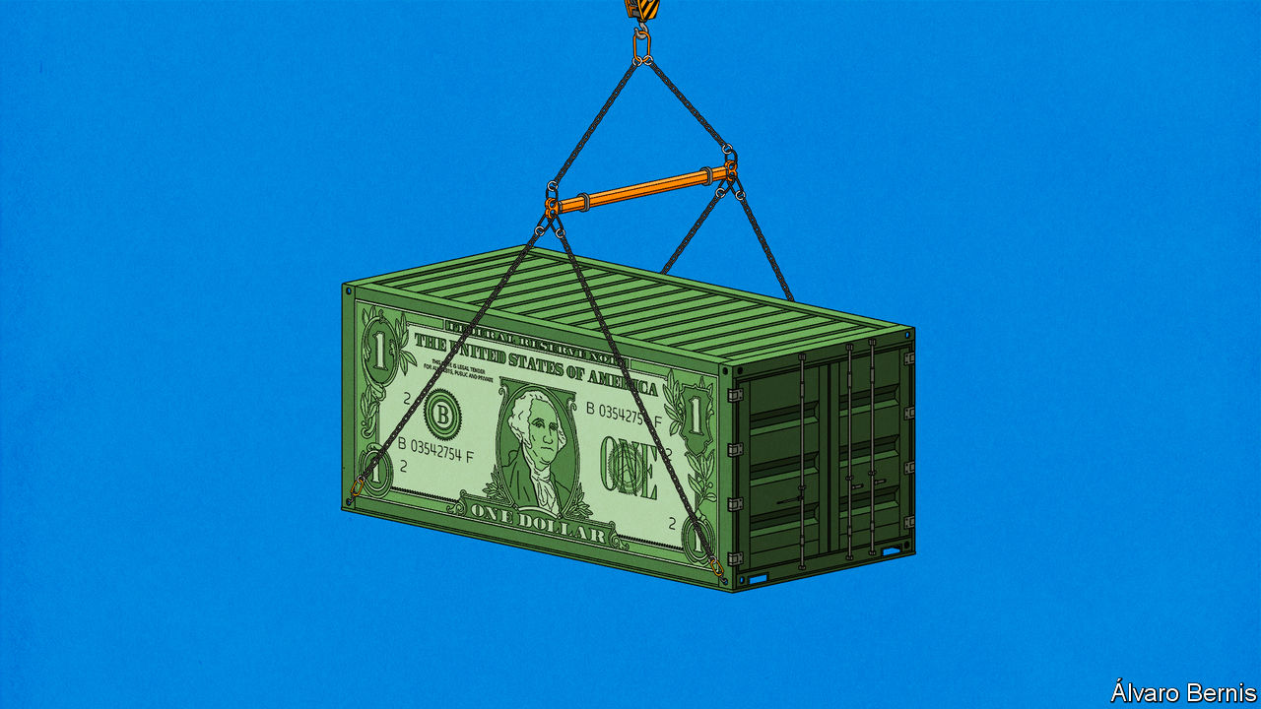

CRASHING CURRENCIES hurt. They make imports more expensive, cutting into household budgets and raising businesses’ costs. But economics has long held that this pain brings with it its own salve. More expensive imports should drive new demand for home-made replacements and thus for the workers who make them, geeing up the economy. What is more, a devalued currency means exports are suddenly cheaper to buyers abroad. That, too, should boost demand. When the value of the Colombian peso collapsed in the summer of 2014, it was on the basis of these assumptions that the country’s finance minister greeted the fall as “a blessing in disguise”.

It wasn’t. There were, the IMF opined in a subsequent report, a number of reasons for this, many specific to Colombia. But one problem was a factor which is embedded in the machinery of today’s international commerce. Colombia does not trade in pesos. It trades almost exclusively in dollars; 98% of its exports are invoiced in them. This is an extreme example of a general point. The amount of trade carried out in American dollars vastly exceeds the amount that America imports and exports. Although that may seem like a detail of book-keeping, it matters a lot. A growing body of evidence suggests that the dollar’s prominence in trade undermines the advantages which flexible exchange rates are meant to offer. And when the dollar strengthens, global trade tends to contract.

For decades, economists’ thinking about trade and currencies was summarised in a model created in the 1960s by two researchers at the IMF, Robert Mundell and J. Marcus Fleming. They assumed no special role for any dominant currency, but rather that traders would agree on prices in the exporter’s currency. A Colombian devaluation, say, would immediately turn peso-priced batteries into bargains abroad, encouraging foreign buyers to scoop up more of them. Meanwhile shoppers in Bogotá wanting to buy Brazilian T-shirts would resent being made to fork out more pesos to cover the price fixed in real.

This simplifying assumption was potentially consequential. As early as 1947, Joan Robinson of the University of Cambridge noted that the currency companies used for invoicing could mute the expenditure-switching effect. If the prices of Colombian exports were in dollars, not pesos, a devaluation would leave prices faced by American importers—and their demand—unaffected. But though that might matter in principle, did it matter much in practice?

In 1973 Sven Grassman of the Institute for International Economic Studies used Swedish data to answer in the negative. He found that in 1968 around two-thirds of Swedish trade had been indeed invoiced in the currency of the exporter. This “fundamental symmetry in international payment patterns” became known as “Grassman’s Law”. Swedish exports to America, which were mostly invoiced in dollars not kronor, were written off as the exception. That suggested that Mundell and Fleming were right.

Over the next decades more data further supported Grassman’s Law—always with the same American exception. But by the 1990s some researchers were beginning to doubt its validity. Their main argument was that the actual prices of goods did not vary as much or as quickly as would be expected if payments were in fact symmetrical. Grassman’s Law said that the price of Brazilian T-shirts in Colombian markets should vary with the peso-real exchange rate, for example. But such prices were in fact much stickier.

In the mid-2000s Linda Goldberg and Cedric Tille of the Federal Reserve Bank of New York compiled data describing 24 countries in the late 1990s and early 2000s. This confirmed that Grassman’s Law was wrong: exports were not generally priced in the currency of the country they came from. In 2001, for example, they found that South Korea invoiced 82% of its imports in dollars, despite only 16% of its imports coming from America.

Other work confirmed and updated their findings: the dollar has a huge role as a “vehicle currency” in which to invoice transactions to which no Americans are party, particularly in developing countries (see chart). Gita Gopinath of the IMF has compiled data covering just over half of world trade to show that the dollar’s share of invoicing was 4.7 times larger than America’s share of the value of imports, and triple its share of world exports. Another IMF study showed that the dollar’s share has not decreased in step with America’s declining share of overall trade.

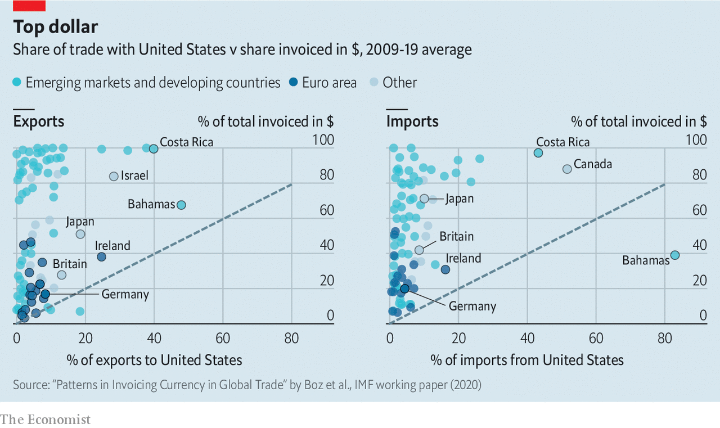

The euro’s creators had hoped that it might supplant the dollar’s status. But even though almost half of trade is invoiced in euros, that is mostly because of how much trade involves countries that use the currency. Between 1999 and 2014 euro-denominated trade was only around 1.2 times the euro zone’s share of global imports.

Other would-be challengers appear to have failed even more miserably. Scant Chinese data suggest that in 2013 only 17% of Chinese trade was settled in renminbi, and in 2012 only around half of such settlements were invoiced in renminbi. In order to avoid financial sanctions, Russia has recently shifted away from the dollar when paying for imports from China. But the euro, not the renminbi, benefited most.

A lack of historical data makes it impossible to say whether Grassman’s Law held in the 1970s and has since weakened or whether it was the always an artefact of insufficient data. Whichever is true, economists busied themselves trying to work out why exporters used dominant currencies.

One suggestion is that using the same vehicle currency when setting prices for a certain market lets companies avoid erratic price movements relative to their competitors. Ms Goldberg and Mr Tille offered some support for this when they showed that dollar invoicing was more common in markets, such as precious metals, where competition is cut-throat. Another suggestion is that the rise of global supply chains saw more exporters importing some inputs. Invoicing imports and exports in the same currency would preserve their profit margins in the event of a devaluation.

The arguments for a vehicle currency do not necessarily mean that that currency has to be the dollar. But why would it not be? The dollar already dominates the financial world. Central banks stash 58% of their official foreign-exchange reserves in it. It is the global currency of choice when issuing securities. Banks use it for around half of their cross-border claims. According to SWIFT, a payments system, it is used in two-fifths of international payments.

Indeed the worlds of finance and trade are intertwined. Exporters borrowing in dollars will want to price their foreign sales in the same currency, to protect against a sudden devaluation which would increase the value of their debt. Assets denominated in dollars offer their owners more security, because they will hold their value relative to imports priced in dollars.

Having established the importance of dollar dominance for global trade, economists updated their understanding of exchange-rate gyrations. In America sticky prices set in dollars mean the demand for imports is impervious to exchange-rate shocks. A Colombian light aircraft priced at $50,000 will cost the same when the dollar is worth 3,000 pesos as when it is worth 4,000. The change will eventually have an effect—but it will be partial, and slow. One study has found that two years after an exchange-rate shift only 44% of its effect would be seen in prices in America. Another found that just as prices did not change much, neither did the volumes importers chose to buy. After a 1% dollar depreciation, they found that the volume of imports into America fell by a measly 0.003%.

## Money, money, money

All this allows America to enjoy what Ms Gopinath describes as a “privileged insularity”. Its adjustment to a dollar depreciation happens almost entirely through exports, which immediately become cheaper in foreign markets. Devaluations against the dollar in other countries, by contrast, see them suffer. It becomes harder to afford imports while they don’t get the added export oomph the old models suggested. Exporters’ dollar earnings will be worth more in local currency, which might tempt some of them to expand. But that takes time. And the benefits are often offset by the higher cost of imported inputs.

Around the world invoicing imports in dollars means that it is devaluations against the greenback, rather than against the currency of the country you are trading with, that count. Emine Boz of the IMF, Ms Gopinath and Mikkel Plagborg-Muller of Princeton University found that prices of imported goods were relatively unresponsive to bilateral exchange-rate movements. Over short-term horizons they were six times more sensitive to the dollar exchange rate. The price of Brazilian-made football shirts in Mexico will stay the same if the peso depreciates relative to the real, but not relative to the dollar. If the peso drops with respect to the dollar, though, those shirts will become less affordable and may no longer be sold.

During the East Asian crisis of 1997-99 South Korea, Malaysia and Thailand all experienced currency depreciations of at least 60% relative to the dollar—and saw their export volumes stagnate or fall. With prices set in dollars devaluations did nothing for their export competitiveness within the region. And demand for imports from elsewhere in the region—also priced in dollars—plunged. Ms Boz and her co-authors have found that, after accounting for the business cycle, a 1% appreciation in the value of the dollar translates into a 0.6% decrease in the volume of trade between countries in the rest of the world.

Dollar dominance means trade is vulnerable to the global financial cycle, too. A study by Valentina Bruno and Hyun Song Shin of the Bank for International Settlements found that a dollar appreciation leads banks reliant on dollar funding to shrink their credit supply. Companies reliant on those banks—and their dollar-denominated financing of trade—then slow their exports, an effect particularly marked in companies with longer supply chains. Trade is a finance-hungry business.

Policymakers around the world yearn to be free of the dollar’s grip. That seems unlikely. The dollar’s dominance is the product of millions of individual decisions, each seemingly optimal, which in concert lead to collective problems. Each dip in the dollar’s value leads to a rush of wishful chatter about the dollar’s demise, but for long as these optimisations continue to make sense it is hard to see how that wish can come true. At least, though, for a while, the chatter-inducing weakness will provide a fillip to trade. ■

This article was downloaded by calibre from <https://www.economist.com/schools-brief/2020/08/29/global-trades-dependence-on-dollars-lessens-its-benefits>

|  |  |  |  |
| --- | --- | --- | --- |
|  | Articles | Sections | Next |

|  |  |  |
| --- | --- | --- |
| Schools brief | Sections | Books & arts |

Science & technology

Automation: Walking with robots

.

Covid-19: Trials and tribulations

.

|  |  |  |
| --- | --- | --- |
| Schools brief | Sections | Books & arts |

|  |  |  |  |
| --- | --- | --- | --- |
|  | Articles | Sections | Next |

#### Robotics

# Robots that can walk are now striding to market

They will be able to go where people can, but existing bots cannot

Aug 25th 2020 |

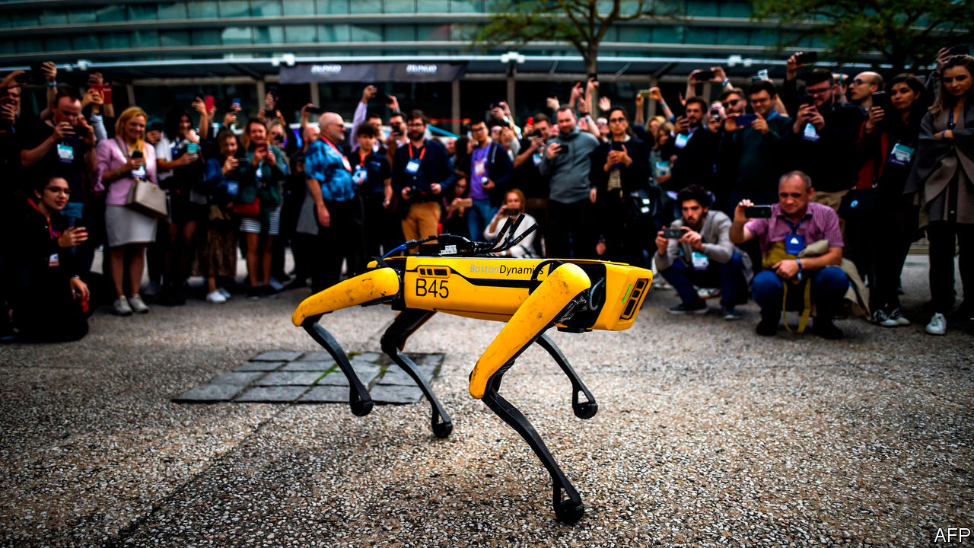

THEY MIGHT appear cutesy, but a pair of robots that turned up recently at the Ford Motor Company’s Van Dyke Transmission Plant, in Detroit, are practical working machines. They may, indeed, point to the future of automation. Putting robots into factories is hardly a new idea—some 2.4m of them are already at work in plants around the world. But most of these are little more than giant arms, bolted firmly to the ground, that weld and paint things. Those few that have the mobility to manage tasks like delivering components do so by scooting along on wheels. The new devices at Van Dyke are rather different sorts of beasts. They can walk.

This pair of bright-yellow quadrupeds look a bit like dogs, prompting one to be nicknamed Fluffy and the other Spot (which latter moniker is also the official name given to this model of robot by the firm that manufactures them, Boston Dynamics, a subsidiary of SoftBank). The pair are not there to amuse the factory’s human workers, though, but rather to perform an important task that Ford hopes will save it a ton of money. With laser scanners mounted on their backs, Fluffy and Spot can scamper around the 200,000 square-metre plant collecting data. Those data will be employed to build a detailed computer model of the entire manufacturing operation. This sort of model is called a digital twin, and Ford’s engineers will use it to work out how to rearrange the production line to produce a new gearbox.

Over the years, factory plans get out of date as things are moved around and new equipment is brought in. Surveying the transmission plant by hand would take weeks and cost some $300,000. Ford reckons that Fluffy and Spot, which can both climb stairs and crawl into hard-to-reach areas, will cut the time required by half and complete the job for “a fraction of the cost”. Although Ford is leasing the robots, Boston Dynamics has now put them on sale for $75,000 a pop. At that price they would soon pay for themselves doing tasks like the one being undertaken in Van Dyke.

The Spot range is the first of Boston Dynamics’s walking robots to be commercialised. More such machines are starting to appear from other firms and research groups. Some are also quadrupeds. Others are bipedal. The two-legged sort can be more agile and, if equipped with arms as well, are better suited to tasks like picking things up or operating controls. What all of these machines have in common is that they represent—forgive the pun—a huge step forward in robot locomotion.

## Four legs good, two legs better

If robots are to go where people go, they need to be able to move in the way that people move. Wheels are useless for navigating much of the world—just ask anyone who uses a wheelchair, says Aaron Ames, a robotics expert at the California Institute of Technology (Caltech). “We can make robots walk really well now,” he says. Such robots can, though, look a little odd. When a torso with two legs attached strolls out of Dr Ames’s laboratory it causes a bit of a sensation on Caltech’s campus. But this is something people are going to have to get used to, because many more are coming.

Problems remain, and improvements are needed. “But once we get there, we are going to have millions of walking robots in human environments,” says Jonathan Hurst, co-founder of Agility Robotics, a firm based in Albany, Oregon. It has just launched Digit, a bipedal, two-armed robot which has the look of an ostrich about it. At present, Digit costs $250,000. But it is early days. As more walking robots are put to work their development will accelerate and their production volumes increase, bringing the cost of a machine like Digit down to the tens of thousands of dollars.

This process is similar to the emergence of flying drones. They once cost millions, and had limited uses, until researchers worked out how to make small aircraft hover using multiple co-ordinated rotors. These devices could fly easily and autonomously. Prices fell to $500 or less, and multi-rotor drones are now employed for all manner of jobs, from cinematography to aerial surveying to delivering packages. Some in the field of robotics think walking robots have started down a similar path.

What changed? “We now understand the mathematics of locomotion to a much greater degree,” explains Dr Ames. Old-school walking robots, such as Asimo, a famously cheesy android unveiled in 2000 by Honda, a Japanese carmaker, have stilted gaits. They shuffle along, placing one foot forward, checking their balance, moving the other foot, rechecking their balance, and so on. “When you are walking, you don’t do that,” he says. “Your feet are just coming down and catching yourself.”

## Stroll on!

The way that humans walk is sometimes described by biomechanists as controlled falling. Making a stride involves swinging a leg out and placing it down with small subconscious corrections to maintain stability as the mass of the body above it shifts forward. Each leg works like a spring. These movements are predictable, and in recent years researchers have found out how to model them mathematically. Together with better actuators to operate a robot’s limbs, and sensors which can measure things more accurately, these models have made it possible to recreate this style of walking in robots. It does not require any fancy machine learning or artificial intelligence to do so, just good old-fashioned computation, adds Dr Ames.

The difference between Asimo’s gait and that of the new breed of bot is striking. Whereas Asimo’s chunky legs look leaden, Digit strides confidently along on a lean pair of limbs, happily swinging its arms as it goes. Atlas (pictured), an experimental humanoid made by Boston Dynamics, is more capable still. It can walk, run, jump and even perform backflips. Asimo did a lot of celebrity photo-opps, but it never went into production. Honda quietly stopped work on the project in 2018, to concentrate on more “practical” forms of robotics, such as mobility devices for the elderly.

It is easy to conclude, as many do, that these new walking robots simply mimic nature. But that is not quite the case. A quadruped, being a stable platform, is a good starting point from which to design a walking robot. After co-ordinating the four limbs, getting a good balance and fitting a system of vision that lets the robot work out where to put its feet, Spot’s designers ended up with a dog-oid. Michael Perry, head of business development for Boston Dynamics, says that is not surprising because nature has been developing efficient designs for a long time.

Another example of art evolving to imitate nature occurred during the design of Digit. This inherited its ostrich looks from Cassie, a two-legged torso which Agility sold to a number of research groups. Cassie’s developers had to find a way to stop some of the robot’s actuator motors from working against each other. Their solution turned out to look like a pair of bird’s legs.

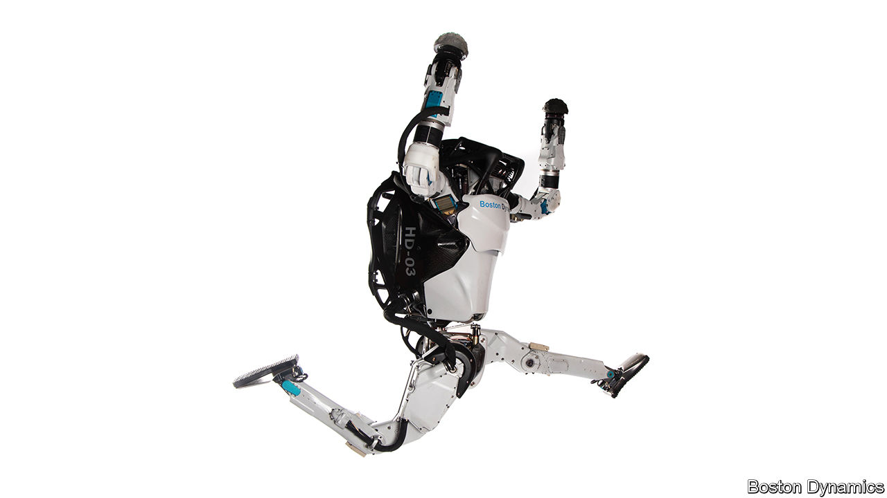

Cassie subsequently acquired arms and evolved into Digit as the result of the engineers’ attempts to solve another problem. When it swung a leg forward Cassie’s body twisted a little, which sometimes caused the robot to fall over if it was walking quickly. In nature, some animals use tails to improve their balance when manoeuvring at speed. Borrowing this idea, Agility’s researchers attached a pair of tail-like appendages, one on each side of the robot’s torso, to improve its mobility. That worked. Then they turned the appendages into a pair of arms. These can catch the robot should it fall, and help it get up again.

The arms can perform other useful tasks, too, such as moving boxes in a warehouse. Digit can carry up to 20kg. Distributing and delivering goods is likely to be an important application for walking robots, reckons Dr Hurst, especially now that e-commerce has boomed as a result of restrictions imposed in the wake of covid-19. Some automated distribution centres are set up for conventional fixed and wheeled robotic systems, but these have usually been built this way from scratch. Most warehouses are designed around people. Robots with legs, which move in a similar way to human workers, would fit right in.

With further development, walking robots will undertake more complex tasks, such as home deliveries. Ford is working on this with a Digit robot that rides in the back of a van. Though robots with wheels already make some deliveries, reaching many homes is tricky, and may involve climbing steps or stairs. “Legs are how you would want to get up to most front doors to deliver a package,” observes Dr Hurst.

Exactly how this might be done remains to be seen. Unless they are on a preprogrammed mission, most mobile robots require an operator to provide basic instructions to, say, proceed to a certain point. The robot then walks there by itself, avoiding obstacles and climbing or descending steps and stairs along the way. This means a walking robot making door-to-door deliveries might need some kind of digital map of the neighbourhood, to know in advance the paths it can traverse and the flower beds it should avoid. That might involve a big data-acquisition effort, much like those used to build digital maps for driverless cars. Similarly, in a factory or a warehouse, a walking robot would need to be shown the ropes by a human being before it was let loose to work on its own.

## Self determination

A fully autonomous robot that could walk into an unknown environment and decide for itself what it needed to do remains a long way off. One of the hardest tasks for such a device would be caring autonomously for someone at home. The robot would have to be able to make numerous complex decisions, such as administering the correct medicine, deciding whether or not to let strangers into the house or knowing when to take the dog for a walk. Yet many roboticists think they will get there, or at least close to it, one day.

In the meantime, the new generation of robots now being developed will keep building up the machines’ capabilities. At Boston Dynamics Mr Perry reckons that, besides surveying, Spot will find many roles in inspection and maintenance. Such robots can, for instance, enter hazardous environments like electrical substations without them having to be taken off the grid, as is necessary whenever a human engineer goes inside.

Instead of just looking for problems, Spot’s next trick will be to take action to resolve them, such as throwing a switch or turning a valve. It will do this with a single manipulator arm which makes it look less like a dog and more like a long-necked Brachiosaurus. A prototype of this configuration is already running around the company’s offices, opening and shutting doors.

This version of Spot should go on sale next year. As for Atlas, Boston Dynamics’s humanoid, that is currently too expensive to spawn a commercial version. But the lessons being learnt from it will help provide the engineering needed for other robots to come, says Mr Perry.

Some of these walking robots of the future may not be deployed on this world. At Caltech, Dr Ames thinks robots with legs will have advantages in planetary exploration—negotiating difficult terrain and entering caves, for example. Meanwhile, back on Earth, he and some colleagues at other institutions are using the new knowledge of robotic locomotion to develop lightweight prosthetic devices for those unable to walk easily, and powered exoskeletons for those who cannot walk at all. In a world not made for wheels, this raises the tantalising prospect that walking robots will one day help rid the world of wheelchairs. ■

This article was downloaded by calibre from <https://www.economist.com/science-and-technology/2020/08/25/robots-that-can-walk-are-now-striding-to-market>

|  |  |  |  |
| --- | --- | --- | --- |
|  | Articles | Sections | Next |

|  |  |  |  |
| --- | --- | --- | --- |
| Previous | Articles | Sections | Next |

#### The coronavirus pandemic

# Anti-covid-19 medicines are being approved too easily

And maybe for the wrong reasons

Aug 29th 2020 |

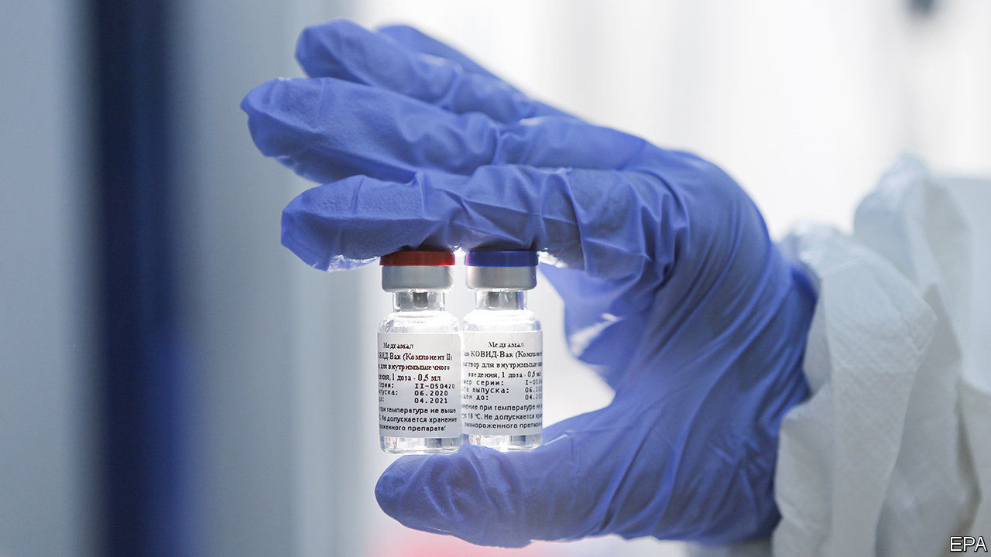

WHAT DO A malaria drug, a Russian vaccine and the blood plasma of people who have recovered from covid-19 have in common? All have been approved for use by governments in response to the coronavirus pandemic, with little or no scientific substance to back those decisions up.

On March 28th, near the pandemic’s beginning, America’s Food and Drug Administration (FDA) issued emergency-use authorisation for hydroxychloroquine, an established but not risk-free antimalarial medicine which was controversially being proposed by some people, including Donald Trump, the country’s president, as a possible covid treatment. It did so, the authorisation stated, based on “limited in vitro and anecdotal clinical data”. On August 11th Vladimir Putin, Mr Trump’s Russian counterpart, said his government was the world’s first to approve a coronavirus vaccine, despite a lack of proper tests. And on August 23rd Mr Trump announced approval of the use of convalescent plasma therapy to treat covid-19. He described it as a “very historic breakthrough” on the basis of a study the statistics of which the head of the FDA, Stephen Hahn, got publicly and spectacularly wrong.

That regulators move fast in emergencies is to be applauded. But these three examples have raised worries that sometimes they are moving too fast, and possibly for the wrong reasons. In one instance, indeed, things have gone full circle. Hydroxychloroquine’s approval was rescinded on June 15th, after a series of well-conducted trials showed that it had no effect on covid-19. The worry is that the other two approaches may prove similarly futile—diverting attention and effort from more promising avenues or, worse, causing actual harm.

## Don’t just say “yes”

The Russian announcement was of the development, by the Gamaleya Research Institute of Epidemiology and Microbiology, in Moscow, of Sputnik V. This involves two injections, three weeks apart (see chart). Each shot is of a harmless virus that has been modified to express one of the proteins made by SARS-CoV-2, the virus that causes covid-19. This is a perfectly sensible approach. Unfortunately, Sputnik V has not yet been through the trials, normally involving many thousands of people, which would be needed to show that it works and is safe. In fact, it has been given to a mere 76 people, and no results from these tests (nor from any of the animal tests that the institute says it has run) have yet been published. Mr Putin has, in other words, simply redrawn the finishing line for making a vaccine, stepped over it, and declared victory.



America’s behaviour is not much better. Again, the approach behind the product approved is reasonable in principle, but insufficiently tested. Convalescent plasma therapy transfuses blood plasma from those who have recovered from an infection (and which is therefore rich in antibodies against whatever had infected them) into patients with the illness to be treated. As Soumya Swaminathan, chief scientist of the World Health Organisation (WHO), observes, this tactic has been used to treat infectious diseases for over 100 years, and is effective against some, but not others. Trials of it as a treatment of covid-19 are therefore under way around the planet, but Dr Swaminathan says the results so far are “not conclusive”, and the trials themselves have been small. As a result, the WHO considers it an “experimental therapy”.

Not so, apparently, the FDA. Mr Trump made his announcement with Dr Hahn on the same platform. Two things have upset people about this. One is that the basis for the emergency approval was an observational study of ways of administering plasma (either less or more than three days after diagnosis) rather than a randomised controlled trial in which some patients were given a placebo instead of the treatment under test. The other is that, even granted this difference, the advantage seen in the study in question was too inconclusive to justify the approval given.

Dr Hahn described the benefits of treating early with convalescent plasma by saying that, “if the data continue to pan out, [of] 100 people who are sick with covid-19, 35 would have been saved because of the administration of plasma”. Jonathan Reiner, a professor of medicine at the George Washington University Medical Centre, tweeted that this was “shockingly wrong”, and that the actual figure was 3.2. Dr Hahn has since clarified that he confused the relative reduction in risk of mortality (of 35% between the two arms of the study) with an absolute risk reduction. That is a pretty fundamental mistake.

Meanwhile, in Hong Kong—a part of the world which looked as though it had SARS-CoV-2 under control—news has emerged of someone who, having had covid-19 once and recovered, has now been infected by a slightly different strain of the virus. Extrapolating from a single case is risky, but this one calls into question how long someone who recovers from infection retains immunity from re-infection. The answer is crucial to understanding how herd immunity to the virus develops in populations, and may also have implications for vaccine development. Doctors will now be looking hard for similar examples, so that such understanding can be improved.■

Editor’s note: Some of our covid-19 coverage is free for readers of The Economist Today, our daily [newsletter](https://my.economist.com/user#newsletter). For more stories and our pandemic tracker, see our [hub](https://www.economist.com/news/2020/03/11/the-economists-coverage-of-the-coronavirus)

This article was downloaded by calibre from <https://www.economist.com/science-and-technology/2020/08/29/anti-covid-19-medicines-are-being-approved-too-easily>

|  |  |  |  |
| --- | --- | --- | --- |
| Previous | Articles | Sections | Next |

|  |  |  |
| --- | --- | --- |
| Science & ... | Sections | Economic & ... |

Books & arts

Body art: The new ink masters

.

Elena Ferrante’s new novel: The second sex

.

The Freemasons: Inside the Lodge

.

Pop music: Send for “Help!”

.

|  |  |  |
| --- | --- | --- |
| Science & ... | Sections | Economic & ... |

|  |  |  |  |
| --- | --- | --- | --- |
|  | Articles | Sections | Next |

#### The new ink masters

# China makes its mark on the world of tattoos

The innovations pioneered by China’s tattooists are transforming the art of inked flesh everywhere

Aug 29th 2020 | WENLING, ZHEJIANG



THE ARMS are those of a tall young man, his muscles toned and skin firm. One is covered in thick sweeps of black Chinese calligraphy from shoulder to wrist. That and the other limbs—around ten in all—are piled in a disembodied heap on Wu Shang’s desk. They are models that he commissioned, made of silicon rubber that looks and, crucially for him, feels like real skin. Wu Shang is a tattooist in the coastal city of Wenling. Having seen hundreds of his carefully inked pieces of art walk out of his studio door, he wanted to keep a few to decorate the walls. “Otherwise, all I have is imperfect pictures,” he says.

These might be the quirkiest tattoos in China, but they are part of a much broader trend. Tattooed arms, backs and legs are fast becoming common sights in the country’s biggest cities. The delicate flora and fauna of traditional Chinese art have migrated from rice paper to bodies, carried along by a revolution in techniques. And the innovations pioneered by China’s tattooists for their swelling market are transforming the art of inked flesh everywhere.

The Communist Party is not among those who appreciate their work, instead viewing tattoos as undesirable avatars of hip-hop culture. As part of its fumbling effort to control them, China’s top media regulator has ruled that actors cannot show their tattoos on television. Footballers have been ordered to cover up theirs before taking to the pitch.

At the same time, the party has shown some flexibility, bowing to the facts on the skin. The People’s Liberation Army now allows recruits to have small tattoos. For a government so concerned about cultivating its global appeal, the real question is why it cannot recognise the beautiful gift under its nose—or, more accurately, on the forearms of the nation.

Tattooing is not new in China. Literature from the Tang dynasty (618-907AD) describes people getting tattooed with scenes of natural beauty and lines from poetry. Without question the most famous tattoo in Chinese history belonged to Yue Fei, a revered 12th-century general in the Song dynasty who had four characters inscribed on his back: jing zhong bao guo, or “serve the realm with utter loyalty”.

These, though, are the positive exceptions. For much of Chinese history tattoos were seen as markers of trouble. They were the preserve of borderland barbarians, rogues, bandits and criminals, whose faces were sometimes tattooed as punishment. Some believe that Confucianism frowns on tattoos as an act of filial impiety that damages your body, which is seen as an extension of your parents.

China’s modern dalliance with tattoos began in the 1980s as foreign fashions streamed into the country, just then opening to the world. Tattoo parlours popped up in its biggest cities, especially Shanghai and Beijing. Artists mostly imitated the designs popular elsewhere. But by the late 1990s a uniquely Chinese style was emerging, best captured in the work of Shen Weiguo, a soft-spoken man whose studio in Shanghai remains a fixture on the Chinese scene today.

Mr Shen was drawn to the Japanese fondness for dense images, infused with historical legends and covering the whole back. He also admired Western oil painting and China’s own cultural heritage. In his hands these were fused into what became known as the “Chinese neo-traditional school”, similar to the tattoos associated with Japan’s Yakuza gangsters but with Chinese content and brighter colours. (Think more dragons, fewer waves and less rigid rules.) Not that Mr Shen himself likes being called a neo-traditionalist. “I jump around a lot. As soon as you define yourself as this or that, you stop evolving,” he says.

Two other distinctively Chinese styles are now edging out the neo-traditional school in popularity. One is classic calligraphy, updated with a modern sensibility. Chinese characters often appear as tattoos in the West, too, but these mostly look like basic handwriting. By contrast, Wu Shang and other tattooists in China apply bold, inventive strokes (see below).



The other style is an approximation of ink-wash painting, the stuff of traditional Chinese landscapes. Among its finest exponents are Joey Pang (see below) and Chen Jie (see main image), two women who got started in the early 2000s, the former in Hong Kong, the latter in Beijing. Orchids bloom up the napes of necks; songbirds perch on branches that run across shoulders and down arms; mist-wreathed mountain ranges extend across collarbones. Their tattoos have an almost ethereal quality, as if floating above the skin. And just as important, they are perfect for the age of social media: Ms Chen has more than 420,000 followers on Instagram.



As is increasingly common globally, some of the best Chinese tattooists had formal art training before opting for ink and skin as their preferred medium. Wu Shang attended the prestigious China Academy of Art in Hangzhou, where he studied Impressionist painting. He says that he intended Wu Shang, his nom de plume, as a tribute to the French artist Paul Cézanne, meaning “I am no Cézanne”. Coincidentally or not, it can also mean “None are better than me”.

For art-school graduates, the lucrative potential of tattooing is part of the allure. A famous tattooist can charge 3,000 yuan ($435) an hour. Purists worry that such rewards have created unwanted pressures. Consider the fate of Ms Pang, the ink-wash pioneer in Hong Kong. She spent a decade studying under a calligraphic master. As her reputation spread, people came from around the world to her studio. By 2017 her waiting list stretched three years into the future. “I need time to think and draw before I work on skin, and I didn’t have that,” she says. Her husband was also her business partner. When their relationship collapsed, she left him and her business and fled to Dali, a city nestled among mountains in the south-western province of Yunnan, her birthplace.

After a couple of years spent fighting deep depression, Ms Pang is getting back into tattooing with a new studio. It looks nothing like the dingy lairs of the popular imagination. It is a one-room country retreat, with a floor-to-ceiling glass wall and a courtyard set up for tea service. “I can reconnect with my art here,” she says, speaking in her first interview since her disappearance. She adds a pledge to former clients: she will complete their unfinished tattoos for nothing if they come to Dali.

## The other revolution

Ms Pang’s ability to create watercolour-like works on skin is a result of dramatic improvements in tattooing equipment, which is linked to China’s rise as a manufacturing powerhouse. Tattooists used to rely on coil-based machines, which produced a buzzing sound as the needle bounced up and down. Over the past two decades many have switched to rotary alternatives. They are lighter and quieter, with more efficient motors. This allows tattooists greater precision as they wield two different formations of needles: a pen-like point for outlines and a flat brush for colouring. Their technique resembles painting, mixing different hues to generate the right look and then dabbing the colours on the skin.

But China’s manufacturing muscle has also generated a problem: a proliferation of cheap tattoo machines. “It used to be really hard to get tattoo equipment if you weren’t an artist yourself,” says Matt Lodder, an art historian at the University of Essex who has written extensively about tattoos. Now the devices can be easily purchased online. In the West some in the tattoo industry (normally averse to rules) have started calling for regulation to control the sale of equipment and ensure that studios meet adequate standards.

In China several prominent tattooists are taking a different approach. They have set up schools. In Wu Shang’s studio four students are hunched over flat pieces of silicon rubber—mimicking skin, just like his model arms—trying to recreate images that they first painted on paper.

That might seem inoffensive, but it goes against a widespread but unwritten code. Masters may take an apprentice or two under their wings, but only if they are truly committed to the craft. The idea that anyone can just show up, pay a tuition fee and after a few months apply ink to skin leaves purists aghast. Even in China some are critical. Mr Shen, the neo-traditionalist, says that he honed his technique over many years by wielding needles by hand. “You need to learn about the relationship between skin and needle. You can’t just get that overnight in school,” he says.

There is, however, a counter-argument. People in the business estimate that China now has tens of thousands of tattoo studios, up from hundreds a decade ago. Last year at least 16 large tattoo exhibitions were held around the country, bringing together crowds of would-be tattooists and soon-to-be-inked patrons. Given the surging demand, the need for well-trained artists is evident. Wu Shang knows that all too well. A garish orange-and-yellow fish on the underside of his left forearm testifies to the experiments on himself that taught him his craft. Who could begrudge his students wanting to start on fake arms? ■

This article was downloaded by calibre from <https://www.economist.com/books-and-arts/2020/08/29/china-makes-its-mark-on-the-world-of-tattoos>

|  |  |  |  |
| --- | --- | --- | --- |
|  | Articles | Sections | Next |

|  |  |  |  |
| --- | --- | --- | --- |
| Previous | Articles | Sections | Next |

#### New Italian fiction

# Elena Ferrante returns to Naples, and to familiar themes

“The Lying Life of Adults” is a dark coming-of-age tale about sexism and self-determination

Aug 29th 2020 |



The Lying Life of Adults. By Elena Ferrante. Translated by Ann Goldstein.Europa; 324 pages; $26 and £20.

FIFTEEN MILLION readers have waited five years for a new novel by the pseudonymous Italian writer Elena Ferrante, author of a riveting quartet of stories set in Naples that shot her to global fame. “The Lying Life of Adults”, a dark tale, does not disappoint. Yet it also demands more of Ms Ferrante’s many fans by probing even more painfully the oppression of women that drove her explosive Neapolitan saga.

Like “My Brilliant Friend”, the first in that series, this is a story of growing up: the universal struggle to separate from the family and establish a self. Ms Ferrante’s genius lies in the laser focus she brings to bear on female experience. In often lacerating detail, she portrays their protracted battle to define themselves independently of men.

Giovanna is 12, secure in the love of her intellectual parents until a question disrupts her world. Is she or is she not “very ugly” like her father’s estranged sister Vittoria, “a monstrous being who taints and infects anyone who touches her”? The search for an answer leads Giovanna to the depths of Naples, and the poverty-stricken neighbourhood from which her father escaped. Like the Neapolitan quartet, this story revolves around tension between the subterranean working class and the heights occupied by wealthy intellectuals. Yet on this smaller canvas it focuses on male entitlement and the female rage that results—and the lies about both that men and women tell themselves.

Like Elena and Lila, Ms Ferrante’s world-famous heroines, Giovanna and her aunt Vittoria represent those with and without education. Vittoria is an older version of the brilliant and irresistible Lila, drawing Giovanna into the violent world of her neighbourhood. Yet unlike Lila, Vittoria is repellent, distorted by a life of loss and stunted opportunity. The men in this book, too, are nearly all “animals” who want only sex and callously upend women’s lives. When a family rupture lays bare her own father’s lies, Giovanna plunges into a crisis of self-hatred in which she makes herself as ugly and obnoxious as possible.

This abasement is painful to witness. Readers inhabit the obsessive, anxious mind of an adolescent girl, see-sawing between pride and degradation. When a male professor takes an interest in her, redemption seems nigh. Naturally, Ms Ferrante rejects the romantic template. But Roberto is, instead, the first man to look at Giovanna’s eyes and not her breasts. From him she gains not love, but understanding. “I felt like laughing,” she reports at 16. “I had been deceived in everything…but the mistake had been to make it a tragedy.” What she really wants is to be respected, she concludes: to feel she is “much more than a cute or even beautiful small animal with whom a brilliant male can play a little and distract himself”.

Fans will appreciate the many parallels with Ms Ferrante’s earlier books. Stark reality coexists with magical objects, in this case not dolls or shoes but a gem-studded bracelet that propels the plot. Ms Ferrante’s unique style—again superbly captured by Ann Goldstein’s translation—is as urgent as ever, proceeding by confrontation and volcanic self-revelation, with little traditional description. Ms Ferrante’s women are angry, prickly, intelligent and exhausted by the effort of trying to exist in a patriarchal world. So fundamental a truth is a challenge few writers take on. But then, few are as able, as Ms Ferrante has put it, “to tell without distortions what I know”. ■

This article was downloaded by calibre from <https://www.economist.com/books-and-arts/2020/08/29/elena-ferrante-returns-to-naples-and-to-familiar-themes>

|  |  |  |  |
| --- | --- | --- | --- |
| Previous | Articles | Sections | Next |

|  |  |  |  |
| --- | --- | --- | --- |
| Previous | Articles | Sections | Next |

#### Inside the Grand Lodge

# A global history of the Freemasons

It is a more diverse outfit than many of its detractors assume, John Dickie argues

Aug 29th 2020 |

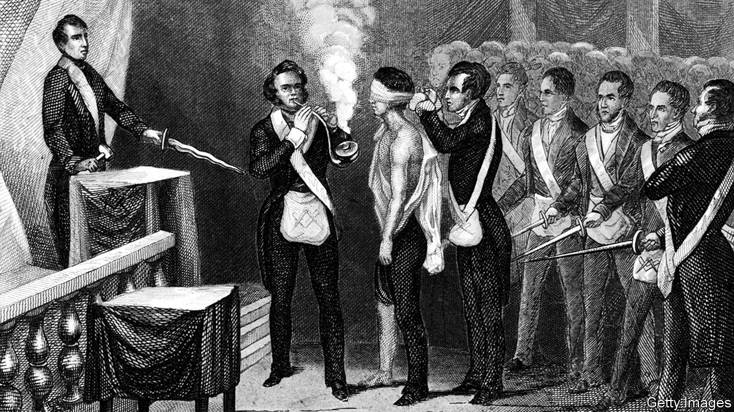

The Craft: How the Freemasons Made the Modern World. By John Dickie.PublicAffairs; 496 pages; $32. Hodder & Stoughton; £25.

SINCE THEY first came to prominence in the alehouses of 18th-century London, the Freemasons have proved adept at self-promotion. From their blindfolded initiation ceremony, obscure rituals and symbols and infamous handshake, the organisation has grasped the powerful attraction of mystery as a recruiting tool. Today the secret society has around 6m members, most of them in America.

Conspiracists have long speculated that these individuals are part of a secret “world order”, with ties to the Illuminati and satanic cults. Debunking these theories is relatively easy, but in his new book John Dickie goes much further. Based on years of research into the archives of the Grand Lodges, he has produced a global history of the organisation, explaining how the brand spread far beyond Europe. “The Craft” is a fascinating tale of imperial trade, warfare and scientific progress which presents the Masons as a response to the broader development of the modern world.

In their simplest form the Freemasons are groups of (almost exclusively) men, who undertake to pursue a “beautiful system of morality” and self-improvement according to a symbolic code. Their society is united by pledges to defend rational, enlightenment values, and over the centuries has attracted many high-profile members, including Wolfgang Amadeus Mozart, Winston Churchill and Walt Disney. In this account, however, Mr Dickie veers away from celebrity biography to focus on the broader membership. His characters are idealists and misfits—political exiles and refugees, traumatised soldiers, addicts who have overcome their vices. Their organisation, says Mr Dickie, is essentially a network of patronage. But he emphasises how many Masons treat its values of friendship, respect, integrity and charity as genuine anchors in their lives, not simply as window dressing for a practical agenda.

It is tempting to see the Masons as an elite clique of white, male, middle-class gatekeepers. And that has often been true. But the outfit described in “The Craft” is more diverse. In early modern Europe, Mr Dickie writes, the Lodges were among the few places where men from different classes could socialise. The Masons wore (and still wear) gloves during their meetings “so that no Brother can tell the difference between the hands of a Duke and the hands of a dustman”. Slaves were forbidden to join, but several American branches, such as that led by Prince Hall, a black leatherworker from Boston, played a role in the abolitionist struggle. In theory the Masons do not accept females, yet Mr Dickie meets Olivia Chaumont, who in 2007 became the order’s first transgender member.

Most books about the Masons speculate on the extent to which they have shaped history. Mr Dickie is more interested in the opposite question. He shows how reactionaries have consistently projected their darkest fears onto the society. In 18th-century Lisbon, as the Inquisition entered its decline, the Catholic authorities presented the Masons as an illicit gay cult. After the French revolution the English feared them as Jacobin agitators; Hitler and Mussolini ranked them among fascism’s most dangerous foes.

For all that, in moments of violence and political chaos the Masons have tended to come out on top. Mr Dickie is also a historian of the Mafia, and he suggests a connection between Italian Lodges and organised-crime syndicates. Some leading Masons, such as Licio Gelli, the head of Italy’s P2 Lodge in the 1970s, have collaborated profitably with terrorists and money-launderers. According to a former Grand Master in Calabria, 28 out of 32 Lodges in the region were known to be controlled by the ’Ndrangheta as recently as the 1990s.

“The Craft” is a well-researched account that dismantles any lingering suspicion that the Freemasons are preparing for world domination. Almost all such calumnies assume they have some form of central government—Mr Dickie makes clear that there is no such thing. While the Lodges share some core principles, they are remarkably various. Masons have been revolutionaries and reactionaries, progressives and conservatives. By chronicling these shifts, Mr Dickie has turned legend into history. ■

This article was downloaded by calibre from <https://www.economist.com/books-and-arts/2020/08/29/a-global-history-of-the-freemasons>

|  |  |  |  |
| --- | --- | --- | --- |
| Previous | Articles | Sections | Next |

|  |  |  |  |
| --- | --- | --- | --- |
| Previous | Articles | Sections | Next |

#### Home Entertainment

# The therapeutic properties of “Help!”

The album includes some of the sweetest melodies and tightest harmonies the Beatles produced

Aug 29th 2020 |

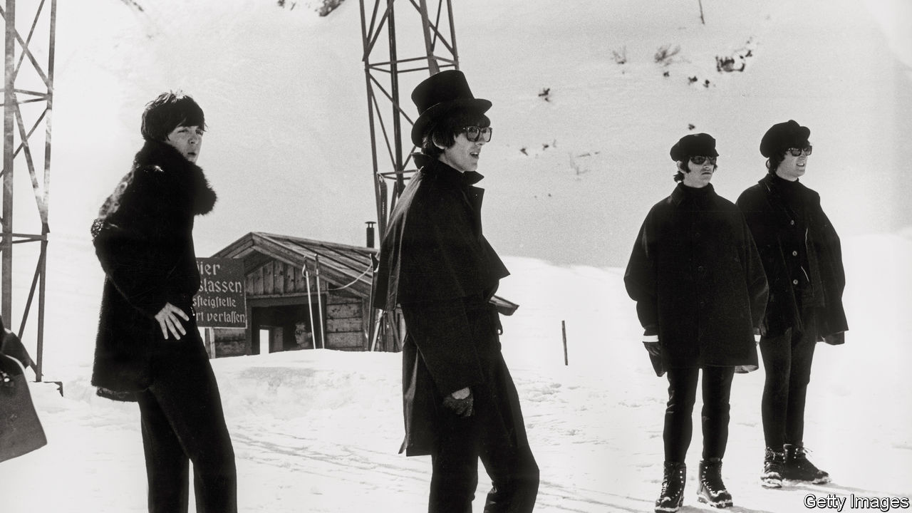

THE ONLY benefit to overplaying the Beatles’ greatest albums—surely a common problem in these lockdown days—is that it forces the listener back to their less celebrated material. Weary of “Rubber Soul” and “Help!” is at hand.

“Rubber Soul”, written and recorded in two months in late 1965, is considered a watershed in the band’s development. The album was the first over which the Beatles had creative control, and it is both experimental and coherent. On “Norwegian Wood”, George Harrison introduced the sitar to pop; John Lennon showed a new lyrical depth on “In My Life”. Ringo Starr called it the band’s “departure album”. By comparison, “Help!”, a poppier album completed a few months earlier, might seem to represent what they were departing from.

The silliness of the film to which it formed the soundtrack hasn’t helped its reputation. It featured the four being chased around the Alps by evil cultists who were after one of Ringo’s rings. But the Beatles did not evolve in fits and starts, just rapidly. Many of their later innovations are discernible on “Help!” in nascent form.

Its title track was a forerunner to Lennon’s more confessional style. “And now my life has changed in oh so many ways/My independence seems to vanish in the haze,” he wrote of his confining marriage. His anguished tone was belied by George Martin revving up the tempo. The effect is comical—one of the band’s qualities—as well as incongruous.

There is a similar tension in some of Paul McCartney’s contributions. “Last night is the night I will remember you by...when I think of things we did, it makes me wanna cry!” he sings on “The Night Before”, one of the jauntiest songs about rejection ever. It feels like a teenage precursor to “I’m Looking Through You”, his dig at Jane Asher on “Rubber Soul”.

“Help!” also features a lot more experimentation than is commonly remembered. “I’ve Just Seen a Face”, another McCartney foot-stomper, was the band’s first fully acoustic song (and includes a prime bit of Beatles Scouse, rhyming “her” with “aware”). The string quartet on “Yesterday” was equally novel. The song’s promotion of Mr McCartney, who wrote and performed it solo, seems in retrospect to prefigure his rise to dominate the band. But on “Help!” that role still belonged to Lennon, who contributed most of the mid-60s pop that is its therapeutic essence.

“You’ve Got to Hide Your Love Away”, his homage to Bob Dylan; “You’re Going to Lose That Girl”; “Ticket to Ride”; “It’s Only Love”: these songs include some of the sweetest melodies and tightest harmonies the band produced. Without underrating the extent of Lennon’s later contributions, they perhaps represent the moment at which he was at his zenith compared with his two songwriting rivals in the band. Play them through lockdown days: they can help.■

This article was downloaded by calibre from <https://www.economist.com/books-and-arts/2020/08/29/the-therapeutic-properties-of-help>

|  |  |  |  |
| --- | --- | --- | --- |
| Previous | Articles | Sections | Next |

|  |  |  |
| --- | --- | --- |
| Books & arts | Sections | Graphic detail |

Economic & financial indicators

Economic data, commodities and markets

.

|  |  |  |
| --- | --- | --- |
| Books & arts | Sections | Graphic detail |

|  |  |  |  |
| --- | --- | --- | --- |
|  | Articles | Sections | Next |

# Economic data, commodities and markets

Aug 29th 2020 |

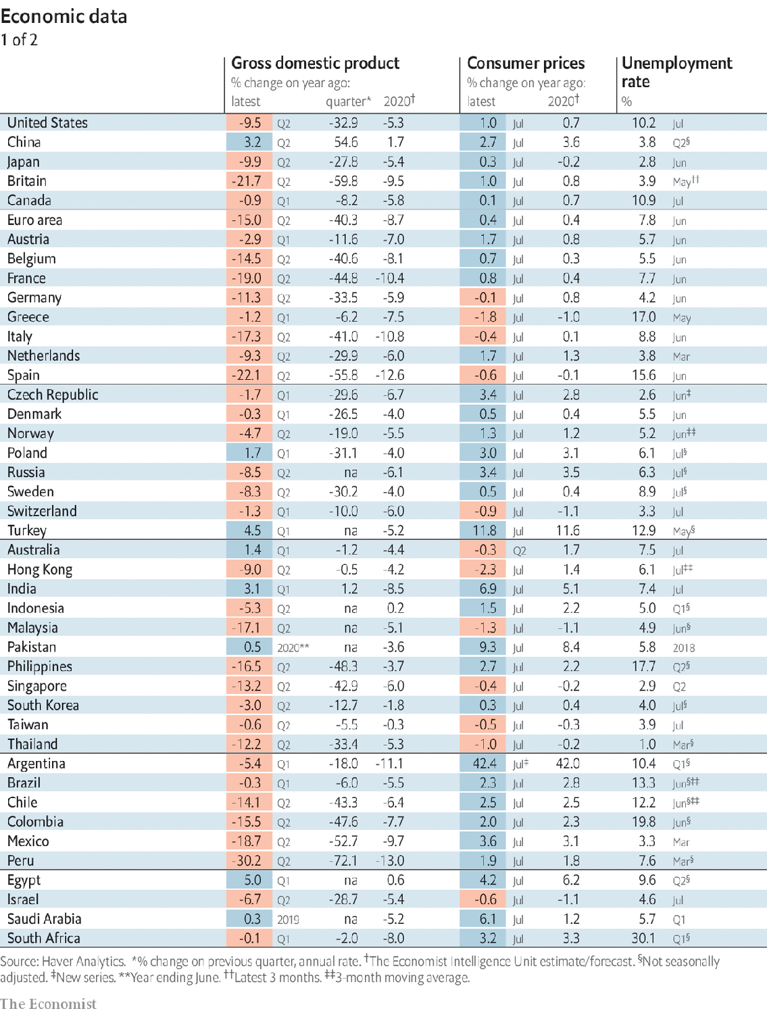

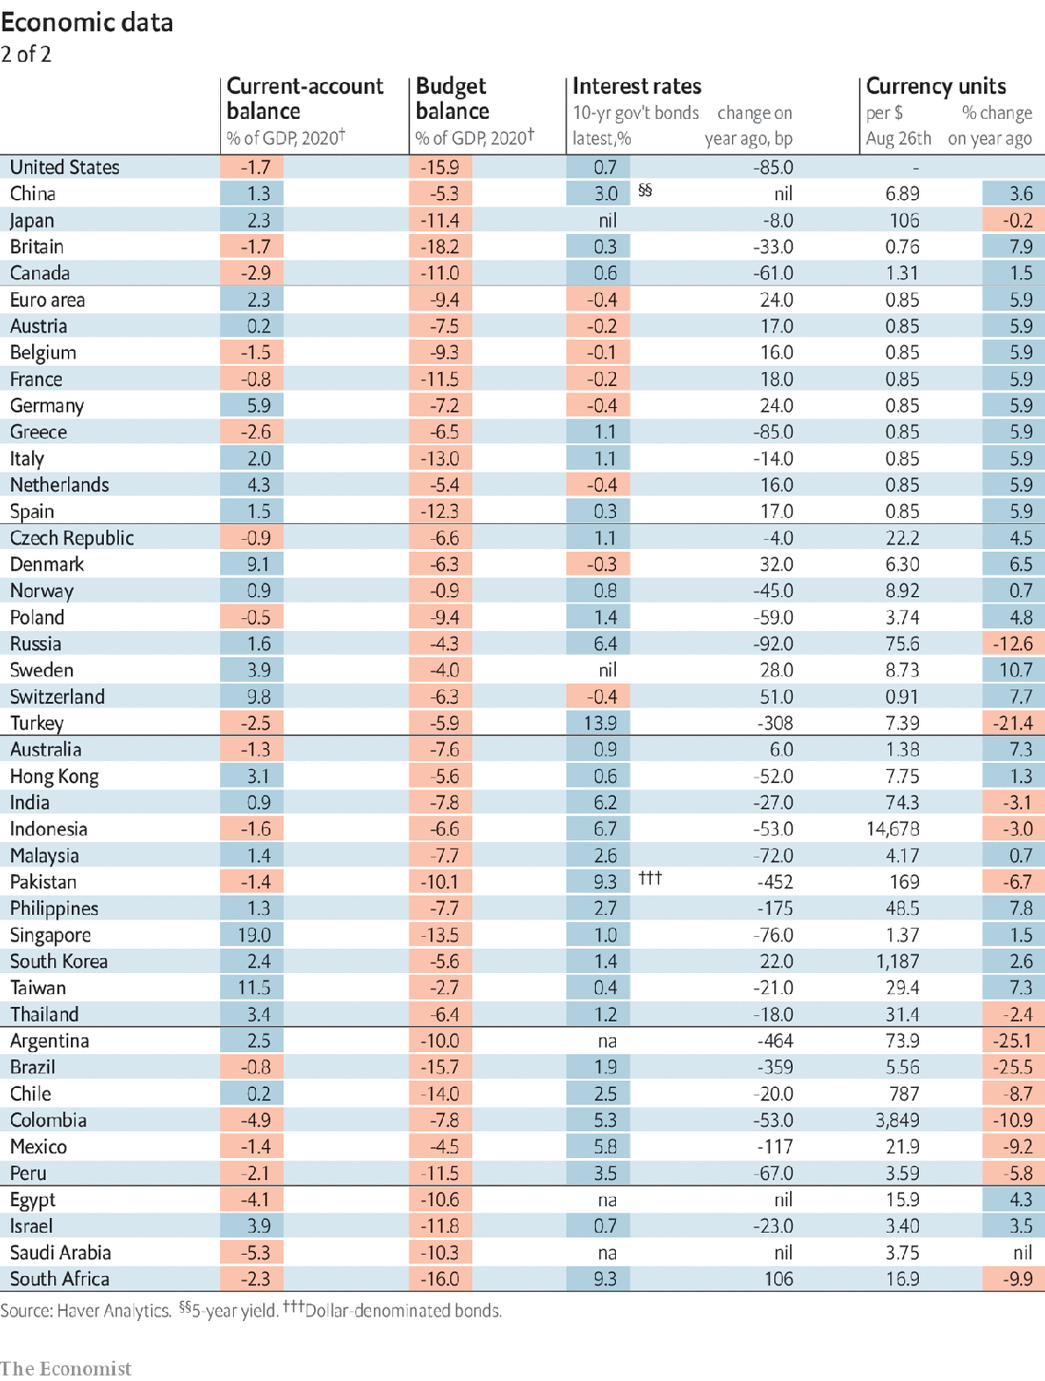

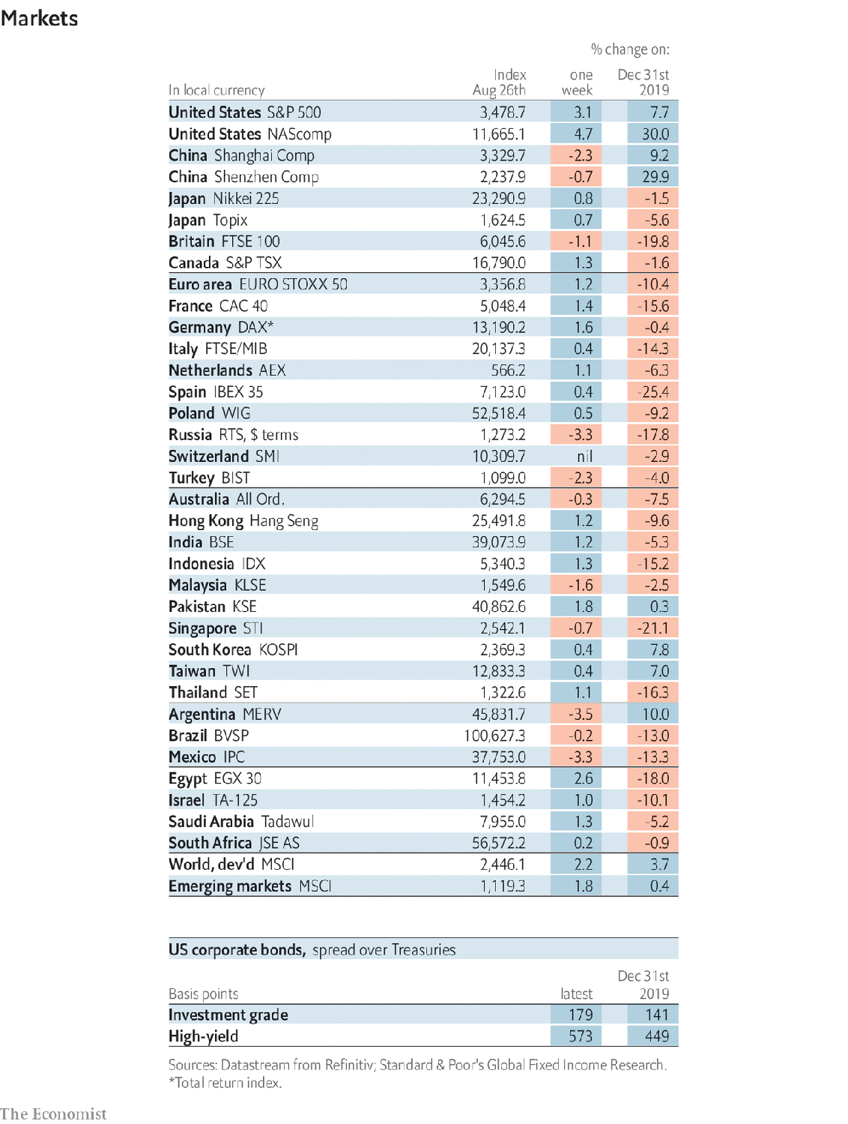

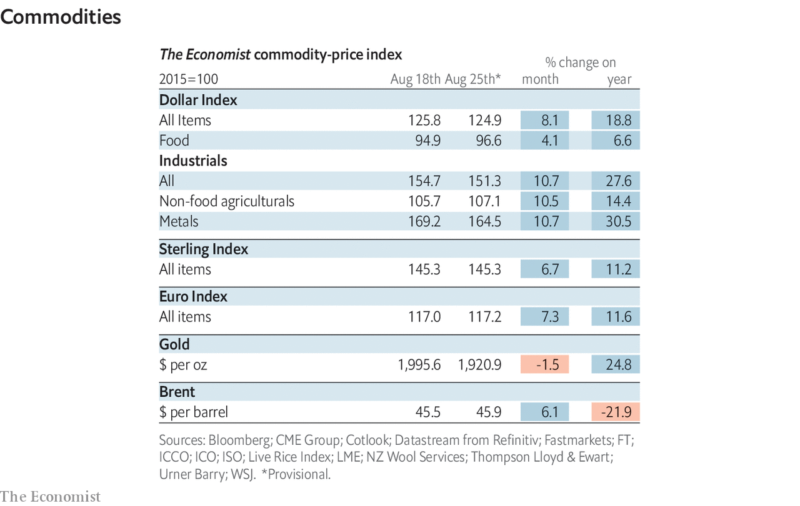

This article was downloaded by calibre from <https://www.economist.com/economic-and-financial-indicators/2020/08/29/economic-data-commodities-and-markets>

|  |  |  |  |
| --- | --- | --- | --- |
|  | Articles | Sections | Next |

|  |  |  |
| --- | --- | --- |
| Economic & ... | Sections | Obituary |

Graphic detail

Vaccination: A first-world problem

.

|  |  |  |
| --- | --- | --- |
| Economic & ... | Sections | Obituary |

|  |  |  |  |
| --- | --- | --- | --- |
|  | Articles | Sections | Next |

#### A first-world problem

# Conspiracy theories about covid-19 vaccines may prevent herd immunity

Anti-vaccination sentiments are more prevalent in rich countries than in poor ones

Aug 29th 2020 |

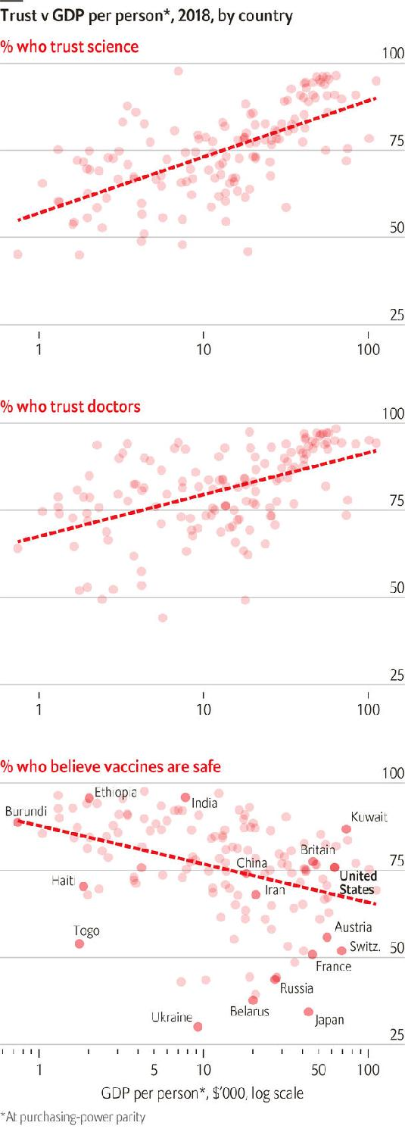

DO VACCINES CAUSE autism? Are politicians scaremongering about covid-19 to drum up profits for drug firms? Will Bill Gates use injections to implant microchips in your children?

The answer to all three questions is no, though scientists once debated the first. In 1998 the Lancet, a medical journal, published a study showing a link between jabs and developmental disorders. However, it was retracted after an investigation found that Andrew Wakefield, the lead author, had been paid by people suing vaccine producers. The British doctor was struck off, and large trials did not replicate his results.

Nonetheless, Mr Wakefield’s hoax transformed “anti-vaxx” sentiment into a mainstream belief. The Centre for Countering Digital Hate, an NGO, reckons 58m people follow English-language social-media accounts spreading such misinformation—including conspiracy theories about covid-19, big pharma and Mr Gates.

Polls from 2018 by the Wellcome Trust, a charity, show this idea is most contagious in rich countries, where barely 70% of residents think vaccines are safe. Confidence fell in France and Japan after people turned against government schemes for swine flu and papillomavirus. Trust is also low in former Soviet states, where jabs were mandatory and health advice was unreliable. By contrast, 85% of west Africans and 95% of South Asians think vaccines are safe.

This is not because people in rich countries have given up on medical research. In fact, they express more trust in doctors and science than people in poor countries. Sadly, many have mistaken Mr Wakefield and his cronies for credible experts. People in developing countries have heard less of such tosh, and witnessed more of the harm caused by deadly but preventable diseases.

The West’s distrust of vaccines has already been costly. Measles was almost wiped out there after mass inoculation began in the 1960s, but has returned. In 2019 the World Health Organisation revoked the “measles-free” statuses of Albania, Britain, the Czech Republic and Greece. America reported its most cases since 1992.

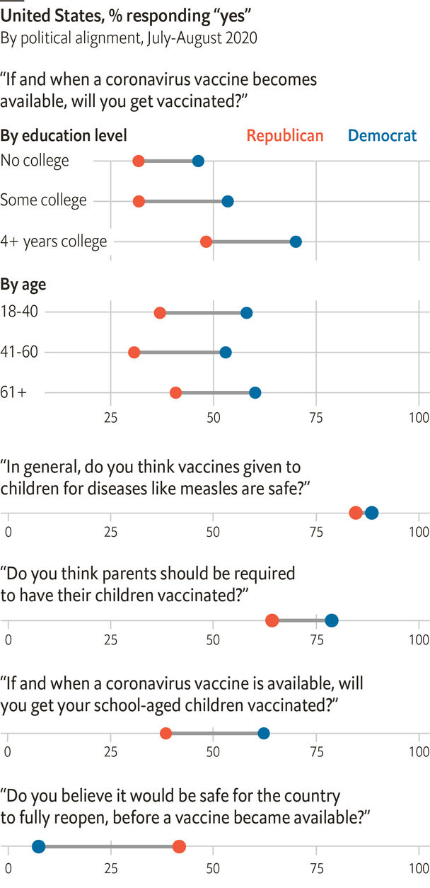

As covid-19 has spread, YouGov, a pollster, has asked Americans about vaccines. Despite Mr Wakefield’s anti-vaxx propaganda—he now lives in the United States—at least 85% of both Republicans and Democrats think measles jabs are safe for children. But the partisan gap widens for mandatory injections, and is wider still for covid-19 shots. Only 37% of Republicans say they would get vaccinated against the virus, compared with 61% of Democrats. The figure is barely 30% for middle-aged and less-educated people on the right. Even after adjusting for such factors, we find that Republicans are less supportive than Democrats of the same background.

This is bad news for governments hoping to banish covid-19. Wellcome’s polls show that many countries trust vaccines less than America does. The share of their residents willing to take a covid-19 jab may be below 50%. Whether that would provide herd immunity is unclear, since most estimates of the threshold range from 40-70%. Regardless, the polls show that convincing people to take vaccines may be as difficult as producing them in the first place. ■

Sources: Wellcome Trust; World Bank; YouGov/The Economist

Editor’s note: Some of our covid-19 coverage is free for readers of The Economist Today, our daily [newsletter](https://my.economist.com/user#newsletter). For more stories and our pandemic tracker, see our [hub](https://www.economist.com/news/2020/03/11/the-economists-coverage-of-the-coronavirus)

This article was downloaded by calibre from <https://www.economist.com/graphic-detail/2020/08/29/conspiracy-theories-about-covid-19-vaccines-may-prevent-herd-immunity>

|  |  |  |  |
| --- | --- | --- | --- |
|  | Articles | Sections | Next |

|  |  |  |
| --- | --- | --- |
| Graphic detail | Sections |  |

Obituary

Marvin Creamer: Wind, sea and stars

.

|  |  |  |
| --- | --- | --- |
| Graphic detail | Sections |  |

|  |  |  |  |
| --- | --- | --- | --- |
|  | Articles | Sections | Next |

#### Wind, sea and stars

# Marvin Creamer died on August 12th

The first man known to have sailed round the globe without using instruments was 104

Aug 29th 2020 |

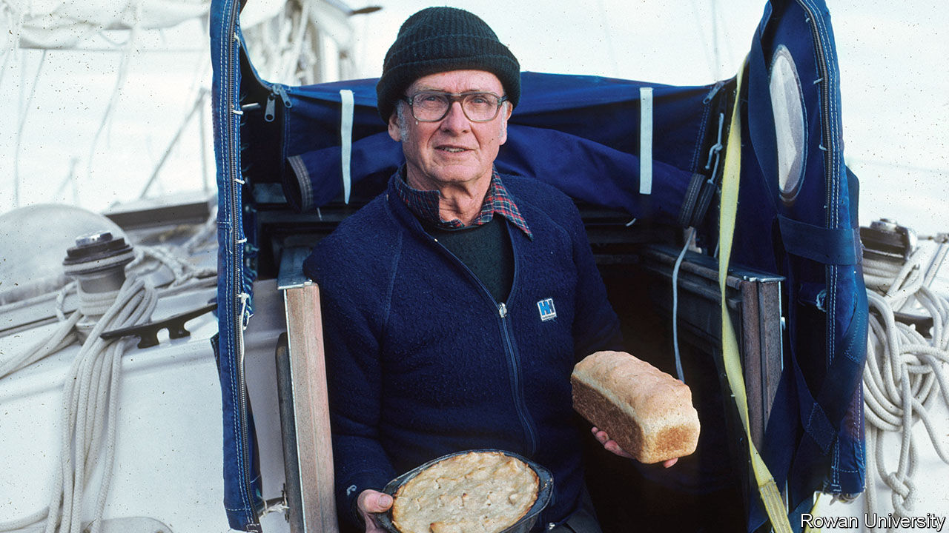

WHEN FRANCIS DRAKE rounded the globe in 1577-80, he took an astrolabe, compass and cross-staff with him. As Ferdinand Magellan, the first known circumnavigator, started out in 1519, he had at least an astrolabe and compass. But when Marvin Creamer set sail from Cape May, New Jersey in 1982, into thick overcast and a howling gale, on a voyage of 30,000 miles requiring nearly a year at sea, he carried, to his delight, no instruments at all.

Well, to be quite accurate, there were a few. He had an hourglass, the only time-keeper, to mark the watches of his small crew. Down in the bilge, in a duffel bag, were a radio, sextant, compass and clock, in case of emergency. His wife Blanche, with whom he had had months of lively discussions about this voyage—she dead against him sailing off, he, at 66, desperate to go—had insisted on this. But he had had it sealed by the navy, intending never to get those “toys” out, and never did. Lastly, there was a transmitter somewhere on the Globe Star to give the little cutter-rigged sloop’s position regularly to the coast guard. But it did not tell him where he was, and that was vital. He was going by the stars.

The ancient sailors he so admired, the Vikings and Chinese traders, as well as more modern Polynesians, had gone the same way. None of them, as far as was known, had circled the globe; but it seemed to him that they might have made predictable landfalls, setting a course and then returning again. He meant to prove, and never had much doubt—5%, perhaps—that they could also have got further. Endurance or fame were not the point of this endeavour, which even he admitted looked insane. It was the intellectual challenge of finding out how the ancients might have done it.

To prepare himself he had done some hard study of oceanography and meteorology, in the gaps between teaching geography in the department he had founded at Glassboro State College, now Rowan University. And he had gone seafaring: first fishing on small outboards past the barrier islands off New Jersey, where he would venture out so far that his colleagues thought him either lost, or mad, and later sailing across the Atlantic to Ireland and Africa. It was on a voyage back from the Azores in 1974, when he had taken the dark-to-daylight watch and the compass-light kept failing, that he looked up and thought: why not? All he had to do at that moment was find Polaris, the Pole Star, put his shoulder in line with the keel, and steer straight on. It worked like a dream.

Star-steering had intrigued him since childhood, when his farmer-father taught him to observe the different positions of the setting sun from the south-west corner of the barn. On his voyage, a clear view of sunset or sunrise could tell him his position; but for latitude without a sextant he needed to make a geometry of the night sky, drawing an imaginary line between Polaris and his chosen navigation-star and watching where that star made its meridian transit. Finding a fixed point in the southern hemisphere was tricky until he learned to use Acrux and Gacrux, two of the brightest stars in the Southern Cross, as pointers to the southern celestial Pole. (Delta Orionis, right over the celestial Equator, was most useful for longitude.) Both north and south of the Equator, his calculations proved so accurate that almost all the Globe Star’s landfalls, on a route from Dakar via Sydney round to Bermuda, were within 15 miles of the target, and close to the dates he’d set.

Yet for much of the voyage he could not see the night sky at all. Crossing the Pacific, they had five sights of the stars in 5,000 miles. To estimate latitude and direction he had to be fiercely observant in daylight, too. He watched the sea most: its deep swell, the surface interaction of new waves with old ones, and the shadows they cast; its colour, whether blue in the deep or green in plankton-filled waters, and the wake of the boat. He guessed the Globe Star’s speed from the time bubbles took to move from bow to stern. His log showed that, having veered off the Horn in fog and with no landmarks, he was unsure whether they had rounded it or not. But he thought they had because the sea had gone from a dark transparent green to a lighter green and then turned dark again—the colour, an old mariner had told him, of the Atlantic.

He guessed they had, too, from the sudden icy breath of a north wind coming off the snow-covered Andes. The wind was always a useful indicator. Leaving Cape May, he had set course south-east for Senegal by keeping the freezing north-westerly at the midpoint of the back of his neck. After days in the doldrums, floating with no direction, the sudden nail-scraping squeak of a hatch told him that a dry wind was blowing up from Antarctica. Heavy cumulus clouds indicated land; diving petrels showed, specifically, the Falklands (as did theRAF fighter jets that buzzed them, so soon after the war). Red sand-streaks on the sails in the dew of morning proved they were close to the Sahara.

For him, having the time of his life, happily chewing day after day the canned hamburger which Blanche, once resigned, had nobly put up for him, all the interest and point of the circumnavigation lay in these essential observations. Of course, there were dramas. Twice they almost capsized, with the mast 45% underwater. Going through Drake Passage near the Horn broke the “indestructible” steel tiller, though he was a good enough mechanic to rig up another. More than once they nearly came to grief on rocky, unlit coasts. Passing Tasmania, in the worst weather of the trip, he had to haul down wet sails with a dislocated shoulder. A galley fire almost incinerated the boat, as well as the loaf he was baking. Frustrations, but par for the course. He was just thrilled to prove that the ancients could have undertaken serious long-distance sailing, without toys, more often than people thought.

Naturally he wrote a book about it. But publishers showed no interest. No one had mutinied in this story, or been lost overboard; it was academic rather than tragic. Besides, there were lots of sailing books, and circumnavigations were increasing. That was all true; but then again, how many of those sailors had estimated latitude by watching yager gulls, or knew they were approaching home when a housefly settled in the cabin? ■

This article was downloaded by calibre from <https://www.economist.com/obituary/2020/08/29/marvin-creamer-died-on-august-12th>

|  |  |  |  |
| --- | --- | --- | --- |
|  | Articles | Sections | Next |